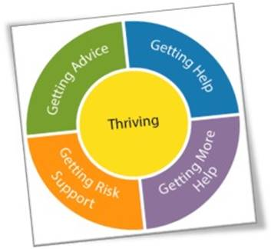**Family Thrive**

**Team around the Family**

|  |  |  |  |
| --- | --- | --- | --- |
| **Team Around Family Meeting** | | **Date:** | |
| **Child(ren) relating to this TAF:** | |  | |
| **Family Members / Professionals Present** | **Relationship to child/family** | | **Contact Details** |
|  |  | |  |
|  |  | |  |
|  |  | |  |
|  |  | |  |
|  |  | |  |
|  |  | |  |
|  |  | |  |
| **Apologies:** |  | |  |
|  |  | |  |
|  |  | |  |
|  |  | |  |
|  |  | |  |
|  |  | |  |
|  |  | |  |

|  |
| --- |
| **What is working well** |
|  |
| **What are we worried about** |
|  |
| **Young Person / Family views of the plan and what needs to happen?** |
|  |

|  |
| --- |
| **Any Other points of discussion or actions needed to achieve the Wellbeing Goals?** |
|  |

|  |  |  |  |  |  |  |  |  |  |  |  |
| --- | --- | --- | --- | --- | --- | --- | --- | --- | --- | --- | --- |
| **Scaling –** having discussed what life is like for your child right now, where is this on the scale? Child, parent and lead professional should scale – please write the person’s name underneath their score. | | | | | | | | | | | |
| 0 | 1 | 2 | 3 | 4 | 5 | | 6 | 7 | 8 | 9 | 10 |
| Extremely concerned | | | | | | All is well | | | | | |
| The Professional, the parents/carers, and the child or young person should all scale separately. There is no need to agree. This is powerful for opening up a discussion about why views are similar or different for each person involved. | | | | | | | | | | | |

|  |  |  |  |
| --- | --- | --- | --- |
| **Updated Family Plan agreed at TAF meeting** |  |  |  |
| **Wellbeing Goal**  **What do we want to achieve?** | **How will we achieve this? (action)** | **Who will do this? When will it be done?** | **Goal completed by family (date)** |
|  |  |  |  |
|  |  |  |  |
|  |  |  |  |
|  |  |  |  |

|  |  |
| --- | --- |
| **Next Meeting date and time:** |  |