

**Will I have to pay?**

After your needs assessment, the council looks at your money situation

They check your income, savings, and disability-related expenses

**What do I need to show?**

You may be asked for:

* Bank statements
* Pension or benefit letters
* Bills or receipts for disability-related costs

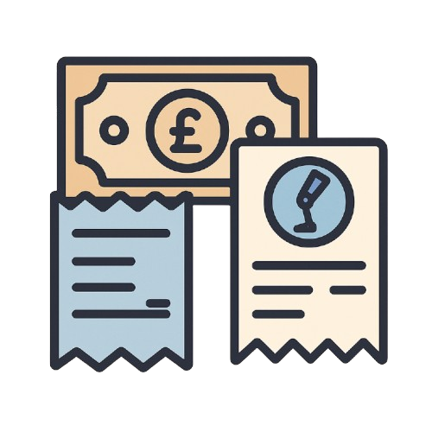

**How is the payment worked out?**

If you have **over £23,250** in savings:

* You pay the **full cost** of your care

If you have **less than £23,250**:

* The council uses a formula to work out what you pay:
* Income – Buffer – Disability Costs = What you pay

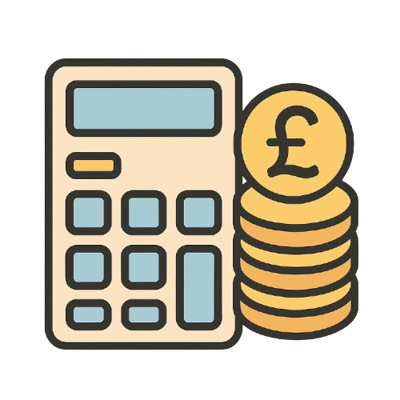

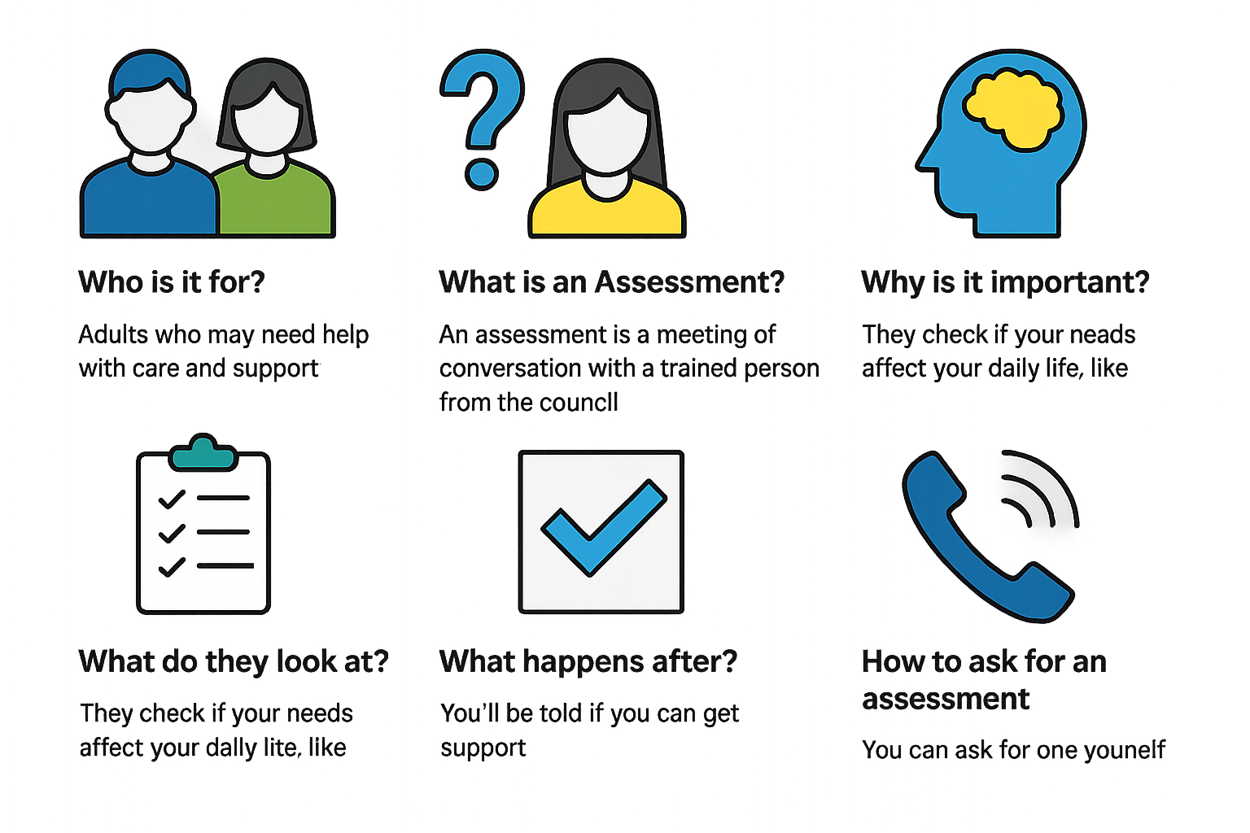

**What counts as disability-related costs?**

Things like:

* Extra heating or water bills
* Equipment (wheelchair, stairlift)
* Incontinence supplies
* Help with cleaning or laundry

**What if I don’t want a financial assessment?**

* You can say no
* But you’ll have to pay the **full cost** of your care

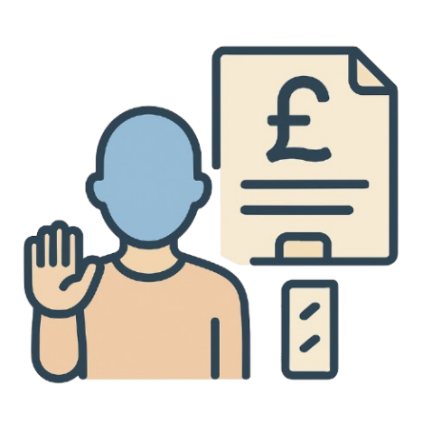

**What if I disagree?**

* You can ask for a review
* Keep paying while it’s being looked at
* If your charge is reduced, you’ll get a refund

