**Who will help me leave hospital?**

* **Hospital team** – doctors, nurses, therapists
* **Social worker** – helps plan care at home
* **Therapists** – check if you need equipment
* **Family or carers** – can help with planning

Everyone works together to make a plan that suits you.

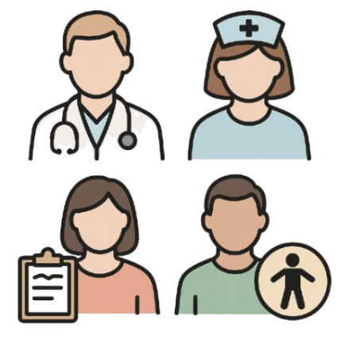

**What happens before I leave?**

Staff will check:

* You are well enough to go home
* You have a plan for care and support
* You have your medicine and know how to take it
* Your home is safe
* You understand what happens next

*Tip: Ask questions if anything is unclear.*

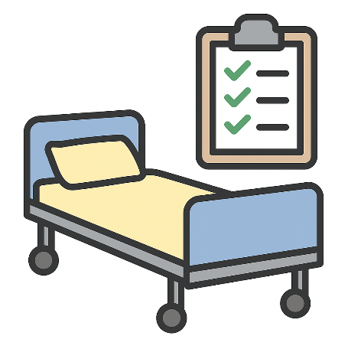

**Getting ready to go home**

You can:

* Get your home ready
* Plan how you’ll get home
* Ask for help with meals or medication
* Keep important phone numbers nearby
* Tell staff about any help you already have

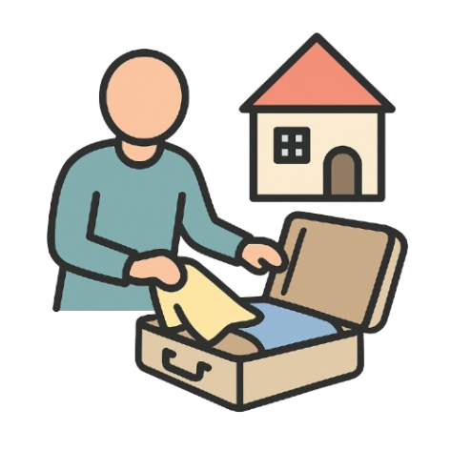

**What if I need more help at home?**

You can ask Adult Social Care for help with:

* Washing, dressing, or using the toilet
* Equipment or changes to your home
* A longer-term care plan
* Money advice for care costs

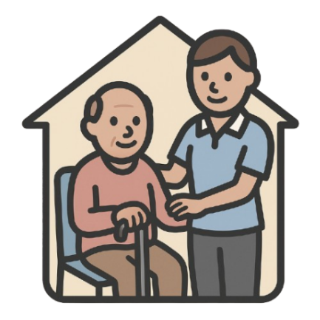

**Your rights**

You have the right to:

* Be involved in your discharge plan
* Say no to support (if you understand the risks)
* Be assessed for care under the Care Act
* Speak up if you feel rushed or unsafe



**Need more help?**

Talk to your:

* Discharge coordinator
* Hospital social worker  
  Or call **Lewisham Adult Social Care**:  
  020 8314 7777

