**What is safeguarding?**

Safeguarding means:

* Keeping adults safe from harm
* Making sure people are treated with dignity and respect
* Helping people stay safe at home, in care, or in the community



**Who needs safeguarding?**

* Adults who:
* Are aged 18 or over
* Need help with care or support
* Can’t protect themselves from harm or abuse

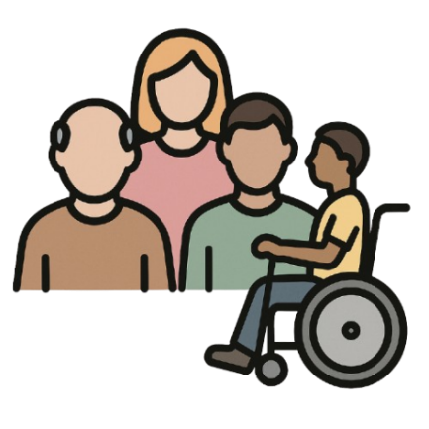

**What is abuse?**

Abuse is when someone hurts you or treats you badly.  
It can be:

* Physical (hitting, pushing)
* Emotional (shouting, bullying)
* Financial (stealing money)
* Neglect (not giving food, care or medicine)
* Sexual (touching without consent)
* Discrimination (being treated unfairly)

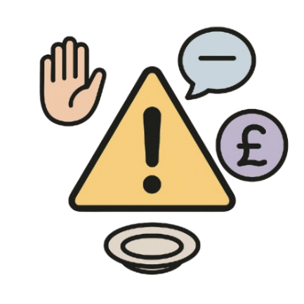

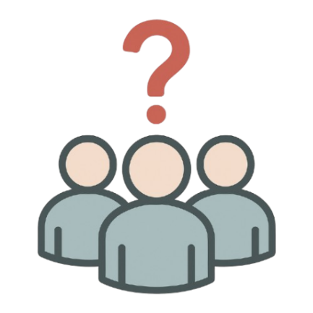

**Who might cause harm?**

* Family or friends
* Carers or staff
* Strangers
* Anyone in a position of trust

**What should I do if I’m worried?**

If you think someone is being hurt or is unsafe:

* Tell someone you trust
* Call **Lewisham Adult Social Care**:  
  020 8314 7777
* If someone is in danger now, call **999**



**What happens next?**

The council will:

* Listen to your concerns
* Look into what’s happening
* Work with the person to keep them safe
* Take action if needed

