**Who is a carer?**

A carer is someone who helps a family member, friend, or neighbour who:

* Is ill
* Has a disability
* Is older and needs support

You are a carer even if:

* You don’t live with the person
* You help them for just a few hours a week
* You are not paid to care

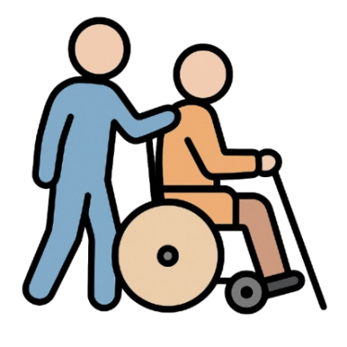

**Why support carers?**

Caring can be hard work.

You might need:

* A break
* Help with money
* Someone to talk to
* Support to stay healthy



**What support can I get?**

Lewisham Council can help with:

* A **Carer’s Assessment** – to see what support you need
* **Money advice** – benefits and financial help
* **Support groups** – to meet other carers
* A **Carer’s Emergency Card** – in case something happens to you



**What is a Carer’s Assessment?**

This is a meeting with someone from the council.  
They will ask:

* What you do to help
* How caring affects your life
* What support would help you

You might get:

* A support plan
* Help with equipment or services
* Advice and information



**How to get help**

You can:

* Ask for a Carer’s Assessment
* Call Lewisham Adult Social Care on 020 8314 7777

