Please read & keep for future reference

Rats
Post treatment advice sheet

As you are aware we have treated your property for rats today. Please take the time to read the customer information below as following this advice will greatly assist a speedy and successful treatment. Should you require any further information please contact us on the telephone number provided.

- Please ensure that children and domestic animals are kept away from the bait during the treatment period.
- If you suspect accidental poisoning, immediately contact the Accident and Emergency Department of your local hospital, or your local GP. The products that have been used will be indicated on your copy of the job sheet given to you by the operative.
- Where practical, the pest operative will remove any dead rodents during treatment and uneaten bait and at the end of the treatment period.
- Clean all floor areas routinely to deny rodents access to crumbs, especially when children are present. Restrict eating to one easily cleanable area.
- To help prevent further infestation proofing should be carried out. Particular attention should be paid to any holes, gaps around pipes, broken airbricks etc. of diameter greater than 25mm (1”). Do not use materials that
can be shredded for bedding (paper, card, cloth, expanding foam etc.). Rats can gnaw through quite hard surfaces so use metal or sand & cement.

- 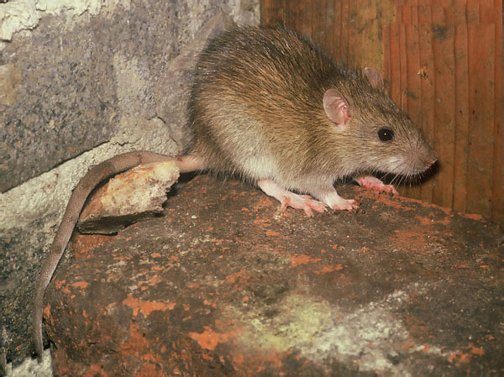Remove any outside debris such as old furniture, builder’s rubble and rubbish that can be used for nesting.
- Be aware of any tree branches overhanging your property and trim them if necessary – rats have been known to use these to gain access above ground level, particularly the loft.
- Do not leave any scraps of food lying in the garden; this includes food for wildlife and composting materials. Rats have been known to take up residence in compost bins for the warmth generated and food scraps added. Make sure your bin is lidded, has no holes and is standing on a wire mesh with holes less than 25mm
- Any edible items such as bulbs, bird food potatoes, fruit kept in outhouses (garages, sheds etc.) should be stored in sealed metal or plastic bins.
- Make sure any refuse/recycling bins have secured lids. Do not leave bagged rubbish out until it is due for collection.
- If a drainage defect is suspected, our technician may be able to check this by looking in any manholes on your property, carrying out a smoke test etc. Ultimately, however, it will be up to you as the occupier to follow through on these suspicions arranging for a camera survey, if necessary, and for any repairs to be done.

If the rats have entered your home:

DO NOT:

- Leave foodstuffs and/or dirty dishes out, particularly overnight.
- Leave household rubbish in containers that could be accessed, preferably remove it from the property regularly.
- Leave any food spillages, clean them up immediately.
- Leave foodstuffs on the cooker top.
- Leave pet food down; remove it after your pet has eaten.
- Do not touch or remove any bait.

DO:
- Make sure you wash all pots, pans crockery etc. prior to use, especially if there is evidence of rats having been in the cupboards where they are kept.
- Wipe food preparation surfaces down with an anti-bacterial cleaner.
- Clean up any droppings or urine with disinfectant. Wear disposable gloves.

If you find a dead rat you can double bag it in plastic bags and put it in your normal refuse. Make sure you let our technician know. If you are unable to deal with it yourself please telephone and ask for further advice.

Most rat treatments will require on average 3 visits depending on the circumstances. Our technician will agree with you the dates for each appointment. Please make a note of these as any missed appointments may count towards your 3 visits.

Further visits will be at our discretion and will depend very much on whether any advice we have given regarding proofing and/or repairs is followed.

The fee for this service is £75 for domestic treatments or the commercial rate starting from £125 + vat. Residents on receipt of LBL Benefits are currently entitled to a free treatment

Please note: The materials used for this treatment remain the property of Lewisham Council and every effort will be made to remove them at the end of the treatment.

LEWISHAM COUNCIL PEST CONTROL RESERVES THE RIGHT TO WITHDRAW FROM TREATMENTS IF ANY ADVICE GIVEN IS NOT FOLLOWED UP.

For further advice contact Call point on 020 83147171 or visit our website www.lewisham.gov.uk

