##### Lewish square mono-hiPlease read & keep for future reference

Mice

**Post treatment advice sheet**

As you are aware we have treated your property for mice today. Please take the time to read the information below as **following this advice will greatly assist a speedy and successful treatment**. Should you require any further information please contact us on the telephone number provided.

* Please ensure that children and domestic animals are kept away from the bait during the treatment period.
* If you suspect accidental poisoning, immediately contact the Accident and Emergency Department of your local hospital or your local GP. The products that have been used will be indicated on the separate (yellow) job sheet also given to you by the operative.
* Where practical, the pest operative will remove any dead rodents during treatment and uneaten bait and at the end of the treatment period.
* Clean all floor areas routinely to deny rodents access to crumbs, especially when children are present. Restrict eating to one easily cleanable area.
* To prevent further infestation any advice given regarding proofing should be followed up.
* Particular attention should be paid to any holes, gaps around pipes, broken airbricks etc.

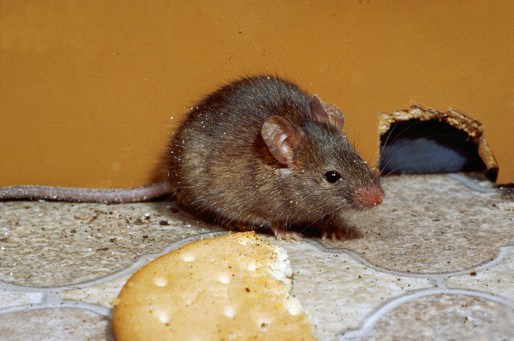

**Don’t forget a mouse can squeeze through a gap that you could get a pencil into**.

Do not use materials that can be shredded and used for bedding (paper, card, cloth etc.). The best materials to use are wire wool forced into any gap/hole and held in place with mastic if necessary. For gaps under doors a bristle strip can be fitted.

**DO NOT**:

* Leave foodstuffs and/or dirty dishes out, particularly overnight

.

* Leave household rubbish in containers that could be accessed, preferably remove it from the property regularly.
* Leave any food spillages, clean them up immediately.
* Leave foodstuffs on the cooker top.
* Leave pet food down; remove it after your pet has eaten.
* Do not touch or remove any bait.

**DO:**

* Make sure you wash all pots, pans crockery etc. prior to use, especially if there is evidence of mice having been in the cupboards where they are kept.
* Wipe food preparation surfaces down with an anti-bacterial cleaner.
* Clean up any droppings or urine with disinfectant. Wear disposable gloves.
* Keep any foodstuffs in sealable mouse proof containers.

If you find a dead mouse you can double bag it in plastic bags and put it in your normal refuse. Make sure you let our technician know. If you are unable to deal with it yourself please telephone and ask for further advice.

Most mice treatments will require up to 3 visits, and possibly a fourth to remove any uneaten bait.

**After the third visit we will revue the situation and our technician will make his recommendations with regards to the necessity of further visits.**

**The fee paid (£125 full rate, £62.50 for discretions or the commercial rate) is for up to 3 visits.**

**The treatment method used remains the property of Lewisham Council and every effort will be made to remove it.**

**Our technician will agree with you the follow up visit dates. Please make a note of these, if any appointment is missed this will count towards your 3 visits.**

**So please let us know well in advance if you cannot keep any given appointment.**

**We require 1 working days notice to cancel or change any appointment or you may lose that appointment and/or forfeit the fee.**

**If not you may be asked to contact Callpoint on 020 8314 7171 to arrange further visits for a fee.**

**LEWISHAM COUNCIL PEST CONTROL RESERVES THE RIGHT TO WITHDRAW FROM TREATMENTS IF ANY ADVICE GIVEN IS NOT FOLLOWED UP.**

.

For further advice contact Call point on 020 83147171 or visit our website www.lewisham.gov.uk