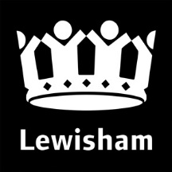

MAYOR & CABINET 14 SEPTEMBER 2021
  - The Local Authorities (Executive Arrangements) (Meetings and Access to Information) (England) Regulations 2012

  - Notice of Intention to Conduct Business in Private

Notice is hereby given in accordance with Regulation 5 of the Local Authorities (Executive Arrangements) (Meetings and Access to Information) (England) Regulations 2012 that the items listed below are likely to be considered in private.

The reason that these items are likely to be considered in private is that they involve the disclosure of exempt information under the following category of Schedule 12A of the Local Government Act 1972:

(3) Information relating to the financial or business affairs of any particular person (including the authority holding the information)

1. Reginald Road Land Assembly
To consider commercial land assembly costs for a housing initiative.
2. Procurement of Housing Management System and implementation of a Customer Relationship Management System
To consider the costs of the procurement of an IT system
3. Procurement of Lewisham Advocacy Hub
To consider the procurement costs of a Community Services facility
4. Cockpit Arts Deptford Redevelopment
To consider the costs of an extension to existing workspace provision
Published August 16 2021

Email committee@lewisham.gov.uk

Kim Wright
Chief Executive

