Bed Bugs
Pre-treatment preparation sheet

Please read & keep for future reference
Your appointment with the Pest Control Service to treat your premises for an infestation of Bed Bugs is on:-

Treatment Date………………………….

Job Reference…………………………..

Before the Pest Control Officer arrives to commence treatment you must carry out the following preparations:-

- Remove all bed linen from the bed(s) to be treated.
- Take down curtains and nets.
- Empty wardrobes and drawers in the room(s) to be treated, especially divan bed drawers.
- Remove stored items from the floors and clear everything from under the bed.
- Wash all bed linen, curtains, clothing and other washable items at the hottest temperature recommended by the manufacturer or have it dry cleaned before it is used again or put away.
- Clean the rooms to be treated thoroughly. Empty the vacuum cleaner directly into the dustbin or change the bag after cleaning.
- Make sure rooms to be treated are clear enough for the Pest Control Officer to move the bed(s) and furniture easily as they treat.

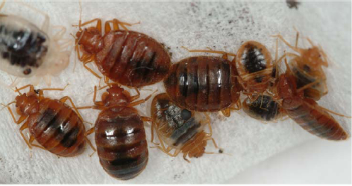

- People and domestic pets must leave the rooms being treated and not be allowed to return until the insecticide is dry.

If you do not carry out these preparations the Pest Control Officer will not carry out the treatment.

After the Pest Control Officer has carried out the treatment:-
- Do not enter these rooms for at least two hours or until the Officer advises.
- Do not vacuum or clean any treated floors for at least 15 days to allow the insecticide time to work.

Two treatments are usually sufficient to control the infestation as the products used carry on working for some weeks. The bed bugs should die off gradually after coming into contact with the insecticide. Our technician will make a 2nd appointment with you. If there is still a problem 4-6 weeks after the last visit you will need to book a new treatment.

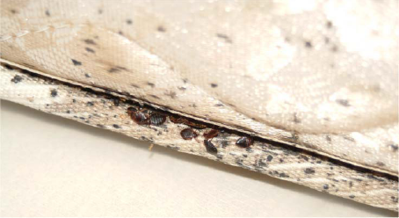
For further advice contact Call point on 0208 3147171 or visit www.lewisham.gov.uk

