The safety and wellbeing of our communities

A Safer Lewisham Plan
2019-2020

Agreed March 19

About the document

The Crime and Disorder Act 1998 as amended by section 97 and 98 of the Police Reform Act 2002, places a requirement on Community Safety Partnerships (CSP) (In Lewisham, the Safer Lewisham Partnership) to develop a three year Crime and Disorder Strategy which sets out how crime and Anti-Social Behaviour will be tackled

An additional responsibility is also placed on Community Safety Partnerships to produce a Strategic Assessment to ensure emerging community safety trends are captured, and priorities are refreshed where necessary.
The Annual Plan outlines the main priorities for the Safer Lewisham Partnership, which have been identified through the Strategic Assessment.
Lewisham Council and the Safer Lewisham Partnership have a statutory obligation to analyse crime and disorder problems in the borough and agree priorities for a given financial year where the Partnership will focus most of its resources and activity.
This document should be read alongside the Councils Corporate Strategy 2018-2022
The following documents and information provides further context:
London Police and Crime Plan 2017-2021
London Knife crime action plan – 2017 and Lewisham Knife crime action plan 2018
VAWG Plan 2017-2021
Domestic Abuse Story Board - 2018
Bedfordshire university contextual safeguarding and risk 2018
Missing, Exploited and Trafficked Strategy – 2016 and CSE story board 2018
Met police Drugs Strategy – 2018
Lewisham Children and young person’s plan – 2015- 2018
Lewisham’s public health approach to violence – a framework approach 2019
Youth justice plan 2018-2021

Context
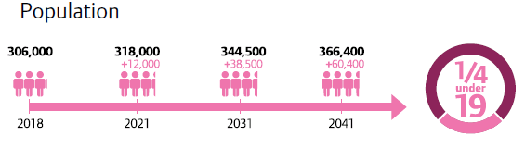
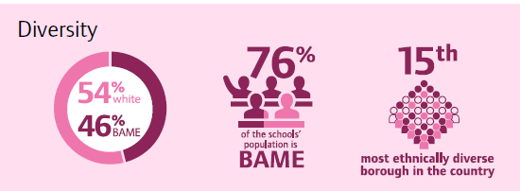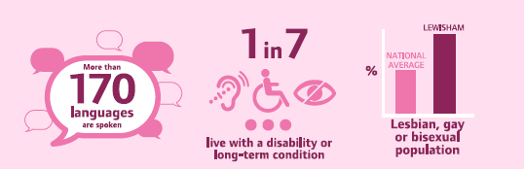

Summary from met dashboard year on year Feb 2017 - Jan 2018 and Feb 2018 -Jan 2019
In 18-19 we asked how do we have less violence in society – how did we do?
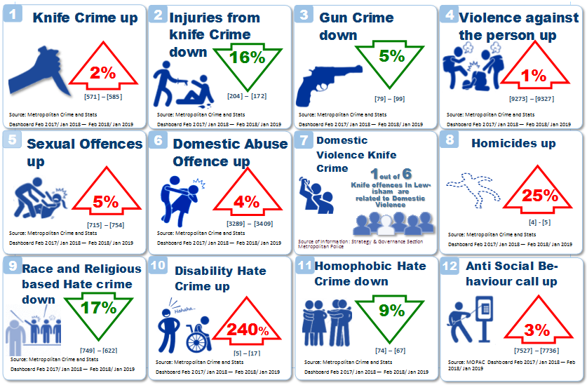
In 18-19 partnership activity has focused on youth violence, domestic violence and knife crime. Increased recognition about the trauma violence causes and approaches that support this understanding has started to show impact. Police enforcement has been significant in the overall impact, removing dangerous individuals from our communities.
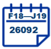

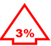
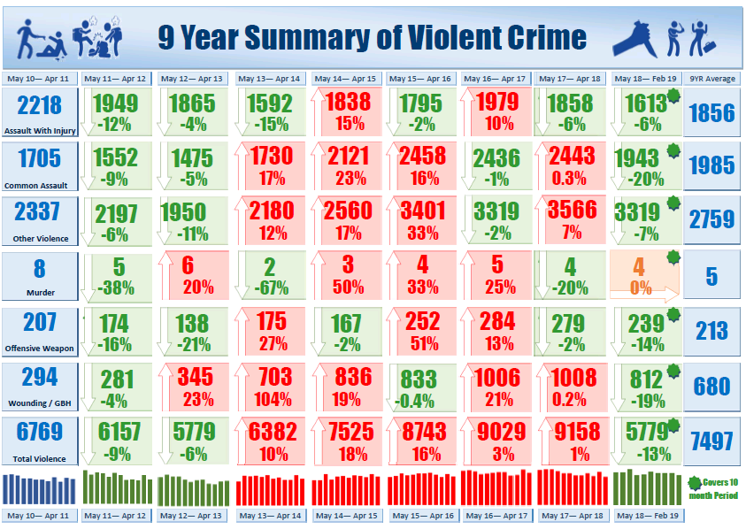
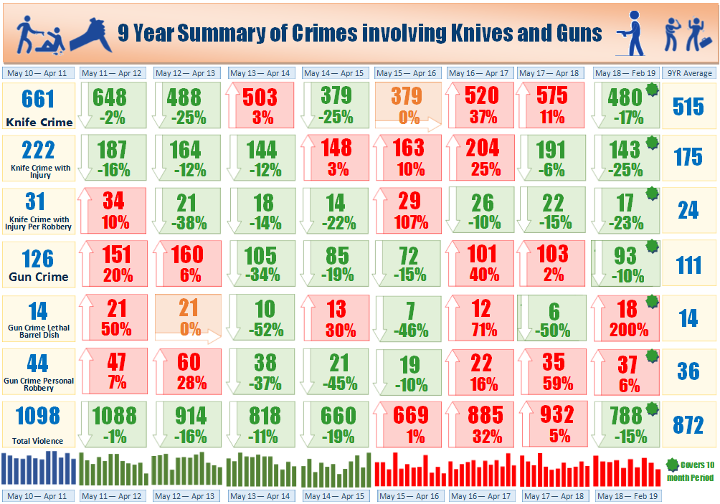
In 18-19 we asked How to create safe spaces and places - how did we do?
The Charity ‘For Jimmy’, working in partnership with Lewisham Council and other key agencies, have been working with schools to help young people to map out their perceptions of safe and unsafe spaces and jointly design solutions. These conferences are driven by the young people so that they can see that they have the power to have a positive impact.
POLICE RELATIONSHIPS
Done: There are now more Safer Schools Officers in schools who are building relationships with children and young people, and these officers will continue to communicate more to explain what they are doing in schools and in the community.
To do: Over the next year, Lewisham Police will focus on putting police officers in the right places – using the Safety Maps to find the places where people feel unsafe. police already work to increase the number of police officers in parks.
They will also try to increase the number of officers in yellow hi-vis jackets by April 2019, because this makes them more visible and makes people feel safer.

SAFE SPACES
Done: For Jimmy has worked with young people in schools to set up 90 new Safe Havens over the past year.
To do: For Jimmy was also asked to make the Safe Havens stickers larger, but unfortunately this is the largest they can get. They will however be raising more awareness with a Safe Havens Engagement worker (Youth & Community Worker) who will be visiting all the shops, visiting schools and meeting parents to explain about Safe Havens.
For Jimmy will also create a map of all the Safe Havens to display in every school.

Collection of Solutions from Young People
- Give more support homeless people (Money/Food)
- School Police
- More street Lights
- Lewisham shopping centre should make people under 18 go in with their parents
- After School Staff in town centres
- Find activities in Lewisham for teenagers to do the children maybe with the centre
- More police around park shopping centres, roads
- More police patrols
- Speed limits, more traffic lights, more speed camera
- In the shopping centre there should be a rule that secondary pupils are only allowed in with an adult and there should be Security
- More child friendly facilities (e.g. leisure facilities or youth centres)
- Safety conferences
- Lewisham shopping centre should have a rule about no fighting in the shopping centre or else the police will come.
- The park outside the school should have more guards patrolling the park
- After school all teachers make sure all secondary teenagers are out of the park
- More police

NEXT STEPS
Lewisham Council and For Jimmy are going to work together with at least 20 schools in Lewisham over the next year to complete hundreds of smaller, individual Safety Maps. This means that every young person involved will have the chance to explain their own view of the area, and we will be able to add them all together to get the best, most accurate picture of Lewisham Borough through the eyes of young people.

BULLYING, GANGS & GENDER ISSUES
Done: For Jimmy have dealt with the issue of bullying by running 18 Safe Havens Programmes across Lewisham over the last year. The programme helps young people to value difference, to care about each other, and to think about the consequences of their actions. It also helps to build confidence and resilience among those who experience bullying.
Lewisham Council has also produced lots of cards with information for young people about bullying, knife crime, healthy relationships and online safety.
To do: For Jimmy will deliver another 18-20 school programmes between September 2018-July 2019.

Safer Businesses
The Safer Lewisham Business Crime Reduction Partnership (BCRP) hosted a Lewisham 3-part interactive training session, with businesses from across the licensed, retail and hospitality industry to learn from MET Police experts on three of the most crucial and prevalent security issues facing our businesses today.
This included:
- WAVE- Welfare and Vulnerability Awareness
- ACT- Action Counters Terrorism
- Project Diffuse- Acid Attack Training Taster session.
The, Safer Business Network sits on the London’s Night Time Commission contributing to working towards making London a 24 hour city. It will feed into the commission on the perception local businesses have about safety at night in Lewisham and what their safety and security concerns are. The Council, Police and BCRP maintain regular meetings with banks on fraud issue, along with supporting Pub Watch and Bet Watch schemes. Lewisham Council are also working with the London Digital Resilience Network to support small to medium size businesses on cyber security issues.

Safer Online
Online safety and vulnerability of young people through social media remains a key focus.
- Youth First continue to roll out the Universal Schools Programme across Lewisham schools
- Youth Offending Service online screening tool being tested.
- The online safety work links to Lewisham Parenting Strategy

Safety at Home
The London Fire Brigade and the Local Authority have analysed fire safety data to identify priority areas of focus.

Safer Communities
Joint Delivery of community dialogue opportunities:
- More than 60 organisations in the borough have had open dialogue on key topics, with Violence, extremism and hate crime featuring prominently.
- The Lewisham Interfaith Forum began in October 2018 and has continued to meet monthly.
- Community based events, such as the Lewisham Positive Women’s Conference discussing the wider harms of extremism (FGM, Hate Crime and Honour Based Violence)
- Lewisham’s third party reporting sites for hate crime re-launched, including the new site at Goldsmiths University.
- Multi agency Problem Solving Partnerships are tackling a number of issues include drug dealing, street drinking, begging, ASB and illegal parking.

In 18-19 we asked how do we reduce negative bias and disproportionality - how did we do?
A focus on negative bias and its impact on communities has led to wide scale unconscious bias training being delivered across partners. Greater analysis of data has enabled improved understanding of the issues and seeking to take action to make a difference. The findings in the youth justice system is starting to demonstrate some positive impacts. Further action is needed across the whole journey of the child.
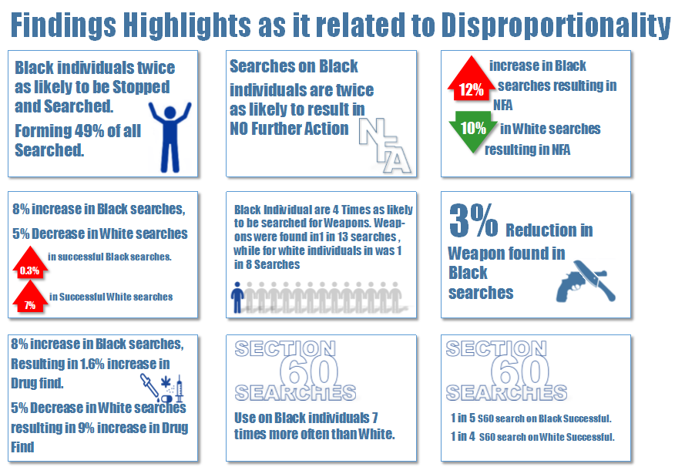
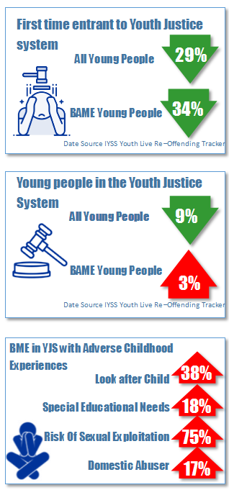

In Lewisham today we: (Illustrative)

The Journey of a Child
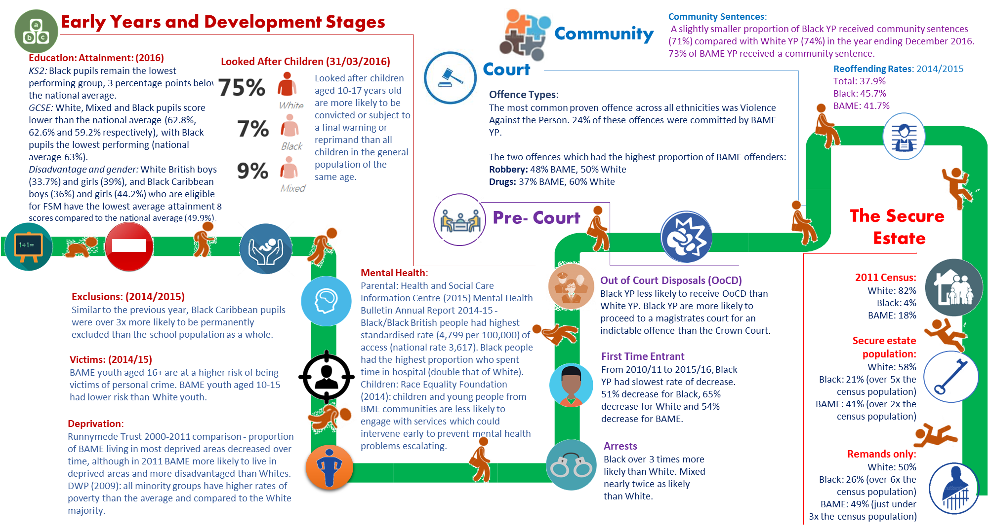

In Lewisham today we are: (this is illustrative and not an exhaustive list)
- Supporting early childhood development and meeting the needs of adults (parents)
- Supportive breastfeeding borough to support attachment, attainment and baby bonding.
- Nurse family partnership provides prenatal health advice and support, child development education, and life coaching for vulnerable first time mothers
- Children’s centre offer including 5 to thrive model. Based on ‘building blocks for a healthy brain’, and on five key 'activities' Respond · Cuddle · Relax · Play · Talk
- Parenting support and advice including programmes such as Core Assets.
- Street doctors; student medics giving young people skills and confidence to help in an emergency as well as influencing towards positive educational options.

- Identifying protection and safety for those who may need additional support
- Youth Justice Interventions using a trauma informed restorative model.
- Functional family therapy accredited
- Range of community based interventions through the voluntary sector
- Hospital based youth workers through the voluntary sector to support those injured using a teachable moment method.
- Non-violence resistance programme (NVRP) delivered to parents to support models of restorative approaches.
- Cooth online counselling support for young people
- A core service for adults with drug and alcohol issues, offering people recovery support and prescribing with partnership offers across justice, housing and health services, alongside harm reduction including needle exchange coordination and blood borne virus testing.
- A ‘primary care recovery service’ delivered in partnership with 8 GP ‘hub’ surgeries providing community based recovery support and prescribing
- Health and wellbeing service for young people including CAHMS provision for mental health.

- Preventing escalation
- Violence reduction Team direct support to individuals and families
- Programmes such as Athena (supporting victims of Violence against Women and Girls), the community groups programme to support mothers and children who have experienced Domestic abuse are essential.
- The Missing, Exploited and trafficked approach moving towards a Concern Hub. This multi-agency approach identifies the critical risks, harms and vulnerabilities and implements the right safety plans and intervention.
- Pan London Rescue and Response county lines programme to identify and provide targeted case work for those at risk or involved
- Working with Women’s Solace Aid, Southwark and Lambeth Councils, Lewisham Council has developed a Lewisham Domestic Abuse perpetrator programme
- Police enforcement both reactive and proactive to arrest exploiters & the most dangerous individuals involved in organised criminality.

- Reducing the effects
- The Stop the Violence campaign helps to deliver violence prevention messages, raise awareness of violence and seeks to change social norms.

- Universal approach
- Trusted adult’s community champions who are supported through workshops in key principles and issues regarding violence and are able to support through peer networks in local community areas.
- The delivery of the universal schools safety programme (USSP) to year 7s across the borough providing support and opportunities for children to explore issues related to Bullying, knife crime, healthy relationships, drugs and alcohol and on-line.
- Safe havens delivered by For Jimmy as a clear support from the business community in enabling a safer streets ethos and adults playing a key role in keeping children safe
- Delivery of unconscious bias across the partnership
- working with young people in Lewisham schools to help them develop their own Healthy Relationships strategy, written by young people
- Through funding secured from the Home Office developing a pilot project for children and young people affected by domestic abuse is implemented the pilot is raising awareness through implementing a series of interventions in schools and delivering bespoke therapeutic support services. The pilot is focused on two wards, with learning from the pilot to be shared across the borough
- Support to young people with drug and alcohol issues through an integrated Young People’s Health and Wellbeing Service offering holistic support across substance misuse and sexual, physical and mental health.
- 3rd party reporting sites for hate crime
- Delivery and wide scale awareness of unconscious bias and its effect on systems, services interventions and lives of our residents.
In setting the 2019-20 direction of travel a number of aspects have been taken into consideration. There are a number of drivers for the approach which include:
- The London Mayors Police and Crime Police 2017-2021which has been adopted by Lewisham as the 4 year statutory Strategy. (Strands include A better police service, A Criminal Justice System for London, Keeping children and young people safe, VAWG. Hate crime and counter terrorism).
- Regional work being undertaken in respect of the London Landscape, devolution options and future projections in respect of harm and vulnerability and any regional and sub-regional commissioning across agencies
- Reviews in respect of disproportionality and cohesion including Baroness Young, MP David Lammy, and Dame Louise Casey
- Findings from reviews being undertaken by central and regional government and partners including MET police drugs strategy, London VAWG refresh, DIP review, IOM review, Youth Custody prison reform etc.
- Inspection outcomes and identified learning from Domestic Homicide Reviews and Serious Case reviews that relate to the Partnership
- Information from our local strategic needs assessment and local residents survey Lewisham’s local assessment profiles (LAP)
The Borough partners and residents have identified the following as being essential for our collective approach:
- Taking approaches to violence and disproportionality that make a difference to our residents
- Reduction in harm and vulnerability being critical as part of an overall prevention, intervention and enforcement approaches; Considering contextual and geographical risks
- Reducing fear, harm and Re-victimisation is critical.
- Improving trust, confidence and satisfaction
- Using data and analysis which is single, collective and cumulative whilst also considering future foresight modelling

For 2019-2020 the Partnership seeks to focus on:
- In taking a public health approach to tackling violence there will be a collective and whole system approach to exploitation, harm and violence.
- The partnership will build on the foundations in place towards making Lewisham a trauma informed borough;
- The strength of our response places equal focus on victims and perpetrators to help support and bring about positive change

In taking a public health approach to tackling violence there will be a collective and whole system approach to exploitation, harm and violence
Violence is not normal nor acceptable. Many of the factors that may lead to violence include exposure to violence, experiences to adverse childhood experiences (figure 1) and the environments in which we live from birth to older age. Greater understanding of these aspects will seek to promote preventative approaches, promote protective factors and build resilience for individuals and the community as a whole. Violence prevention needs to be seen as a key part of tackling inequalities.
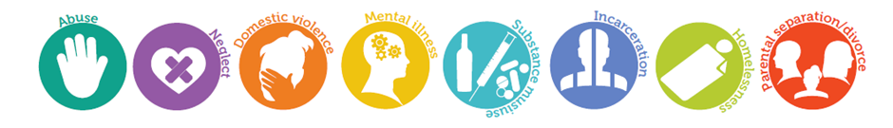
Figure 1 - Adverse Childhood Experiences (ACEs)
Lewisham is taking a public health approach to reducing violence which means:
- Understanding the extent of all violence, where and how it happens and who is affected to better inform including youth violence, domestic abuse, and sexual violence.
- Understanding that violence damages physical and emotional health and can have long-lasting negative impacts. It increases individuals’ risks of a broad range of health damaging behaviours – including further violence – and reduces their life prospects in terms of education, employment and social and emotional wellbeing.
- A wide range of factors relating to individuals, their relationships, and the communities and societies in which they live can interact to increase or reduce vulnerability to violence. Issues such as Adverse Childhood Experiences (ACEs) can have significant impacts on families.
- There are a wide range of strategies that can be used to address risk factors for violence and promote protective factors across all ages. Some can be implemented universally and others are targeted specifically. Using evidence based models will shape impact.
- Working with the strengths that exist in communities to listen and collaborate on designing solutions together.
- Dialogue that challenges social norms aim to prevent violence by making it less socially acceptable.
- The safer Lewisham partnership will play a significant coordinating role through the newly formed violence reduction board.
The Aim is to:
- Reduce the impacts and actual violence across Lewisham
- Identify the causes of violence in Lewisham, and act to deliver short and longer term reductions
- Listen and work with communities to build on their strengths and deliver solutions together.
- Create a learning environment for continuous improvement.
- Impact positively on wider social, economic and health outcomes for our residents.

The partnership will build on the foundations in place towards making Lewisham a trauma informed borough;
“Safety-Throughout the organisation, staff and the people they serve feel physically and psychologically safe.” Guiding Principles of Trauma-Informed Care, 2014.
“A trauma-informed service system and/or organisation is one in which all components of the system have been reconsidered and evaluated in the light of a basic understanding of the role that violence and trauma play in the lives of people seeking or referred to services.
ACES provide a measure of traumatic experiences in childhood are used to influnce prevention and predict future harm. According to Scottish research people with 4 or more Adverse Chid Experiences ( abuse,neglect, household dysfunction) are:
14 times more likely to have been a victim of violence over the last 12 months
15 times more likely to have committed violence against another person in the last 12 months
16 times more likely to have used class A drugs
20 times more likely to have been incarcerated at any point in their lifetime.
Lewisham will aim to adopt the following principles and apply to organisations throughout the borough:
- Safety – creating spaces where people feel culturally, emotionally and physically safe
- Transparency and Trustworthiness – full and accurate information about what’s happening and what's likely to happen next
- Choice – an approach that honours an individual’s dignity
- Voice – creating the opportunity where the individuals views, opinions and feeling are heard and acknowledged
- Collaboration and mutuality – healing happens in relationship and partnerships with shared decision making
- Empowerment – Recognition of an individual’s strengths. These strengths are built on and validated.

To achieve these outcomes the following is needed:
- Realising the prevalence of trauma through a consistently applied training program
- Recognising and supporting how stress and fear affects all individuals involved with the program, organization or system, including its own workforce
- Resisting re-traumatisation, labelling and re-victimisation
- Responding by putting this knowledge into practice. The Trauma Recovery Model responds to readiness of intervention to underlying need.
- Restorative: Using conflict or an incident as an opportunity to repair harm and heal relationships

The strength of our response places equal focus on victims and perpetrators to help support and bring about positive change
Studies of trauma among groups of young people found that:
- 91% of violent young offenders have experienced abuse or loss
- 40% of female and 25% of male youth in custody have suffered violence at home
- 33% of female offenders have suffered sexual abuse

Research also indicates that offenders are more likely than non-offenders to have suffered adverse effects from traumatic experiences, which appear to be linked to offending behaviour. Trauma can result in inappropriate aggression and is strongly associated with a range of problematic behaviour including violence, antisocial/criminal conduct, sex offending and substance misuse. We understand that many child and adult offenders will have been subject to a range of adverse experiences, from substance misuse problems, difficult family backgrounds including experience of childhood abuse or time spent in care, unemployment and financial problems, to homelessness and mental health problems and this knowledge underpins our trauma informed, restorative approach to tackling offending. However we also acknowledge that there are victims of the crimes perpetrated by these exploiters and our focus on supporting these victims must remain resolute.

Services for all victims will:
- Support through a recognition of trauma to assist with recovery
- Provide safety advice and planning
- Support participation in the criminal justice processes as appropriate improving compliance to the victims code of practice
- Crime prevention advice for all
- Restorative approaches to help heal the harm caused.
Lewisham approach to breaking the victim/offender cycle will:
- Focus on both the individuals and their families, understanding the dynamics of these relationships and interactions.
- Aim to stop re-victimisation within interpersonal relationships.
- Explore appropriate perpetrator desistance programmes.
- Create approaches to tackle specific victim/perpetrator relationships
- Focus on how perpetrators are supported to change and understand the impact of their harmful behaviour.
- The developed as a multi-agency Concern Hub which works with children under 25; those who are missing or who are victims of child sexual exploitation, child exploitation, harmful sexual behaviour, county lines, serious youth violence and gangs.
- Challenge social norms to making interpersonal violence of all kinds less socially acceptable.
- Coordinate this work through the Violence Reduction Board, the Concern Hub and the Violence Against Women and Girls Steering Group.

Action at all levels
- Lewisham is committed to tackling and reducing the impacts of violence and crime on our communities, linking into strategies and plans that are in place such as the Violence against Women and Girls (VAWG) Plan 18-21, knife crime action plan 18/19, the Public health approach to violence framework 2019, the children and young person’s plan 2019 and building stronger communities programme.

- Working with colleagues in other London boroughs on this agenda to share practice and findings will help to build the evidence base and opportunities for collaborative working. Doing more together helps to bring about greater change and impact.

- Working with the London Mayor’s office for policing and crime (MOPAC) is essential to ensure that Lewisham are learning from and feeding into the work of the Violence Reduction Unit for London. This focus for London is essential as our communities are affected by what occurs across London. Accessing resources for Lewisham community and voluntary sector groups, partners and the Council will be a priority where available.

- Working at a National level to influence policy and bring about whole scale change is something we will continue to do working with colleagues in the Ministry of Justice, Home Office, National Crime Agency, and Department of Education. Lewisham is constantly learning from its approach to date and are keen to ensure that this is fed into National learning to help greater understanding about violence.

Monitoring impact
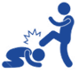 Violence -non domestic better use of social media
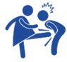Domestic violence increased awareness of staff welfare
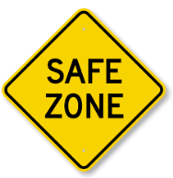
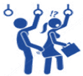Sexual Violence increased feeling of safety, trust and confidence
Anti-social behaviour
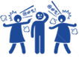Hate crime community champions helping to make a difference
Burglary
Stop and search

Finance and Resources
There have been a number of significant changes in the funding and resourcing for all aspects of the Criminal Justice system both locally and regionally. Mayor of London is the Police and Crime Commissioner, and he delegates this portfolio to Mayor’s Office for Policing and Crime - MOPAC. MOPAC not only holds the Met Police to account for delivering its priorities, but it also has overarching responsibilities for crime reduction in the capital and has significant powers to commission services. All partners are committed to working collaboratively and to support funding applications where appropriate to continue the support required to deliver on the areas identified as priorities.
Resources across the partnership have reduced significantly and all agencies are seeing large scale transformation. The changing landscape will impact on deliverability and will need to be reviewed and monitored regularly and closely by the Safer Lewisham Partnership.
To deliver this plan the ability to undertake regular detailed analytical products is essential. This is a significant risk to the Partnerships ability to review performance regularly and understand the impact of the work.
Further copies of the Plan can be obtained on request to the public protection and Safety division within the Council.
If you would like the information in the document translated into a different language, provided in large print or in Braille or the spoken word, please contact us on:
Post: Public Protection and Safety Division, London Borough of Lewisham, Lawrence House, Catford Road, SE6 4RU
In developing this plan, there has been a series of consultation processes as well as collation of data from a range of sources. These have included an on-line Crime Survey. We would welcome any feedback, suggestions or proposals from individuals or organisations.
For practical advice in relation to community safety and crime prevention, please visit the website: www.crimereduction.gov.uk
Call Crime Stoppers anonymously on 0800 555 111 to give information about a crime
Fearless is Crime stoppers youth service aimed at 11-16 year olds, which aims to increase awareness of the dangers surrounding street crime, drugs and violence. Fearless is a site where young people can access non-judgemental information and advice about crime and criminality. This site also provides a safe place to give information about crime - 100% anonymously. www.Fearless.org.
For information on your local Safer Neighbourhood Teams please visit: http://www.met.police.uk/teams/lewisham/index.php
Stop the Violence Now here: https://www.lewisham.gov.uk/young-people/staying-safe/Pages/Support-our-campaign-to-end-youth-violence.aspx | For information on staying safe : https://www.lewisham.gov.uk/young-people/staying-safe/Pages/default.aspx

