The contribution of
Religious Education to
the Post-16 Curriculum

Attainment Targets

Delivering the agreed syllabus
Religious Education requirements

Introduction: The contribution of Religious  Education to the Post-16 Curriculum  Religious Education is a statutory requirement for all students in Key Stage 5 who are registered in either a school with a sixth form, a sixth form college constituted as a school or registered in a school working as part of a consortium, except for those withdrawn by their parents. It must be made available in sixth form colleges to students who wish to take it. Although it is not a requirement in colleges of further education, similar arrangements should apply.  Schools should provide Religious Education to every student in accordance with legal requirements. It must be taught according to the locally agreed syllabus or faith community guidelines.  Religious Education courses broaden and enhance the curriculum by giving students the opportunity to consider a wide range of religious, philosophical, psychological, sociological and ethical issues and to develop their own codes of belief.  Sixth form Religious Education is intended to support and recognise the achievements of all students at Key Stage 5. | The flexible course of study explained in these requirements promotes the religious imagination and the development of key skills. It provides for students with a variety of aptitudes, abilities  and needs that may not be fully met through current AS and A Level examination syllabuses and encourages all students to explore ways of communicating and presenting their knowledge and understanding of religion in a variety of media.  In this way sixth form Religious Education caters for and affirms  a range of learning styles, individual interests and gifts and talents of students.  Religious Education at post-16 should be planned as carefully  as in the statutory period of schooling and should give due consideration to:  - breadth and balance of knowledge, understanding and skills;  - differentiation to meet the needs and abilities of the full range of students;  - the spiritual and moral development of students;  - preparation for work and adult life;  - progression and continuity from Key Stage 4 and through the Sixth Form;  - assessment and accreditation wherever possible including self and peer assessment;  - challenge.

The two Attainment Targets, ‘Learning about Religions’ and ‘Learning from Religions’ continue to underpin the syllabus at this stage and all planning should cater for both of these.

Attainment Target 1: Learning about religions

Students should be taught to:

- investigate, study and interpret significant religious, philosophical and ethical issues, including the study of religious and spiritual experience, in light of their own sense of identity, experience and commitments;
- think rigorously and present coherent, widely informed and detailed arguments about beliefs, ethics, values and issues, drawing well-substantiated conclusions;
- develop their understanding of the principal methods by which religions and spirituality are studied;
- draw upon, interpret and evaluate the rich and varied forms of creative expression in religious life;
- use specialist vocabulary to evaluate critically both the power and limitations of religious language.

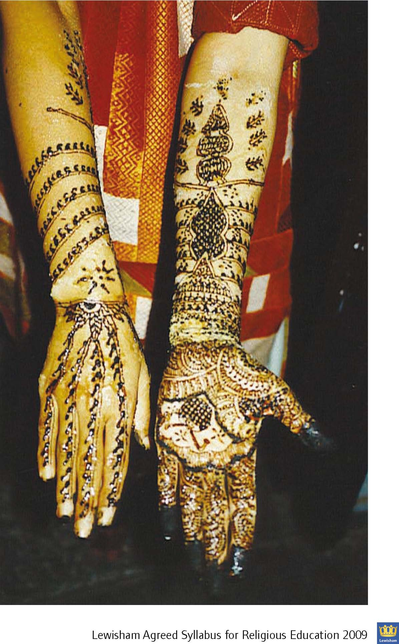

Attainment Target 2: Learning from religion

Students should be taught to:

- reflect on, express and justify their own opinions in light of their learning about religion and their study of religious, philosophical,
moral and spiritual questions;
- develop their own values and attitudes in order to recognise their rights and responsibilities in light of their learning about religion;
- relate their learning in Religious Education to the wider world, gaining a sense of personal autonomy in preparation for adult life;
- develop skills that are useful in a wide range of careers and in adult life generally, especially skills of critical enquiry, creative
problem-solving, and communication in a variety of media.

Learning about religion includes enquiry into and investigation of the nature of religion, its key beliefs, teachings and practices,
their impact on the lives of believers and communities, and the varying ways in which these are expressed.

It also includes the skills of interpretation, analysis and explanation.

Pupils learn to communicate their knowledge and understanding using specialist vocabulary.

It also includes identifying and developing an understanding of ultimate questions and ethical issues.

Learning from religion is concerned with developing pupils’ reflection on and response to their own experiences and their learning about religion.
It develops pupils’ skills of application, interpretation and evaluation of what they learn about religion, particularly to questions of identity and belonging, meaning, purpose and truth and values and commitments, and communicating their responses.

The Key Stage 5 section of the Lewisham Agreed Syllabus has been updated to reflect recent national curriculum developments and issues with
a focus on encouraging young people to have enquiring minds, communicate ideas and develop their knowledge, skills and religious literacy.
As with the previous Agreed Syllabus, there is no prescription of content, curriculum design, methods of teaching and learning styles at this key stage so that schools can plan and deliver an appropriate curriculum that provides a coherent and meaningful experience for their students while meeting statutory obligations and contributing to other current priorities for all schools, e.g. Safeguarding, British Values, Prevent Strategy, provision for pupils’ spiritual, moral, social and cultural development.

Links with the wider curriculum
There are a number of ways that schools could extend opportunities for students to engage with a wider thematic and issues-based curriculum. Those engaged in sixth form teaching are keen to provide opportunities for students to become more articulate and reflective. They are also mindful of the need for CV building so that all students can present themselves with some confidence when applying for Higher Education and careers. The longer-term aim is to prepare young people for adulthood, of course, not just to pass exams.
In a recent discussion with the Young Mayor's advisers, those young people believed it was important to find out about and debate issues around beliefs and values of those in the wider community and to consider how these are reflected in current affairs here and abroad.

Aims
This Key Stage 5 syllabus aims to:
- build on the previous educational experience of young people while recognising their maturity, status and interests at this stage of their education;
- engage young people in a systematic enquiry into significant human questions so that they can develop the understanding and skills needed to appreciate and appraise varied responses to these questions, as well as develop views of their own;
- enable young adults to engage with a wide range of ideas and beliefs in contemporary society through a range of disciplines including philosophy, psychology, sociology, science, the arts and literature;
- prepare students for a greater understanding of the role of belief and culture in the modern world, enabling them to develop more critical approaches to media and popular portrayals of religion, faith and belief; and
- provide a range of opportunities for investigation, personal research, discussion and presentation of views and ideas.

Opportunities
Schools should provide their students with the opportunity to:
- develop their knowledge and understanding of the nature, role and influence of religion and belief in the world;
- explore a personal sense of meaning and purpose in own their lives and how they relate to others;
- develop their skills and ability to arrive at a reasoned opinion and to handle controversial issues; and
- develop an understanding of and respect for different beliefs and life‐styles.

Content
The following units are suggestions of the type schools might wish to offer either as stand-alone study/discussion units or through other approaches suggested below:
- Why do people believe in the existence of God?
- What impact do religious and other beliefs have on morality, behaviour, culture and politics?
- Ethics – how does belief impact on medical ethics and practice e.g. abortion, euthanasia, cloning, organ donation, medical treatment?
- Conflict – what part do religious and other belief systems play in conflict on a personal, community and global level? What enables different individuals and communities to live together respectfully for the wellbeing of everyone?
- How have religious beliefs and practices changed over time? Are they still evolving? Is there a difference between a religion and a cult?
- What has been (and continues to be) the impact of religion on science and the arts.
- Personal faith and values – and their impact on individual behaviour, relationships, gender, sexuality and personal responsibility.
- What are the ethical issues involved in global issues such as population growth, the environment, famine and thirst, migration, modern slavery, etc?
- How do religions and beliefs deal with issues of good and evil?
- What do we feel about how religions and beliefs are portrayed in the media?

Delivery
The Agreed Syllabus expectations for sixth form Religious Education are 18 hours per year to include at least one experiential opportunity such as a conference or field trip. This would be the equivalent of 3 full day or 6 half day conferences but it could be delivered in a variety of imaginative ways to engage all young people – visits, debates, film, exhibitions, theatre visits, etc.

The following are some suggestions as to how schools individually and collectively might move forward on this:
- Debates: There is already some experience of this within schools and there has been a strong tradition of Lewisham-wide debating for young people across different schools and colleges. One suggestion would be for there to be an inter sixth-form debate, open to all schools and colleges in the borough, to be held in the Civic Suite and hosted by the Mayor and the Young Mayor. A wide range of ethical /moral issues would make ideal subjects for debate.
- Schools could offer a half day conference for their own students, and possibly open to other students, with invited guest speakers on a topic that would have resonance for young people e.g. Is nuclear war ever justified? What are the implications of AI for humanity? Should there be limitations on personal wealth?
- There could be a joint conference – out of school hours – open to students from across the borough schools. Schools could take it in turns to host one of these each year.
- Universities might be approached to lead a small programme of expert seminars with the staff from a range of departments (e.g. philosophy, theology, politics, and religious literacy)
- Schools could arrange termly visits to significant places of worship or other venues like the Holocaust Centre - perhaps a role for a sixth form student council?
- A catalogue of good and reliable guest speakers could be drawn up for use by schools and colleges taking due consideration of the new rules for General Data Protection Regulation (GDPR) compliance.
- An annual essay competition could be established with an appropriate prize e.g. a visit hosted by a politician to the Lords or Commons. This could include meeting members of one of the All Party Parliamentary groups on issues around faith or belief.
- Volunteering and fund raising linked to a charity or hospice.
- Each taught A Level or vocational programme might, if they are not doing this already, consider moral and ethical considerations relevant to the subject.
- A Sixth Form Question Time – for Lewisham sixth form students – chaired by a student with invited guests including local MPs and organised and recorded with the help of A Level or Tec media students
- The school’s programme should be published on the school ‘s website with other curriculum planning. It should clearly explain which faiths and beliefs will be included and be visible for parents and other interested bodies to examine

