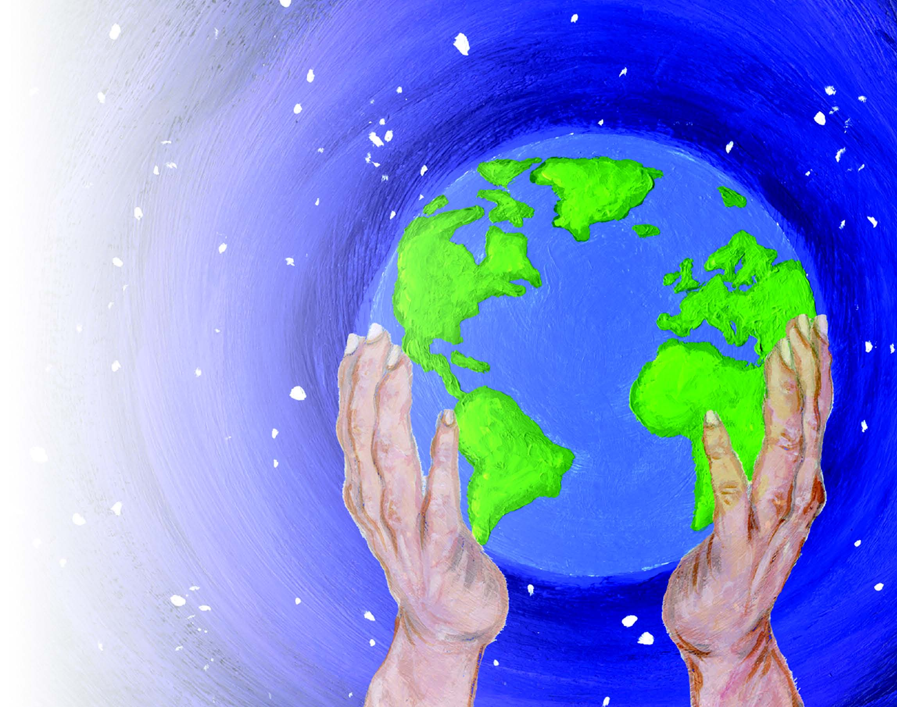

Key Stage 3 Programmes of Study

Buddhism

Christianity

Hinduism

Islam

Judaism

Sikhism

Introduction and Programmes of Study

Throughout Key Stage 3, pupils should be extending their understanding of Christianity and the other principal religions in a local, national and global context. They deepen their understanding of important beliefs, concepts and issues of truth and authority in religion and apply their understanding of religious and philosophical beliefs, teachings and practices to a range of ultimate questions and ethical issues, with a focus on self-awareness, relationships, rights and responsibilities. They enquire into and explain some personal, philosophical, theological and cultural reasons for similarities and differences in religious beliefs and values, both within and between religions. They interpret religious texts and other sources, recognising both the power and limitations of language and other forms of communication in expressing ideas and beliefs. They reflect on the impact of religion and belief in the world, considering both the importance of interfaith dialogue and the tensions that exist within and between religions and beliefs. They develop their evaluative skills, showing reasoned and balanced viewpoints when considering their own and others’ responses to religious, philosophical and spiritual issues.

Knowledge, skills and understanding

Attainment Target 1: Learning about religion

Pupils should be taught to:
- investigate and explain the differing impacts of religious beliefs and teachings on individuals, communities and societies;
- analyse and explain how religious beliefs and ideas are transmitted by people, texts and traditions;
- investigate and explain why people belong to faith communities and explain the reasons for diversity in religion;
- analyse and compare the evidence and arguments used when considering issues of truth in religion and philosophy;
- discuss and evaluate how religious beliefs and teachings inform answers to ultimate questions and ethical issues;
- apply a wide range of religious and philosophical vocabulary consistently and accurately, recognising both the power and limitations of language in expressing religious ideas and beliefs;
- interpret and evaluate a range of sources, texts and authorities, from a variety of contexts;
- interpret a variety of forms of religious and spiritual expression.

Attainment Target 2: Learning from religion

Pupils should be taught to:
- reflect on the relationship between beliefs, teachings and ultimate questions, communicating their own ideas and using reasoned arguments;
- evaluate the challenges and tensions of belonging to a religion and the impact of religion in the contemporary world, expressing their own ideas;
- express insights into the significance and value of religion and other world views on human relationships personally, locally and globally;
- reflect and evaluate their own and others’ beliefs about world issues such as peace and conflict, wealth and poverty and the importance of the environment, communicating their own ideas;
- express their own beliefs and ideas, using a variety of forms of expression.

Breadth of study

Through conversations with schools, the Lewisham Agreed Syllabus Conference members are aware of different models of curriculum planning being provided at Key Stage 3 in Lewisham schools. Whilst some schools continue to provide a three-year Key Stage 3 programme, others have been required to shorten the programme by between a term and a year. This makes delivery of an Agreed Syllabus planned to be taught across 3 years impossible for some schools, so the Agreed Syllabus has been remodelled to provide for all of these eventualities.

Materials in the syllabus are now labelled core and optional. All students should be taught the core units, whichever delivery model has been implemented. Every unit, whether core or optional should be allocated approximately a half term or six sessions for delivery if both Attainment Targets are to be addressed.

Whichever model of delivery a school has allocated, the following tables explain what should be taught:

Table 1 - Statutory Units

Unit | Equivalent in half terms
Buddhism | 1 unit
Christianity | 4 units
Hinduism | 1 unit
Islam | 1 unit
Judaism | 1 unit
Sikhism | 1 unit

Depending on the length of the course, three, six or nine optional units should selected from Table 2.

If a school delivers an extended programme, it is expected that at least some of the faith units will be selected from the optional list.

Schools may wish to take into account the faiths studied at Key Stage 4/GCSE and ensure that the optional units for these faiths are studied at Key Stage 3.

Table 2 - Optional Units

Unit | Equivalent in half terms
Baha’i | 1 unit
Buddhism | 1 unit
Christianity | 1 unit
Creation and origins* | 1 unit
Hinduism | 1 unit
Humanism | 1 unit
Islam | 1 unit
Judaism | 1 unit
Non–Religious World Views | 1 unit
Other World Faiths | 1 unit
Philosophy & Ethics | 1 unit
Sikhism | 1 unit
* An expanded exemplar unit planner is also included

During this key stage, pupils should be taught the knowledge, skills and understanding through the areas of study described above. They will also be considering the following:

Themes
- Beliefs and concepts: the key ideas and questions of meaning in religions and beliefs, including issues related to God, truth, the world, human life, and life after death.
- Authority: different sources of authority and how they inform believers’ lives.
- Religion and science: issues of truth, explanation, meaning and purpose.
- Expressions of spirituality: how and why human self-understanding and experiences are expressed in a variety of forms.
- Ethics and relationships: questions and influences that inform ethical and moral choices, including forgiveness and issues of good and evil.
- Rights and responsibilities: what religions and beliefs say about human rights and responsibilities, social justice and citizenship.
- Global issues: what religions and beliefs say about health, wealth, war, animal rights and the environment.
- Interfaith dialogue: a study of relationships, conflicts and collaboration within and between religions and beliefs.

The delivery if RE in this key stage should enable the following Experiences and Opportunities
- Encountering people from different religious, cultural and philosophical groups, who can express a range of convictions on religious and ethical issues.
- Visiting, where possible, places of major religious significance and using opportunities in ICT to enhance pupils’ understanding of religion discussing, questioning and evaluating important issues in religion and philosophy, including ultimate questions and ethical issues.
- Reflecting on and carefully evaluating their own beliefs and values and those of others in response to their learning in religious education, using reasoned, balanced arguments.
- Using a range of forms of expression (such as art and design, music, dance, drama, writing, ICT) to communicate their ideas and responses creatively and thoughtfully.
- Exploring the connections between religious education and other subject areas such as the arts, humanities, literature and science.

What do Buddhists believe? | Where do Buddhists learn about their faith? | How do Buddhists express/demonstrate their faith, beliefs and spirituality?
Four Noble Truths  The wheel of life (karma, samsara, rebirth and nirvana) | Teachings of the Buddha (Buddha Dharma)  Stories from Buddha’s life showing how he discovered how to overcome suffering and unhappiness and become ‘awakened’  Pali Canon (Theravada) e.g. Metta Sutta (Discourse of Loving Kindness) | Daily worship and offering (puja)  Going for Refuge  Importance of quiet reflection.  Meditation  The Sangha (community):  - People practicing Buddhism in ordinary lives.  - Monks and nuns
Ethics and relationships in Buddhism | Buddhists attitudes to rights and responsibilities/global Issues and Interfaith dialogue | Buddhist beliefs about religion and science
Shila (discipline / ethics)  Five Precepts | Tolerance of different forms within Buddhism and of other religions. | Buddhist cosmology and cyclical nature of existence
Key Questions
- In what ways does the lifestyle of a Buddhist reflect Buddhist beliefs?
- Why do Buddhists meditate?
- In what ways does the idea of loving kindness (metta/maitri) underpin Buddhist values and behaviour?

What do Christians believe? | Where do Christians learn about their faith? | How do Christians express/demonstrate their faith, beliefs and spirituality?
Christians believe that The Bible is God’s word and is relevant to their lives today.  Christians believe that God created the world that Jesus is the Son of God and that Jesus will come again.  What is the Trinity?  Christians believe that the full nature of God is revealed and expressed in the Trinity – Father, Son and Holy Spirit. | How Christians interpret the Bible in the 21st Century.  How relevant do Christians believe the Old Testament is to them today?  - Old Testament: - e.g. History, Noah’s Ark, Tower of Babel.  What do Christians believe it means that Jesus is coming again?  - Life of Jesus – Son of God;  - Second coming. | Christians express their faith by reading The Bible, applying its teaching to their lives and by being good stewards of the Earth’s resources.
Ethics and relationships in Christianity | Christian attitudes to rights and responsibilities, global issues and interfaith dialogue | Christian beliefs about religion and science
Christians believe The Bible shows them how to live in relationship with other Christians, other faiths, the community and the world they live in. | What the Bible teaches Christians about how they should approach topical global issues.  What relationship is there between the Christian Bible and the sacred texts of other faiths?  - Islam, Judaism and Sikhism. | Does the Christian view of creation fit with the Big Bang Theory?  Are religion and science compatible?
Key Questions
- How do Christians learn about their faith from The Bible?
- What guides Christians from different traditions in how they interpret The Bible?
- How does The Bible influence how Christians live their lives today?
- How does The Bible link to the texts of other faiths?

What do Christians believe? | Where do Christians learn about their faith? | How do Christians express/demonstrate their faith, beliefs and spirituality?
God gives humans free will, but also guidelines to live by and shape the decisions that they make. | What informs and influences the way Christians make ethical decisions?  Sources of authority for Christians to apply to their daily lives.  - 10 Commandments;  - The Sermon on the Mount;  - WWJD – “What Would Jesus Do?” | What does true forgiveness mean for Christians? e.g.  - Jimmy Mizen’s Family;  - Neville Lawrence father of Stephen  - “When faith gets shaken” stories.
Ethics and relationships in Christianity | Christian attitudes to rights and responsibilities, global issues and interfaith dialogue | Christian beliefs about religion and science
Do Christians believe God forgives everyone, whatever they have done?  - Right and Wrong;  - Goodness and evil;  - Forgiveness and reconciliation.  (Use examples from the local area and the news.)  Do Christians believe there is ever such a thing as a just war?  - Pacifism/Just Wars? | Was Nelson Mandela a freedom fighter or a terrorist?  - Other examples of Christians whose lives have been based on their interpretation of Christian ethics include Elizabeth Fry, Gladys Aylward, Dr Barnardo, Gee Veronica Walker, Martin Luther King, Mother Teresa  - Justice and Equality. | Compatibility of ethical examples in science with Christian beliefs, e.g. organ donation.
Key Questions
- In what ways do the authority of Jesus and The Bible underpin Christian values and behaviour?
- How do Christians from different traditions interpret The Bible for living in the 21st. Century? – Commonalities and differences.
- How do Christians relate to members of other faiths and none?
- How do Christians live out their faith in the world today?

What do Christians believe? | Where do Christians learn about their faith? | How do Christians express/demonstrate their faith, beliefs and spirituality?
Christians believe that God sent His Son, Jesus Christ, who died for everyone and that each person has to make their own decision to follow Him. This is marked by and through rituals of life. | Christians learn about the rites of their faith by living in community with other Christians, observing and experiencing the rituals. | How Christians bring their faith into celebrating a new baby:  - Birth, naming, Christening, Baptism.  Why do many Christians read the Bible and pray every day?  - Personal prayer, Bible study, good works, acts of kindness.  Why people make personal decisions to be baptised and/or confirmed  How Christians express their faith in marking the end of life  - Death, funerals, belief in everlasting life.
Ethics and relationships in Christianity | Christian attitudes to rights and responsibilities, global issues and interfaith dialogue | Christian beliefs about religion and science
Christian views of sex and sexuality  - Similar and different Christian views and attitudes to marriage; and  - Similar and different attitudes to sex and sexuality. | Christian beliefs about their responsibility to care for the elderly in their families and community  - Biblical examples and teachings | Body and Spirit  - Rituals of life and death, including burial, according to Christianity,  - Similarities and differences of belief between faiths.
Key Questions
1) How do Christians mark significant points in their lives through their faith?
2) How does the Bible influence how Christians live their lives today?
3) How do Christians express their faith in their relationships with others?
4) How are some Christian beliefs and practices similar to those of other faiths?

What do Christians believe? | Where do Christians learn about their faith? | How do Christians express/demonstrate their faith, beliefs and spirituality?
Christians believe that God is worthy of worship and that they should live their lives in a way that worships God in everything that they do. | How the Bible influences the way Christians worship today.  - Use of The Bible in worship;  - Source of the language and liturgy of worship. | Different styles of Christian worship:  - When and why Christians pray.  - What Christians understand to be the purpose of prayer.  How do Christians use music, art and dance in worship?  What is the significance of the design and use of buildings in some Christian worship?  Why do Christians take part in the sacraments?  - Baptism, Communion, Confirmation, anointing of sick and the dying, etc.
Ethics and relationships in Christianity | Christian attitudes to rights and responsibilities, global issues and interfaith dialogue | Christian beliefs about religion and science
Christians believe they should respect the worship traditions and beliefs of all other denominations and faiths.  Awareness and understanding of similarities and differences in Christian worship across denominations. | Christian responses to the persecution of Christians because of their beliefs and worshipping practice.  - Terry Waite  - Coptic Christians  - Investigate current national and international examples from the news | Saints  - The importance of Saints in some Christian traditions.  - Gregor Mendel and plant genetics.
Key Questions
1) What, when, how and why do Christians worship?
2) How does The Bible influence the way Christians worship today?
3) How do different Christian denominations relate to each other as members of the worldwide family of Christians (East and West)?
4) How are some Christian beliefs and practices similar to those of other faiths?

What do Hindus believe? | Where do Hindus learn about their faith? | How do Hindus express/demonstrate their faith, beliefs and spirituality?
Concept of God:  - Para Bram-mam – Supreme;  - Shiva & Shakti;  - Vishnu & Lakshmi;  - Bram-maa & Sarasvati; and  - Ganesh, Murugan, Hanuman.  Between Life & rebirth  - Karma: Cause and Effect of Actions;  - Story of Dasharatha (Father of Rama) and Shravan from Ramayana; and  - “Matha, Pitha, Guru, Deivam”- the importance of mother, father, teacher and god. | The Vedas  Bhagavath Gita  Puranas  Festivals  - Holi  - Ganesh Charthurthi  Stories  - Story of Narasimha | Meditation  Dietary practice  Yoga as a spiritual discipline  Values demonstrated by Mahatma Gandhi
Ethics and relationships in Hinduism | Hindu attitudes to rights and responsibilities, global issues and interfaith dialogue | Hindu beliefs about religion and science
Non-Violence/Ahimsa: Refraining from violence.  Charity of Food, Clothing, Water and Education | Equality of Women and Men  Caring for family  How Caste can be a support network and guidance not discrimination or segregation. | Vegan and Vegetarian  Hindus believe the Rigveda and its scientific principles showed the existence of planets millennia before they were proved in the works of many famous scientists such as Newton, and Einstein

Key Questions
1) Hindus believe that god is everywhere and in everything. How do Mahashivaratri and Narasimha emphasis this belief?
2) How do Hindus derive guidance from Bhagavat Gita to fulfil their responsibilities?
3) How has the caste support network (allocation/reservation) helped in improving lives with deprived Hindus in education and integration?
4) How does the story of Dasharatha (Father of Rama) and Shravan show the impact of Dharma and Karma?
5) Why do you think it is important to see men and women as equal and how do the Hindu god and goddess Shiva and Shakthi contribute to this belief?
6) The Hindu diet varies according to the stages of life, how do Hindus feel this has an impact on spiritual thinking?
7) Why is Ganesh a very important god for Hindus?

Karma :- The Story of Dashratha (Father of Rama) and Shravan
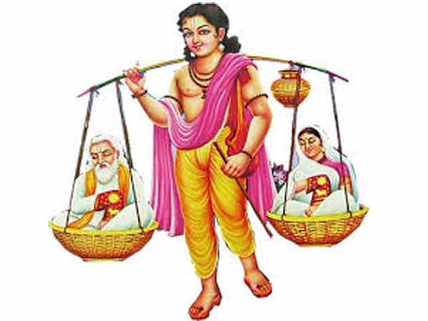
King Dashratha was the father of Rama. As a ruler, he always helped his people to grow and spread happiness in their lives. He had all the qualities of the best king possible and thus, his state’s people loved him a lot.

Dashratha was a skilled archer. He could aim at his target just by listening to the sound coming in from a direction.

Shravan Kumar’s parents were hermits/saints. Due to ageing they had become blind and unable to move. It is a typical Hindu belief that a pilgrimage to the various shrines and holy places, undertaken in old age, purifies the soul. At that time, transport was scarce and costly, and so Shravan Kumar decided to put his parents each in one basket and to tie each to an end of a bamboo pole, which he would carry on his shoulders while on their pilgrimage.
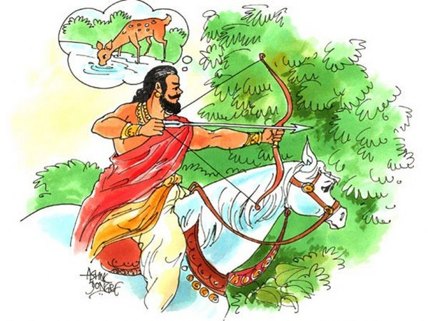
One day, young Prince Dashratha was hunting in the forest of Ayodhya, when he heard a sound near a lake. Hoping to hit an animal he unleashed an arrow. The sound of the gurgle in the water had attracted Dashratha’s attention and he had aimed his arrow mistaking it to be a deer.

As soon as he shot the arrow, Dashratha could hear the cry of a human. Dashratha realised that the target hit by his arrow wasn’t a deer but a man.

He rushed to the aid of his victim but by then Shravan was too badly injured. Before breathing his last, Shravan asked Dashratha to take the pitcher full of water for his parents.

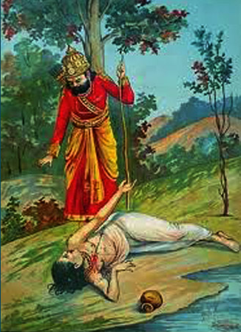
When he reached out to Shravan’s parents, the Prince of Ayodhya, loaded with a sense of guilt, admitted to killing their son unintentionally. But the old couple, who had lost their only child forever, couldn’t bear the loss and they cursed Dashratha by telling him that he would meet the same fate and yearn for his child one day.

“O king, you have killed our only son and the only support to our blind world, the way I am dying today in the remembrance of my son, in the same way, you too will die in the memories of you son.”
This curse turned out to be reality when his son lord Rama went into the Jungle. The king died because he could not bear the separation from his son Rama who was sent away to the forest for 14 years.

Shravan is revered as a dutiful son and is prayed to as a god because he is seen as an example of how one needs to take of one’s parents.

What do Muslims believe? | Where do Muslims learn about their faith? | How do Muslims express/demonstrate their faith, beliefs and spirituality?
The key belief of Islam is:  Tawhid – The Oneness of Allah.  people attempt to comprehend Allah’s greatness through His attributes which are mentioned in the Quran surah 59:22:  - All Merciful – Ar Raheem who acts with extreme kindness  - All Forgiving – Al Ghafoor who forgives over and over  - The Guide – Al Haadi guides living beings to what is good for them  - The Protecting Friend – Al Waliy who supports and protects living beings | Muslims learn about their faith from:  The Quran – Allah’s final revelation as well as the previous revealed books  The final prophet Muhammad (pbuh) as a perfect exemplar of Islamic behaviour – learned from the study of his Sunnah (actions and behaviour) and form his Hadith (accounts of what he said and did) | Faith in action:  Many Islamic organisations work to help people in need all over the world  Locally: Lewisham mosque provides food for the homeless, free counselling services and a supported funeral fund to help aid the costs of burial.  Individually: Muslims will act upon hadith that even a smile is an act of charity

Ethics and relationships in Islam | Muslim attitudes to rights and responsibilities, global issues and interfaith dialogue | Muslim beliefs about religion and science
‘Muslims take guidance from Allah’s words in the Qur’an and the Sunnah of prophet Muhammad in all aspects of life and behaviour.  - children - good name, education, love and affection  - women – refer to 10 hadith about women  - orphans – protect them  - elderly | Muslims understand their responsibility to care and respect the environment and the natural world. | Muslims believe Islam and science are not incompatible. Throughout the Qur’an Allah says that he has given “signs for people who think”. Muslims understand this as a duty to investigate and gain knowledge of His creation.  - barrier between the two seas -the seas not mixing with each other (Qur’an 55:19-20 & 25:53)  - development of the foetus in the womb – the three dark stages of the baby in the womb (Qur’an 23:12-14)
Key Questions
1) How do Muslims demonstrate their faith through their relationships with other people?
2) How is the Qur’an important for Muslims?
3) How do Muslims take guidance from the life of the Prophet Muhammad (pbuh)?

Resources for this unit on the next page

What do Muslims believe? | Where do Muslims learn about their faith? | How do Muslims express/demonstrate their faith, beliefs and spirituality?
https://99namesofallah.name  Quran ref: surah al Hashr verse number 22,23,24  Youtube: Asma al husna 99 names of Allah  Recitation – www.ealimtech.com | https://www.sunnah.com/nawawi40  hadith no. 13, 37 and 7 | https://www.islamic-relief.org.uk/  https://donate.humanappeal.org.uk/  https://muslimhands.org.uk/  http://www.lewishamislamiccentre.com/
Ethics and relationships in Islam | Muslim attitudes to rights and responsibilities, global issues and interfaith dialogue | Muslim beliefs about religion and science
Women - http://www.the-faith.com/featured/10-hadiths-about-women/  Orphans – Quran chapter4 verse 10  Elderly – Quran chapter 17 verse 23-24  Children – Raising children in Islam www.iqrasense.com>muslim-character  www.ilmaeducation.com | Quran: chapter 6 verse 167  10 green hadith video - http://aboutislam.net/shariah/hadith/hadith-collections/10-green-hadiths-video/  http://www.ifees.org.uk/ | YouTube:  - the seas not mixing with each other Quran and modern science  - amazing Quran miracle talk Islam  Quran on human embryonic development – www.scienceislam.com

What do Jews believe | Where do Jews learn about their faith? | How do Jews express/demonstrate their faith, beliefs and spirituality?
- The Shema  - Interpretations of relationship with God and beliefs across branches of Judaism | The Talmud  The Rabbi and rabbinic traditions | The Pilgrim Festivals Pesach (Passover); Shavuot (Feast of Weeks); Sukkot (Tabernacles).  Support for the elderly and vulnerable
Ethics and relationships in Judaism | Jewish attitudes to rights and responsibilities, global issues and interfaith dialogue | Jewish beliefs about religion and science
Family Responsibilities  Honouring parents  Making a new family at marriage | The Holocaust and learning the lessons of the past  Promised Land/Israel and significance of Jerusalem to Jews.  The work of the CCJ | Stewardship  Attitudes to medical advances, and spare part surgery
Key Questions
1) What does the covenant mean to Jews?
2) What is the importance of the Pilgrim Festivals?
3) How do Jews promote learning the lessons of the Holocaust across the wider interfaith community?
4) How was the Holocaust allowed to happen?

What do Sikhs believe? | Where do Sikhs learn about their faith? | How do Sikhs express/demonstrate their faith, beliefs and spirituality?
One God - Satnaam Waheguru, (eternal reality) and the Mool Mantar as an expression of the nature of God. | Rehat Nama as the main authority for living including external appearance and rules for day to day observations.  Guru Granth Sahib has the philosophy of Sikh faith, their relationship to God and the core principles for Sikhs to live by.  Janam Sakhi (the life story) has teachings of Guru Nanak including story of the rich man and the needle. | Daily prayers  The Khalsa  - The birth of Khalsa and relationship to Hinduism.  - The taking of Amrit  - Keeping the 5 Ks
Ethics and relationships in Sikhism | Sikh attitudes to rights and responsibilities, global issues and interfaith dialogue | Sikh beliefs about religion and science
Honest living  Sharing food  Equality and equal status for women | Freedom to practice one’s faith.  Human rights and social responsibility  Opposition to forcible conversions.  All faiths to be respected as of equal worth | Avoiding superstitions.
Key Questions
1) In what ways does the lifestyle of a Sikh reflect Sikh beliefs?
2) What does the idea of honest living involve?
3) In what ways does the idea of the equality of all humans underpin Sikh values and behaviour?

