Journey of Life
and Death

Peace

Understanding Faith
and Belief in Lewisham

What this unit contains |  | During this unit pupils investigate beliefs about life and life after death. The unit encourages them to reflect on and express their hopes for their future. Pupils will have the opportunity to share feelings of loss caused by separation, and consider how faith and belief can provide some answers to life’s most challenging and ultimate questions, and also challenges attitudes, values and commitments in life. They will consider how important it is to celebrate the lives of those they have lost and how remembering can help the healing process. They will examine their attitudes, values and commitments in the light of this learning.  Key Concepts: AT1: Beliefs and Teachings; Practices; Forms of Expression. AT2: Belonging; Meaning and purpose.
Where the unit fits and how it builds upon previous learning |  | This unit should be taught in Year 6. It focuses on elements from the local Agreed Syllabus on ultimate questions. Some lessons have suggested cross-curricular links with ICT, art and design, and design and technology.  CAUTION: Some lessons could be upsetting to a pupil who has recently suffered bereavement. Care needs to be taken to check whether any pupils are in this situation and to deal with this sensitively in communication with parents/ carers.
Extension activities and further thinking |  | - Explore personal feelings about grief through: Michael Rosen’s Sad Book by Michael Rosen (Author), Quentin Blake (Illustrator), Walker Books  - Find out about the work of a local hospice in caring for the families of those who are life limited. Contact St Christopher’s Hospice. 51-59 Lawrie Park Road, Sydenham, London SE26 6DZ Tel: 020 8768 4500  - Visit a war memorial or graveyard
Vocabulary |  |  |  |  | SMSC/Citizenship  - Personal hopes for the future  - Beliefs about death  - Ultimate questions about meaning and purpose in religion.  - Remembering the lives of others.
Christian | Buddhism |  | God | Eulogy
Christianity | Buddhist |  | Hope | Grave
Loss | community |  | Memorial | Gravestone
Sadness | Sikhism |  | Healing | Priest
Remembering | Sikh |  | Bereaved | Spirit
Religious | Reincarnation |  | Burial | Soul
Islam | Heaven |  | Coffin | Judaism
Hindus  Muslim | Grief  Karma |  | Humanist commemorate | Jewish person  Baha’I
Hinduism | Bereavement |  | Cremation

Session 1. Key Question: How is life like a journey?

Learning objectives | A T 1 | A T 2 | Suggested teaching activities | Sensitivities, points to note, resources
Pupils should:  - realise there are significant milestones of the journey of life;  - think about what they would like to happen for themselves and the world in the future;  - understand the importance of hope to human beings. |  | ✓ | Make a class map of a journey of life identifying significant milestones along the way for an imaginary person. This could be drawn as a road with smooth and rocky sections, crossroads, a river etc. | Resources  Template of timeline for modelling to the pupils  RE Today: Exploring the Journey of Life and Death  The Circle of Life – the Lion King e.g. https://www.youtube.com/watch?v=GibiNy4d4gc  Notes for teachers:  This activity may lead to discussion about the end of the journey of a person’s life and may also lead to pupils sharing experiences of the ends of lives  of members of their families. These need to be dealt with very sensitively and a class code of conduct where disclosures are treated with respect would benefit the atmosphere for starting this unit.
 |  | ✓ | Encourage pupils to share thoughts about key moments in their lives so far, e.g. taking their first steps, starting school, learning to read, moving from KS1 to KS2, etc.
 |  | ✓ | The teachers could share with pupils some of the significant milestones in his/her life, e.g. leaving school, first job … then a personal reflection on what the teacher still hopes to see or do in his/her lifetime. Invite pupils to share their hopes - it may be appropriate to make a list of these and for pupils to know that life can sometimes be difficult. Talk about how, during tough times, people hope for better times in the future. Decide on how one might show easy and hard times in life, on the diagram.
 |  | ✓ | Pupils draw their own timelines, based on the idea of the one that has been modelled. The timelines should branch off showing their probable and ideal future.
 |  | ✓ | Plenary:  During this session the pupils can share their timelines with other members of the class. Encourage pupils to share what helps them to look forward to better times during times of difficulty.

Session 2. Key Question: How do we feel when people leave us?

Learning objectives | A T 1 | A T 2 | Suggested teaching activities | Sensitivities, points to note, resources
Pupils should:  - consider human responses to loss and bereavement;  - reflect on their own response to human experience of life and death. |  | ✓  | Start the lesson by reminding pupils how they shared and discussed their  timelines in session 1. Talk about the incidents in them and why they are different e.g. starting school, illness, friends moving, so that pupils consider the different experiences everyone of them has had and also that everyone has had some difficult times to cope with. | Resources  ‘Children Also Grieve’ – Talking about death and healing’ by Linda Goldman (Jessica Kingsley)  Dog puppets or toys can be the dogs in the story  SEAL Pack - Primary National  Curriculum (for those still using this) Relationships Years 1 and 2 Pages 15, 29, 30 and 33  Relationships Years 3 and 4 Page 20 Relationships Years 5 and 6 Pages 22 and 23  Photographs of feelings and emotions (SEN Pack)  Notes for Teachers:  These sessions may all involve pupils sharing experiences of the deaths of members of their families, friends or pets. These need to be dealt with very sensitively and it will help to recall the class code of conduct.
 |  |  ✓ | Read the storybook ‘Children Also Grieve’ with the pupils.
 |  | ✓  | Talk about how the characters cope with their loss and grief and how they begin to feel less sad.
 |  | ✓ | In groups think about questions you might like to ask the dog characters. Then pupils could, using the puppets, ’hot seat’ the characters asking their questions.
 |  | ✓  | Plenary:  Discuss how people feel when people close to them die. How might the book help the audience that it is intended for?

Session 3. Key Questions: What do Christians believe happens after we die?

How does the Christian community respond to bereavement?

Learning objectives | A T 1 | A T 2 | Suggested teaching activities | Sensitivities, points to note, resources
Pupils should:  - learn about ways in which human experiences associated with death, loss and bereavement are understood in Christianity;  - understand the term bereavement;  - be aware that people cope with bereavement in different ways;  - understand how the Christian community supports the person who is bereaved. |  | ✓  | Recap work from last lesson. | Resources  Good News Bibles for pairs or small groups  ‘Pathways of Belief’ Video/DVD:  Christianity – Easter ‘Waterbugs and Dragonflies’ or the book on which this is based:  ‘Waterbugs and Dragonflies: Explaining Death to Young Children’ by Doris Stickney  www.jtsma.org.uk/inspirations_waterbugs.html  www.belovedhearts.com/stories/Doris-WaterbugsandDragonflies-  632617144169637500.aspx
 | ✓ |  | Explore some of the different Christian viewpoints about death and the afterlife. Explain to pupils that the vast majority of Christians believe in some kind of Heaven, in which believers enjoy the presence of God and other believers and freedom from suffering. Views differ as to whether those of other faiths or none at all will be in Heaven, and concepts of what Heaven will be like differ as well.
 |  | ✓  | Watch the short video extract on ‘Waterbugs and Dragonflies’ or read the book to the pupils and discuss the symbolism with them.
 | ✓ |  | Refer to the words of The Bible taken from 1 Corinthians 2:9:  “No eye has seen, no ear has heard, no mind has conceived what God has prepared for those who love him.”
 |  | ✓  | Compare this to the dragonfly which is unable to return to tell the other  waterbugs what he has discovered about life after the pond.
 |  | ✓  | Introduce the term “bereavement” and talk about how different people cope with loss in different ways.
 |  | ✓  | Think about how being part of the Christian community can help Christians who are bereaved in a variety of ways.
 |  | ✓  | Record pupils’ views on Heaven – artistically on posters or in poetry/prose.  During the plenary the pupils can show their posters or read their responses to the class.

Sessions 4 and 5. Key Questions: What do other faiths or beliefs believe happens after we die?

How do they respond to bereavement?

Learning objectives | A T 1 | A T 2 | Suggested teaching activities | Sensitivities, points to note, resources
Pupils should:  - understand the term bereavement;  - learn about the ways in which human experiences associated with death, loss, hope, and meaning in life are understood in Islam, Buddhism, Judaism, Hinduism and Sikhism;  - be aware that people cope with bereavement in different ways;  - understand how each community supports the person who is bereaved. | ✓  | ✓  | Recap the areas covered in the unit so far. Explain that different religions have different answers to the question ‘What happens when someone dies?’ | Resources  Hodder/Wayland series – Life’s End  Various websites  Espresso Faiths - Buddhism (Worksheet on Pets)  Research Sheet  RE Today  Clearvision Buddhism for Key Stage 2’ Video/DVD – ‘The story of Kisa and the Mustard Seed’  Fact sheets for pupils on beliefs about death and bereavement in each faith.  Music
 | ✓  | ✓ | Remember the term ‘bereavement’ and talk about how people cope with loss in different ways. (You may be able to refer to topical local, national or international events or scenarios in familiar television programmes to distance from pupils’ experiences.)
 | ✓ |  | Explain that religious communities have certain beliefs about what happens after we die. Religious communities and individuals help people who are bereaved in different ways. In these 2 sessions the pupils are going to find out some of these. Divide the class into groups, each group will be finding out about one faith or belief and becoming the class experts on what that religion believes about death and what it does to mark the death of someone and to support their family. The group can use fact sheets, books, ICT and audio-visual resources etc. At the end of this double session, each group will feedback to the class on its findings.
 | ✓  | ✓ | Feedback session: Pupil groups report back their findings. Draw out from them how being part of a ‘faith community’ might help people who are bereaved in a range of ways. Talk about the support given by friends to all those who have suffered a loss, whether they belong to a community or not.
 | ✓ | ✓ | Plenary:  Using a circle and a straight line explore the two ideas of reincarnation / rebirth and one earthly life. Sensitively compare and contrast the different beliefs about life after death. Play some peaceful music and ask pupils to think about the different helpful activities. If possible, record a personal response.

Session 6. Key Question: How do we remember people who have died?

Learning objectives | A T 1 | A T 2 | Suggested teaching activities | Sensitivities, points to note, resources
Pupils should:  - know some ways in which human experiences associated with death, loss, hope, and meaning in life are expressed;  - reflect on their responses to human experience of death;  - understand how important it is to celebrate a life and how remembering them can help their friends to become less sad. |  | ✓  | Recap the work done in previous lessons and in particular feelings about parting and loss. Watch the video or read the book ‘The Fall of Freddie the Leaf’ with pupils. Give pupils a leaf shaped piece of paper and encourage them to write their feelings about the story on the leaf. These could be displayed in the  classroom. | Resources  Badger‘s Parting Gifts by Susan Varley  (ISBN 0-00-664317-5)  The Fall of Freddie the Leaf: A Story of Life for All Ages  by Leo F. Buscaglia Publisher: Slack;  (Aug 2002) ISBN-10: 0-80507-195-4  Notes for Teachers:  During this session pupils may share personal experiences of loss. These need to be dealt with very sensitively within the class code of conduct.
 |  |  ✓ | Read ‘Badger’s Parting Gifts’. Then give out text extract.
 |  | ✓ | Highlight all the words that describe feelings. Discuss the parting gifts. Can pupils suggest any ‘gifts’ that people have given them? Write a short account as one of the animals, of an experience with Badger that they might recall to tell the others, and that includes positive feelings that will help them to remember him with less sadness. Play peaceful music while pupils share their writing with each other.
 |  | ✓ | Talk about how important it is to celebrate the lives of people who have died and how remembering can help people to heal.
 |  | ✓  ✓ | Plenary:  During the session, either have a candle lighting ceremony in which each child  lights a candle to remember somebody special.  or  Encourage the pupils to write down some sort of wish. During the plenary session the pupils may consider various parting gifts that have been left to them by those who have died.

Death and Bereavement in Christianity

For Christians Good Friday is when they remember the death of Jesus on the Cross (his Crucifixion) and Easter Day is when they remember Jesus rising, (his ‘astonishing’ Resurrection). Christians believe that when Jesus had risen, it was a promise for a life after death, John 3:16, known as eternal life for those who believe in him.

Christians believe that although death is very sad, living a Christian life ensures that when they die, Christians will continue the next stage of their journey, sharing the promise of an eternal life with God in Heaven and with those Christians who have passed on before.

In many Christian traditions the priest or minister prays with a person who is dying and anoints them with Holy Oil to help them on their journey to eternal life.

Bereavement

Some Christians wear black after someone dies as an outward sign to sympathise and empathise with the sadness of the occasion. The period of wearing black may differ between culture and culture or denomination to denomination within the Christian faith.

Christians remember the life of the person who they have lost. Although Christians believe that their loved one has gone onto a better and everlasting life, they will still miss them and usually feel very sad.

Christians comfort each other at this time through strong community fellowship; visiting each other and talking to each other about their sense of loss. This experience can differ from church to church.

A special service is held for the burial or cremation usually within two weeks of the death. In addition, a memorial service may be held as an opportunity for many people to remember and thank God for a person’s life. This may be held on the same day or several months later.

Before the service the Christian minister visits the bereaved family and helps them talk about their loved one and helps them choose readings and prayers for the service.

The funeral service is usually held within the church, chapel or crematorium. The Christian family are invited to celebrate the life of the person who has died and say ‘Goodbye’.

People often show their respect by sending flowers to adorn the coffin and grave, or they may donate money to a charity in the person’s memory.

The leader of the Christian family, priest, minister or bishop, leads the funeral service. Through prayer, reading, songs and a shared eulogy, Christians are supported to say goodbye to someone who has been part of their family. Christians can only be buried in consecrated ground. Christians may also be cremated and their ashes are either buried or scattered somewhere special to the person who has died and the family.

While earth is sprinkled over the grave, by a faith leader and sometimes by family members, or ashes are scattered, the faith leader will say “Earth to Earth. Ashes to Ashes. Dust to Dust.”

This reminds Christians that a person’s body returns to dust, but the spirit or soul lives on with God. The period of time spent at a graveside can differ between culture and culture and denomination to denomination, e.g. most Pentecostal churches do not leave until their Christian family have buried the Christian family member. While this is being carried out, the congregation continue to sing and comfort each other until the coffin is completely buried.

After a funeral service it is customary for the bereaved family and friends to continue to share time, food and drink in order to comfort each other. Again, the length of this time together can vary between denomination to denomination, from a few hours on the day of the funeral to nine nights.

Families may mark the site of the grave with a gravestone highlighting the life of the person who has died. As part of this an appropriate quote from the Bible with an epitaph about the person may be placed on the gravestone. Some people remember a person in another way such as by placing a plaque on a memorable site or by planting a tree to commemorate the person’s life.

The Christian minister will call or visit and offer to keep in contact and provide support for the family after the funeral.

People who are grieving often need to talk about their loved one and the personal loss they feel. Sometimes they need to be told they are allowed to be sad. They may feel lonely, guilty, fearful and even angry. The Christian Church offers friendship, practical support and prayers.

All Christians will share beliefs and rituals, but within the Christian faith there is also room for people to express their grief in different ways and to deal with their bereavement personally, but knowing that they have the support of their Christian community.

Helpful Bible Quotations

“Jesus said: ‘For God loved the world so much that He gave his only Son, so that everyone who believes in him may not die but have eternal life.’” – John 3;16 (Taken from The Good News Bible.)

“Jesus said: ‘Do not let your hearts be troubled. Trust in God, trust also in me. In my Father’s house are many rooms; if it were not so, I would have told you. I am going there to prepare a place for you. And if I go to prepare a place for you, I will come back and take you to be with me that you also may be where I am. You know the way to the place where I am going.’” – John 14:16 (Taken from The New International Version.)

“Now we see but a poor reflection as in a mirror; then we shall see face to face. Now I know in part; then I shall
know fully, even as I am fully known.” – 1 Corinthians 13:12 (Taken from The New International Version.)

The ‘Committal’ from ‘Common Worship.’ (The Church of England Prayer Book)
“We have entrusted our brother/sister….to God’s mercy,
and we now commit his/her body to be cremated/to the ground:
Earth to Earth, Ashes to Ashes, Dust to Dust:
in sure and certain hope of the resurrection to eternal life through our Lord Jesus Christ,
who will transform our frail bodies that they may be conformed to his glorious body,
who died, was buried, and rose again for us.
To him be glory for ever. Amen.”

Christian Glossary

Anoints | The sacrament of placing holy oil on the body of a person. This is done by a priest for a dying person to help them on their journey to eternal life.
Bereavement | The period that follows when someone has lost someone/something, usually when someone/something has died.
Bishop | A name for the leader of the Christian community.
Burial | When a person who has died is buried in the earth.
Chapel | A Christian place of worship.
Christian | A follower of Christianity.
Church | A Christian place of worship.
Coffin | The container in which the body of the person who has died is placed for burial or cremation.
Commemorate | Remembering something.
Committal | The prayer that is said at a funeral when Christians pray over committing the body of the person who has died to be cremated/to the ground in the sure and certain hope that the person will be raised to eternal life.
Consecrated | Blessed by a priest, bishop or other faith leader.
Cremation | When the body of a person who has died is cremated (burned.)
Crematorium | The place where a cremation takes place.
Crucifixion | Being put to death by being placed on a cross and left to die.
Easter Day | The greatest festival of Christianity, when Christians celebrate the resurrection of Jesus.
Epitaph | A sentiment or statement about the person who has died which is placed on their gravestone.
Eternal life | Everlasting life which Christians have been promised by God that they will have after death.

Eulogy | A review of the life of the person who has died. This is shared at the funeral service and may be given either by the Priest or a family member/one of the friends of the person who has died.
Good Friday | The Friday before Easter Day when Christians commemorate the crucifixion of Jesus.
Grave | The place where a person who has died is buried.
Gravestone | A stone that is laid to mark the place where a person who has died is buried. Details about the person’s life are written  on the gravestone.
Grief | A feeling of something missing and emptiness that a person can experience when someone / something close to them  has died.
Grieving | Enduring the pain that someone can feel when someone/something close to them has died.
Holy Oil | Oil that has been blessed by a priest or bishop and may be used by them in the sacrament of anointing a person who  is dying.
Loss | A feeling of something missing and the emptiness that a person can experience when someone / something  close to them has died.
Memorial Service | A religious service that may be held some time after a person has died for their family and friends to celebrate the life of their loved one and in which to remember them.
Minister | A name for the leader of the local Christian community.
Priest | A name for the leader of the local Christian community.
Resurrection | The rising of Jesus from the dead, which forms the basis of Christianity.
Spirit | The inner nature of a being, the soul.
Soul | The inner nature of a being, the spirit.

SESSION 3 INFORMATION SHEET

Death and Dying in Buddhism

Traditional Buddhists believe that when people die they are reborn as another being - and not always as a human being. The English word for this is rebirth (bhavana or jati in Sanskrit, the language in which many Buddhist sacred texts are written).

When beings die, Buddhists believe that they are reborn in one of the six realms of existence.

Rebirth and the Six Realms

Buddhists believe that there are many kinds of beings in the universe. Some live very long lives. Some others live only for a few hours. Some beings live happy lives full of pleasure. Some others have lives full of suffering and unhappiness.

The Buddha taught that all things change and pass away, including everyone and everything we like and love; and whatever kind of being we are now - for example a human or an animal - we won’t stay like that forever. Buddha taught that lives may be short or long, happy or unhappy, but the one thing humans all have in common is that we will die at some point, and when that happens we will be reborn as another being, maybe a completely different kind of being. This is why Buddhists teach that we should always try to be kindly to other living things because we are all connected together, like members of one great family.

In traditional Buddhism there are said to be six kinds of beings who live in the six realms of existence:
- First there are humans.
- Then there are animals (which includes all the different kinds of insects).
- Then there are the devas (gods) who live for a very long time in a kind of heaven, filled with light and many pleasant things.
- Next are the asuras (jealous gods) who are powerful warriors, always fighting a war against the devas.
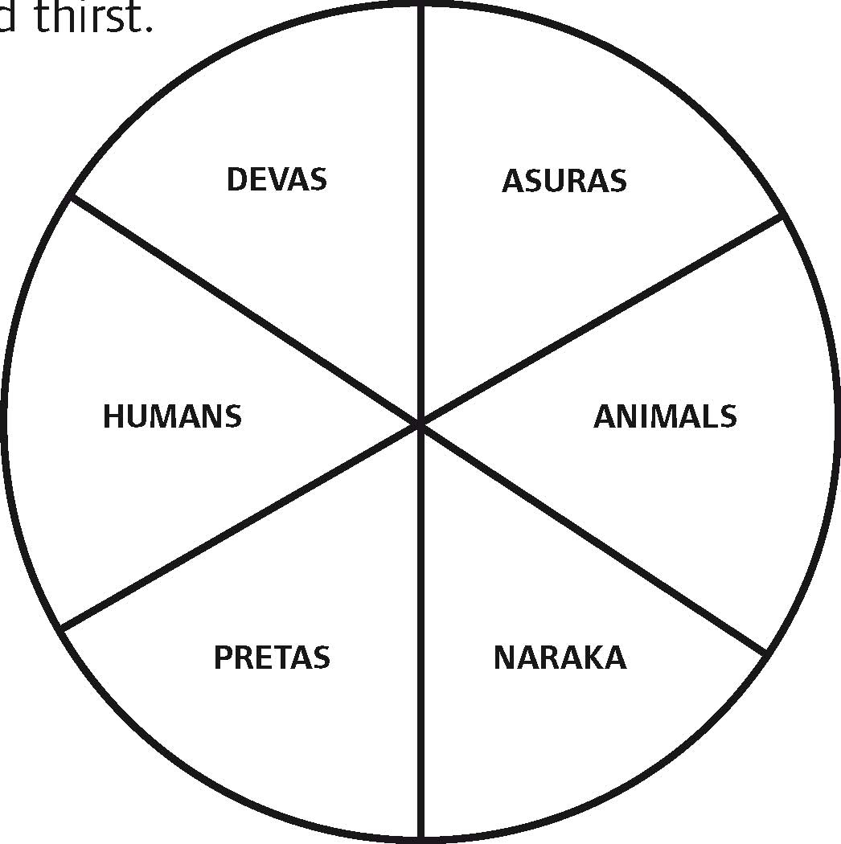
- In the past people everywhere believed in other kinds of non-human beings, like ghosts and fairies, who hang around the edges of our human world. In Buddhism the name for the place where these beings live is called the preta (spirit) realm. Pretas often live lonely lives and suffer from hunger and thirst.
- The last kind of beings live in naraka (hell) which is a horrible nightmarish place full of pain and suffering.

The endless cycle of the birth and death of beings through the six realms is called samsara, which means something like ‘continually moving on’. All beings are trapped in samsara.

The deva, asura and human states are called the higher realms. The animal, preta and hell states are the lower realms. It’s only in the higher realms that we can do good actions and become wise enough to get free from samsara.

Karma and Rebirth

Buddhists believe that the things people do and the way we think is important in this life and also affects the kind of rebirth we will have. This is the idea of karma, which means ‘action’. In Buddhism it matters how we behave. The way we act now shapes our present life. But our actions also have a powerful influence on the kind of being we become after we die and are reborn.

For example, when our minds are filled with angry thoughts towards other people, we always want to fight and other people become frightened of us. We may have very few friends and make lots of enemies. Always being angry causes a negative kind of karma and makes us very unhappy and lonely in this life. Buddhists believe that after someone like that dies, because of the habit of being angry, they are more likely to be born somewhere where they are surrounded by lots of fighting. On the other hand, if we are kind, generous and work for the happiness of others, this creates good karma, and we will probably be reborn in one of the higher realms.

Things Buddhists do for dying people

Buddhists think that it is important for people to die in a peaceful place, cared for by those they know and trust.

Sometimes the dying person will be visited by their Buddhist teachers who chant special verses. They might also re-take some of their Buddhist vows. Dying people are encouraged to let go of the attachment to this life by giving away their wealth for the benefit of others - maybe to help support a monastery or print Buddhist texts, but also to help relieve suffering and poverty in the world.

After Death

Immediately after death, it is common for Buddhist scriptures to be chanted around the body, and for people who were close to the dead person to say farewell and make wishes for them to have a happy rebirth. Buddhist ceremonies are performed, and the benefit of doing the ceremony is dedicated to the person who has died, to make sure they are born as another human being.

In Buddhism the body is usually cremated, following the example of the Buddha. The destruction of the body through fire is thought to be a very powerful teaching on impermanence and helps the family and friends to realise that the person has left this life and cannot return.

Rebirth

In South East Asian countries the person who dies is thought to be reborn immediately after dying. In Tibetan and Chinese Buddhism there is said to be a period of seven weeks between one life and the next.

In Tibetan Buddhism, a picture of the dead person is sometimes placed on the shrine for seven weeks. Special words are chanted regularly during this period. On the 49th day, the picture is burned, and special prayers are made.

In many East Asian Buddhist countries special prayers are made for the dead person to be reborn in a Pure Land, a happy place where they can learn much more about the Buddha’s teachings and train in ways to help free other beings from suffering.

Buddhist Glossary
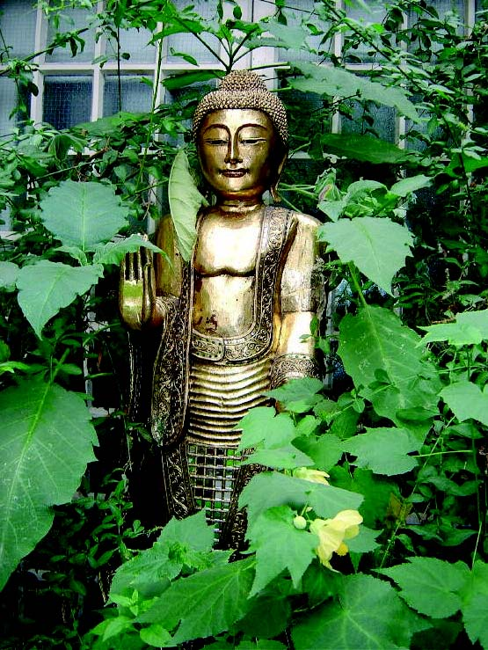

Asura | ‘Jealous God’ – one of the six realms
Being | Every kind of living thing, apart from plants.
Deva | ‘God’ – one of the six realms. A bit like Heaven, but doesn’t last.
Karma | Actions with a strong intention that influence not only the current life, but also future rebirths.
Naraka | ‘Hell’ – one of the six realms. Like hell, but doesn’t last.
Preta | ‘Spirit’ or ‘Hungry Ghost’ – one of the six realms.
Pure Land | ‘Buddha Realm’. A kind of temporary heaven presided over by a Buddha, where people can go further on the Buddhist path.
Rebirth | The process by which beings are endlessly born into one of the six realms. The traditional Sanskrit words for this are Bhavana which means ‘becoming’ or Jati which is ‘birth’.
Samsara | The endless cycle or wheel of birth and death, driven by the actions of beings (karma).
Six Realms | The six realms cover all the possible kinds of beings that exist in the universe. None of these realms are permanent.

SESSION 4 AND 5 INFORMATION SHEET

SESSION 4 AND 5 INFORMATION SHEET

Rituals Related to Death in The Hindu Family

Hindus believe in reincarnation. They believe that death is the start of a long sleep for the soul, before it sets out on a new life. Hindus believe that death is part of the cycle of life and is what happens before you set out on a new life.

Each life teaches new lessons and brings a soul closer to God. Good deeds will bring you nearer to God and bad deeds will push you away from him so that you will just stay in the cycle of life and death and not move towards freedom.

What happens when a Hindu dies?

Where possible, relatives gather around a dying person, dip a leaf of sweet basil in water from the Ganges or milk, and place this on the lips of the dying person while they sing holy songs and read holy texts. If available, a special funeral priest is called. A light is lit in the home which is kept alight for twelve days. The “chief mourner” leads the rites. This person is either the eldest son in the case of the father’s death or the youngest son in the case of the mother. If there are no sons the work will be done by the nearest male relative.

After death, the chief mourner performs arati, passing an oil lamp over the remains, and then offering flowers. The body is prepared for cremation. Sesame oil is applied to the dead person’s head. The body is bathed with water, anointed with salve of sandalwood, kum kum powder and vibuthi from the nine kumbhas, dressed in best clothes and placed in a coffin. The women then walk around the body and offer puffed rice into the mouth to nourish the deceased for the journey ahead. A widow will place her Mangalsutra around her husband’s neck, signifying her enduring tie to him. The coffin is then closed. The ritual homa fire can be made at home or kindled at the crematorium.

The Funeral

How a Hindu funeral is organised differs in India and in the UK

In India  These days, in most families the body is laid in a coffin and covered with flowers before it is driven to the crematorium. In the crematorium, a small candle or oil lamp (Diwali lamp) is lit, which the main mourner holds in his hand while carrying a container of water on his shoulder. He circles the dead person three times, and a hole is made in the container each time he goes around. The coffin is then moved to the cremation room (Shamshan ghat). Only men go to the cremation site, led by the chief mourner.  When there is a funeral pyre, the body is carried three times counter-clockwise around the pyre, and then placed upon it. At each turn around the pyre, a relative knocks a hole in the water container with a knife, letting water out, signifying life is leaving its vessel. | In the UK  The body is laid in a coffin and covered with flowers before it is driven to the crematorium. In the crematorium, a small candle or oil lamp (Diwali lamp)  is lit.  At a gas-fuelled crematorium, sacred wood and ghee are placed inside the coffin with the body. Where permitted, the body is carried around the chamber, and a small fire is lit in the coffin before it is consigned to the flames. The chief mourner then engages the cremation switch.

Returning home, everyone bathes and shares in cleaning the house. A lamp and water pot is set where the body lay in state. The water is changed daily, the picture of the deceased is placed in a room and a garland is placed on it. A lamp is lit next to it and is kept lit for twelve days.

The family shrine room is closed, with white cloth draping all images. During these days of ritual impurity, family and close relatives do not visit other homes, though neighbours and relatives bring daily meals to relieve the burdens during mourning. The mourners do not attend festivals, temples, visit swamis, nor take part in marriage arrangements. Some families observe this period for up to one year.

About twelve hours after the cremation, men from the family return to collect the remains. Water is sprinkled on the ash; the remains are collected on a large tray. At crematoriums the family can arrange to personally gather the remains: ashes and small pieces of white bone called “flowers.” In crematoriums these are ground to dust, and arrangements must be made to preserve them. Ashes are carried or sent to India for depositing in the Ganges or are placed in an auspicious river or the ocean, along with garlands and flowers.

Helping the family

After the cremation, friends visit the bereaved family for the next two weeks, to pay their respects and provide support. Devotional songs are sung and scriptures are read from the Ramayana. This period may be longer if it is a young person who has died or it is an unexpected death. The friends and family talk together about the dead person, share happy memories about their lives with that person and help around the home. Hindus believe that by sharing their grief with each other, the amount of grief will be halved. They believe that although everyone will miss the deceased, death is not sad. The dead person has learned the lessons he or she was meant to learn in life and will move on nearer
to God.

The Final Farewell

Each month during the first year after the death, a pinda rice-ball and bowl of water are offered in memory of the dead person. A widow will erase her sindoo and wear white clothes for the first year after her husband’s death. Sons will hold a memorial service each year on the day of their father’s death as long as they are alive.

At the yearly anniversary of the death (according to the moon calendar), a priest conducts the shraddha rites in the home, offering pinda to the ancestors. This ceremony is done yearly as long as the sons of the deceased are alive (or for a specified period). It is now common in India to observe shraddha for ancestors just prior to the yearly Navaratri festival. This time is also appropriate for cases where the day of death is unknown.

SESSION 4 AND 5 INFORMATION SHEET

Hindu Glossary
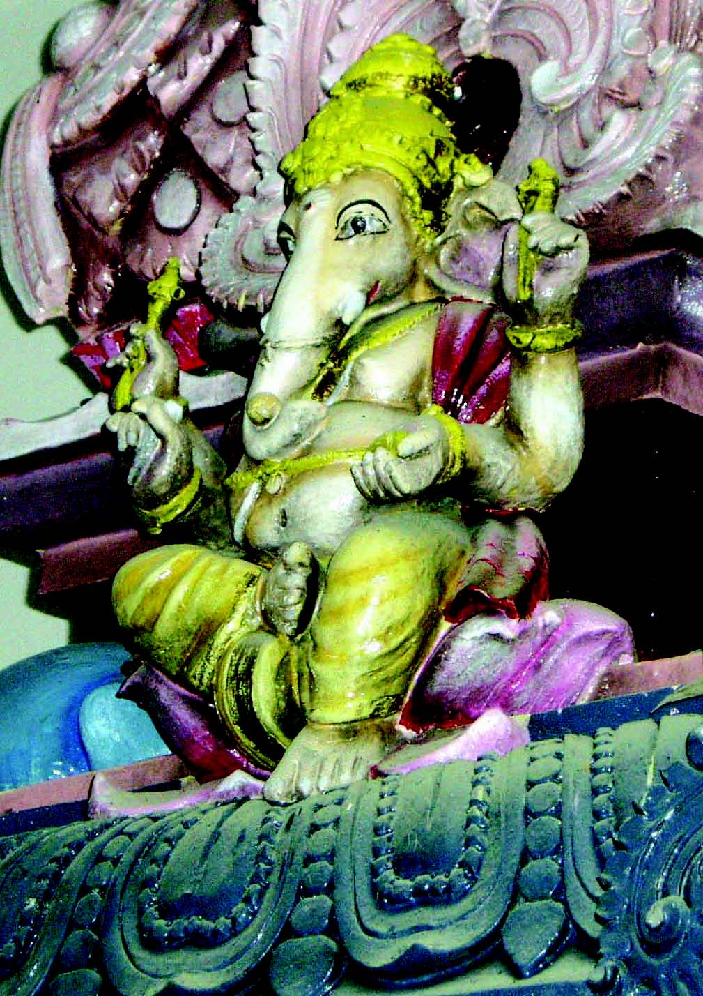
Auspicious | Lucky
Chief mourner | Either the eldest or the youngest son or the nearest male relative
Cremation | Burning
Homa | Fire used in worship
Kumbhas | Brass water pots
Mangalsutra | Wedding pendant
Pinda | Rice-ball
Reincarnation | Rebirth into a new body for another life
Shraddha | Hindu ritual of treating people to feasts in the name of the deceased
Sindoor | Marriage mark

Death and Bereavement in the Humanist Belief system

Death
Humanists believe that this is the one life we have. They believe that there are no gods, no heaven or hell, and that we no longer exist as people once we have died.

They believe that their bodies, or the atoms that make up their bodies, will continue to exist as part of the natural world. However, the person themselves will live on only in other people's memories, or in the work they have done while alive and left behind them, or in their children.

Many humanists, like many people, would prefer not to die. However, they believe that wanting something to be true is not the same as it being true. They believe that death is a natural part of life, and because we can’t avoid that, it makes sense to try not to be afraid of it, but instead to come to terms with it. Then we can focus on finding meaning and purpose in the here and now.

For humanists, life is all the more precious because it comes to an end. Humanists have no expectation of reward or punishment after death. The main thing is to try to lead good and happy lives now, while we are alive, and to help other people do the same. We don't get another chance.

Humanists think that really important questions for all of us are ‘How can I live a fulfilled and worthwhile life? How can I help others to do this? Asking the question “What would I like to be remembered for when I am dead?” helps people to think about the answers to these questions.

When a person is dying
Because humanists do not believe in gods or an afterlife, they believe that the important things to do when somebody is dying are the ‘humane’ things: supporting and comforting them as far as possible, alleviating their suffering, listening to and respecting their wishes as far as possible, helping their close relatives and friends who may also be suffering.

When someone dies
When someone they know dies, most people feel grief, sadness, shock, pain and possibly other emotions such as anger, guilt, or remorse.
If they were close to the dead person, these emotions can be even more overwhelming.

Humanists believe that this is true for religious and non-religious people alike. The natural human response is to comfort, or seek comfort from, those around us, and humanists will do this in whatever way comes most naturally to them. This could include staying close, or ‘being there’ for someone; showing respect for the dead person; practical help; or simple expressions of sympathy.

A humanist funeral or memorial ceremony
Humanism has no rules about what should be done with the body of the person who has died, other than legal requirements. The body may be cremated, or buried, or even, if the person has left instructions, donated to medical science. There may be a funeral, or there may be a memorial ceremony separate from this.

A humanist funeral is a positive celebration of a person's life, specially created for that person and their family, with music, readings and time to reflect.

It will
- focus sincerely and affectionately on the person who has died
- allow friends, relatives and acquaintances to express their feelings and to share their memories
- celebrate the life of the person who has died by paying tribute to them, to the life they lived, the connections they made and left behind.

It will usually include:
- music that is in some way connected to the dead person: for example songs they liked, or that reminds their friends of them
- family or friends’ memories or stories about the dead person.
- an eulogy: a talk focussing on the achievements of the dead person, and the meaning of their life.
- A brief period for quiet reflection. There will often be religious people amongst the mourners, and this can be a chance for them to offer their own private prayers if they wish.

It may also include readings of poetry and prose, a non-religious reflection on death, or symbolic actions like candle lighting, or formal words
of goodbye and may be conducted by a trained humanist celebrant, or by family or friends themselves.

Humanists believe that a funeral like this helps the bereaved in their grief.

Notes about Death and Bereavement in Judaism

As death approaches an observant Jew would read, or have read for them, a Prayer of Confession followed by the Shema, a prayer said twice a day. The Shema declares that there is one G-d, which is the main belief of Judaism.

There are no services at the Synagogue concerning a funeral. Prayers are said at the cemetery in a prayer hall. Evening services are held in the ‘House of Mourning’ (usually the home of the deceased, or a close relative) followed by a memorial service. This starts on the eve of the funeral and continues for seven days (the shiva), (except for Shabbat – Sabbath)

At the ‘House of Mourning’ (Bet Avel), all shiny surfaces such as mirrors and TV’s are covered. This is so that the mourners are not tempted to look at themselves, but think of their departed loved one. Great respect is shown to a person after death - as in life. A memorial candle is lot in the house after the funeral and is kept burning throughout the Shiva

Jews believe that the soul of the departed goes to Heaven and the Lord restores the souls to the dead.

Jewish people believe that all their good deeds are ‘weighed up’ against their bad deeds, with one angel speaking for their ‘good deeds’ and another angel speaking about their ‘bad deeds’. When the good deeds outweigh the bad deeds, the soul can enter Paradise, or Gan Eden, the Garden of Eden.

Eternal Life is a cornerstone of Jewish belief. Jewish people believe that this life, life on earth, is a ‘preparation’ for the ‘Heavenly World’. Jewish people also believe that their souls (but not their bodies) are destined for Eternal Life.

Jewish people believe all their deeds on earth are weighed in this way. They believe that their souls return to G-d in this way. After a person has died, the same respect is shown for them as when they were alive. With this in mind, the body is
not left alone at any time. A ‘watch’ is kept from the time of death until the funeral. Funerals in the Jewish tradition are held very quickly, sometimes on the day of death, but usually on the next day.

It is very unusual for there to be a delay, except for Shabbath or a festival. A funeral would break the laws of Shabbath (the Jewish Day of Rest), as Shabbath is a day of joy.

Jewish people are always buried in a Shroud. Men are buried in their Tallit (Prayer Shawl) over the Shroud. Coffins are always plain, with no decoration or adornments, and made of unpolished wood. It is not usual to have flowers at a Jewish funeral. These are all signs of the equality of all, in death.

The Mourners (Aveylim) at a funeral would be parents, siblings, children and spouse of the deceased.

One of the main customs to take place before the funeral, either at the Mourners’ house before leaving for the funeral, or at the cemetery, is to ‘Make Kriah’. A piece of clothing on each Mourner would be cut by a friend, relative or by the Rabbi. Kriah is always cut on an actual piece of clothing, such as a shirt or cardigan, but not a tie or scarf, etc. Kriah is cut on the left side of the clothing for a parent, (over the broken heart), and on the right for other relatives. This signifies the more intense grief for a parent. After the cutting, the garment is then torn further by the Mourner who recites the following blessing: ”Blessed art Thou O Lord our king, King of the Universe, the true Judge “

Each Mourner will wear their torn clothing for the week of intense mourning known as the Shiva except on the Shabbat as there is no mourning on the Sabbath.

At every Jewish Cemetery there is a Prayer Hall. Prayers are said in the Prayer Hall both before and after the burial. A tribute may be paid before the burial by a friend or relatives or read by the Rabbi.

The service is aimed at honouring the deceased, and not at comforting the mourners. The service mostly consists of chanting of Psalms. No music is played and the chanting is not accompanied by an instrument. While walking to the graveside, Psalm 91 is chanted.

After the coffin is lowered into the ground, first the Aveylim, and then all those present who wish to, are invited to throw three spades full of earth into the grave. This is done until the entire coffin is covered, showing continuing concern for the deceased. The spade is not passed from hand to hand, but each person returns the spade to the mound of earth, for the next person to take. This is so each individual makes the choice to perform the act of his own free will and also that trouble is not passed on. The sound of the earth on the coffin is an act of finality.
It helps all concerned to accept the death of the relative or friend. There are two parts of the final goodbye: respect for the deceased, and comfort for the mourners.

Before re-entering the Prayer Hall it is customary for all those who have been on the ‘grounds’ of the cemetery to wash their hands. This represents washing their hands clean of pre-occupation with death. Water is a symbol of life and a source of life in Judaism; no life survives without water. Washing of hands also shows faith that death is not the end, and that life, for the living, must go on. If there are ten men (boys aged over 13 years and one day and men) present, the service in the Cemetery will conclude with the Aveylim reciting the Mourners Prayer, or Kaddish. This prayer declares the greatness of G-d, and the acceptance of his will. If there are not ten men (a Minyan or quorum) present, this prayer cannot be said.

On taking their leave of the Aveylim, both from the cemetery, and later from the House of Mourning, visitors wish each Mourner a ‘Long Life’. This is one of the ways Jewish people tell each other to ‘move on’, and not let grief take over their lives. This is a very important concept in Judaism. Concern is for the living, while showing respect for the deceased.

It is considered to be an exceptional ‘good deed’, (Mitzvah), to ‘accompany the dead’ to their final resting place. This is because this is one Mitzvah for which no reward from the recipient can possibly be expected or given. It is not necessary to have known the deceased to ‘accompany the dead’. It is still considered to be a very important Mitzvah.

There are two parts of the final ‘goodbye’. respect for the deceased and comfort for the mourners.

On return from the Cemetery, the Aveylim eat a special ‘meal’, consisting of a hard-boiled egg, a bagel, and a piece of salt herring. This is called the ‘Meal of Consolation’. The significance of these foods is as follows: The egg, for fertility, and for continuity, an egg has no beginning or end, as mankind has no beginning or end. The bagel, also for continuity, and, as bread, is the staff of life, the sentiment that life must go on. The salt herring signifies the sad time brought by the death of a relative or friend, and reminds us of tears. They also refrain from wearing leather shoes during the Shiva.

After the funeral, the Aveylim observe seven days of intense mourning. This period is called ‘Shiva’ meaning seven (days). A memorial candle is kept alight for all of the seven days. During this time, the Aveylim do not work, or beautify themselves, they do not cook or clean, and they sit on low chairs, and wear slippers, not leather shoes, all signs of mourning. They will not listen to music. Friends and relatives come to the house to speak to them and comfort them.

The Aveylim only leave the house to attend the Synagogue on Shabbath. Friends and family bring ready prepared food for the Aveylim. The three daily prayers (Morning, Afternoon and Evening) are held at the Shiva House for the week of mourning, except for on the Shabbath, as they are then said in the Synagogue. Kaddish is said by the Aveylim at each of these services, as long as there is the required Minyan.

From the day of the funeral, thirty days of mourning are observed, referred to as ‘Shloshim’, meaning ‘Thirty’ (days). During this time, the Aveylim do not go to parties, listen to music, watch TV, cut their hair, or shave their beards. After the first week of Shiva, the Aveylim continue to say Kaddish in the Synagogue, at all daily services. If an Aveylim is mourning the loss of a parent, these restrictions and prayers will continue for one year.

On the anniversary of the death of a relative according to the Jewish calendar starting at sunset of the previous day, (counting from creation), the Aveylim lights a candle in their home. The candle lasts for 24 hours, and is a reminder of the deceased. On this day, the Aveylim again does not listen to music or attend parties etc. The Aveylim would also say Kaddish in the Synagogue, as before.

Although it is acceptable to dedicate a memorial stone to mark the grave of a loved one after the Shloshim have elapsed, it is more customary to do so at the end of a year. A memorial service is held at the cemetery which gives family and friends a chance to show their respect even if they were unable to attend the funeral which would have been at very short notice.

Note: G-d has been used because it is Jewish practice not to write the Lord’s name as this makes a document or paper holy.

SESSION 4 AND 5 INFORMATION SHEET

S

Jewish Glossary
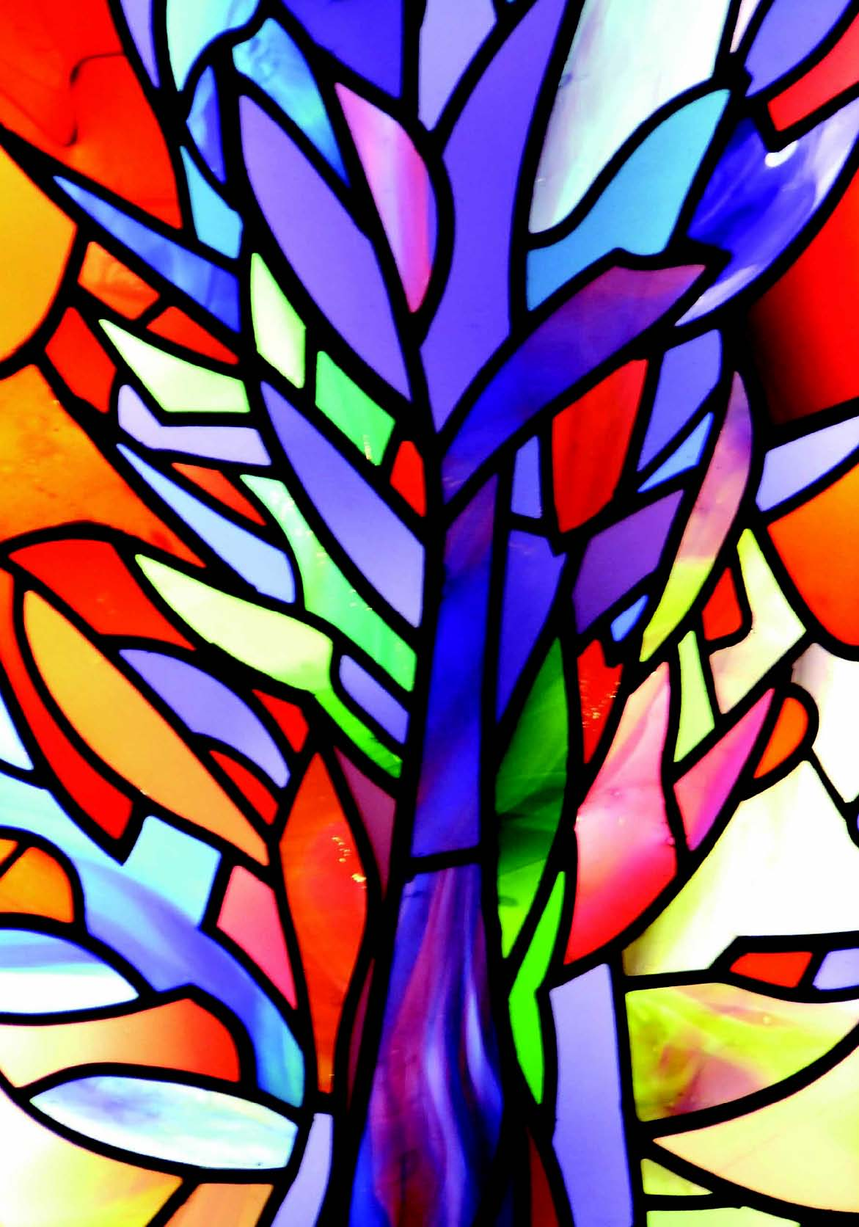
Aveylim | Mourner
Bet aveyl | House of mourning
Kaddish | Mourners prayer or memorial prayer
Kriah | Cutting of mourners clothes
Minyan | Quorum of ten men (over 13 yrs and one day)
Mitzvah | Good deed
Shiva | Seven days of intense mourning
Shloshim | Thirty days of mourning
Tallit | Prayer shawl
ION 4 AND 5 INFORMATION SHEET

References

The Jewish Book of Mourners, Why? By Albert Kolach
www.mazornet.com/deathandmourning
Jewish Perspective of Death and Mourning.

Notes about Death and Bereavement in the Muslim Faith

Death
For Muslims, the purpose of life and death and of the afterlife in Islam is explained in the Qur’an. For a Muslim, death is the return
of the soul to their Creator, Allah, and so the inevitability of death and the hereafter is never far from the Muslim’s mind.

When a Muslim is dying
Family members and friends of the dying person should be informed and should support him or her in reminding them of Allah.
They should be kind and patient and not leave the dying person alone.
They remind him or her:
- About all the good things that he or she has done, about Allah’s mercy, and of Allah’s forgiveness.
- Encourage the dying person to say: “La ilaha illa-Allah.”
- To lay the dying person so that the Qibla is on his right side.
Prophet Muhammad (pbuh) said: “Let no Muslim die except expecting and hoping the best from Allah.”

What should be done when someone dies?
Muslims are recommended to do the following when someone dies:
- When the person has died, close their eyes and cover them.
- Prepare the body for burial without delay, as soon as death is confirmed by a doctor.
- Settle any debts of the dead person.

Informing Family and Friends
Muslims tell the family, friends, and other good people when someone dies so that they can attend the funeral. It is a Muslim’s duty to offer condolences, comfort, and sympathy to the family and the relatives of the deceased.

Grieving for the Deceased
Muslims are agreed that crying and grieving for the dead is natural, but it is not acceptable to be angry with Allah for the person’s death.
It is allowed and acceptable for a Muslim to be sad and grieve for as long as they want to and as long as they need. However people are encouraged to not to give way to loud and outward mourning.

Preparation of the Deceased
Wherever someone dies, it is very important that the body is taken to be washed as soon as possible. Muslims have been taught to treat the dead body with gentleness and respect. Cremation is forbidden. Instead, the body is washed , scented, and covered with clean cloth for burial.
There are certain steps in the preparation of a Muslim’s body for burial, these are:-

Ghusul - This involves a ritual washing like wudu and then there is a complete washing of the whole body. Male bodies are washed by men and female bodies are washed by women, these will often be close relations.

Kafan - This is the shroud that is used to wrap the body of the person who has died. The kafan is made up of two small cloths to cover private parts and three further sheets to wrap the body of a male. Five sheets are used to cover a female.

The Funeral
Praying for the person who has died and having funeral prayers at the mosque Salat-ul-Janazah, are essential in Islam. There is no call to prayer just before the funeral prayer because that call (Adhaan) has been made at the person’s birth, so all of life is seen as an act of worship. The congregation pray to ask Allah to forgive the dead person’s sins, have mercy on him or her and to grant them a place in Jannah.

Burial
The deceased person should be buried by Muslims as soon as possible in a Muslim cemetery. The body should be turned towards the Qibla. Generally graves should be simple. People may visit them afterwards to pray for the person who has died and to remember that there is an end to earthly life but also to reflect on the life after death.

Bereavement
The initial bereavement period lasts for three days, during which prayers in the home are recited almost continuously. Friends and community members will cook and bring food to the hoe of the deceased to support the family. They will also stay with them as much as possible to comfort the bereaved.

“Allah has created life and death as a test to see who is the better in conduct.”
From The Qur’an, Sura 67:2

Ref: What to do after a death? A practical guide for Muslims. www.gardens-of-peace.org.uk

SESSION 4 AND 5 INFORMATION SHEET

Muslim Glossary

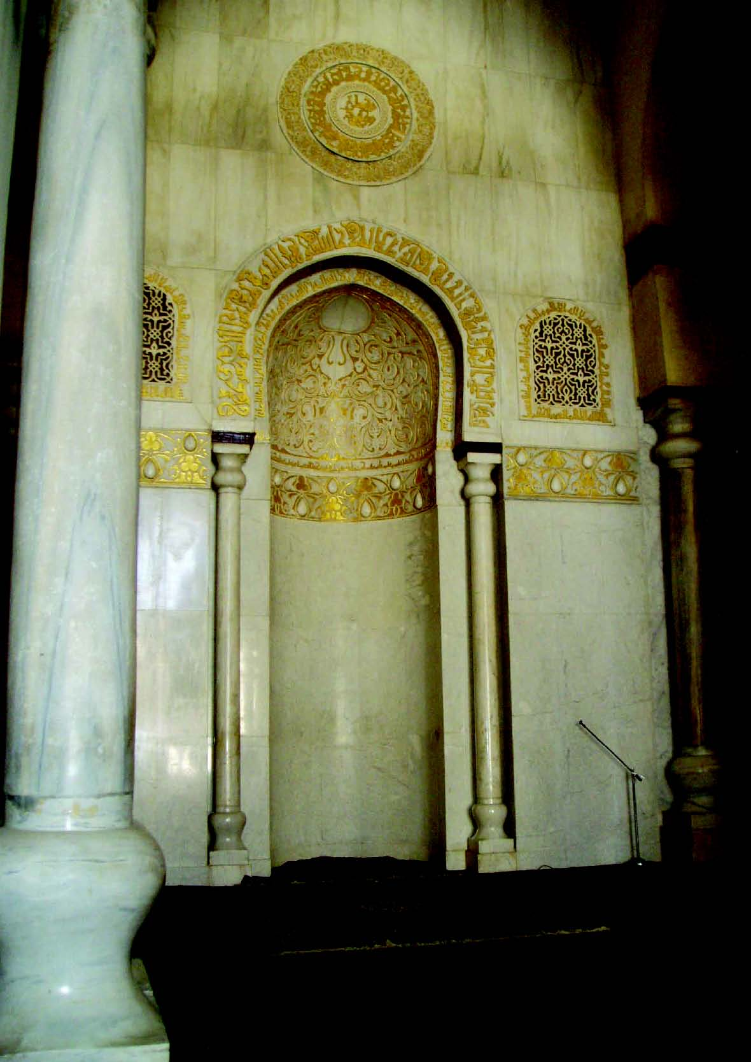
Allah | God, in Arabic.
Ghusul | Washing of the dead body.
Hajj | Pilgrimage to Makkah. Hajj Robes are the robes worn by men  during the Hajj. Women do not wear Hajj robes.
Jannah | This is paradise, a place that Muslims believe has been prepared as a reward for those who have lived a good life. ‘A good life’ means one that Allah considers good.
Kafan | Shroud used for wrapping the dead body.
“La ilaha illa-Allah” | “There is no god but Allah.”
Qibla | Towards Makkah.
Qur’an | The final revealed message from God.
Salah-ul-Janazah | The funeral prayers.
Wudu | Ritual washing before prayer.

Notes about Death and Bereavement in the Sikh Faith

Sacred Text
This text tells Sikhs to behave well in this life, so that when they die they will be able to stay with God and escape reincarnation.

‘Strive to seek that for which you have come into the world, find through the grace of the Guru, God will dwell in your heart. You will abide in His presence, in comfort and in peace and not return ever to be born and to die once more.’
Guru Arjan

The Long Sleep
Many Sikhs believe in reincarnation. They believe that death is the start of a long sleep for the soul, before it sets out on a new life. Sikhs believe that death is part of the cycle of life and is what happens before you set out on a new life.

Each life teaches new lessons and brings a soul closer to God. Good deeds will bring you nearer to God and bad deeds will push you away from him and that you will just stay in the cycle of life and death and not towards freedom.

Sikhs believe that souls are rewarded for good deeds and that when all lessons are learned God will free them from the need to experience another life. Then they will be able to join God and be liberated (mukti) from the cycle of birth and death.

The Sikh holy book, the Guru Granth Sahib, says that mukti can only be achieved by living a God-conscious life, where everything you do is guided by the word of God. Sikhs believe that the only thing that you carry with you when you die are good deeds. (See Guru Nahak’s story of the Rich Man and the Needle.)

What happens when a Sikh dies?
When a Sikh dies the evening prayer is said and everyone remembers God by saying ‘Waheguru!’ meaning ‘Wonderful Lord’.

Everyone is treated equally in Sikhism because Sikhs believe that everyone is of equal importance and was created by one and the same God, so no matter how wealthy or powerful a Sikh may be in this life, his or her funeral will be the same as the poorest Sikh’s. Sikhs believe
in cremation, not burial, as the body that is left is just a shell for which the soul has no more use. The cremation should take place as soon as possible, and in India it usually happens on the same day as the death, or the next day.

Before the cremation, the body is washed, traditionally yoghurt and water are used. It is then dressed in new clothes, including the Five Ks – the symbols of the Sikh faith: shorts, uncut hair, sword, bracelet and a comb. The body is then placed on a bier or in a coffin and covered with a plain cloth. It is brought home on the way to the funeral so that friends and relations can pay their respects to the dead person one last time.

When a death occurs, the family and friends make arrangements to read the Guru Granth Sahib. This can either be read whenever the bereaved wish or continuously (Akhand Path). The continuous reading takes approximately 48 hours to complete. Sometimes the Guru Granth Sahib is read over a week or more.

The Funeral
On the way to the place where the cremation takes place, the body is taken to the Gurudwara for prayers. It is not usually taken inside the building, the prayers are said outside the building. Then a procession takes the body to the funeral ground where it will be cremated.

Once they arrive, the friends and relations say a general prayer over the coffin. This is the concluding prayer (Keertan Sohila), and this is the same prayer which is said every night when the Guru Granth Sahib is placed in its resting place in the Gurudwara. At the cremation site the funeral pyre is lit. The eldest son usually does this. If the cremation takes place in a crematorium, the nearest relative will indicate when the cremation should begin. After the cremation, everyone returns to the Gurudwara for the Bhog service, in which Shabads (hymns) from the Guru Granth Sahib are recited and sung.

Everyone shares Karah parshad, a sweet which symbolizes equality of all humans, and they have a meal in the community kitchen, or langar. Both of these rituals symbolize equality to Sikhs. They also remind everyone that life must go on for those left behind. Sikhs often give money to charity at this time.

Helping the Family
After the cremation, friends visit the bereaved family for the next two weeks, to pay their respects and provide support. This may be longer if it is a young person who has died or it is an unexpected death. They talk together about the dead person, share happy memories about their lives with that person and help around the home. Sikhs believing that by sharing their grief with each other, the amount of grief will be halved. This will help bring the community together and may heal any family conflicts that existed before the person died.

Sikhs believe that although everyone will miss the deceased, death should not be sad. The dead person has learned the lessons he or she was meant to learn in life and will move on nearer to God.

The Final Farewell
In Sikhism it is forbidden to erect a tomb of memorial to a dead person because Sikhs do not believe that the body is of any use after the soul has left it. In India, therefore, after a cremation many families arrange for the dead person’s ashes to be taken to Kiratpur near Anandpur Sahib. There they are sprinkled onto the waters of a river. Sikhs living outside India that cannot arrange to travel there for this purpose will still arrange for the ashes to be scattered onto flowing water in the local river or sea.

Sikh Glossary

Akhand Path | The 48 hour continuous reading of the Guru Granth Sahib
Bhog | Food offering
Guru Granth Sahib | Last and everlasting Guru, Sikh holy book
Karah parshad | A sweet pudding which symbolizes equality of all humans
Keentan Sohila | Concluding prayer of the day for Sikhs
Langar | Food prepared and shared in the community kitchen
Mukti | Liberation
Shabads | Hymns
Waheguru | Wonderful Lord
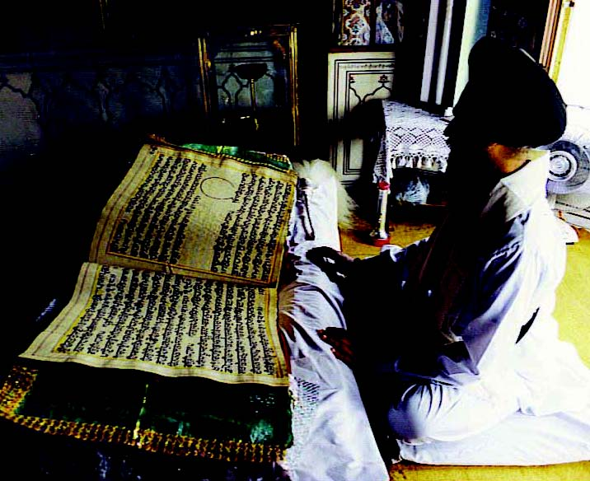

ION 4 AND 5 INFORMATION SHEETESSION 4 AND 5 RESEARCH SHEET

Make some notes for your feedback under the name of the religion.

- Which faith or belief are you studying?

- Where do people of this community believe they go after death?

- What can you find out about that place?

- In this faith or belief what does it teach about how this life influences what happens to believers / people after death?

- What rituals or traditions are used by members of this community when a believer
has died?

- Are there any special ways that this community has helped people to remember someone who has died?

From “Badger’s Parting Gifts”

“Although Badger was no longer with his friends, he had given each of them
a special memory of him.

He wanted them to help each other using these gifts.

Even though Mole and his friends felt lost, alone and unhappy, in time their sadness melted like the winter snow.

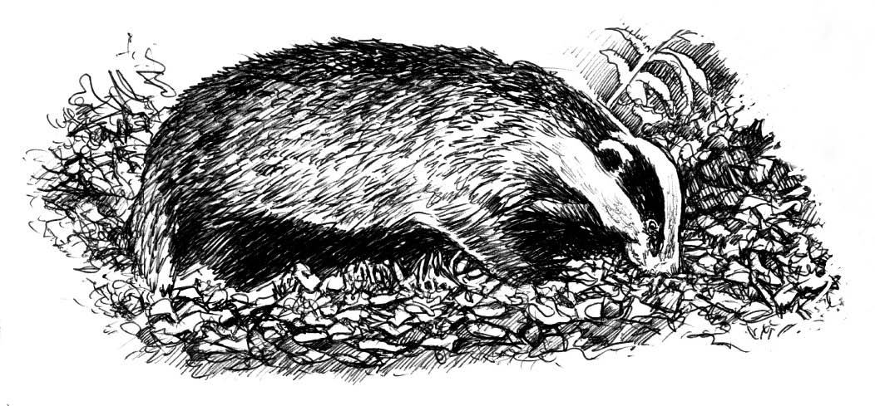
They remembered the joyful moments they had shared with Badger and all that he had taught them, and they felt thankful that they had known him. As he had left them he had felt free and happy, not afraid.”

By Susan VarleyION6 RESOURCE SHEE

What this unit contains |  | This unit contains the following content from Christianity: How Christian places of worship give opportunities for peaceful reflection, meditation and prayer, e.g. worship in the Quaker tradition; Christian beliefs about ‘the Peace of God’; Jesus’ teaching ‘Blessed are the Peacemakers’; Martin Luther King and peaceful, non-violent protest.  Also content from one of the following two faiths, either:  Islam: As-Salaam, one of the beautiful names of Allah meaning the Source of Peace. As-Salaamu alaykum (Peace be upon you)’ as a greeting of peace, which is always shared by Muslims.  or  Hinduism: Non injury to living things - Ahimsa. Gandhi’s life - demonstrating Ahimsa in practice through non-violent protest. Teachers need to emphasise that peace and living harmoniously with your neighbour is an important belief of all religions.
Where the unit fits and how it builds upon previous learning |  | This is a unit to be taught in Key Stage 2 over half a term.  It makes links with the Christianity work on the Bible, local Christian places of worshipand Christian celebrations.  Spend a moment each day, during the unit, reflecting in silence about peace.
Extension activities and further  thinking |  | - Find out about conscientious objectors from the Christian tradition and how the Quakers responded in  World War 2.  - Read Psalm 23 or Psalm 46: 10 – how might Christians or Jews interpret these in their lives?  - Consider how to stand up for peace and take a stand against violence. How can you be a friend to others?  - Consider what it might mean to ‘love your neighbour’ focusing on positive ways to contribute to support for people who are suffering from conflict.  - Investigate beliefs about peace in other faiths.
Vocabulary |  |  |  |  | SMSC/Citizenship  - Peaceful reflection.  - Peaceful resolution of conflict.  - Investigate how communities function.  - What peace means in an international context, and how this affects how people are able to live.
peace | Muslim |  | gentle | other words
peaceful | Islam |  | sea | describing
friend | Hinduism |  | sky | qualities
enemy | Hindu |  | asylum seeker | generated by the
refugee | Ahimsa |  | conflict | pupils
war | kind |  | confrontation
Christianity | unkind

Session 1. Key Questions: What is peace? What does peace mean in the world and to you?

Learning objectives | A T 1 | A T 2 | Suggested teaching activities | Sensitivities, points to note, resources
Pupils should:  - consider the meaning of the word ‘peace’ in secular and spiritual contexts;  - explore what peace can mean to them in their lives;  - explore what peace can mean with friends and family. |  |  | Introduce the word peace to the class and provide some thinking time while quiet music is played for them to reflect on what ‘peace’ is. Share children’s ideas or feelings on what peace is and means to them. | Resources  The Seeds of Peace by Berkeley,  Barefoot Books.  ISBN: 1-84148-006-1  Peacetimes by Scholes, Belitha Press.  ISBN: 1-85561-761-7  Any peaceful music.
 |  | ✓
 |  | ✓  | Talk about times when they feel peaceful. What influences that feeling for them, e.g. being on good terms with others, being in places and around people that make them feel peaceful? Make a class list of these influences.
 |  | ✓  | Read ‘The Seeds of Peace’ to the class and discuss the issues raised by the book. What does the old hermit mean when he says to the sad merchant “Peace comes from within you. It is like a seed.”?
 |  | ✓  | Encourage children to talk about whether feeling peaceful makes a difference to living alongside others. How is it different if they are feeling irritated and argumentative?
 |  | ✓  | Read ‘Peacetimes’ around the class and select some of the statements in the book to be illustrated by the class with pictures or photographs from their own lives or from newspapers or magazines illustrating topical situations.

Session 2. Key Question: What does Peace mean for countries and the people living in them?

Learning objectives | A T 1 | A T 2 | Suggested teaching activities | Sensitivities, points to note, resources
Pupils should:  - investigate what peace means in an international context;  - understand how this affects the way people are able to live;  - consider the peaceful resolution after conflict. |  |  | Consider what peace between countries means. What is different when there is no peace? What are the difficulties that lead to times of conflict? | Resources  The story of the ‘Peace Crane’  ‘Peace One Day’ by Jeremy Gilley and Karen Blessen.  Topical newspaper articles, radio and television news reports.  Make use of internet news sites.  Details of how to fold cranes can be found on:  www.ppu.org.uk/learn/early/cranes_early_years.html  Notes for Teachers:  Ensure this lesson addresses current affairs.  To send a thousand cranes to the Children’s Monument in Hiroshima’s Peace Park, string them on garlands of 100 cranes each, and mail them to:  Office of the Mayor  City of Hiroshima  6-34 Kokutaiji-Machi  1 Chome Naka-ku, Hiroshima 730 Japan
 |  | ✓
 |  | ✓  | Talk about how it must be to live in a country where there is no peace. Investigate local issues around the dangers left behind by refugees or asylum seekers.
 |  | ✓  | Depending on topical news items, pupils may speak of issues to do with death and injury, lack of sanitation or food, lack of homes or education. Teachers will need to be sensitive to the anxieties of pupils, particularly those who have experienced war conditions, and channel their feelings to empathy and care for those enduring these experiences today.
 |  | ✓  | Consider how it must be to come to a time of peace after a time of war. Encourage empathy towards those seeking a safe haven.
 |  | ✓  | Read the story of the Peace Crane and make some peace cranes for the school, writing on them wishes for those who are not at peace.

Session 3. Key Question: What does peace mean to Christians?

Learning objectives | A T 1 | A T 2 | Suggested teaching activities | Sensitivities, points to note, resources
Pupils should:  - consider Christian beliefs about ‘the peace of God’;  - reflect on Jesus’ teaching ‘Blessed are the Peacemakers’;  - know how Christian places of worship give opportunities for peaceful reflection, meditation and prayer. | ✓  | ✓  | To find out what Christians mean by ‘the Peace of God’ and how they feel this affects their lives, you might organise an opportunity for pupils to talk to local Christians about what this peace means to them in daily life and in times of difficulty. Alternatively before this lesson pupils might devise a brief questionnaire on this topic and send to the local church or e-mail to local Christians so that responses can be shared during the lesson. Pupils can also investigate worship in the Quaker tradition and how this is held in an atmosphere of meditative silence. | Resources  The Beatitudes.  Newspaper articles, pictures, music etc.  www.bbc.co.uk/religion/religions/christianity/subdivisions/quakers/worship.shtml  beehive.thisislincolnshire.co.uk/default.asp?WCI=SiteHome&ID=7786&PageID=41567
 | ✓  |  | Examine the Beatitudes from the Sermon on the Mount, when these were said and what Jesus meant by them.
 | ✓  | ✓  | In groups illustrate Jesus’ words by a collage of newspaper articles, speech bubbles, Power Point presentation, or through dance and/or drama.
 | ✓  | ✓  | Talk about the places of worship that they know, e.g. the local church and in groups share information and ideas and record how the place or the areas within foster peaceful reflection, meditation and prayer.

Session 4. Key Question: How did Martin Luther King’s attitude to peace change lives?

Learning objectives | A T 1 | A T 2 | Suggested teaching activities | Sensitivities, points to note, resources
Pupils should:  - know how Martin Luther King’s faith led him to fight injustice through peaceful, non-violent protest. |  |  | Explain that over 40 years ago in the USA, before many of the pupils’ parents were even born, there were laws saying that white and black children couldn’t go to school together, and that people with darker skin had to ride in the back of a bus. Ask pupils, “What would you feel like if you came to school and you were told that, because you had brown hair or blue eyes or because you were a girl that you weren’t allowed to come here?” | Resources  Selma – a 2014 historical drama film based on the 1965 voting rights marches Selma –Montgomery, led by Martin Luther King.  (http://www.imdb.com/title/tt1020072/)  This session could be adapted so that students could alternatively study Malala, Rosa Parks, Mairead Maguire and Betty Williams, Wangari Maathai,  http://gaps-uk.org/celebrating-nine-women-campaigners-for-peace-mairead-maguire-and-betty-williams/
 |  | ✓
 | ✓  | ✓  | Display a picture of Martin Luther King. He was a Christian minister who spoke to many people; black and white, and taught them to stand up and say that the laws were wrong. He used only peaceful methods to solve problems. Martin Luther King had a dream that all kinds of children would go to school together and be friends, and that when people worked together, they were able to change the laws. Read part of Martin Luther King’s famous speech “I have a dream” and discuss its meaning.
 |  |  | Martin Luther King was a very brave man who continued his work even when people tried to kill him and, through peaceful protest, changed laws that were unfair. After his assassination the US government designated a national holiday, the third Monday in January each year, to celebrate his life.
 |  | ✓  | Either:  - Design a class flag for peace  - Make a friendship tree, each leaf with a wish for peace from a different member of the school community – afterwards make the leaves into a peace book.  - Make banners in home languages illustrating words such as peace, respect, joy, equality.

Session 5a. Hinduism Key Question: How was Gandhi able to change attitudes peacefully?

Learning objectives | A T 1 | A T 2 | Suggested teaching activities | Sensitivities, points to note, resources
Pupils should:  - know that Ahimsa is an important concept in Hinduism;  - know that Gandhi was a famous Indian politician and campaigner through non-violent, peaceful protest;  - know how Ahimsa influenced Gandhi’s life. |  | ✓  | Explain and record the meaning of Ahimsa. Ahimsa is a Hindu religious concept which advocates non-violence and a respect for all life. Ahimsa is Sanskrit for avoidance of himsa, or injury. It is interpreted, most often, as meaning peace and reverence toward all sentient beings. List actions that promote and go against Ahmisa. | Resources  www.gandhiinstitute.org/AboutGandhi/index.cfm  www.gandhiinstitute.org/www.en.wikipedia.org/wiki/Ahimsa
 | ✓  | ✓  | Introduce the story of Gandhi. There are various books appropriate for primary schools that cover Gandhi’s life. He was born in 1869, a Hindu and did not live an easy life. In the storytelling explain that he struggled to find freedom for his countrymen and to spread his belief in non-violent resistance. Gandhi practiced and engaged the theory of peace and justice as the world had never seen before.
 | ✓  |  | As a class reflect on the following from the UN Universal Declaration of Human Rights 1948:  “All human beings are born free and equal in dignity and rights. They are endowed with reason and conscience and should act towards one another in a spirit of brotherhood.”
 | ✓  | ✓  | Each pupil should record one local, national or world event that does not uphold this statement. How might Gandhi have responded to these?

Session 5b. Islam Key Question: How do Muslims associate Peace with Allah?

Learning objectives | A T 1 | A T 2 | Suggested teaching activities | Sensitivities, points to note, resources
Pupils should:  - know that ‘As-salaam’, is one of the beautiful names of Allah meaning the ‘source of peace’;  - consider why the Muslim greeting ‘As-salaamu alaikum’ (peace be upon you) reflects their belief in Allah. |  | ✓  | Make a class list of as many different greetings as can be recalled. Introduce the idea that the origin of the western handshake is that an open right hand showed you were not carrying a weapon; if two men met and offered each other empty right hands, this presumably meant that neither would stab the other. So the handshake was a sign of peace and peaceful intentions towards someone else. | Resources  ‘Pathways of Belief’: Islam programme 1  BBC Active DVD ‘Worship and Sacred Places’  Qur’an quotes about Allah.
 | ✓  |   | Muslims all over the world use the Islamic form of greeting, “Assalamu alaikum”, which means “Peace be to you”.
 | ✓  |  | Show pupils the section from ‘Pathways of Belief’ Islam where the names of Allah are introduced.
 | ✓ |  | Read the Qur’an quotes about Allah and, using beautiful writing, record some of the names and qualities of Allah.
 |  | ✓  | Record why you believe it is important for greetings to demonstrate that people welcome each other peacefully. Record peaceful greetings to be displayed to welcome visitors to the classroom.

Session 6. Key Questions: What does peace mean to us?

How can we foster peace in our lives?

Learning objectives | A T 1 | A T 2 | Suggested teaching activities | Sensitivities, points to note, resources
Pupils should:  - express personal responses to the subject of peace;  - consider practical ways of becoming agents for peace in schools and in the wider community. | ✓  | ✓  | Display on the whiteboard the text of the Jewish prayer for peace read at the Lewisham Holocaust Memorial Day service and read it aloud to focus pupils on the meaning. Discuss the meaning of the prayer in the light of the topics studied in the previous lessons. | Resources  Jewish prayer for peace.  http://www.peaceoneday.org
 |  | ✓  | Pupils should engage in one of the following:  - Devise a proposal to the school council to consider having a peace event to link with local communities to let them know how the school feels about local conflicts.  - Make a Peace Table in the class/school as a special table for children to go to when there is a conflict to be worked out.  - Make a classroom pledge for Non-violence. Encourage family involvement by sending home copies of the pledges for families to work with their children to make family pledges.  - Learn about Nobel Peace Prize Winners and others who have worked for peace.  - Learn more about the United Nations and its efforts to keep international peace.  - Sing or compose songs celebrating peace, the earth and all people.  - Create playground games that promote cooperating and working together as a team rather than competitively.  - Write to local politicians, radio and TV stations, newspapers, etc. to spread the word of peace.

Peace Cranes
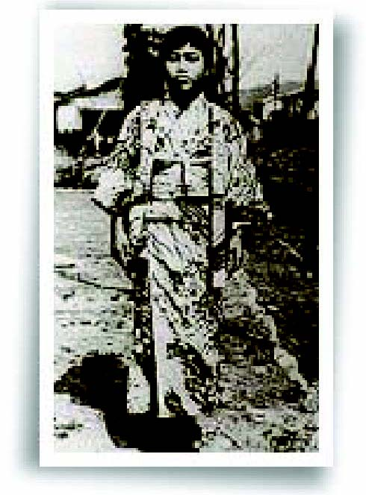
‘Paper Crane, I will write peace on your wings and you will fly all over the world’.
Sadeko Sasaki, age 12

An ancient Japanese legend says that your greatest wish will come true if you fold one thousand origami cranes.

Sadeko Sasaki was only two years old when the atom bomb was dropped on Hiroshima, Japan in 1945.
She was not immediately affected but ten years later, as a direct result, she became very ill, developed leukaemia, and had to stay in hospital.

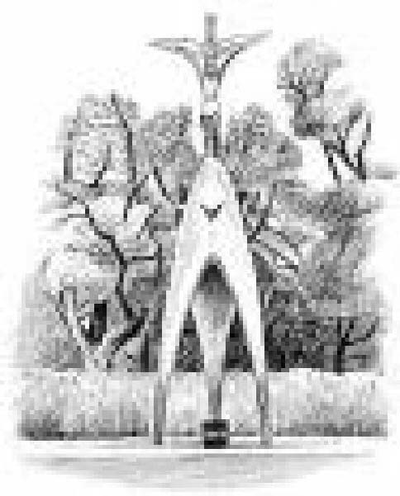
While Sadeko was in hospital, her best friend told her of the Japanese legend that
if a person could fold 1,000 paper cranes, the gods would grant them a wish. Sadeko wished to get
better so that she could run again. She started folding cranes, but unfortunately she was only able
to fold 654 before she died at the age of twelve.

Inspired by her courage and strength, Sadeko’s friends and classmates put together a book of her letters and published it. They began to dream of building a monument to Sadeko and all of the children killed by the atom bomb. Young people all over Japan helped collect money for the project. In 1958, a statue of Sadeko holding a golden crane was unveiled in Hiroshima Peace Park. The children also made a wish which is inscribed at the bottom of the statue and reads:

“This is our cry; this is our prayer, Peace in the world”.

Today, people all over the world fold paper cranes and send them to Sadeko’s monument in Hiroshima.

SSION 2 RESOURCE SHEET

Quaker Worship

John 4:23 “But the hour is coming – in fact, it is already here – for true worshippers to worship the father as he truly is, without regard to place.
It is worshippers of this sort the father is looking for.”

John 4:24 “God is not tied to this place, and those who worship God must worship him as he truly is, without regard to place.”

Matthew 18:20 “In fact, wherever two or three are gathered together
in my name, I will be there among them.”
translation by the Jesus Seminar

Quakers worship together in two ways - ‘unprogrammed’, and ‘programmed’. Whichever way they do so, when Quakers come together to worship God,
they do so in obedience to these passages.

SESSION 3 RESOURCE SHEET 1

SESSION 3 RESOURCE SHEET 1

Quaker Worship (continued)

What do Quakers say? The following is an outline of what may happen during their Meeting for Worship developed by the Bristol Quakers

If you are wondering what God may be,
looking for a purpose in life,
craving company, or seeking solitude,
come to our Meeting for Worship!

We shall not ask you to speak or sing,

We shall not ask you what you believe,

We shall simply offer you our friendship,

And a chance to sit quietly and think,

And perhaps somebody will speak, And perhaps somebody will read,

And perhaps somebody will pray, And perhaps you will find here that which you are seeking…

We are not saints, we are not cranks,

We are not different –

Except that we believe
that God’s light is in us all,
waiting to be discovered.

www.digitalbristol.org/members/quakers/worship.html

SSION 3 RESOURCE SHEET 2

The Beatitudes

When Jesus saw the crowds, He went up on the mountain, and after He sat down, His disciples came to Him. He opened His mouth and began to teach them, saying...

Beatitudes

“Blessed are the poor in spirit, for theirs is the kingdom of Heaven.

Blessed are those who mourn, for they shall be comforted.

Blessed are the gentle, for they shall inherit the earth.

Blessed are those who hunger and thirst for righteousness, for they shall be satisfied.

Blessed are the merciful, for they shall receive mercy.

Blessed are the pure in heart, for they shall see God.

Blessed are the peacemakers, for they shall be called sons of God.
Blessed are those who have been persecuted for the sake of righteousness, for theirs is the kingdom of Heaven.
Blessed are you when people insult you and persecute you, and falsely say all kinds of evil against you because of Me.
Rejoice and be glad, for your reward in Heaven is great; for in the same way they persecuted the prophets who were before you.”

Martin Luther King Jnr

Martin Luther King Jnr’s work in America led to him receiving the Nobel Peace Prize.

This is an extract from his acceptance speech.

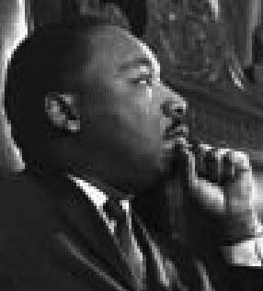
‘We will not build a peaceful world by following a negative path.
It is not enough to say “We must not wage war.”

It is necessary to love peace and sacrifice for it. We must concentrate not merely on the negative expulsion of war, but
on the positive affirmation of peace.’

SESSION 4 RESOURCE SHEET 1

Excerpt from Martin Luther King’s Dream speech

‘I say to you today, my friends, that in spite of the difficulties and frustrations of the moment,
I still have a dream. It is a dream deeply rooted in the American dream.

I have a dream that one day this nation will rise up and live out the true meaning of its creed:

“We hold these truths to be self-evident: that all men are created equal.”

I have a dream that one day, on the red hills of Georgia, the sons of former slaves and the sons
of former slaveowners will be able to sit down together at a table of brotherhood.

… I have a dream that my four children will one day live in a nation where they will not be judged
by the color of their skin but by the content of their character. I have a dream today.

I have a dream that one day the state of Alabama … will be transformed into a situation where little black boys and black girls will be able to join hands with little white boys and white girls and walk together as sisters and brothers. I have a dream today.

… With this faith we will be able to work together, to pray together, to struggle together, to go to jail together, to stand up for freedom together, knowing that we will be free one day.’

SESSION 4 RESOURCE SHEET 2

ESSION 5a INFORMATION SHEET

Gandhi

Gandhi was born in a town in the north-west of India, to a rich family of the merchant caste. He went to England as a young boy where he trained as a barrister and took his bar finals in 1891.

His political career started in South Africa. Appalled by the treatment of Indians there he organised his first peaceful protests and succeeded in repealing some of the discriminatory laws. He also worked as a stretcher carrier in the Boer War, preaching self-denial and pacifism.

On his return to India, he travelled the countryside on foot, talking and learning from the ordinary people. He joined the Indian National Congress turning it from a largely powerless political organisation into a mass movement with millions of ordinary peasant followers. He founded the Sabarmati Ashram near Ahmadabad which was part school, part refuge, and part headquarters for the independence movement.

Gandhi came to international attention in 1930 with the Salt March which led to his first arrest and imprisonment. Time magazine named him Man of the Year and the following year he was released from jail. The press coverage brought him more supporters. In 1942 he threatened a mass campaign of civil disobedience and was again imprisoned. India rioted so his power only grew. However whenever his followers failed to contain their violence he would atone for it with periods of fasting and self-denial. The authorities were terrified he would die in jail, and he was released after 21 months.

In 1947, after World War 2, India was granted independence as Britain no longer had the will or resources to oppose Gandhi. However Britain introduced partition, dividing India into the main Hindu region and creating Pakistan, a Muslim country. This was a great disappointment to Gandhi as his lifelong aim had also been to bring together the divided religions of India.

In his talks, Gandhi quoted from different religions to increase mutual understanding. Over a million people died in the rioting that followed partition. He continued to work to reunite India and Pakistan but the people would no longer follow him as before. Four months after partition, on January 30 1948, a right-wing Hindu nationalist shot him.

ESSION 5a RESOURCE SHEET

Gandhi quotes

“Ahimsa means not to injure any creature by thought, word or deed, not even to the supposed advantage of this creature.”

“Truth is my religion and Ahimsa is the only way of its realisation.”

“I do not envisage God other than truth and non-violence. If you have accepted the doctrine of Ahimsa without a full realization of its implications, you are at liberty to repudiate it. I believe in confessing one’s mistakes and correcting them. Such confession strengthens one and purifies the soul. Ahimsa calls for the strength and courage to suffer without retaliation, to receive blows without returning any.”

Qur’an Quotes about Allah

Allah is He, other than Whom there is no other god;
Who knows both what is hidden and what can be witnessed;
He is the Most Compassionate and Merciful.
Allah is He, other than Whom there is no other god;
the Sovereign, the One, the Source of Peace,
the Guardian of Faith, the Preserver of Security,
the Exalted, the Compelling, the Supreme.
Glory be to God, beyond any associations.
He is Allah, the Creator, the Evolver, the Bestower of Form.
To Him belong the Most Beautiful Names:
Whatever exists in heaven and earth declares His Praise and Glory.
And He is Exalted in Power, the Wise.

Al Hashr (exile) 59:22 – 24. tr. Helminski

As-Salam
The Source of Peace.
And know that God invites man unto the abode of peace,
and guides him that wills to be guided onto a straight way.

Yunus (Jonah) 10:25. tr. Asad

Jewish Prayers for Peace

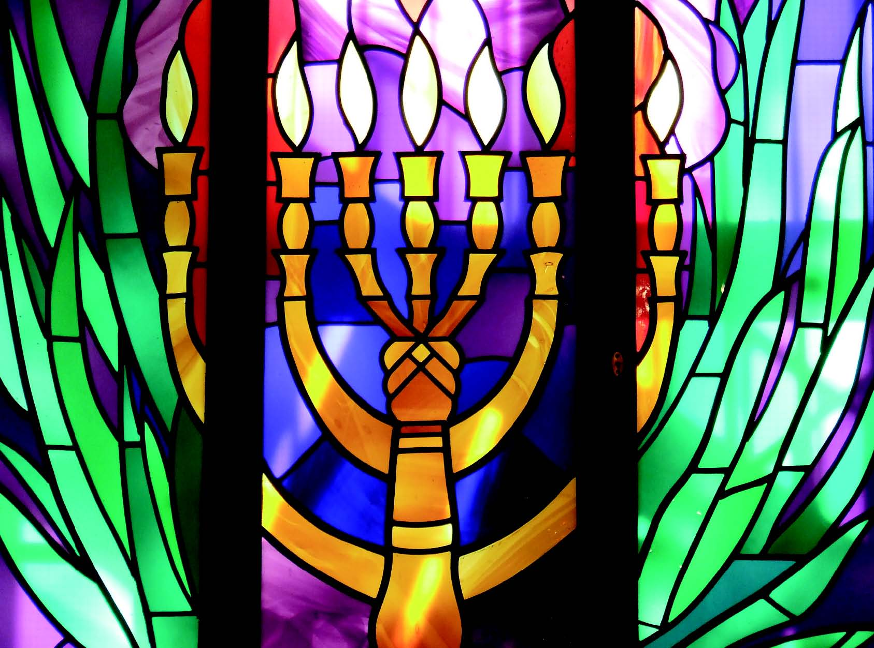
O God, whose name is peace, and who commands us to seek peace, send peace to your world and to all its inhabitants, so that all may dwell in safety with none to make them afraid. Too long has your world been darkened by the shadow of terror and death. Too many tears have been shed by families stricken by grief. Too many lives have been lost, too much hope destroyed by hate. Therefore, O God of life, teach Your children to cherish life, so that the days of bloodshed may end, and enemies become neighbours and the sounds of grief be stilled.

O God, who heals the broken-hearted and binds up their wounds, send Your healing to the injured and Your comfort to those who mourn, freedom to those held hostage, and hope in place of fear.
May God give strength to His creatures and may He bless us all with peace.
Amen

An opportunity for each school to design its own unique RE unit of work for Upper KS2

Key questions to be addressed by this unit:
- what can we discover about the faiths and beliefs in our class and school?
- what can we discover about the faiths and beliefs in the local community and Lewisham borough?
- how have faith and belief communities in Lewisham changed over the past 50 years?
- what are the reasons for changes in these communities?
- how do faith groups work in partnership with each other and the local community?
how has life in Lewisham been enriched by the diversity of the faiths and beliefs that make up the borough?
Beliefs, teaching and sources – What do people  believe in and where do these beliefs come from? |  | Practices and ways of life –  How do people live their lives? |  | Forms and expressing meaning –  How do people show their beliefs?
recall beliefs, teaching and sources of relevant faiths  identify key beliefs of smaller local communities, not previously studied, e.g. Rastafarianism |  | are there any ways where practices and ways of life are shared with, or impact on, the broader community?  how have practices and experiences changed over the years? |  | how do faith & belief communities show and share their beliefs and faiths in the wider community? Has this changed?  do people from the same faith do things differently because of their family’s link to other countries, e.g. specific foods eaten at festivals?
Identity, diversity and belonging –  What does it mean to be a member of a faith locally, nationally and globally? | Meaning, purpose and truth –  How does faith help people to have an understanding of life’s journey? |  | Values and commitment –  What is important to me and my faith?
to which communities do the class belong?  what communities make up the school, area and borough?  how has this changed in the past 50 years? | how do faith & belief communities support members of other communities when they have a need (times of celebration or crisis). |  | do you need to have a faith or belief to have values?  does the broader community link people of faith and belief with those that have no religious faith?

