The Natural World – statutory unit

Optional Units:

Belonging / Who am I?

Right and Wrong

Sharing food

Weddings

What this unit contains |  | This unit involves pupils in investigating patterns, rhythms in nature, change, growth and the cycle of life. It provides an opportunity to experience awe and wonder as pupils reflect on attitudes to life, living things and the world. Through this unit pupils are introduced to the belief that whilst some people believe the world was a wonderful accident, people of many faiths, and specifically Jews, Christians and Muslims, believe a Creator God, designed the world.  Content includes Jewish and Christian beliefs about God as a Creator, responsibility for living things on the planet as a response to this belief, harvest thanksgivings and St Francis as an example of living a life in response to these beliefs.  Islamic beliefs about Allah, the Creator of all things and people as the custodians of the earth.
Where the unit fits and how it builds upon previous learning |  | The unit should be taught at the start of term 1 in Year 1. It introduces pupils to beliefs in Judaism, Christianity and Islam, incorporating content from the appropriate sections of the syllabus.  Throughout the unit pupils should be encouraged to notice change in the world around them – in the weather, in plant life around the school, in themselves and in seeds/bulbs that can be grown in class. If possible they should be encouraged to care for creatures, for example feeding fish or birds.
Extension activities and further thinking |  | - Explore and respond to Christian images of creation from works of art from different periods. For example Michelangelo’s images of the Creator and His creation in the Sistine chapel.  - Find out what other members of the school community believe about how the world began  - Discuss elements of the natural world which may at first seem unappealing and consider their place in the greater scheme of things (snakes, spiders, slugs in the garden).  - Discuss other beliefs about origins held by members of the class.
Vocabulary |  |  |  | SMSC/Citizenship  - Ultimate questions about the origin of life on the planet and beliefs about a Creator who cannot be seen.  - Ways to care for the planet.  - The work of a school council and how pupils can be active members of the school community.
Create | Christianity | mysterious | unique
Creator | Judaism | earth | special
God | Muslim | sea | shell
Allah | Islam | sky | feather
dead | make | animal | stone
alive | living | bird | egg
Christian | beautiful | Saint Francis

Session 1. Key Question: Where did the world and everything in it come from?

Learning objectives | A T 1 | A T 2 | Suggested teaching activities | Sensitivities, points to note, resources
Pupils should:  - know that the world contains many beautiful natural things, all of which are unique;  - consider that life is special and transient;  - consider beliefs about origins. |  |      | Before the lesson prepare a collection of items from different natural environments, e.g. water, land, air. Have items derived from the natural world e.g. oil, wool, feathers, eggshells, stones, shells, seedpods, leaves, plants.  Talk to the class about one object from the collection. How many different words can they suggest to describe the item? Do they know what it is and where it comes from? Introduce them to the idea that although there may be many similar items in the world, each one is unique.  Distribute items so each pupil has one. Look closely at it and think of words to describe. Ask them: Is it dead or alive? Was it ever alive? Did anything ever live on or in it? What does it feel like? Smell like? Who made this object? Who made the first example of this object?  Talk about the fact that some people in the world believe that everything was made by a Creator (maker) God whilst others believe the world began from a large explosion in space.  Using a range of art materials encourage pupils to draw or paint their special item. Label pictures.  Plenary  Ask the class where the birds are that grew the feathers or the creatures that lived in the shells? Share outcomes of the lesson and display. | Resources  Items for natural world display. Art materials – pastels, chalks, paints and a range of brushes, Paper of different colours, grades and sizes.  Throughout the unit pupils should be encouraged to notice change in the world around them – in the weather, in plant life around the school, in themselves and in seeds/bulbs that you can grow in class. If possible they should be encouraged to care for creatures, for example feeding fish or birds.  Encourage children to share what they believe about the origin of the world

Session 2. Key Question: What do Jews and Christians believe about the creation of the world?

Learning objectives | A T 1 | A T 2 | Suggested teaching activities | Sensitivities, points to note, resources
Pupils should: |   |   | Watch a video or read a version of the Jewish/ Christian Creation story. As a class sequence the steps of creation and focus on the repetition of ‘it was good’. Talk about the responsibilities given to Adam and Eve in caring for the garden and naming the animals. How might they have felt? | Resources  Video / DVD: Creation Stories – Quest, Channel 4 (www.tts-group.co.uk/quest-creation-stories-dvd/1004017.html )  Christian creation story retold. e.g. The Creation by James Weldon Johnson – https://www.youtube.com/watch?v=jehhUNgXUBY  Images of creatures from around the world including large, small, nocturnal, reptiles, mammals, fish, birds. Include some animals that are ‘endangered’. Charity information about saving endangered creatures, e.g. whales, dolphins, orangutans, tigers.
- know that Jews and Christians believe that the world was created by God;

- know that Jews and Christians believe that people have a responsibility to care for God’s creation;

- consider the need to care for the planet today;

- know about conservation projects to support wildlife or the natural environment;

- support the local environment and become involved in the work of the school council.
 |   |   | Show pupils images of creatures from around the world – can they recognise them? Do they know their names? Reflect on the way that Adam and Eve had so many names to choose. Do pupils know where in the world animals live?
 |   |   | Explain that some creatures are finding it hard to live and people are trying to help them to survive. Show pupils information about a conservation charity and link to human responsibilities as carers for the world. How might Adam and Eve feel about this project?
 |  |   | This lesson could link to local conservation work or the need for it in and around the school grounds. Groups of pupils could formulate rules for caring for part of the school grounds. The class could then decide which rules are the best and make a class list and some posters to encourage others to keep the rules.
 |  |  | They could take this work to the school council as a proposition for the school to consider following or developing.

Session 3. Key Question: How do Christians thank God for the world? How do they show their care for other people?

Learning objectives | A T 1 | A T 2 | Suggested teaching activities | Sensitivities, points to note, resources
Pupils should: |   |  | Either: | Resources  ‘The Tiny Seed’ by Eric Carle ‘Ears and the Secret Song’ by Meryl Doney (Lion)  BBC Active DVD Celebrations and Special Times. https://www.tts-group.co.uk/celebrations-and-special-times-cd-rom-bbc/1003510.html
- know that Christians celebrate Harvest festivals to thank God for His creation;  - know that at harvest Christians remember that humans are dependent on the weather and nature for the food and drink needed to survive;  - know that Christians often use harvest as a way to share food with those less fortunate than themselves. |  |  | - Watch the film of children from Bushey Baptist church collecting and distributing items for the community at harvest. Invite a local Christian into the class to talk about harvest in their church - why and how it is celebrated and is an opportunity to share with others.
 |   |  | - Visit a local church to see it decorated for harvest and hear how harvest is a time when Christians thank God and share with others.
 |   |   | - Read a harvest story and consider what contributes to the plants growing and how at harvest Christians thank God for ensuring the harvest is good.
 |   |   | - Make a harvest loaf in class in the shape of ears of corn. Explain how the ingredients have been dependent on nature and that at harvest Christians thank God for the way He provides for their needs.  5. Find out about environmental charities.
 |  |   | After the lesson either organise a charitable collection or link the school’s Harvest celebration to donations for local charities for the less fortunate or the work of the local Food Bank.

Session 4. Key Question: How did St. Francis show his thanks to God for His creation?

Learning objectives | A T 1 | A T 2 | Suggested teaching activities | Sensitivities, points to note, resources
Pupils should: |   |   | Talk about how sometimes people’s beliefs make them choose to live in particular ways. Ask pupils for any examples they may know such as following food rules, celebrating festivals, working for charities. | Resources  Stories about St Francis, e.g. from  RE-tell Stories volume 5 – Lewisham Education  ‘St Francis’ by Wildsmith, Oxford  ‘Lives and Times St Francis‘ (big book) Heinemann  ‘The Circle of Days’ by Reeve Lindbergh, Candlewick Press ISBN-13: 978-0763603571  Pictures of Franciscan friars  Pictures of animals  https://www.youtube.com/watch?v=bqD6fUHlFBY
- know why St Francis is a Christian example of caring for and protecting living things;
 |  |  | Read with pupils the story of the life of St Francis, an example of someone who tried to follow Jesus’ teachings. Explain that the title ‘Saint’ is sometimes given to Christians who have lived particularly special lives.
- know St Francis’ canticle to the sun from ‘The Circle of Days’;

- consider ways that they can think of and help others.
 |   |   | Discuss why Francis gave up his rich clothes and lifestyle to live simply. How hard might that have been for him and his friends?
 |   |  | Read the ‘Circle of Days’ and talk about what it tells about St Francis’ beliefs about the natural world.
 |  |   | Discuss how the story and Francis’ words show that Francis was determined that he would follow Jesus’ teachings and be peace – loving, kind and thoughtful to everyone and every creature.  Make a class list of times when people have behaved kindly or when others have been kind and thoughtful to them. Initiate a class ‘thoughtfulness’ award to give to members of the class to wear for a day if they have been particularly thoughtful or kind to others.

Session 5. Key Question: What do Muslims believe about the creation of the world?

Learning objectives | A T 1 | A T 2 | Suggested teaching activities | Sensitivities, points to note, resources
Pupils should:  - know that Muslims believe Allah is the Creator of all things;  - know that Muslims respect and appreciate everything that Allah created and believe that people are the custodians of the earth;  - know that many Muslims do not draw human beings or creatures. |  |  | Show pupils the star and crescent symbol and explain that in this lesson they are going to find out about what Muslims believe about where everything in the world came from. | Resources  Notes to Teachers:  The use of the star and crescent symbol in this lesson is to make clear to pupils that during this lesson they are learning about the Muslim faith. This is not a universally accepted symbol of Islam.
 |   |  | Watch the part of the first Islam programme from the Pathways of Belief video that explains about Muslim beliefs about creation. Afterwards draw out the new vocabulary that pupils have encountered and clarify their understanding.
 |   |  | Show pupils the beautiful images inspired by nature that can be found in the Muslim world. Explain that many Muslims believe that humans should not be drawn or produced in other art media but that respect is shown to Allah’s creation and it is celebrated in many decorative ways.
 |   |  | Explain that Muslims thank Allah for His wonderful creation. Show pupils the prayer mat and explain that this is often used to kneel on during prayer, to provide a clean place to pray.
 |   |   | Assessment task Either draw flowers or plants from around the class/ school or do bark or leaf rubbings and use these to make small paper prayer mats that show how much Muslims recall Allah’s creation and thank Him in their prayers. Label to explain what Muslims believe about creation and display outcomes.

Session 6. Key Question: How should we care for the world?

Learning objectives | A T 1 | A T 2 | Suggested teaching activities | Sensitivities, points to note, resources
Pupils should:  - reflect on attitudes to life, living things and the world;  - identify living things in the environment that they can care for and protect;  - recognise their roles and responsibilities in caring for the world. |  |   | Consider how pupils feel when they have made something that they are proud of. How do they feel if someone spoils or damages it? | Resources  Materials for design project.  Throughout the unit pupils should be encouraged to notice change in the world around them – in the weather, in plant life around the school, in themselves and in seeds / bulbs that you can grow in class. If possible, they should be encouraged to care for creatures, for example feeding fish or birds.
 |   |   | Design an area of the school that can be either part of the natural world or can incorporate part of the natural world and can be used for quiet reflection. This could be a focus about how special the world is or can be used as a memory garden or a place where people can go if they want to think about something. This could link to Islamic beliefs about the garden of Paradise.
 |  |   | If making a garden area is not possible, you might develop some tubs or window boxes or even set up a bird table to help the local birds.
 |  |   | Make up a code of conduct for that area. How could it best be shared with others/kept in a good state?
 |   |  | Link to Jewish, Christian and Muslim beliefs and explain that other faiths and beliefs have different stories to explain how the world began.  Take proposals to the school council.

What this unit contains |  | In this unit pupils draw on their understanding of what it means to belong, and then relate it to how children are given a sense of belonging in four religions: Christianity, Islam, Hinduism and Sikhism. Pupils investigate how children are welcomed into different religions. They think about how people show they belong and what is special for them about belonging.
Where the unit fits and how it builds upon previous learning |  | This unit should be taught as an optional unit in KS1. It includes a focus on elements from the local Agreed Syllabus on symbol and dress. Through this unit pupils will focus on a number of Key Questions and begin to deepen the knowledge they have already gained from their life experiences, and begin to build on their depth and knowledge of understanding of peoples’ lives within each faith or belief to support the curriculum at KS2.
Extension activities and further thinking |  | - Complete a piece of writing about what it means to belong to a religion they have studied or another faith or belief to which they belong themselves.  - Write about what it feels like to not belong and how people should help someone who is lonely.  - Consider why people who believe in a faith come together in groups to worship and share time.
Vocabulary |  |  |  |  | SMSC/Citizenship  - How religious or belief groups show they take responsibility for others.  - The duty of members of religions or beliefs to care for everyone.  - How people belong to a range of different groups within the wider community including a faith or belief group.
belonging | Islam |  | Hinduism | temple
family | Qur’an |  | Brahman | Christianity
worship | Surah |  | Rama | Cross
naming ceremony | Hadith |  | Sita | Bible
Sikhism | prayer mat |  | Murti | baptism
Gurdwara | Adhan |  | Puja | Church
Five ‘K’s | Aqiqah |  | shrine | chapel
Guru Granth Sahib | Bismillah |  | Vedas | clerical collar
Kaur | Mosque |  | Namakaran | Humanism
Singh | Muhammad (pbuh) |  | Ganesh

Session 1. Key Question: What does it mean to belong?

Learning objectives | A T 1 | A T 2 | Suggested teaching activities | Sensitivities, points to note, resources
Pupils should:  - explore ways in which they belong;  - learn how belonging is expressed and made explicit;  - understand the importance of belonging to a group or groups. |  |  | Prior to the lesson arrange for the class to bring in an example of uniforms of different groups they belong to e.g. brownies, football teams. Ideally pupils should sit in these groups. Children who do not belong to activity groups will belong to a ‘class’ group representing the class and school. Alternatively pictures can be presented. | Resources  Digital camera  School photograph  Class photograph  School badge  Access to PC  Photos of different groups that may not be represented.  Session 1 Resource Sheet.  When using the Resource sheet be sensitive to family backgrounds of children in the group.
 |  |   | Class teacher could present the class with a poster of his/her own belonging mind map, or web. Explain to the children how an individual can belong to different groups, i.e. family, mothers, women, parents, colleges, social clubs … (Resource sheet)
 |  |   | Talk about how by belonging to the class each of them already belongs to a group. They are members of the school, possibly show a school photograph and also a member of their class (show a class photograph), as well as being members of their other entirely different groups outside school.
 |  |   | In the groups where they are sitting pupils can create either a mind map or Venn diagram to show what they already know about the groups members of the class belong to. They can send ambassadors to other tables to ask questions to inform their work.
 |  |   | As a class discuss how they show they belong to their different groups / clubs e.g. by wearing a uniform, badge etc. Pupils can draw a badge or item of uniform and label with what it means to them. During the lesson the digital camera should be available so that pictures can be taken for a wall display.
 |  |   | In pairs within their group pupils share what they like about belonging to a group/club and what they do when they are meeting together. Are there any group rules they are expected to follow?
 |  |   | Plenary:  Discuss what pupils think it means to belong in terms of benefits and responsibilities.

Session 2. Key Question: What does it mean to belong to a family?

Learning objectives | A T 1 | A T 2 | Suggested teaching activities | Sensitivities, points to note, resources
Pupils should:  - understand the concept of belonging to a family;  - understand the concept of belonging to a faith family. |  |  | Prior to the lesson send a letter home asking the children to bring in family group photos they may have at home. | Resources  Completed family tree – could be teacher’s own or the family tree attached to this unit.  Blank family tree  Different Families: Same Love poster: https://www.stonewall.org.uk/resources/different-families-same-love-poster  Names and symbols for:  Christianity – Christian  Sikhism – Sikh  Islam – Muslim  Hinduism – Hindu  Notes for teachers:  Sensitivity  Teachers need to be sensitive towards the different kinds of family structures represented in their class.  Prior to the next lesson do a class audit of the pupils’ faiths.
 |  |   | Discuss with pupils the concept of belonging to a family and what it means to them. (Ensure this is done inclusively so that all pupils feel that their family experience is valid).
 |  |   | Look at a pre-drawn family tree. Within a class there will be many variations, so try to keep to a simple one. Discuss this with the pupils. They could then complete their own family trees using a template.
 |  |   | Look at the Different Families: Same Love poster and discuss the variety of family types with students.  If possible get a member of a child’s family to come in and talk about what belonging to a family means to them and how each person is valued. If not possible, the classroom assistant or another adult could do this for the class.
 |  |   | Discuss with the class other people who are important in their families, but who are not on the family tree. In pairs get the pupils to talk about how they contribute to their family.
 |   |   | Introduce the idea that people who believe in God belong to a family too – a religious family. Explain that they do things together to show that they belong. Introduce the names of the faiths to be featured in the following lessons.

Session 3. Key Question: What are the outward signs that a person belongs to a religious family?

Learning objectives | A T 1 | A T 2 | Suggested teaching activities | Sensitivities, points to note, resources
Pupils should:  - understand that there are a number of religions and beliefs in the world;  - understand that religious people feel they belong to a faith;  - know that religious people have different ways of showing that they belong to their faith. |  |  | In order to complete the task within these lessons and to maintain a high standard, groups should be encouraged to record their work and keep in folders to be presented as a project. | Resources  Artefacts:  Pictures of a Sikh person  5 K’s  Cross/crucifix  Fish badge  Pictures of a member of a choir or a priest or Espresso/LgFL ‘Faiths’ picture  of a choir boy and a vicar  Books e.g. ‘I am a Sikh’ (Hachette Publisher’s), ‘Living as a Sikh’, ‘My Sikh Life’ (Evans Publisher’s). (A version is also available for each faith)  Digital technology  Research Sheet 1  During this the teacher should take pictures of the pupils.  Teachers should take the opportunity to point out that religious jewellery is important for its symbolic purpose.
 |   |   | (Ideally during this unit a visit to a Gurdwara, Mosque, Temple (Mandir /Kovil) or church is strongly recommended.)  For the next three sessions the pupils should be split into groups and they should work in the same group each week.
 |   |   | Recall from the end of the last lesson the idea of a religious family and how members wear things to show that they belong. Ask any pupils who belong to a specific faith group to share what belonging to that group means to them with the pupils studying that faith.
 |   |   | Class teacher to create research groups, each group to be allocated a faith  (Christianity, Islam, Hinduism, Sikhism), using a variety of resources including any artefacts within the school, the pupils should explore the religion they are  becoming the class experts about using the research sheet to guide them.
 |   |   | In this session each member of the group should draw and label a different item of clothing or religious jewellery that is important in the religion they are studying, which they can use during the feedback to the class. These can also be used for display afterwards.
 |   |   | Each group reports back to the class about what they have found out. This will allow the whole class to know about the religions included, whilst allowing a more in-depth study of a religion.

Session 4. Key Question: What happens to a child when they join a religious family?

Learning objectives | A T 1 | A T 2 | Suggested teaching activities | Sensitivities, points to note, resources
Pupils should:  - understand the concept of belonging to a family;  - understand the concept of belonging to a faith family. |  |  | Pupils should work in the same groups as last week. | Resources  Research Sheet 2  Digital camera  Books  CD’s  Video clip of a baptism from Espresso LgFL ‘Faiths’ or BBC Video/DVD  ‘Places for Worship’  Video/DVD clip from ‘Pathways of Belief ‘Sikhism: Sikh naming ceremony  BBC Active DVD ‘Rites of Passage’ sections on Belonging  DVD’s  Digital camera  Picture of a font  Video of a humanist naming ceremony: http://understandinghumanism.org.uk/uhtheme/celebrations-and-ceremonies/
 |   |   | Show the class a short clip from a video/DVD of a christening/infant baptism, a naming ceremony (Humanist, Muslim or Sikh) ‘Namakaran’ (Hindu naming ceremony).
 |   |   | Ask the pupils to share their experiences about any of these ceremonies which they might have attended. Pupils might wish to bring in any gifts they received at their own initiation ceremony to share with the class.
 |   | ✓  | In groups they should begin to explore these initiation ceremonies in more depth, using the research sheet to guide them.
 |  |  | Notes should be made to help them feedback and these can be added to the poster.
 | ✓  | ✓  | Plenary:  All groups to feedback to the class.  Ask the questions:  How do these ceremonies show that the religious and non-religious communities are welcoming this person not just the individual family?  Why is it important and does a public ceremony like this need to take place?

Session 5. Key Question: How do children belong to a religious family?

Learning objectives | A T 1 | A T 2 | Suggested teaching activities | Sensitivities, points to note, resources
Pupils should:  - know what is involved for a child in belonging to a religion. | ✓  | ✓ | The children should work in the same groups as previous weeks. Quickly recap on the work covered last week to help them. | Resources  Research Sheet 3  Books  Posters  Digital camera  Espresso/LgFL ‘Faiths’  BBC Active DVD ‘Beliefs and Belonging’.
 | ✓  | ✓  | Ask pupils if there are any activities which they do at home that are to do with their religion e.g. Christian families saying grace, daily Bible readings, prayers, family Christmas activities, Sikh family prayers, Hindu daily worship / puja at a home shrine, Muslim prayer, reading the Qur’an.
 |  | ✓  | In groups using pictures and books pupils should deepen their understanding of how families might worship together at home or in their place of worship and the part children might take in the worship. They can use Research sheet 3 to assist them. This will also be helpful to them in their feedback to the remainder of the class.
 | ✓ 
 | ✓  | ✓  | Report back, within groups, to the class about their learning. This part can also be used as an opportunity for pupils in the other groups to ask questions.

Session 6. Key Question: What have we learnt about the importance of belonging to a religious family?

Learning objectives | A T 1 | A T 2 | Suggested teaching activities | Sensitivities, points to note, resources
Pupils should:  - know how people show they belong to a religion;  - understand what is special about belonging;  - understand about the ideas of being special. |  |  | Pupils should work in the same groups as previous weeks. | Resources  Books  Digital Camera  Posters  Research Sheets from previous weeks  It is important that pupils recognise that they do not have to belong to a faith or belief community. There are many ways to belong and we can belong to groups that cross over religious and belief groups. We can form our own identities.
 |  | ✓  | Explain to pupils that this week they are going to produce, edit and publish their project into a book about the faith they have been studying over the previous weeks. They can use all the notes they have made in their feedback, but it should contain something about clothing, joining and worship within the faith family.
 |  | ✓  | Explain that the book should be a mixture of drawings, which might be annotated and short pieces of writing, perhaps two or three sentences.
 | ✓  | ✓  | Groups to work independently to complete the task, sharing with the class their work at the end.
 |  |  | Pupils can be share these books with another class or in an assembly, possibly with parents depending on arrangements within the school.
 | ✓  | ✓  | Plenary:  Present the books at the front of the class. Tell the children about the TV programme ‘Through the Keyhole’ Using artefacts or pictures introduce some things that may have been seen if children look through a keyhole. Class teacher to ask the children ‘Which religious family home might this be?’ Children to identify through their gained knowledge which faith can be identified by the religious objects.

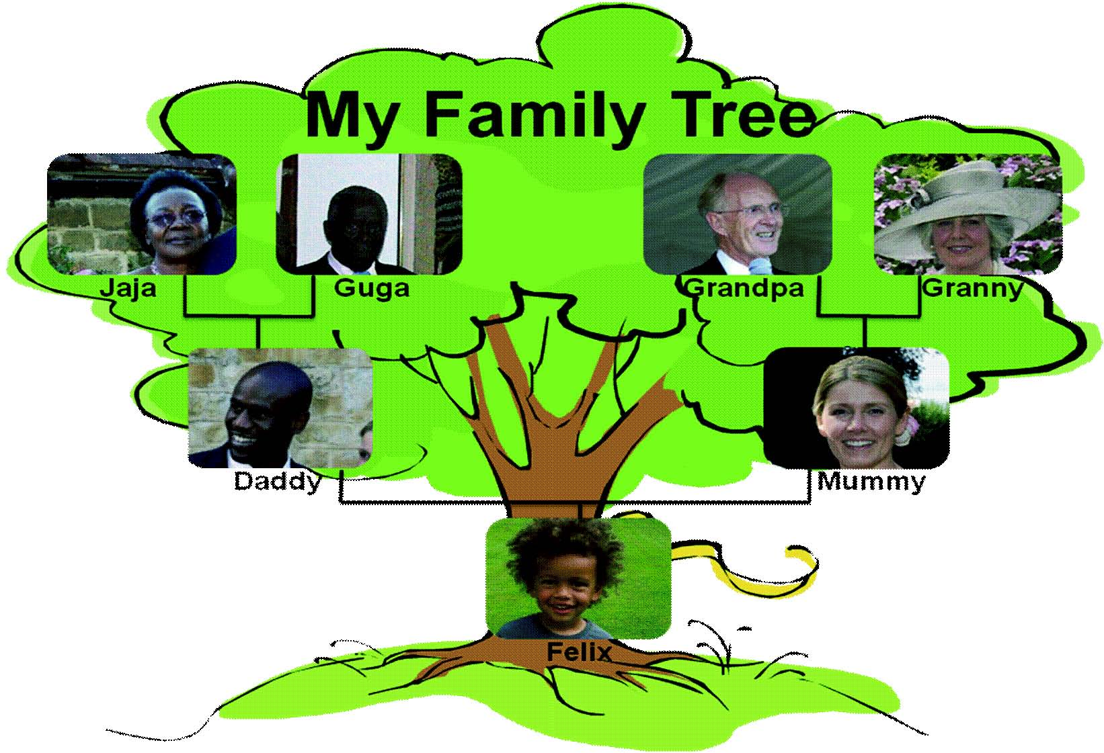

Example family tree

Research Sheet 1

- In the faith that you are studying, what clothes or religious jewellery do people wear that show they belong to their faith community?

- What are these items called?

- What do these items of clothing or religious jewellery mean to the people wearing them?

- Draw and label these items. Each member of your group should draw a different item if possible.

- Can you find out more about these items?

SESSION 3
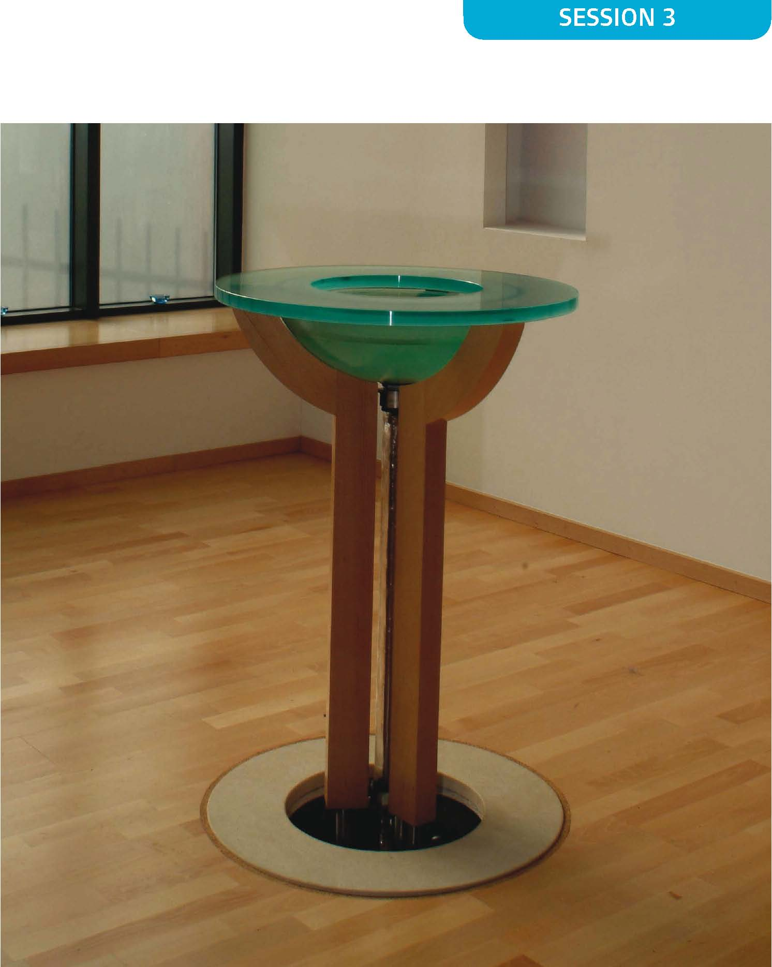

Research Sheet 2

- Name the ceremonies that introduce children or young people to their faith community.

- Why do these ceremonies happen?

- Make some notes for your feedback.

SESSION 3

Research Sheet 3

- What is the name of the special building used by the people of this faith?

- Can you collect and present any pictures of your special building?

- What might families do at home to worship?

- When might families go to a place of worship together and why?

- Within the faith you are studying how are children involved?

SESSION 3

What this unit contains |  | This optional unit provides an opportunity to consider what pupils consider as right and wrong behaviour and how this relates to living in groups. Pupils should talk about rules and their necessity for living in a group. They should share their feelings about saying sorry and talk about how they feel when others apologise to them. Pupils should consider what forgiveness means and talk about their readiness to forgive. They should think about the common values of different faiths and beliefs in relation to rules about behaviour towards others, making sure children appreciate that you do not need to be a member of a faith to have a moral outlook to life. The unit includes:  Jewish and Christian beliefs about God’s Ten Commandments, particularly the two greatest Commandments, loving God and loving your neighbour and stories about Jesus teaching and demonstrating these.  Buddhism: The teaching of the Buddha about how to live. The importance of being kind, generous, truthful, loving, helpful and patient through the story of the Lion and the Jackal from the Jataka tales. Understanding that Buddhists believe that actions have consequences. Or  Islam: The importance of respect for self and others. Honesty and kindness. Story of Prophet Muhammad (pbuh) and the Old Woman demonstrating the example of Prophet Muhammad (pbuh).
Where the unit fits and how it builds upon previous learning |  | This optional unit should be taught at the start of term 1 in Year 2 if chosen. It introduces pupils to beliefs in Judaism, Christianity, Buddhism and Islam.
Extension activities and further thinking |  | - Find out about how the importance of the Ten Commandments in the Jewish faith is shown by their place over the Ark in the synagogue.  - Examine different rules followed in the homes of members of the class.  - Tell the story of the starfish and discus how Humanists believe empathy and considering consequences help them to consider issues of right and wrong. https://eventsforchange.wordpress.com/2011/06/05/the-starfish-story-one-step-towards-changing-the-world/ or https://www.youtube.com/watch?feature=youtu.be&v=Z-aVMdJ3Aok&app=desktop
Vocabulary |  |  |  |  | SMSC/Citizenship  - Rules are important in making society work.  - Some people live their life by religious rules.  - Some religions believe God wants human beings to follow particular rules.  - There are different rules in society which include the law.
right | honesty |  | important | Buddhism
wrong | respect |  | Bible | Buddha
forgiveness | fairness |  | Old Testament | Prophet
sorry | love |  | New Testament | Muhammad (pbuh)
apologise | care |  | Jesus | lion
punishment | neighbour |  | Samaritan | jackal
mistake | friend |  | compassion | Qur’an
rules | Commandment |  | kindness

Session 1. Key Questions: How important is it for groups of people to have rules for how they behave?

How important is it for people to agree on the rules?

Learning objectives | A  T  1 | A  T  2 | Suggested teaching activities | Sensitivities, points to note, resources
Pupils should:  - consider what is right and wrong behaviour;  - consider why it is important for people to have rules when with others. |  | ✓ | Using the right and wrong situation cards provided either as a whole class or in small groups, discuss whether each behaviour described is right or wrong. Some will be hard to put into these categories – so talk about them and why they are hard to categorise. | Resources  Right and wrong situation cards.
 |  | ✓ | Why is it better for everyone if there are some rules that everyone follows? Talk about some of the situations or school specific rules e.g. walking on the left up and downstairs, not running, being polite.
 |  | ✓ | Develop a class set of rules for behaviour either in the class, school grounds or in the dinner hall. Try to word in a positive way, e.g. ‘Don’t be unkind to others’ would be written as ‘Be kind to others’. Is it important that everyone agrees to these rules? If not, why not?
 |  | ✓ | Design a poster either alone or in pairs to illustrate one of the rules.
Plenary:
Share poster ideas with each other and feed back positively to each other’s ideas.

Session 2. Key Questions: Why are there punishments when people break rules?

Should people be forgiven if they are sorry?

Learning objectives | A  T  1 | A  T  2 | Suggested teaching activities | Sensitivities, points to note, resources
Pupils should:  - know what happens when rules are broken;  - consider why it is important to say sorry when rules have been broken. |  | ✓ | Read out the scenarios which involve children showing wrong behaviour. In pairs ask children to consider what should be done to those children who have broken rules. | Resources  Scenario cards.
 |  | ✓ | Get pairs of children to act out one of the scenarios. Children should decide who is breaking the rule and who is deciding what is to be done. What rule has been broken in each scenario? How are those who have broken rules punished? Is it important that there they are punished? If so, why?
 |  | ✓ | Think about each of the scenarios acted out. Should wrong behaviour be forgiven if the children involved are sorry? Should there still be a punishment if children have apologised? Get pairs of children to act out one of the scenarios again, but this time the child who has broken the rules either agrees or refuses to say sorry. As a whole class discuss which children should be forgiven, the children who agree to apologise or the children who refuse and why?
 |  | ✓ | Plenary:  As a class discuss situations when it would be easy to forgive someone and situations when it would be difficult to forgive someone.

Session 3. Key Question: What are some of the rules by which Christians believe they should live life?

Learning objectives | A  T  1 | A  T  2 | Suggested teaching activities | Sensitivities, points to note, resources
Pupils should:  - know that the Ten Commandments taught people how to behave towards God and each other;  - Know that Jesus summarised these to help people into two great Commandments using another Jewish text. | ✓ |  | Introduce the story of Moses taking the children of Israel out of Egypt where they were slaves and taking them into the desert where they spent several years wandering. In the desert were some mountains and God told Moses to come up the mountain where he gave him ten special rules for the people to follow in their community. | Resources  BBC. ‘Pathways of Belief’. The Bible.  Video Plus/DVD.  Ten Commandments for children sheet  Two Greatest Commandments sheet
 | ✓ |  | Show children a video / DVD describing ‘The Ten Commandments’ or tell the story; then, using the Ten Commandments for children sheet, focus on the content of the Commandments. Which are about how people should behave towards each other and which of the Ten Commandments are about how they should behave towards God?
 |  | ✓ | Discuss why it is important not to steal or envy etc. Do pupils think there are any rules that should be in there and are missing? Briefly write their own rules to add to the Ten Commandments.
 | ✓ | ✓ | Which two of the Ten Commandments do children think are most important? Discuss children’s responses. Find what Jesus said about the two greatest Commandments in the Gospel of Matthew. These two were from Jewish law too. Discuss why Jesus considered them to be the most important ones.  Explain that the second of these commandments, ‘The Golden Rule’ can be found in religions and beliefs all over the world and is admired by many religious and non-religious people.

Session 4. Key Question: How should people treat others?

Learning objectives | A  T  1 | A  T  2 | Suggested teaching activities | Sensitivities, points to note, resources
Pupils should:  - consider ways to address issues such as racism, name-calling and bullying;  - encourage positive behaviour such as by helping others, standing up for people who are being treated unkindly or by setting a good example. | ✓ | ✓ | Either read, or watch the story from the Bible of the Good Samaritan, where Jesus told people about the qualities people should show to each other (Luke 10:25-37). Recreate the story in a modern context through a storyboard or drama to demonstrate an understanding of the inner meaning. | Resources  Teachers might like to devise an alternative approach using the Sikh story of the Guru and the Water Carrier
 |  | ✓ | What do children know about racism, name-calling and bullying? Do children think these are examples of right or wrong behaviour? Ask children to consider what effect these types of behaviour have on others. How might these link to the way the man was treated in the story?
 |  | ✓ | Talk about right behaviour such as helping others, standing up to people who are being treated unkindly and setting a good example. Can children think of situations when they can help others, when they can stand up to people who are being treated unkindly and when they can set a good example? List examples. Ask children to think about a time when they have shown an example of these types of behaviours and illustrate. What words can they use to encourage others to behave in similar ways? Children to write encouraging words above their illustrations.
 | ✓ | ✓ | Plenary:  Make a ‘Good Samaritan’ or ‘Good Neighbour’ award that can be given to the child who best puts the message of the story into practice.

Session 5. Key Question: How does Buddhism teach how you should treat others?

Learning objectives | A  T  1 | A  T  2 | Suggested teaching activities | Sensitivities, points to note, resources
Pupils should:  - know the story of the Lion and the Jackal;  - understand the message of the story, that actions have consequences and that good actions have good consequences. | ✓ |  | Read or watch the story of the Lion and the Jackal, explaining that this is a Buddhist story with an inner meaning. Explain that the Buddha taught people how to behave through stories. | Resources  The Lion and the Jackal by  Adiccabandhu and Padmasri.  Clearvision Trust/Windhorse  Publications  Or Video/DVD version of the story on ‘The Monkey King’ video/DVD from  https://www.clear-vision.org/Schools/Teachers/KS1.aspx  Clearvision Trust  https://www.clear-vision.org/Home/Home.aspx
 | ✓ | ✓ | With the pupils talk about how the story is about helping others, about telling lies and about saying sorry.
 |  | ✓ | Pupils should write about either:  - How you thank people who help you  - How you feel when people say things about you that are not true  or  - A time when you were sorry about something and how you said or showed you were sorry for what you had done.
 | ✓ | ✓ | Plenary:  Expand on the Buddhist beliefs that actions have consequences. Whose actions in the story had which consequences?

Session 6. Key Question: How does Islam teach how you should treat others?

Learning objectives | A  T  1 | A  T  2 | Suggested teaching activities | Sensitivities, points to note, resources
Pupils should:  - know that as well as the Qur’an Muslims also learn about how to behave through stories about Prophet Muhammad (pbuh);  - understand the message of the story of Prophet Muhammad (pbuh) and the Old Woman;  - recognise their values about behaviour and those of others. | ✓ |  | Read or watch the story of Prophet Muhammad (pbuh) and the Old Woman, explaining that this is a Muslim story with an inner meaning. Explain that as well as learning how to behave from their holy book, the Qur’an, Muslims also learn from stories about how Prophet Muhammad (pbuh) set them a good example. The Hadith and Surah, accounts and traditions of the Prophet’s life are essential guidance to Muslims. | Resources  ‘Pathways of Belief’ Islam: Programme 1  https://keluargaahmadblog.files.wordpress.com/2017/03/prophet-muhammad-and-the-old-woman.pdf
 |  | ✓ | After watching the film think about how you would describe Prophet  Muhammad’s (pbuh) character. Muslims believe he was chosen by Allah to receive the message that is written in the Qur’an because he was such a good person. How can you see that in this story?
 | ✓ | ✓ | Discuss and record answers to these two questions:  - What might have happened if Prophet Muhammad (pbuh) had not gone upstairs in the story?  - What message did Muhammad (pbuh) give to the old woman about how Allah expected people to behave?
 | ✓ | ✓ | Plenary:  How are the ideas about behaviour in the religions and beliefs studied similar and how different? How are the ways that these religions and beliefs say people should behave the same as those of members of the class and how different?

Right and Wrong situation cards

Swapping food from your packed lunch with someone else’s because you think it would be nicer. | Taking home a pencil from school. | Breaking something and hiding it or not owning up and getting other people into trouble. | Not washing up your paintbrush and paint pot after art or not putting your reading book away in the right place.
Running through the corridors. | Owning up if you have done something wrong and got other people into trouble. | Saying sorry if you’ve hurt someone’s feelings. | Owning up if your goal was offside and no-one saw it.
Speaking with your mouth full. | Telling a teacher if someone else has done something wrong. | Listening to the teacher whilst talking. | Forgiving someone if they have apologised after accidentally bumping into you.

Right and Wrong scenario cards

A lunchtime supervisor catches a group of Year 3 children ganging up on a Year 1 child in a corner of the playground at lunchtime. They have been punching and kicking the Year 1 child and making threats to ‘get’ them after school. What should the dinner lady do?

A child is helping to sharpen pencils in the classroom during morning play. After writing on the flipchart the teacher turns around and catches the child putting a rubber from someone else’s pencil case into his or her own pocket. What should the teacher do?

Two children have a fight in the cloakroom. The teacher breaks up the fight up and asks other children in the class if they saw who started it? One child sticks up for his or her friend and says that the other child started it by pushing their friend over as he was getting his coat. The teacher finds out that this is not true. What should the teacher do?

SE

The Ten Commandments for children

The first commandment is to put God first. This means that nothing should be more important than God – a hobby you enjoy, tv or computer games, even your friends and family should not be more important than God.
The second commandment is to worship only God. This is like the first commandment in that people following this commandment should not bow down and worship a statue.
The third commandment is to use God’s name with respect. Many people use God’s name like a swear word, or say it when they’re upset. God asked people to use His name when we’re talking to Him, or talking about Him in a nice way.
The fourth commandment is to remember God’s Sabbath. God wanted people to take one day of the week and rest. When God made the world in six days, He rested on the seventh day.
The fifth commandment was to respect parents.
The sixth commandment says don’t hurt others.
The seventh commandment is for those who are married and tells people to be faithful to their partner in marriage.
The eighth commandment is don’t steal. This means that we shouldn’t take something that doesn’t belong to us.
The ninth commandment is don’t lie.
The tenth commandment is don’t be envious of others. This means that people shouldn’t wish to have things that someone else has.

The Two Greatest Commandments

And he said to him, ‘You shall love the Lord your God with all your heart, and with all your soul, and with all your mind. This is the great and first commandment.

And a second is like it; You shall love your neighbour as yourself. On these two commandments depend all the law and the prophets.’

Matthew 22:36

What this unit contains |  |  | This optional unit contains the following content from Christianity: How Christians follow the example of Jesus who shared food with His disciples at the last supper. Christians also often pray before a meal to thank God for their food.  And content from the following two faiths:  Sikhism: The Langar and sharing. Concept of hard earned food. The story of Guru Nanak and Bhai Lalo.  Hinduism: Offering food to deities to be blessed during puja. Prasad. Story of Krishna and Sudhama
Where the unit fits and how it builds upon previous learning |  |  | This is an optional unit for Key Stage 1.  It makes links with the Natural World unit and Christianity units on Easter and symbols.
Extension activities and further  thinking |  |  | - Find out about foods shared during some festivals in other faiths and beliefs.  - Find out about any special food rules followed by people in the school.  - Find out about the sharing of the kola nut in African traditions. The symbolism of this is peace.
Vocabulary |  |  |  |  |  | SMSC/Citizenship  - Equality  - Sharing with others – in communities and with wider groups  - Investigate how communities function  - Friendship and what makes a good friend
food | Christianity | Jewish |  | reply
special times | Christian | Passover |  | guest
invitations | Hinduism | Holy communion |  | Jesus
sharing | Hindu | Mass |  | Krishna
favourite | Sikhism | Lord’s Supper |  | Sudhama
please | Sikh | Eucharist |  | Guru Nanak
thank you |  | remembering |  | Bhai Lalo

Session 1. Key Questions: What meals do we share with others? How is that sharing made special?

Learning objectives | A  T  1 | A  T  2 | Suggested teaching activities | Sensitivities, points to note, resources
Pupils should:  - consider special times in their lives when friends, family and others come together to share food;  - explore how there are special times in people’s lives and in the year where particular foods are important;  - reflect on the feelings associated with sharing |  | ✓  | Ask pupils what are their favourite foods? How often are they able to have these? | Resources  Pictures from magazines, photographs or illustrations of families and faith  communities showing people sharing foods.  BBC Active DVD ‘Celebrations and Special Times’ – Introduction
 |  | ✓  | As a whole class activity, list times when members of the class eat alone and when they eat with others. Focus on shared family mealtimes in the week – when they occur and how this is different from eating alone, e.g. sitting at table together, using best table manners.
 |  | ✓  | Look at pictures of people sharing food together. Can you identify any of them? Why is it obvious that these meals are not ‘everyday’? What makes such times special and how do the people involved in meals like this feel? Encourage pupils to share how they have felt during special celebratory meals.
 | ✓  | ✓  | List special times that are common to people, whether religious or not, when there are special meals – e.g. weddings, birthdays, retirements, and festivals. What foods are eaten? Who shares these celebrations? What else happens that makes it obvious this is a special time? (e.g. best clothes, invitations, catering for all dietary needs.) Some people say prayers at the start of a meal e.g. giving thanks for the food to be consumed. This may be called Grace. Are there any foods the class would like to eat more often but are only available at special times (e.g. Christmas pudding)?
 | ✓  | ✓  | From discussions draw out experiences that are common to a number of occasions e.g. laying table with a ‘best’ cloth, using best cutlery or crockery, inviting special guests, good manners, a special cake. Pupils should each draw or describe a meal that has been special for them – why was this special?

Session 2. Key Question: What do Christians recall about Jesus’ last supper with his followers?

Learning objectives | A  T  1 | A  T  2 | Suggested teaching activities | Sensitivities, points to note, resources
Pupils should:  - know that Jesus had some special friends, helpers and followers;  - know that Jesus shared food with his friends at the Last Supper;  - consider the feelings of Jesus and his friends at the Last Supper. | ✓ |  | Remind pupils of stories of Jesus that they already know – probably the Nativity will feature most. Explain that when Jesus grew up he travelled around, teaching people about God. | Resources  BBC Whiteboard Active DVD ‘Worship & Sacred Places’ Christianity – Holy Communion  http://www.schoolsresourcesonline.com/products.aspx?CurrentPage=2&categoryId=52  Teacher’s note:  Depending on prior learning about Easter, the Last Supper story may need  contextualising.
 | ✓ | ✓ | People often get together with their friends and share meals. Jesus had a group of friends who travelled with him for several years. Although many people grew to love Him and learned a lot from Him, some people grew angry and afraid of Jesus and how popular he was. Jesus was Jewish and He travelled to Jerusalem to celebrate the Jewish festival Passover. He had a special meal with his friends before what happened at the first Easter. Christians call this ‘The Last Supper’ and remember this meal today.
 |  |  | Watch BBC Whiteboard Active DVD – ‘Worship & Sacred Places’ Christianity – Part 1-2 (The Last Supper)
 |  | ✓ | Sequence the story of The Last Supper.  Or pupils could
 | ✓ |  | - act out the story of The Last Supper in role play.  - make some freeze frames depicting different scenes from the above story.

Session 3. Key Question: Why is it important for Christians to share bread and wine?

Learning objectives | A  T  1 | A  T  2 | Suggested teaching activities | Sensitivities, points to note, resources
Pupils should:  - know that the bread and wine used at communion services remembers the last meal Jesus shared;  - to understand how the communion service is important for Christians. | ✓ |  | Recap the story of The Last Supper, reminding children about how important this meal was for Jesus and his friends. | Resources  Artefacts:  Chalice  Paten  BBC Whiteboard Active DVD ‘Worship and Sacred Places’ section - Christianity – Holy  Communion  Short response sheet
 | ✓ | ✓ | Explain that, just like Jesus’ first friends, Christians follow the example of Jesus and the instructions that Jesus gave them. Why do you think they do that?
 | ✓ | ✓ | Show pupils the artefacts used in the communion service. Then show them the brief piece of film ‘Communion’ from the DVD, sections beginning and Part 2 (which are on the either side of The Last Supper story.) Discuss how Christians remember Jesus’ special meal with His friends when they celebrate the Eucharist. This is sometimes called ‘The Lord’s Supper’ in some churches, ‘the Mass’ in some or ‘Holy Communion’ in others.
 | ✓ | ✓ | What shows that this is an important service for Christians in the film? Why is it important for Christians to continue to share bread and wine together? Fill in a short response sheet.

Session 4. Key Question: Why is sharing food important to Sikhs?

Learning objectives | A  T  1 | A  T  2 | Suggested teaching activities | Sensitivities, points to note, resources
Pupils should:  - know that the Gurus taught that everyone is of equal importance;  - know the story of Guru Nanak and Bhai Lalo;  - in the Gurdwara people share food together to show this equality. | ✓ |  | Explain that this lesson will focus on the beliefs of another faith, Sikhism. Some important rules for Sikhs about food are:  - Food must be obtained by hard work  - Sharing food with others is important  - Know everyone is equal and should have enough food. | Resources  Story of Guru Nanak and the poor man Bhai Lalo  Film of people eating in a Gurdwara  https://www.truetube.co.uk/film/blood-and-milk
 | ✓ |  | The word Guru means teacher. The first Sikh Guru, Guru Nanak, who lived in India about six hundred years ago, started Sikhism. Like Jesus he travelled around telling people how to follow God.
 | ✓ |  | Tell the story of Guru Nanak and Bhai Lalo.
 | ✓ | ✓ | When you have read the story, hot seat with the teacher in role as Guru Nanak. Draw out with the class what the Guru wanted people to learn from the situation. Watch an excerpt of video / DVD showing people sharing food in a Gurdwara, explaining that the Langar in the special kitchen where food is prepared daily for anyone to come to eat.

Session 5. Key Question: Why is offering food to God important to Hindus?

Learning objectives | A  T  1 | A  T  2 | Suggested teaching activities | Sensitivities, points to note, resources
Pupils should:  - know that making an offering of food in Hindu worship is a way of receiving blessings from God;  - consider why the small offering Sudhama made to his friend Krishna was rewarded so much. | ✓ | ✓ | Explain that in this lesson pupils will be finding out how Hindus offer food to God during their worship. | Resources  Film or images of food being offered during Hindu worship.  Story of Krishna and Sudhama, his friend the Brahmin (available from a number of sources).
 | ✓ | ✓ | Show pupils film or images of Hindu worship at a home shrine. Explain that offering food to God includes receiving blessed food back to share. This offering also takes place in the Hindu Temple. You could visit the local Hindu Kovil (temple) to see how this takes place and ask questions about it.
 | ✓ | ✓ | Tell the story of Krishna and Sudhama, his friend, the Brahmin. Introduce the fact that Hindus believe Krishna was God come to earth.
 | ✓ | ✓ | Hot seat with the children in Sudhama’s role. Draw out why Sudhama felt so embarrassed at the offering he made to Krishna and also why Krishna rewarded Sudhama so well.

Session 6. Key Question: How does sharing food together make us feel?

Learning objectives | A  T  1 | A  T  2 | Suggested teaching activities | Sensitivities, points to note, resources
Pupils should:  - have the opportunity to prepare, share and eat food together;  - consider how sharing together makes us feel. | ✓ | ✓ | Recap on what has been learnt in the unit about some of the importance of food in the faiths studied. | Resources  Planning sheet  Party/picnic food.
 | ✓ | ✓ | Include views about sharing meals and how most faiths use food as part of sharing.
 | ✓ | ✓ | Organise a class party or picnic, this could be based around preparing and sharing the food from a particular faith or culture. Point out to pupils that there is a need to conserve the world’s resources and food is a valuable resource. Choices as to which foods to offer to guests should provide an opportunity to talk about foods that members of the class are unable to eat for different reasons – e.g. health or faith rules. This experience is an opportunity for the whole class to share with each other and some guests. These guests could be parents, members of another class or school, people from the community or other members of the school community, e.g. Head teacher, Governors or the premises officer.
 |  |  | Using the planning sheet, organise and experience a food sharing event.

Short response sheet

We talked about why Christians share bread and wine together

I think it is because

The Story of Guru Nanak and Bhai Lalo

Guru Nanak was travelling around the country. In one town his custom was always to stay with a poor, but honest carpenter called Bhai Lalo. On one occasion while he was there, Guru Nanak was invited by a very rich local man to have a meal with him. Guru Nanak was important and the rich man could not understand why Nanak didn’t want to eat rich food with rich people.

“Why don’t you like my delicious cakes and prefer to eat your friend Lalo’s dry bread?” he asked.

“Why do you want to give me such an expensive meal?” asked Guru Nanak.

“For me it is nothing, a tiny part of my wealth, don’t worry about it,” said the rich man.

“The food my friend Lalo gives me is a big sacrifice for him but he does it because he is my friend. He works hard for it and he provides for me with love. You will never make such a sacrifice for me, that is why I prefer my friend Lalo’s dry bread,” Guru Nanak replied.

Guru Nanak continued to stay and eat with Bhai Lalo.

The rich man went away and thought about what Guru Nanak had said and became more understanding about the importance of honest work.

Sharing Food Planning Sheet

- Food choices – following work done earlier in the unit or through sessions in health education on food preferences and intolerances, pupils should consider dietary requirements and faith rules that will affect the experience that they and their guests can share together, catering for everyone, then plan your menu and shopping list.

- Design, make and send your invitations.

- Plan the venue and wet weather contingency plans as necessary.

- Purchase and prepare foods, table coverings, table decorations etc.

- Write some thank you thoughts to say about the foods that will be shared and the company of the people with which the food is shared.

- Share the occasion, considering the enjoyment of all.

Tidy up.

SION 4
What this unit contains |  |  | This unit provides an opportunity to find out about weddings as part of a number of focuses on change and the cycle of life across Key Stages 1 and 2.  As they work through the unit, in relation to the faiths studied, pupils will examine the following areas:  - Ways of celebrating (What do people do?)  - The story (Who is it all about and the feelings the ceremony demonstrates)  - The community (Which wider community’s celebration is this?)  - The symbols (Why do they do that?)  - The inner meaning (What is it really about?)  Pupils should each study weddings in the Christian tradition and that of one other faith or belief from Hinduism, Humanism, Judaism or Sikhism, with all of these covered across the class. Teachers need to emphasise that there are many family experiences and many ways that people choose to live – this unit will focus on the choice of marrying a partner and setting up a home together with a ceremony that marks the promises made to each other. Teachers need to be sensitive to the experience of pupils whose parents’ marriages have not lasted or who have different family patterns.
Where the unit fits and how it builds upon previous learning |  |  | This unit provides an opportunity of focusing in depth on one Rite of Passage, Weddings, as part of a focus on change and the cycle of life.
Extension activities and further  thinking |  |  | - In session four research a wedding celebration from a faith or belief other than Christianity and the other faiths being covered by the class.  - Many weddings are very expensive – discuss whether the expense really matters
Vocabulary |  |  |  |  | SMSC/Citizenship  - Public commitment to a partnership  - The Journey of life  - Promises and vows
wedding | page boy | Sikh |  | Rabbi
Christian | best man | Judaism |  | Tallit
Christianity | father of the bride | Jewish |  | Henna
bride groom | celebrant | choir |  | Sindur
wedding rings | Hinduism | Cantor |  | Puja
usher | Hindu | (c)huppah |  | Ganesh
priest | promises | Ketubah |  | mangal sutra
vicar | vows | Mazel tov |  | garlands
Bridesmaid  Humanism | Sikhism | Mitzvah |  | shanhai musi

Session 1. Key Question: What special times have we shared with others?

Learning objectives | A  T  1 | A  T  2 | Suggested teaching activities | Sensitivities, points to note, resources
Pupils should:  - know that there are times in life when people share common human experiences;  - reflect on special times they have shared. | ✓  ✓ | ✓  ✓  ✓ | Make a simple timeline and help pupils to share and list life experiences, both secular and religious, e.g. it’s my birthday, when mum had a new baby, when we went to a wedding.  What is a celebration? Watch the ‘Introduction to the idea of family celebrations’ in the BBC Active DVD. Extend pupils’ understanding of a celebration, using examples from the class to illustrate.  As a class, talk about and make a class list of celebrations pupils have taken part in. | Resources  Wedding pictures from any website.  Personal/children’s parents wedding pictures (if appropriate)  BBC Active DVD ‘Rites of Passage’ and ‘Celebrations and Special Times’; ‘What do people do when they celebrate special times?’  Short Response sheet  Notes for Teachers:  Teachers need to be aware of and sensitive to the different family structures of children within their class and ensure that their approach and the children’s understanding are inclusive.
 |  | ✓ | Explore the experiences in a number of ways e.g.  Who is the celebration all about?  What did the people do?  Why did they do it?  Who also shares the celebration?  What was it really about?
 |  | ✓ | On a short response sheet, pupils should draw and write about one of their special experiences, these can contribute towards a class display of happy times.

Session 2. Key Question: What is a wedding?

Learning objectives | A  T  1 | A  T  2 | Suggested teaching activities | Sensitivities, points to note, resources
Pupils should:  - know that growing up sometimes involves deciding to marry someone;  - know that the celebration is called a wedding;  - understand that a wedding is sometimes celebrated in a faith community;  - understand that a wedding is a way for a family to celebrate a change in the lives of two people. |  | ✓ | Recap with the children the special times explored in the last session and share some of their work. Talk about the journey of life and introduce the idea that a wedding is also a special time of celebration. | Resources  Photos of traditional Christian weddings.  BBC Whiteboard Active DVD ‘Rites of Passage’ Unit 4 ‘A world of weddings’.  Notes for Teachers:  Pupils need to understand that weddings do take place outside of places of worship. Also that not every  partnership goes on to include a wedding and that some families do not feel they want to be married.
 | ✓ | ✓ | What is a wedding? Ask the class if they have been to any weddings. Make a list of what they think happens during a wedding. Explain that sometimes people get married in a civil service and sometimes in a place of worship, if possible link to examples of weddings attended by members of the class.
 | ✓ | ✓ | Look at various pictures of a Christian wedding or watch one of the Christian wedding services taking place in the BBC Active DVD, freezing the film as necessary. Discuss with children what is happening in these pictures and how people are feeling during the service.
 | ✓ | ✓ | What are the key ways in which people celebrate weddings? Do they have special clothes or eat special food? Do they give gifts or send cards?
 | ✓ | ✓ | Make a class record organising information about a wedding using the headings introduced in the previous lesson:  Who is it all about? (i.e. the couple getting married)  What did the people do?  Why did they do it?  Whose celebration was it?  What was it really about? (i.e. telling everyone that you are changing your life as individuals and becoming a family)

Session 3 and 4. Key Question: What happens in a Christian wedding?

Learning objectives | A  T  1 | A  T  2 | Suggested teaching activities | Sensitivities, points to note, resources
Pupils should:  - know that Christians celebrate a wedding with their family, friends and the wider Christian community;  - know what happens during a traditional Christian wedding;  - know some of the symbols of a Christian wedding and understand their meaning;  - understand that a Christian wedding is celebrating the story of a relationship and asking God to bless it. |  |  | During these two sessions pupils will find out more about Christian weddings. | Resources  Bride magazines  Pictures from catalogues or magazines of engagement rings, wedding rings, wedding clothes.  Wedding invitations  Photographs  Role play material such as dressing up clothes e.g. bridesmaids dresses, suits,  top hats, plastic flowers, tiara, invitations etc.
 | ✓ | ✓ | With the class recall what they saw on the video clip from the previous lesson. Explain that historically the bridegroom had to ask permission of the bride’s father to ask her to marry him. When this had happened and the bride had agreed to get married, the couple are ‘engaged’. Then they could prepare for their wedding. Talk about the preparations that pupils think will be needed for a wedding. Who will need to be invited? Where will it be held?
 | ✓ | ✓ | Visit a church to see the place where a wedding might take place or invite in a Minister to talk about the preparations that take place before the wedding. Ask the Minister to discuss what happened during the wedding service, particularly the promises that are made and the symbolism of the ring. Discuss with pupils what the Christian wedding is really about. Talk about the vows that are made. They give the couple the opportunity to make a promise to each other about their love. They do this in front of their family and friends and God.
 | ✓ | ✓ | Either:  - act out parts of the wedding  - suggest the promises that pupils feel the couple should make to each other  - Organise the class into groups to research one other faith or belief for in the next lesson.

Session 5a. Key Question: What happens in a Jewish wedding?

Learning objectives | A  T  1 | A  T  2 | Suggested teaching activities | Sensitivities, points to note, resources
Pupils should:  - know what happens during a Jewish wedding;  - understand that the celebration is shared with family, friends and the faith community;  - know some of the symbols in a Jewish wedding;  - understand the inner meaning of a Jewish wedding. | ✓ |  | Examine pictures/ video/ DVD of a Jewish wedding. What do people do? Focus on preparations, the ceremony and the sequel. | Resources  BBC Active DVD ‘Rites of Passage’ Unit 4  www.yeshautyisrael.com/wedding
 | ✓ |  | Discuss - who is it about? Consider the role of the bride, groom, and the groom’s two male witnesses, parents of the bride, the groom’s family, bridesmaid/attendants, cantor and Rabbi.
 | ✓ |  | Where is it conducted, and why? Who is there to share? i.e. the community, family and friends. Jews believe that marriages are made in heaven so when a couple is married they are often referred to as a ‘heaven blessed’ couple
 | ✓ |  | Talk about the symbols in a Jewish wedding, e.g. clothes and accessories, wedding rings and stamping on the wine glass.
 | ✓ | ✓ | Focus pupils on what it is really all about; bring out the idea that the two  separate people are becoming one.
 | ✓ | ✓ | Prepare group to talk to the class during the next lesson about how a Jewish wedding is similar or different to other weddings.
 | ✓ |  | Children could design an invitation to a Jewish wedding using Jewish symbols.

Session 5b. Key Question: What happens in a Hindu wedding?

Learning objectives | A  T  1 | A  T  2 | Suggested teaching activities | Sensitivities, points to note, resources
Pupils should:  - know what happens during a Hindu wedding;  - understand that the celebration is shared with family, friends and the faith community;  - know some of the symbols in a Hindu wedding;  - understand the inner meaning of a Hindu wedding. |  | ✓ | Show pictures/video of a Hindu wedding, ask children what can they see in the pictures? Talk about whose celebration it is i.e. the community, family and friends.  - Can you tell who the bride and groom are? How can you tell?  - What do you notice about the clothes the people wear?  - Where is it conducted and why? Does a wedding have to happen in a temple or can it be conducted anywhere? | Resources  www.ngfl.ac.uk  www.bbc.co.uk/religions  BBC Whiteboard Active DVD ‘Rites of Passage’ Unit 4  Wedding music  Hindu wedding video  Teachers notes:  Hindu weddings
 | ✓ | ✓ | Explain that Hindus believe that fire is God, so they take their vows by circling the fire and make it their witness. Discuss what the ceremony is really all about; drawing out the idea that the two separate people are becoming one.
 | ✓ |  | Using videos, websites and books find out:  - How many days do the ceremonies last for?  - What other rituals happen before the wedding day?  - Why are the colours worn by the bride so different from those worn by Christian brides?  - Explanations for symbols in the wedding, e.g. clothes and accessories, henna for the bride, garlands, coconut, mangal Sutra (necklace that symbolises that a woman is married).
 | ✓ |  | Prepare group to talk to the class during the next lesson about how a Hindu wedding is similar or different from other weddings.
 | ✓ |  | Children could:  - design invitation cards using the wedding symbols  - make henna patterns

Session 5c. Key Question: What happens in a Sikh wedding?

Learning objectives | A  T  1 | A  T  2 | Suggested teaching activities | Sensitivities, points to note, resources
Pupils should:  - know what happens during a Sikh wedding;  - understand that the celebration is shared with family, friends and the faith community;  - know some of the symbols in a Sikh wedding; and  - understand the inner meaning of a Sikh wedding. | ✓ | ✓ | Show pictures/video of a Sikh wedding, ask children what can they see in the pictures? Talk about whose celebration it is i.e. the community, family and friends.  - Can you tell who the bride and groom are? How can you tell?  - What do you notice about the clothes the people wear?  - Where is it conducted, and why? Does it have to happen in a Gurdwara or can it be conducted anywhere? | Resources  A Sikh wedding- Olivia Bennett  BBC Whiteboard Active DVD ‘Rites of Passage’ Unit 4
 | ✓ | ✓ | Explain that Sikhs believe the Guru Granth Sahib is their sacred book, so they take their vows by circling the book and make it their witness. Discuss what the ceremony is really all about; drawing out the idea that the two separate people are becoming one.
 | ✓ |  | Using videos/DVDs, websites and books find out:  - How many days do the ceremonies last for?  - What other rituals happen before the wedding day?  - Why are the colours worn by the bride so different from those worn by Christian brides?  - Symbols in the wedding
 | ✓ |  | Prepare group to talk to the class during the next lesson about how a Sikh wedding is similar or different from other weddings.
 | ✓ |  | Children could:  - design invitation cards using wedding symbols  - make henna patterns

Session 5d. Key Question: What happens in a Humanist wedding?

Learning objectives | A  T  1 | A  T  2 | Suggested teaching activities | Sensitivities, points to note, resources
Pupils should:  - know what happens during a humanist wedding;  - understand that the celebration is shared with family and friends;  - explain why the love and support of other human beings is important in everyone’s lives; and  - understand how humanists can make their wedding personal and meaningful. | ✓ | ✓ | Show pictures/video of a humanist wedding, ask children what can they see in the pictures? Talk about whose celebration it is i.e. the couple, family and friends.  - Can you tell who the wedding couple are? How can you tell?  - Where is it conducted, and why? (The couple are free to choose)  - What feelings do you think people have? | Resources  understandinghumanism.org.uk/uhtheme/celebrations-and-ceremonies  Includes: lesson plan, presentation, activities, example promises, photos, video, and humanist perspective on celebrations and ceremonies  BHA Ceremonies website: humanistceremonies.org.uk - Leaflets about weddings are available to download  Stephen Fry video on humanist ceremonies: https://www.youtube.com/watch?v=wzTXicmkrQ4  Notes for teachers  A humanist wedding is not a marriage. The couple also have to undergo a legal marriage at a register office. Humanists believe their weddings should be legally recognised marriages just like many religious weddings are.  Many humanists do not think marriage is an essential ingredient of a loving relationship. Not being married does not necessarily mean being any less committed to your partner.
Explain that humanist celebrants work with the couple to create a ceremony that reflects who they really are and make it personal and meaningful to them. They will conduct weddings and civil partnerships for both mixed-sex and same-sex couples. Explain that at a humanist wedding, the couple are free to choose what they want to say to each other (their promises)
- Read examples of promises made at humanist weddings
- What promises do you think it is important to make?
- How might a couple make a wedding meaningful to them?

 |  |  | Explain that as there are no special rules, traditions, or symbols at humanist weddings, but some couples choose their own symbols. Show some symbols from humanist weddings (e.g. handfasting, candles, mixing sand) and ask what they might represent
 |  |  | Prepare group to talk to the class about how a humanist wedding is similar or different from other weddings (e.g. Christian)
Children could:
- Plan a humanist wedding ceremony (guests, symbols, music, readings)
- Write questions a celebrant might ask a couple to ensure their ceremony is meaningful to them

Session 6. Key Question: What do we know about weddings?

Learning objectives | A  T  1 | A  T  2 | Suggested teaching activities | Sensitivities, points to note, resources
Pupils should:  - clarify similarities and differences between weddings they have studied in the unit. | ✓ | ✓ | Pupils should share what they have found out about weddings in the faiths they have studied and also any weddings they have attended. | Resources  Books:  Ceremonies and Celebrations –  Weddings by Linda Sonntag  Wedding Days – Celebrations  of Marriage, by Anita Ganeri
As a class discuss what is similar between the religions:
- Families
- Invitations
- Clothes
- Promises and vows
- Celebration party
- Giving of gifts
- All dress up
- The bride and the groom have special clothes
- Flowers
What is different between the religions:
- The time span of the wedding
- Rituals
- Promises
- Symbols
 | ✓ | ✓ | Assessment Task:  - Why are weddings in places of worship often shared with many people? How do believers show they believe they are shared with God and the wider community?

Response sheet

A special time in my life that I shared with others was

SE
SSION 1

Notes for Teachers Hindu Weddings

A Hindu wedding ceremony is the second of the four Ashrams. Each Ashram has specific duties or dharma that a person must follow. The Grihasta Ashram is known as household life and for taking an active role in the care and protection of ones family and responsibility to society. Wedding ceremonies in the UK are traditionally conducted in the ancient language, Sanskrit and brief translations can be given by the priest.  The pre-wedding ceremonies include an engagement, (involving Vagdhana, an oral agreement). A Lagna Patra, a written declaration, and arrival of the marriage party at the bride’s residence, often in the form of a marriage procession. The post-marriage ceremonies involve welcoming the bride to her new home.  An important thing to note is that despite the fact that the modern Hinduism is based on the Puja, the worship of devas as enshrined in the Puranas. A Hindu marriage ceremony is essentially a Vedic yajña (a fire-sacrifice). The primary witness of a Hindu marriage is the fire-deity (or the Sacred Fire) Agni dev, and by law and by tradition, no Hindu marriage is deemed complete unless in the presence of the Sacred Fire, seven encirclements have been made around it by the bride and the groom together.  IMPORTANT MARRIAGE CEREMONIES: Hindu marriage ceremonies vary in different regions and according to family traditions. The major ceremonies are the following.  - Ganesh Puja - Invoking Lord Ganesh to remove obstacles.  - Agni Puja - Evoking the holy fire as a witness and seeking his blessings.  - Kanyάdάna - Giving away the bride to the groom. Of many auspicious charities. | Giving your daughter in marriage is considered one of the most auspicious. As a condition for offering his daughter for marriage, the father of the bride requests a promise from the groom for assisting the bride in realizing their spiritual and material duties. The groom makes the promises by repeating them three times.  - Mangalsutra – Tying of holy necklace on bride.  - Saptapadi/Saat Phere – The Seven Holy Steps circling the fire.  - ´ilάrόhana – Bride steps on the stone.  The ceremonies involve the Pandit (priest) chanting various prayers and mantras. Saat phere is an important part of the wedding ceremony, undertaken by the bride and the groom around a sacred fire. Saat means seven and Phere means circumambulation. The vows taken in front of Agnidev, the fire God, who acts both as a witness and one who offers his blessings. The vows or promises are considered sacred and unbreakable. The bride and groom circumambulate the fire seven times  reciting the following prayers:  1. With the first step, the couple asks God for plenty of pure and nourishing food. They promise to share this with the less fortunate.  2. With the second step, the couples pray to give them the mental, physical and spiritual strength to lead a healthy life. They promise to share their joys and sorrows.  3. The third step is for preserving wealth, prosperity and virtuous, noble and heroic children. They promise to live with honour and respect.  4. With the fourth step, they pray for attainment of happiness and harmony by mutual love and trust between themselves and within the family including, respect for elders.  5. With the fifth step, they pray for the welfare of all living beings in the Universe. They promise to protect and give in charity to the vulnerable in society, including children and the elderly.  6. With the sixth step, to give them a long, joyous life and togetherness forever.  7. With the seventh, and last, step, for understanding, companionship. They promise each other loyalty and unity with love and sacrifice.

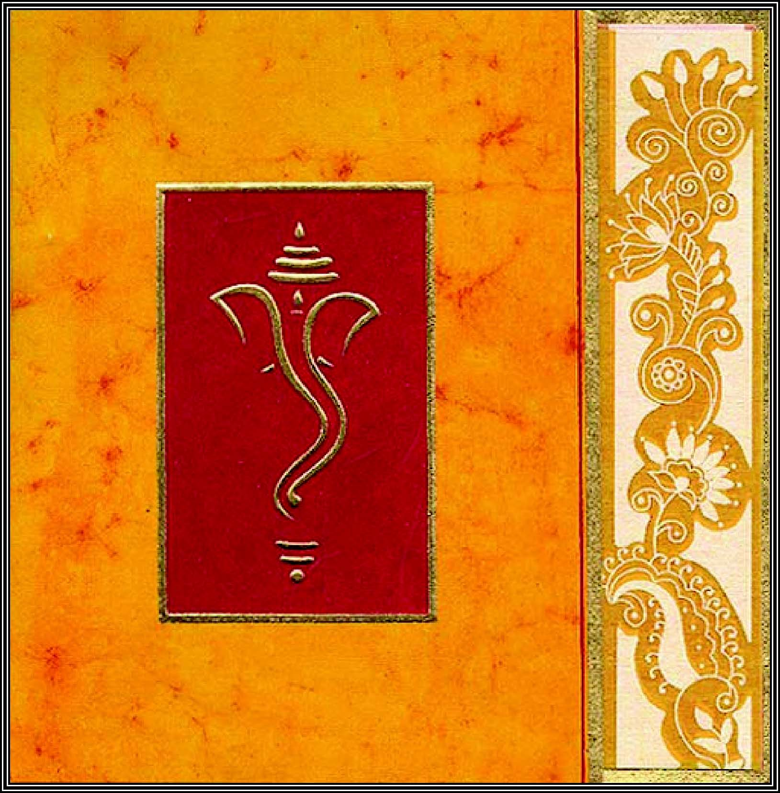

Cover of a typical Hindu Wedding invitation

Hindu Glossary

Ashrams: Four stages of life and development:
- Bramachari Ashram or Student Life – Learning, values and qualities.
- Grihasta Ashram: Married Life/Householder – Married Life. Responsibility to family and Society. To give charity and help the poor and vulnerable.
- Vanaprastha Ashram: Retired Life – Devotee more time to spiritual matters.
- Sannyasa Ashram: Renounced Life- Devotee more time to spiritual matters.

Dharma: Religious and social responsibilities and duties.

Grihasta: Married life and responsibility to family and society.

Vagdhana: An oral agreement of marriage.

Lagna Patra: A written declaration of marriage.

Puranas: Hindu holy scriptures.

Puja: Ceremony.

Agni Dev: Fire God.

Ganesh Puja – Ceremony Invoking Lord Ganesh to remove obstacles.

Agni Puja – Ceremony evoking the holy fire as a witness and seek his blessings.
Kanyάdάna – (Kanya – unmarried woman, dana,-charity). Considered one of the highest acts of charity. A father gives his daughter’s hand in marriage to the groom.

Mangalsutra - Tying the holy necklace on the bride.

Saptapadi – Taking seven steps or vows.

Saat Phere (Saat- seven, Phere- circumbulating) – The Seven Holy Steps circling the fire.

Śilάrόhana – Bride steps on the stone.

