******Key Stage 1 and 2 Programmes of Study**

**Buddhism**

**Christianity**

**Hinduism**

**Islam**

**Judaism**

**Sikhism**

# Key Stages 1 and 2 Programmes of Study

**Statutory and non-statutory content**

**Key Stage 1**

Throughout Key Stage 1, pupils explore Christianity and two other principal religions. They learn different beliefs about God and the world around them. They encounter and respond to a range of stories, artefacts and other religious materials. They learn to recognise that beliefs are expressed in a variety of ways and begin to use specialist vocabulary. They begin to understand the importance and value of religion and belief, especially for other children and their families. Pupils ask relevant questions and develop a sense of wonder about the world, using their imagination. They talk about what is important to them and others, valuing themselves, reflecting on their own feelings and experiences and developing a sense of belonging.

**Knowledge, skills and understanding for Key Stage 1**

**Attainment Target 1: Learning about religion**

Pupils should be taught to:

1. explore a range of religious stories and sacred writings and talk about their meanings;
2. name and explore a range of celebrations, worship and rituals in religion, noting similarities where appropriate;
3. identify the importance, for some people, of belonging to a religion and recognise the difference this makes to their lives;
4. explore how religious beliefs and ideas can be expressed through the arts and communicate their responses; and
5. identify and suggest meanings for religious symbols and begin to use a range of religious words.

**Attainment Target 2: Learning from religion**

Pupils should be taught to:

1. reflect on and consider religious and spiritual feelings, experiences and concepts such as worship, wonder, praise, thanks, concern, joy and sadness;
2. ask and respond imaginatively to puzzling questions, communicating their ideas;
3. identify what matters to them and others, including those with religious commitments, and communicate their responses;
4. reflect on how spiritual and moral values relate to their own behaviour; and
5. recognise that religious teachings and ideas make a difference to individuals, families and the local community.

**Breadth of study**

During the two years of Key Stage 1, pupils in Lewisham schools should be taught the knowledge, skills and understanding through the following areas of study:

**Religions and beliefs and compulsory units**

1. Christianity for Key Stage 1 – 4 half termly units
2. **Two** other principal religions from the content provided for Buddhism, Hinduism, Islam, Judaism and Sikhism, one of which should be a religious community with a significant local presence in and around the school – the first two units of each = 4 half termly units
3. A secular world view, where pupils introduce this from their own experience as appropriate; and
4. The Natural World statutory unit

**Plus three of the four following Key Stage 1 Optional Units:**

1. Belonging / Who am I?
2. Right and Wrong
3. Sharing Food
4. Weddings

**Themes**

* + - 1. Believing: what people believe about God, humanity and the natural world;
      2. Story: how and why some stories are sacred and important in religion;
      3. Celebrations: how and why celebrations are important in religion;
      4. Symbols: how and why symbols express religious meaning;
      5. Leaders and teachers: figures who have an influence on others locally, nationally and globally in religion;
      6. Belonging: where and how people belong and why belonging is important; myself: who I am and my uniqueness as a person in a family and community;

**Experiences and opportunities**

1. Visiting places of worship and focusing on symbols and feelings.
2. Listening and responding to visitors from local faith communities.
3. Using their senses and having times of quiet reflection.
4. Using music, dance, drama, art and design to develop their creative talents and imagination.
5. Sharing their own beliefs, ideas and values and talking about their feelings and experiences.
6. Beginning to use ICT to explore religions and beliefs as practised in the local and wider community.

**Key Stage 2**

Throughout Key Stage 2, pupils learn about Christianity and all five of the other principal religions, recognising the impact of religion and belief locally, nationally and globally. They make connections between differing aspects of religion and consider the different forms of religious expression.

They consider the beliefs, teachings, practices and ways of life central to religion. They learn about sacred texts and other sources and consider their meanings. They begin to recognise diversity in religion, learning about similarities and differences both within and between religions and beliefs and the importance of dialogue between them.

They extend the range and use of specialist vocabulary. They recognise the challenges involved in distinguishing between ideas of right and wrong, and valuing what is good and true. They communicate their ideas, recognising other people’s viewpoints. They consider their own beliefs and values and those of others in the light of their learning in religious education.

**Knowledge, skills and understanding for Key Stage 2**

**Attainment Target 1: Learning about religion**

Pupils should be taught to:

1. describe the key aspects of religions, especially the people, stories and traditions that influence the beliefs and values of others;
2. describe the variety of practices and ways of life in religions and understand how they stem from, and are closely connected with, beliefs and teachings;
3. identify and begin to describe the similarities and differences within and between religions;
4. investigate the significance of religion in the local, national and global communities;
5. consider the meaning of a range of forms of religious expression, understand why they are important in religion and note links between them;
6. describe and begin to understand religious and other responses to ultimate and ethical questions;
7. use specialist vocabulary in communicating their knowledge and understanding; and
8. use and interpret information about religions from a range of sources.

**Attainment Target 2: Learning from religion**

Pupils should be taught to:

1. reflect on what it means to belong to a faith community, communicating their own and others’ responses;
2. respond to the challenges of commitment both in their own lives and within religious traditions, recognising how commitment to a religion is shown in a variety of ways;
3. discuss their own and others’ views of religious truth and belief, expressing their own ideas;
4. reflect on ideas of right and wrong and their own and others’ responses to them;
5. reflect on sources of inspiration in their own and others’ lives.

**Breadth of study**

During this key stage, pupils in Lewisham schools should be taught the knowledge, skills and understanding through the following areas of study:

1. Christianity for Key Stage 2 – 5 half term units
2. five other principal religions – Buddhism, Hinduism, Islam, Judaism and Sikhism, - **the remaining** two units from those faiths introduced in KS1 and **all** four units from the other 3 faiths that have not yet been studied totalling 16 half termly units
3. a secular world view, where appropriate

**Plus the following statutory units:**

1. The Journey of life and death
2. Peace
3. Understanding faith and belief in Lewisham

**The units for every faith in Key Stages 1 and 2 have been written to be taught in the order that they are numbered so that learning is scaffolded to develop knowledge, understanding and concepts.**

**Themes**

1. Beliefs and questions: how people’s beliefs about God, the world and others impact on their lives;
2. Teachings and authority: what sacred texts and other sources say about God, the world and human life;
3. Worship, pilgrimage and sacred places: where, how and why people worship, including at particular sites;
4. The journey of life and death: why some occasions are sacred to believers, and what people think about life after death;
5. Symbols and religious expression: how religious and spiritual ideas are expressed;
6. Inspirational people: figures from whom believers find inspiration;
7. Religion and the individual: what is expected of a person in following a religion or belief;
8. Religion, family and community: how religious families and communities practice their faith, and the contributions this makes to local life; and
9. Beliefs in action in the world: how religions and beliefs respond to global issues of human rights, fairness, social justice and the importance of the environment.

**Experiences and opportunities**

1. Encountering religion through visitors and visits to places of worship, and focusing on the impact and reality of religion on the local and global community;
2. Discussing religious and philosophical questions, giving reasons for their own beliefs and those of others;
3. Considering a range of human experiences and feelings;
4. Reflecting on their own and others’ insights into life and its origin, purpose and meaning;
5. Expressing and communicating their own and others’ insights through art and design, music, dance, drama and ICT; and
6. Developing the use of ICT, particularly in enhancing pupils’ awareness of religions and beliefs globally.

|  |  |  |  |
| --- | --- | --- | --- |
| **Unit 1 – The Buddha** | **Unit 2 – Living as a Buddhist** | **Unit 3 – Following the Buddha’s Teaching** | **Unit 4 – The Buddhist Community Worldwide** |
| **The Buddha**   * The Buddha’s life and search for truth. * The Buddha means the ‘awakened one’. * He was a human being who ‘woke up’ from the ‘sleep of confusion’. This is like awakening from a dream and becoming perfectly aware of the truth. The Buddha became free of suffering and was able to help others to ‘awaken themselves’.   **Teachings of the Buddha**   * The Four Noble Truths. People should work at becoming kind, compassionate, generous, truthful and patient. * People should try not to hurt any living thing, take things that are not given and try to be honest and straightforward. * Story of Siddhartha and the Swan. | **The Buddhist Community – Sangha**  Lives out the teachings of the Buddha.   * All members support one another. * Story of The King’s Elephant – keeping good company matters. * Buddhists meditate to help them understand the teachings of the Buddha by developing awareness and mindfulness.   **The home shrine**, **a Temple or Buddhist Centre**   * Place where teachings are given. * Where Buddhists meditate together. * A sacred space, where removal of shoes shows respect. * A shrine – with an image of the Buddha. Images of the Buddha communicate values of wisdom and compassion. | **The Buddha**   * The Buddha is the perfect example of what people can become. * The Noble Eightfold Path. * Symbols, e.g. the wheel and lotus. The Dharma (Buddhist teachings). * Story that illustrates Buddhist values – The Monkey King. * All Buddhists try to learn and practice the Dharma. This is the teaching and practice that leads to awakening. | * The Sangha. * People who follow the Dharma. * Some live as monks and nuns. * Others meditate and practice Buddhism in ordinary lives. * The five precepts.   **Building and Places in the Wider World:**   * Places of pilgrimage and their significance, e.g. Lumbini – birth place of Buddha. Bodhgaya – place of enlightenment. Deer park at Sarnath – first teachings of Buddha. Kushinagar – where he passed away.   **Vaisakha Puja or Vesak/Wesak**  Festival remembering the life, enlightenment and teaching of the Buddha. |
| **Key Questions:**   * What is a Buddha? * How did the Buddha teach that people should live? | **Key Questions:**   * What is the importance of a temple or a Buddhist centre? * Why do Buddhists have images of the Buddha? | **Key Questions:**   * How do Buddhists try to follow the teachings of the Buddha? * How do the teachings and example of the Buddha help Buddhists to grow towards enlightenment? | **Key Questions:**   * Which places have special meaning to Buddhists? * How do Buddhists try to live a good life? |
| **Concepts:**  **AT1:** Beliefs, teachings and sources.  Practices and ways of life.  **AT2:** Meaning, purpose and truth.  Values and commitments. | **Concepts:**  **AT1:** Beliefs, teachings and sources.  Practices and ways of life.  **AT2:** Identity and belonging. Meaning, purpose and truth. | **Concepts:**  **AT1:** Beliefs, teachings and practices.  Forms of expression.  **AT2:** Meaning, purpose and truth. | **Concepts:**  **AT1:** Beliefs, teachings and sources.  Practices and ways of life.  **AT2:** Identity and belonging. Meaning, purpose and truth. |

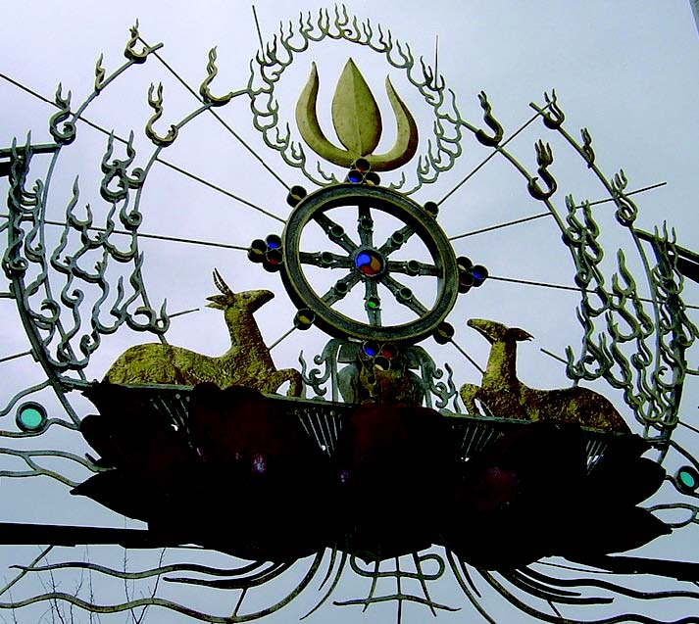

|  |  |
| --- | --- |
| **The Journey of Life and Death**  The ways in which human experiences associated with death, loss, hope, and meaning in life are understood in Buddhism.  **All things change**  Beliefs about death and rebirth. | **Right and Wrong**  The Buddha taught people how to behave through stories.  The story of the Lion and the Jackal.  Actions have consequences; good actions have good consequences. |
| **Key Questions:**   * What do Buddhists believe happens  after death? * What do Buddhists believe the  purpose of life to be? * How do Buddhists support people  during times of loss? | **Key Questions:**   * What is the meaning of the story for Buddhists and for everyone? * How do stories help us to explore  our own beliefs and values? |
| **Concepts:**  **AT1:** Beliefs, teachings, practices.  **AT2:** Meaning, purpose and truth. | **Concepts:**  **AT1:** Beliefs, teachings, practices.  **AT2:** Meaning, purpose and truth. |

The London Buddhist Centre

**YEAR 1**

|  |  |  |  |
| --- | --- | --- | --- |
| **The Natural World Unit**  **Beliefs:**   * God as creator.   **Teachings:**   * People are responsible for living things on the planet.   **Christians try to follow the example of Jesus:**   * St Francis. * Sharing with others, e.g. charities, * the Harvest Festival, sharing food with others. * Christians believe that everyone is important and of equal value. | **Unit 1**  **The Bible and Christmas**  **Beliefs:**   * Christians believe that Jesus is God’s Son * **The Bible is a special book:**   – different from other books.  – Stories about the birth and life of Jesus.   * **Christian celebrations:**   – Christmas: the celebration of Jesus’ birth which shows He is special for Christians. | **Unit 2**  **A Local Church**  **Church buildings:**   * Places where Christians worship together, read the Bible, listen to stories, sing and pray once or more times weekly. * Leaders e.g. priests, ministers, elders. * Objects and symbols in churches. * Important ceremonies e.g. welcoming/dedication/infant baptisms.   Most Christians keep Sunday as a special holy day.  **Christians try to follow the example of Jesus:**   * Caring for others, e.g. children, the elderly. * The work of Christians in the wider community | **Easter (Extra focus)**  **Why do we have hot cross buns and Easter eggs?**  Simple version of Easter story to link with these Easter foods. |
| **Key Questions:**   * How do Christians believe the world began? * What do Christians believe about God? * How do Christians believe they should treat each other and God’s world? | **Key Questions**:   * What do Christians remember at Christmas? * What do Christians believe about Jesus? * Why is the Bible important to Christians? | **Key Questions:**   * What happens in a Christian place of worship? * How does a place of worship help Christians to remember their beliefs about Jesus? * How do Christians try to follow Jesus’ example? | **Key Questions:**   * What do Christians believe happened at Easter? |
| **Concepts:**  **AT1:** Beliefs, teachings.  Concept of God.  **AT2:** Values and commitments | **Concepts:**  **AT1:** Beliefs, teachings and sources.  Concept of God.  Forms of expression.  **AT2:** Meaning, purpose and truth. | **Concepts:**  **AT1:** Beliefs, teachings and sources.  Practices and ways of life.  Forms of expression.  **AT2:** Identity and belonging.  Values and commitments. | **Concepts:**  **AT1:** Beliefs, teachings and sources.  Practices and ways of life.  Forms of expression.  **AT2:** Meaning. |

**YEAR 2**

|  |  |  |
| --- | --- | --- |
| **Unit 3**  **The Life and Teachings of Jesus**  Stories about Jesus which develop Christian values:   * Zacchaeus.   Stories Jesus told which develop Christian values and contain His teaching on forgiveness and love:   * The Lost Son * The Good Samaritan   The two greatest Commandments ‘Love God’ and ‘Love your neighbour’.  **The Bible is a special book:**   * Christians read it to learn about Jesus. | **Unit 4**  **Easter and Symbols**  The story of Jesus’ death and resurrection emphasises the idea that Jesus is special for Christians.  **Symbols**   * Recall symbolism from Year 1 focus * Symbols of Easter e.g. palm crosses, Easter gardens, colours of vestments and in churches, candles * Symbolic actions: washing feet on Maundy Thursday * Christians sharing food together to remember Jesus’ last meal with His friends | **Christmas (Extra Focus)**  Symbols of Christmas:   * Star * Advent Candles * Colours of vestments and in churches |
| **Key Questions:**   * What values do Christians believe Jesus taught? * How do Christians believe Jesus taught them these values? * Why is the Bible a special book for Christians? | **Key Questions:**   * What do symbols of Easter represent? * What symbolic actions take place around Easter? * How do symbols and symbolic actions show the importance of Easter for Christians? | **Key Questions:**   * What do symbols of Christmas mean? * How do symbols show the importance of Christmas for Christians? |
| **Concepts:**  **AT1:** Beliefs, teachings and sources.  Practices and ways of life.  **AT2:** Values and commitments | **Concepts:**  **AT1:** Beliefs, teachings.  Practices and ways of life.  Forms of expression and Symbolism.  **AT2:** Belonging. Death and new life. | **Concepts:**  AT1: Beliefs, teachings.  Practices and ways of life.  Forms of expression and symbolism.  **AT2:** Belonging. |

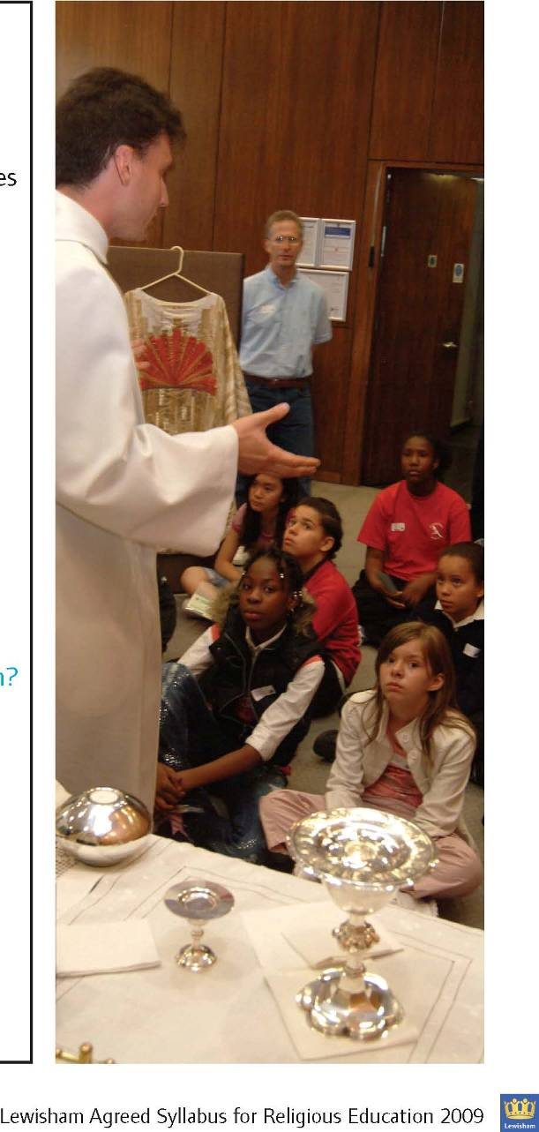

**YEAR 3**

|  |  |  |  |
| --- | --- | --- | --- |
| **Unit 5 – The Bible**   * A source of Christian belief and teaching - some Christians read the Bible every day and find it helpful for their everyday lives. * The Old and New Testaments include many books with different genres; these include history, law and songs: Joseph, Psalm 23, Isaiah’s Prophecy. * The gospel stories tell about events in Jesus’ life. * Jesus’ teaching about the Kingdom of God in parables: The Lost Sheep. * Ten Commandments with particular focus on the two greatest commandments. | **Peace Unit**  **Christian ways of life:**   * Christians respond to personal and social issues, locally and globally, in a number of ways and can draw inspiration from other Christians, e.g. Martin Luther King.   **The Bible:**   * Sermon on the Mount.   **The Church:**   * Worship includes the use of stillness and silence for reflection. | **Christmas (Extra Focus)**  How Christmas is celebrated by  Christians in other countries focussing on the central shared celebration of the birth of Jesus. | **Easter (Extra Focus)**  **Easter story – through the eyes of different characters, e.g.:**   * Peter * Other disciples * Member of the crowd * Mary * Romans |
| **Key Questions:**   * How do Christians use the Bible? * What does the Bible contain? * How does using the Bible help Christians to grow in their faith? | **Key Questions:**   * What do Christians believe about Peace? * How do Christians try to demonstrate Peace? * From where do Christians get their attitudes towards Peace? * How are Christian values about Peace similar to those of other faiths? | **Key Questions:**   * Why is Christmas celebrated in different ways around the world? * What do all Christians share about Christmas? | **Key Question:**   * What were the experiences and feelings of different witnesses of what happened at the first Easter? |
| **Concepts:**  **AT1:** Beliefs, teachings and sources.  Ways of life.  Forms of expression.  **AT2:** Meaning, purpose and truth.  Values and commitments. | **Concepts:**  **AT1:** Beliefs, teachings and sources.  Practices and ways of life.  Forms of expression.  **AT2:** Meaning and truth.  Values and commitments. | **Concepts:**  **AT1:** Beliefs, teachings.  Practices and ways of life.  Forms of expression.  **AT2:** Identity and Belonging.  Meaning and truth. | **Concepts:**  **AT1:** Beliefs, teachings and sources.  Practices and ways of life.  Forms of expression.  **AT2:** Identity and Belonging.  Meaning and truth. |

**YEAR 4**

|  |  |
| --- | --- |
| **Unit 6 – Local Christian Places of**  **Worship**   * Special places for Christians. * There are many different types of Christian places of worship. * Belonging to a group and sharing activities with others is important and meaningful. * Worship includes the use of stillness and silence for reflection. * Reasons why people pray. * The Lord’s Prayer * The Bible (a source of Christian belief and teaching) used in services | **Unit 7 – Christian Celebrations**  **The Church has its own calendar with special names for certain times of the year:**   * Times associated with Jesus’ life; how Christians understand and celebrate these events – Christmas and Easter * Times of reflection: Advent and Lent - Jesus’ temptation. * Sharing the Lord’s Supper. * Pentecost |
| **Key Questions:**   * Why are there different places of worship for Christians? * What similarities are there in what Christians believe? * How does coming together help Christians to grow in their faith? | **Key Questions:**   * How do festivals help Christians to remember Jesus and His teachings? * What happens in places of worship to help Christians understand the meaning behind their festivals? |
| **Concepts:**  **AT1:** Beliefs, teachings and sources.  Ways of life.  Forms of expression**.**  **AT2:** Identity and Belonging.  Meaning, purpose and truth.  Values and commitments. | **Concepts:**  **AT1:** Beliefs, teachings and sources.  Ways of life.  Forms of expression.  **AT2:** Identity and Belonging.  Meaning, purpose and truth.  Values and commitments. |

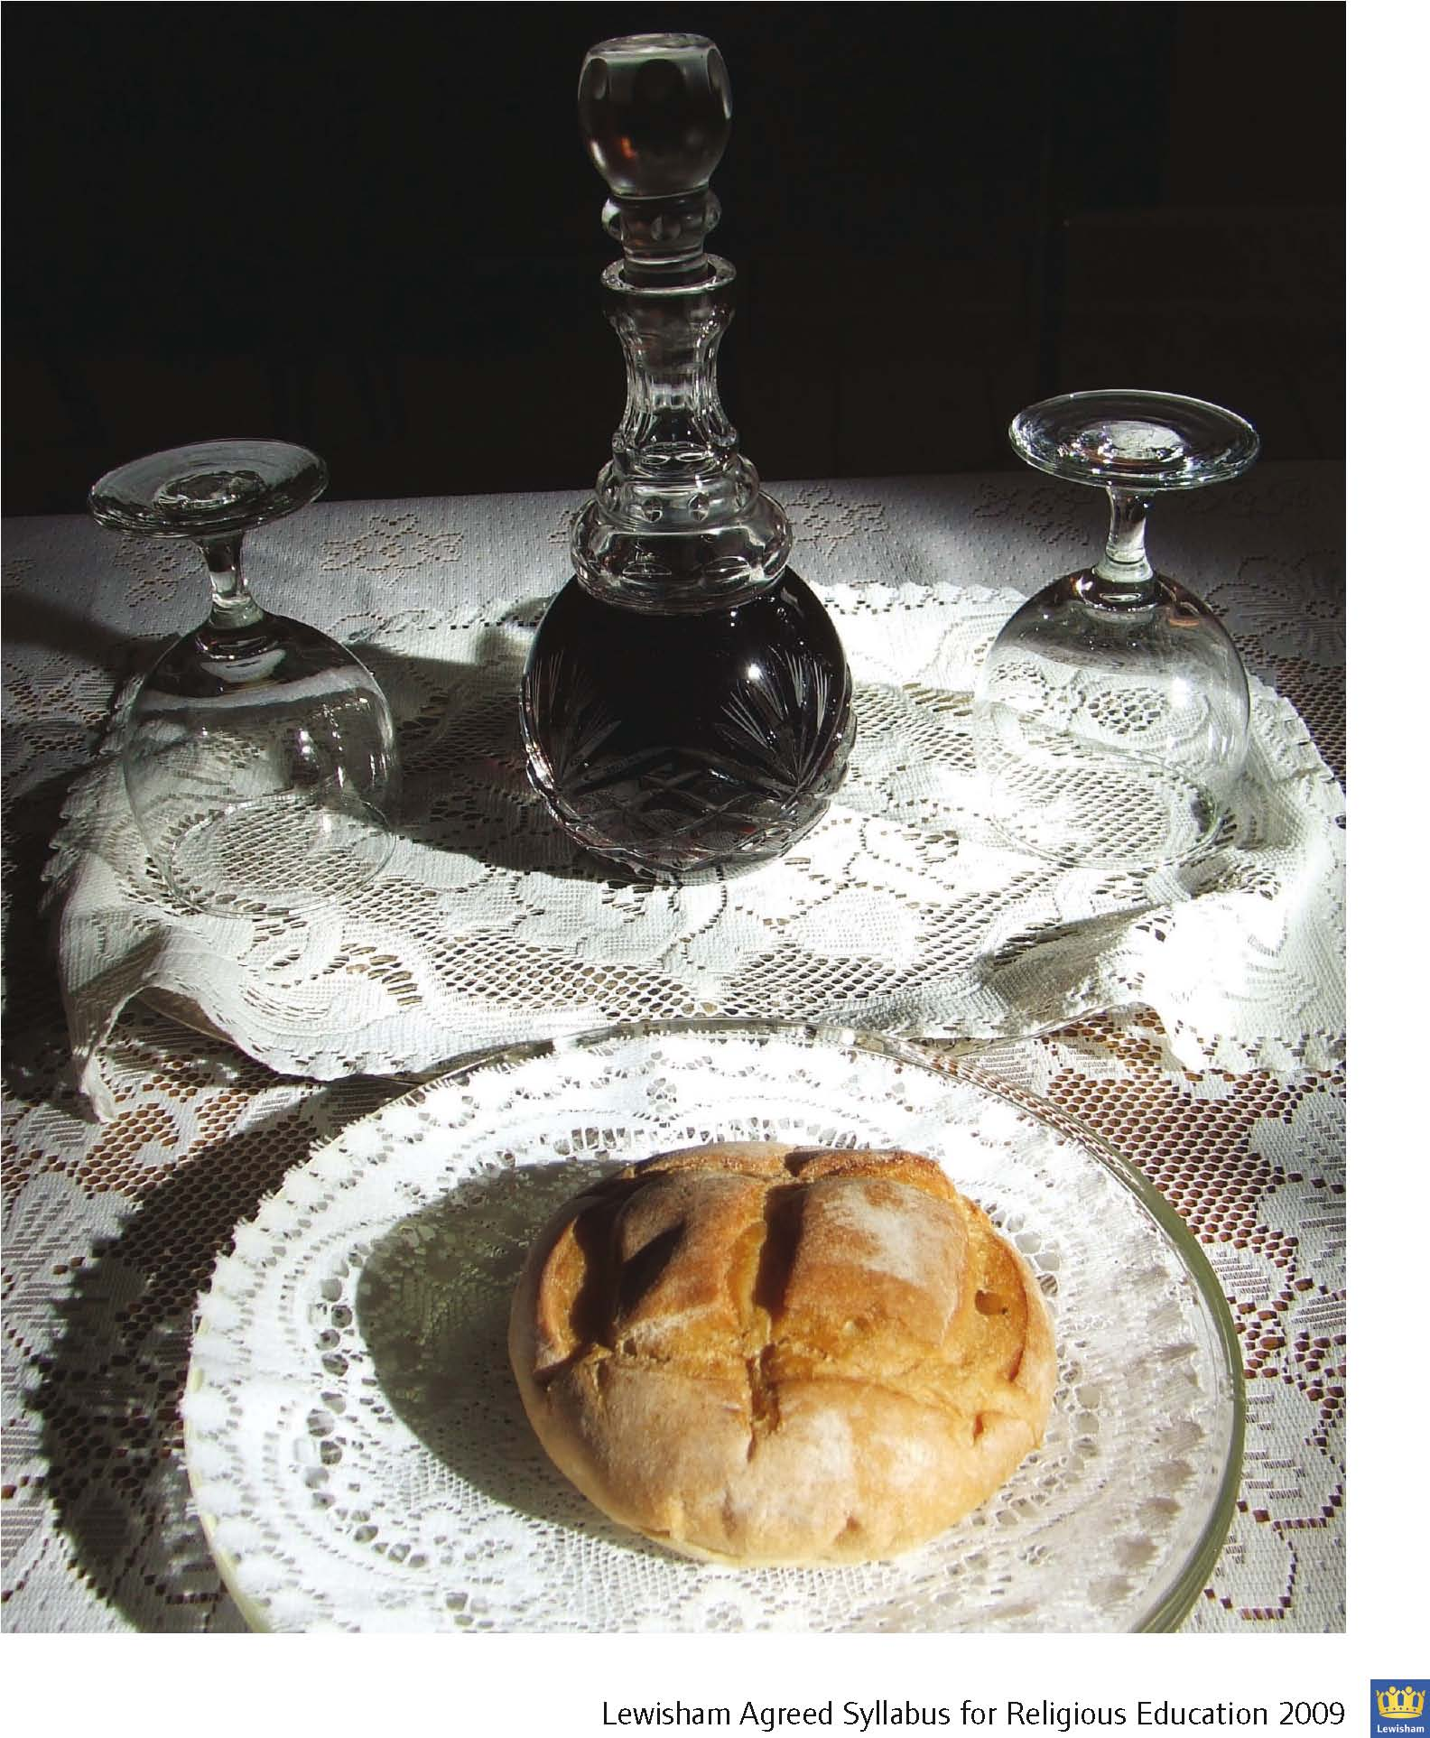

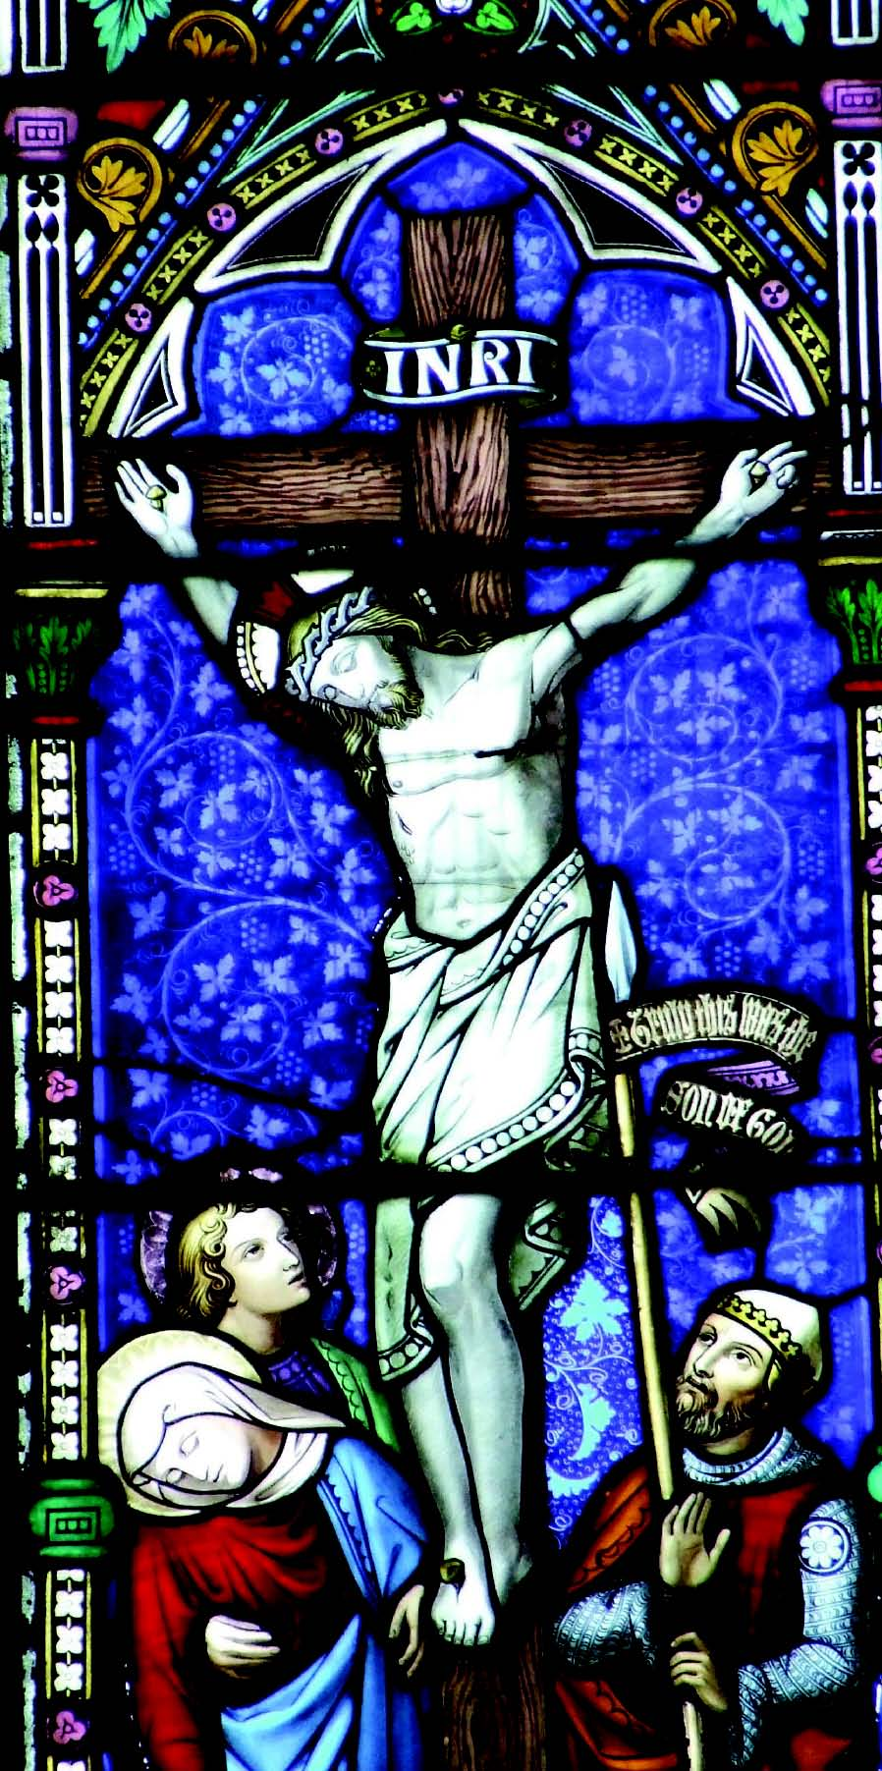**YEAR 5**

|  |  |  |
| --- | --- | --- |
| **Unit 8**  **Jesus Human and Divine** | **Unit 9**  **Leading a Christian Life** | **Christmas (Extra Focus)** |
| **God:**   * Father, Son and Holy Spirit * Christmas – Jesus’ birth. * Choosing 12 disciples AND friends * Jesus’ temptations * Jesus’ baptism * Miracles and acts of healing e.g. ‘Stilling the storm’, ‘The four friends’ or ‘Healing a leper’ * Easter - Jesus’ death, resurrection and afterwards. | Commitment, belonging and belief in the special presence of God during significant life events.  Example of at least one person and one charitable organisation that exemplifies Christianity in action.  Encounter with one local Christian to share how their life is led by faith | Commercialisation of Christmas |
| **Key Questions:**   * Who do Christians believe Jesus to be? * What evidence do Christians base their beliefs upon? | **Key Questions:**   * How do Christians follow Jesus and His teachings in their daily lives? * What Christian values guide the actions of the people and organisations studied? * What are the challenges of living a Christian life today? | **Key Questions:**   * How and why has Christmas become commercialised? * How do Christians try to keep the religious meaning of Christmas? |
| **Concepts:**  **AT1:** Beliefs, teachings and sources.  Ways of life.  Forms of expression.  **AT2:** Identity and Belonging.  Meaning, purpose and truth. | **Concepts:**  **AT1:** Beliefs, teachings and sources.  Ways of life.  Forms of expression.  **AT2:** Identity and Belonging.  Meaning, purpose and truth.  Values and commitments. | **Concepts:**  **AT1:** Beliefs, teachings.  Practices and ways of life.  Forms of expression.  **AT2:** Meaning and truth. |

**YEAR 6**

|  |  |  |  |
| --- | --- | --- | --- |
| **The Journey of Life and Death** | **Understanding Faith and Belief in Lewisham** | **Christmas (Extra Focus)** | **Easter (Extra Focus)** |
| Ways in which human experiences  associated with death, loss and  bereavement are understood in  Christianity. | Christian communities in Lewisham | Christmas and the Nativity through art and other media. | Actions and symbolism of Easter celebrations in the Orthodox Tradition. |
| **Key Questions:**   * What do Christians believe happens after death? * What do Christians believe the purpose of life to be? * How do Christians support people during times of loss? | **Key Questions:**   * what can we discover about this faith in our class and school? * what can we discover about this faith in the local community and Lewisham borough? * how have Christian faith communities in Lewisham changed over the past 50 years? * what are the reasons for changes in these communities? * how do faith groups work in partnership with each other and the local community? * how has life in Lewisham been enriched by the diversity of the faiths and beliefs that make up the borough? | **Key Questions:**   * How have Christians, over time and in different parts of the world, used art to express their beliefs and feelings about Christmas? * How can representations of the nativity help or hinder understanding of Jesus’ real background as a Jew? | **Key Questions:**   * How does the Orthodox Easter symbolise Christian beliefs about Jesus? * What do all Christians share about Easter? * What does Easter teach all Christians about their journey of life and death? |
| **Concepts**:  AT1: Beliefs, teachings, practices.  AT2: Belonging.  Meaning, purpose and truth. | **Concepts:**  AT1: Beliefs, teachings.  Practices and ways of life.  Forms of expression.  AT2: Identity and belonging.  Meaning and truth. | **Concepts:**  AT1: Beliefs, teachings.  Forms of expression.  AT2: Identity and belonging. Meaning and truth. | **Concepts:**  AT1: Beliefs, teachings.  Practices and ways of life.  Forms of expression.  AT2: Identity and belonging. Meaning and truth. |

**Optional Unit**

|  |  |  |  |
| --- | --- | --- | --- |
| **Belonging / Who Am I?**  What it means to belong and worship within Christianity.  How people show that they belong and what is special for them about  belonging to their Christian faith. | **Right and Wrong**  The rules Christians believe they should live by:   * The Ten Commandments taught people how to behave towards God and each other; * Christians believe that to help people Jesus summarised these into 2 great commandments using another Jewish text. | **Sharing Food**  How Christians follow the example of Jesus who shared food with His disciples at the Last Supper. Christians also often pray before a meal to thank God for their food. | **Weddings**  Christians celebrate a wedding with their family, friends and the wider Christian community  What happens during a traditional Christian wedding  Symbols of a Christian wedding and their meaning  Understand that a wedding is celebrating the story of a relationship and asking God to bless it. |
| **Key Questions:**   * What does it mean to belong? * What are the outward signs that a person belongs to a religious family? * What happens to a child when they join a religious family? * What have we learnt about the importance of belonging to a religious family? | **Key Questions:**   * Why did Jesus summarise the Ten Commandments for His followers? * How do Christians try to live according to their beliefs and values? | **Key Questions:**   * Why is it important for Christians to share bread and wine? * What happened at the Last Supper? | **Key Questions:**   * What is a wedding? * What happens in a Christian wedding that show the people getting married believe God is there? |
| **Concepts:**  AT1: Beliefs, teachings.  Practices and ways of life.  AT2: Identity and belonging.  Meaning and truth. | **Concepts:**  AT1: Beliefs, teachings, practices.  AT2: Meaning and truth. | **Concepts:**  AT1: Beliefs, teachings.  Practices and ways of life.  AT2: Identity and belonging | **Concepts:**  **AT1:** Beliefs, teachings.  Practices and ways of life.  **AT2:** Identity and belonging. |

|  |  |  |  |
| --- | --- | --- | --- |
| **Unit 1 God** | **Unit 2 –Hindu Belief and Home** | **Unit 3 – God and Beliefs** | **Unit 4 – Pilgrimage** |
| **Hindu Gods are worshipped as Male or Female**   * Shiva & Shakti; * Vishnu & Lakshmi; * Brahma & Sarasvati; and * Ganesh, Murugan, Hanuman   God has visited Earth at different times in different forms to help people: – Rama – Krishna.  **Important Festivals**   * Diwali * Pongal – ( Harvest Festival ) * New Year – (In April)   **Stories**   * Murugan and Ganesh * Diwali (Rama-Sita and the 10 Headed Demon Ravana) | **The Hindu Home**   * Family * Respect for all people and living things. * Home as a place of worship.   **Worship in the Temple (Mandir / Kovil)**   * Puja, The Arti and Abhisheka ceremonies * The Mandir/Kovil and the home is the Hindu place of worship. | **Sacred Books**   * Ramayana, Mahabharata, * Bhagwat Gita, Veda   **Religious Word**  Aum/Om  **Belief and values**   * The importance of honesty and truthfulness. * Karma: Take responsibility for your actions. * Hospitality is important to Hindus. | **The Wider World**   * Hinduism originated in India. * Hindus live across the world. * Places of pilgrimage and their significance:   + The Ganges   + Kailash   + Rameswaram * Stories associated with places of pilgrimage. |
| **Key Questions:**   * How does the story of Diwali teach about good and evil?   **Concepts:**  **AT1:** Beliefs, teaching, sources.  Practices and ways of life.  **AT2:** Identity and belonging.  Meaning, purpose and truth. | **Key Questions:**   * What is the importance of family in Hinduism? * What is the role of a Hindu temple in a Hindu’s life? * How important is ‘home’ as a place of worship to Hindus?   **Concepts:**  **AT1:** Practices and ways of life.  **AT2:** Identity and belonging. | **Key Questions:**   * What does it mean to be a Hindu? * How important is peace in Hinduism?   **Concepts:**  **AT1:** Beliefs, teaching, sources.  Practices and ways of life.  **AT2:** Identity and belonging.  Meaning, purpose and truth. | **Key Questions:**   * How important is The Holy Ganges and what role does it play in Hindus belief?   **Concepts:**  **AT1:** Beliefs, teaching, sources.  Practices and ways of life.  **AT2:** Identity and belonging.  Meaning, purpose and truth. |

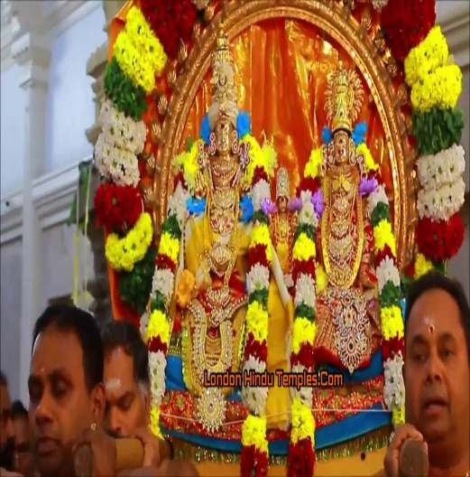

|  |  |  |
| --- | --- | --- |
| **Sharing Food**   * Hindus offer food to God and then consume it as God’s blessing. * Hindus refrain from consuming beef. | **Weddings**   * Understand the inner meaning of a Hindu wedding. * Explore ways of celebrating a Hindu wedding. * Understand the story of the Hindu wedding and the community that celebrate it. * Discussion about the role of the community before and during the wedding. * Understand that family is at the centre of marriage and wedding. | **Belonging**   * Know what is involved for a child in belonging to the Hindu religion * Know about naming in Hinduism   **Special Times (Functions) for a child**   * Seemamtham (Baby Shower) * Namakaran (Baby Naming * Anna Prashana (First Solid food) * Chaula/Mottai (Hair shave on the head) * Upanayana (First Writing) |
| **Key Questions:**   * Why is offering food to God important for Hindus? | **Key Questions:**   * How are Hindu weddings celebrated? * What is the importance of community/family during a wedding? | **Key Question:**   * What does it mean to belong in Hinduism? |
| **Concepts:**  **AT1:** Beliefs, teachings.  Practices and ways of life.  **AT2:** Identity and Belonging. | **Concepts:**  **AT1:** Beliefs, teaching, sources.  Practices and ways of life.  **AT2:** Identity and belonging.  Meaning, purpose and truth. | **Concepts:**  **AT1:** Beliefs, teaching, sources.  Practices and ways of life.  **AT2:** Identity and belonging |

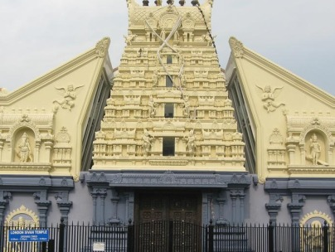

|  |  |
| --- | --- |
| **Peace**  Non injury to living things- Ahimsa  (Non-violence).  Gandhi’s life – demonstrating Ahimsa in practice through non-violent protest. | **The Journey of Life and Death**   * Ways in which human experiences associated with death, loss, hope and meaning of life are understood in Hinduism. * Know how the Hindu community respond to bereavement and helps support the person who is bereaved. * The concept of rebirth |
| **Key Questions:**   * What is the meaning of Ahimsa? * Why did Gandhi practice non-violence?   **Concepts:**  **AT1:** Beliefs, teaching, sources.  Practices and ways of life.  **AT2:** Identity and belonging.  Meaning, purpose and truth. | **Key Questions:**   * How do Hindus deal with bereavement? * What do Hindus believe about death and the afterlife? * What are the rituals after one’s death?   **Concepts:**  **AT1:** Beliefs, teaching, sources.  Practices and ways of life.  **AT2:** Identity and belonging.  Meaning, purpose and truth. |

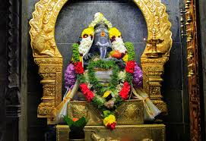

|  |  |  |  |
| --- | --- | --- | --- |
| **Unit 1 – Prophet**  **Muhammad (pbuh) messenger of Allah**  Who is Allah?  Stories from the life of the Prophet  Muhammad (pbuh)  **Living as a Muslim**   * Respect for self and others. * Birth of a baby.   **The Qur’an**   * Revelation of the Qur’an. * The Qu’ran is the holy book of Islam in Arabic. * The Qu’ran must be treated with respect. | **Unit 2 – Five Pillars of Islam**  1. Shahadah – Bearing witness in Allah as the One God and Prophet Muhammad (pbuh) as His messenger.  2. Salah - Prayer.  3. Sawm - Fasting.  4. Zakat - Charity.  5. Hajj - Pilgrimage.  **Worship of Allah**   * Muslims serve Allah in many ways. * Daily Salah. * Giving charity. * Brother/sister hood.   **The Muslim Home**   * Worship in the home.   **Place of Worship**   * The Mosque (Masjid). | **Unit 3 – Ramadan and Id ul Fitr**  **Sawm**   * Ramadan – a time to focus on Allah, being a good Muslim and considering those who have less. * Qur’anic quotes about fasting. * Fasting and eating in Ramadan. * Worship during Ramadan * Id ul Fitr – celebration of keeping the fast at its end. * Zakat al Fitr * Charity at Id. | **Unit 4 – Hajj and Id ul Adha**  Story of Prophet Ibrahim (pbuh) and his son Ismail (pbuh) rebuilding the Ka’aba.  Umrah (lesser pilgrimages. Not fixed to time).  Qur’anic quotes about Hajj  Hajj requirements.  **Id ul Adha**  Festival that takes place the day after the gathering of pilgrims on Mount Arafah. A time for Muslims worldwide to celebrate. |
| **Key Questions:**   * What do Muslims believe? * Why is Prophet Muhammad (pbuh) important to Muslims? * What is the Qur’an? | **Key Questions:**   * How do Muslims express their beliefs? * What does worship mean to Muslims? | **Key Questions:**   * Why do Muslims fast during Ramadan? * How does fasting help Muslims to grow closer to Allah and to each other? * How do Muslims celebrate Id? | **Key Questions:**   * What is a pilgrimage? * Why do Muslims go on Hajj? * Which stories are associated with the places on Hajj? * How does the Hajj make Muslims appreciate they are all part of one family? |
| **Concepts:**  **AT1:** Beliefs, teachings, sources.  Practices and ways of life.  **AT2:** Identity and belonging.  Meaning, purpose and truth | **Concepts:**  **AT1:** Beliefs, teachings, sources.  Practices and ways of life.  **AT2:** Identity and belonging.  Meaning, purpose and truth. | **Concepts:**  **AT1:** Beliefs, teachings, practices.  Concept of God.  **AT2:** Meaning, purpose and truth. | **Concepts:**  **AT1:** Beliefs, teachings, practices.  Concept of God.  **AT2:** Meaning, purpose and truth. |

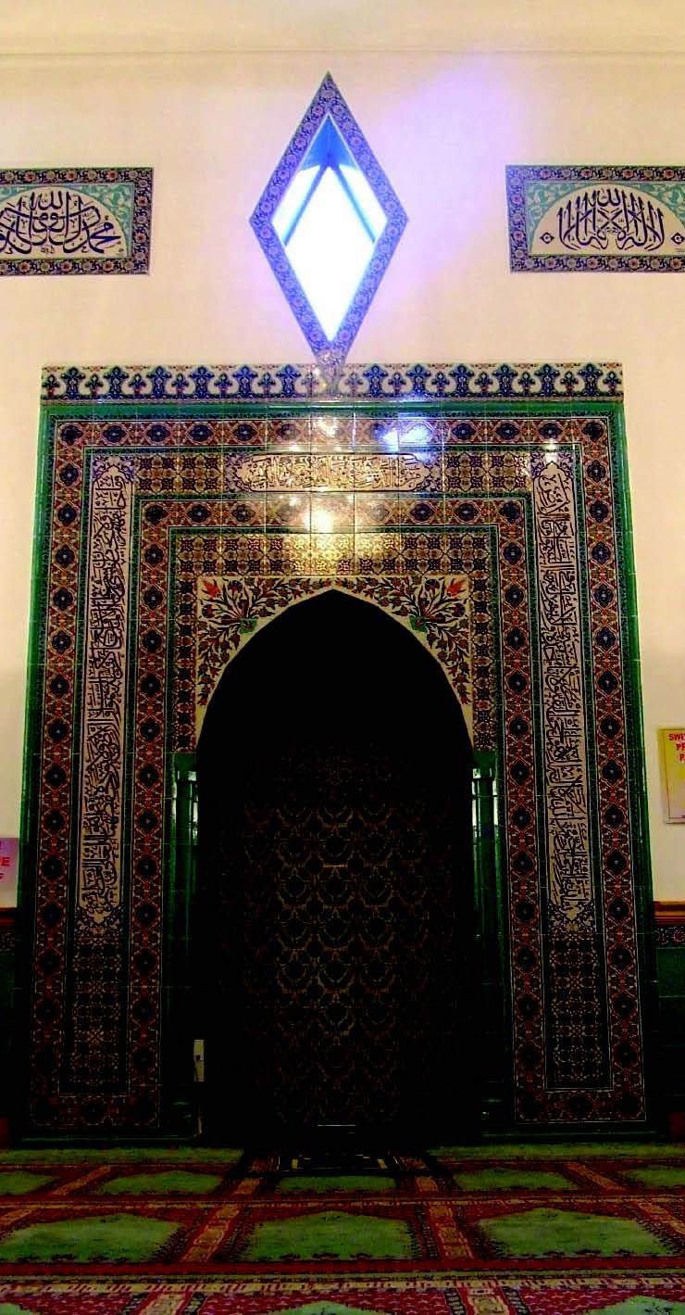

|  |  |  |
| --- | --- | --- |
| **The Natural World**  **Muslims believe in one God**  Allah is the Arabic and Islamic name for God.  He is the Creator, who provides all things.  He has no partners. | **Belonging**  Know what is involved for a child in belonging to the Muslim faith  at home. | **Right and Wrong**  Muslims learn how to behave from the Qur’an and stories about Prophet Muhammad (pbuh).  The story of Prophet Muhammad  (pbuh) and the Old Woman. |
| **Key Questions:**   * How do Muslims believe the world began? * What do Muslims believe about Allah? | **Key Question:**   * How does Muslim life show faith in Allah? | **Key Questions:**   * How does Islam teach how you should treat others? * What message did Muhammad (pbuh) give to the old woman about how Allah expected people to behave? |
| **Concepts:**  AT1: Beliefs, teachings.  Concept of God.  AT2: Values and commitments | **Concepts:**  AT1: Beliefs, teachings, practices.  Concept of God.  AT2: Meaning, purpose and truth. | **Concepts:**  AT1: Beliefs, teachings, practices.  AT2: Meaning, purpose and truth. |

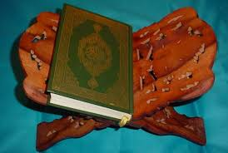

|  |  |
| --- | --- |
| **Peace**  ‘As-salaam’ is one of the beautiful names of Allah meaning the ‘Source of Peace’. | **The Journey of Life and Death**  The ways in which human experiences associated with death, loss, hope, and meaning  in life are understood in Islam. |
| **Key Question:**   * How does the Muslim greeting ‘Assalaamu alaykum’ (Peace be upon you) reflect Muslim beliefs about Allah? | **Key Questions:**   * What do Muslims believe happens after death? * How do Muslims support people during times of loss? |
| **Concepts:**  AT1: Beliefs, teachings, practices.  Concept of God.  AT2: Meaning, purpose and truth | **Concepts:**  AT1: Beliefs, teachings, practices.  AT2: Meaning, purpose and truth |

|  |  |  |  |
| --- | --- | --- | --- |
| **Unit 1 – Shabbat – A Day of Rest**  **Shabbat – the Sabbath Day -** Day of separation and different from other days; a day of rest and joy, remembering God creating and resting.  What happens?   * Preparing for Shabbat. * Sunset candle lighting. * Blessings. * Shared meal – Kiddush * Shabbat Table and customs. * Charity contributions (Tzedakah).[1]   **Synagogue**   * Attend synagogue for prayer with the community on Shabbat.   **Havdalah** and the **end** of Shabbat.   * Spices, wine, plaited candle and the blessing of Shabbat taken into next week. | **Unit 2 – Festivals in Jewish Life**  **Succot (Sukkoth)**   * Festival of Tabernacles. * Celebration at home and in the Synagogue. * Story retold * Harvest.   **Passover (Pesach)**   * Story recalled: Moses and the Exodus from Egypt. * Celebration at home. * Symbolism and ritual of Seder meal – questions from youngest child.   **Hanukkah**   * Story recalled of the miracle of the oil * Celebration at home. * Symbolism of candle lighting and eating doughnuts. | **Unit 3 – Abraham**  **Belief in One God**   * Abram/Abraham. * Abraham and one God. * Abraham and Isaac – obedience to God.   **Torah**   * Jewish Sacred Text. * Where stories about the Jews’ relationship with God are found including the story of Abraham * Written as a scroll in Hebrew. * Treated with respect. * Yad. | **Unit 4 – Prayer and Worship of God**  **The Shema**   * Said twice daily. * Preparing for prayer: Phylacteries, Tallit, Kippah. * The Shema in the Mezuzah – signifying a Jewish home.   **Synagogue**   * Ark. * Ner Tamid. * Torah portion read in services. * Role of the Rabbi. * Minyan. * Family celebrations. * Bar /Bat Mitzvah. |
| **Key Questions:**   * Why is Shabbat important to Jews? * Why do Jews visit the synagogue on Shabbat? * Why is it important to keep traditions/customs alive? | **Key Questions:**   * How does what happens at each Festival help to teach young Jews about their past? * What do these festivals show about the Jews’ relationship with God? | **Key Questions:**   * Why is Abraham important to Jews? * How does the Torah help Jewish people to understand what being Jewish means? | **Key Questions:**   * How does the Shema tell Jews to keep their religion alive? * How does the role of a Jew change after their Bar/Bat Mitzvah? * Why are the home and synagogue equally important in a Jewish person’s life? |
| **Concepts:**  **AT1:** Beliefs, teachings, sources.  Practices and ways of life.  **AT2:** Identity and belonging.  Meaning, purpose and truth. | **Concepts:**  **AT1:** Beliefs, teachings, sources.  Practices and ways of life.  **AT2:** Identity and belonging.  Meaning, purpose and truth | **Concepts:**  **AT1:** Beliefs, teachings, sources.  Practices and ways of life.  Concept of God.  **AT2:** Identity and belonging.  Meaning, purpose and truth. | **Concepts:**  **AT1:** Beliefs, teachings, sources.  Practices and ways of life.  Concept of God.  **AT2:** Identity and belonging.  Meaning, purpose and truth. |

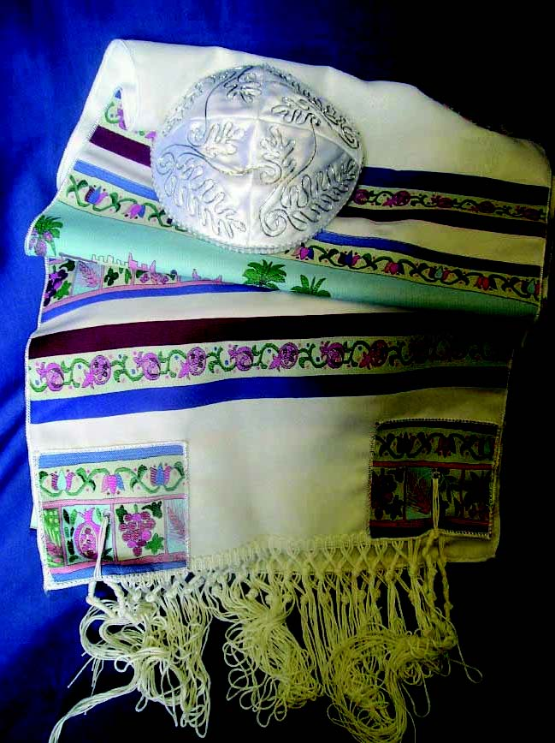

|  |  |
| --- | --- |
| **The Natural World**  Jews believe in one God, The Creator, who designed the world.  Jews have a responsibility for living things on the planet. | **Weddings**  Know what happens during a Jewish  wedding;   * Understand that the celebration is shared with family, friends and the faith community. * Know some of the symbols in a Jewish wedding. * Understand the inner meaning of a Jewish wedding. |
| **Key Questions:**   * How do Jews believe the world began? * What do Jews believe about God? * What do Jews believe about human responsibility for the world? | **Key Questions**   * How are Jewish weddings celebrated? * What is the importance of community/family during a wedding? |
| **Concepts**:  **AT1:** Beliefs, teachings.  Concept of God.  **AT2:** Values and commitments | **Concepts:**  **AT1:** Beliefs, teaching, sources.  Practices and ways of life.  **AT2:** Identity and belonging.  Meaning, purpose and truth. |

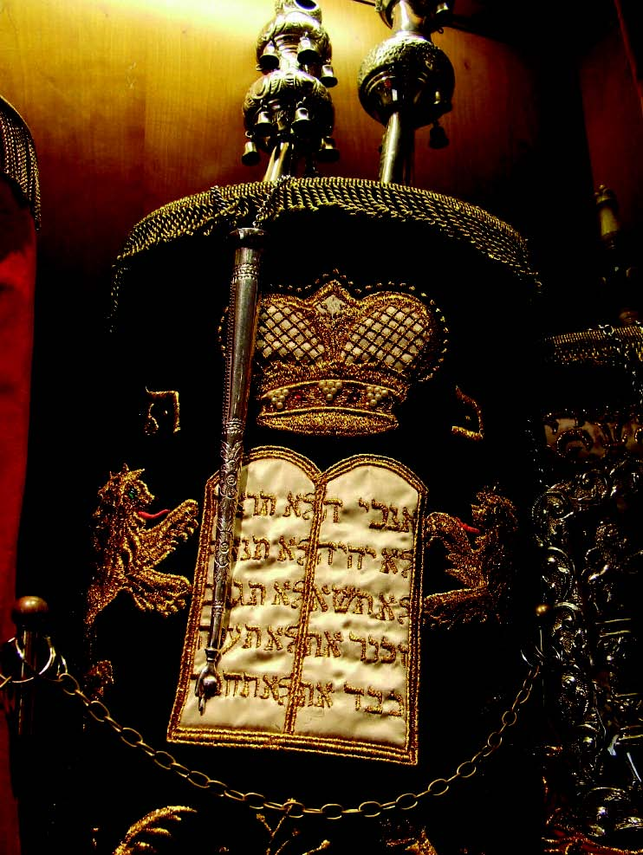

|  |  |  |
| --- | --- | --- |
| **Peace**  Jewish prayer for Peace. | **Understanding Faith and Belief in Lewisham**  The Jewish communities in Lewisham | **The Journey of Life and Death**  The ways in which human experiences associated with death, loss, hope, and meaning in life are understood in Judaism. |
| **Key Questions:**   * What does peace mean to Jews? * How do Jews believe they can foster peace in their lives? | **Key Questions:**   * what can we discover about this faith in our class and school? * what can we discover about this faith in the local community and Lewisham borough? * how has the Jewish faith in Lewisham changed over the past 50 years? * what are the reasons for changes? * how do faith groups work in partnership with each other and the local community? * how has life in Lewisham been enriched by the diversity of the faiths and beliefs that make up the borough? | **Key Questions:**   * What do Jews believe happens after death? * How do Jews support people during times of loss? |
| **Concepts:**  **AT1:** Beliefs, teachings, practices.  Concept of God.  **AT2:** Meaning, purse and truth | **Concepts:**   * AT1: Beliefs, teachings. * Practices and ways of life. * Forms of expression. * AT2: Identity and belonging.   Meaning and truth. | **Concepts:**  **AT1:** Beliefs, teachings practices.  **AT2:** Meaning, purpose and truth  *Torah Scroll* |

|  |  |  |  |
| --- | --- | --- | --- |
| **Unit 1 – Sikh Beliefs**  **Beliefs about God**   * Sikhs believe in one God – symbolised by the Ik Onkar symbol. * God created all things.   **The Gurus**   * There were 10 human Gurus. * Guru Nanak was the first Guru. * Guru Nanak’s life and teaching. * Guru Nanak’s teaching that all people are equal. * Celebration of Guru Nanak’s birthday. | **Unit 2 – Sikh Teaching and Life**  **Sikh Teaching**  Three important rules to follow:   * Work honestly. * Share food with the needy. * Remember God. * The Gurus showed how to put teachings into practice in their lives. * Story of Guru Nanak and Bhai Lalo.   **or**   * Story of Guru Gobind Singh and the Water Carrier, Bhai Ghanaya.   **Sikh Life**   * Special celebrations – naming. * Sikhs worship at home and in the Gurdwara. * The Guru Granth Sahib teaches Sikhs how to live. * Sikhs share and show that everyone is equal in the Gurdwara. | **Unit 3 – The Gurdwara and the Guru Granth Sahib – Final and Everlasting Guru**  **The Gurdwara**   * Centre for the community and place  of prayer and worship. * Nishan Sahib and Khanda symbol. * Shoes removed, hair covered. * Role of Granthi. * Use of music. * Karah Prasad. * The Langar kitchen- shared food.   **The Guru Granth Sahib**   * Sikh holy book, final everlasting Guru * Written in Gurmurkhi. * Treated with respect as a human Guru * Contents:   - teachings of Guru Nanak and other Gurus.  - hymns and prayers that are sung  in services. | **Unit 4 – Belonging to the Sikh Community**  **Guru Gobind Singh**   * The last human Guru. * Celebration of Baisakhi. * Established the Khalsa. * The 5 Ks and Sikh names.   **Belonging to the Community**   * Becoming a Khalsa’d Sikh. * Amrit ceremony. * Obligations accepted with  Amrit - rehat. |
| **Key Questions:**   * What do Sikhs believe about God? * What does Guru mean? * What does it mean to be equal? | **Key Questions:**   * How do Sikhs follow rules in their lives? * What does worship mean to Sikhs? | **Key Questions:**   * How is the Gurdwara a centre for worship and the expression of Sikh values? * Why is the Guru Granth Sahib ‘The Everlasting Guru? | **Key Questions:**   * Why was Guru Gobind Singh important? * What is the significance of the Amrit Ceremony? |
| **Concepts:**  **AT1:** Beliefs, teachings, sources.  Practices and ways of life.  **AT2:** Identity and belonging.  Meaning, purpose and truth. | **Concepts:**  **AT1:** Beliefs, teachings, sources.  Practices and ways of life.  **AT2:** Identity and belonging.  Meaning, purpose and truth. | **Concepts:**  **AT1:** Beliefs, teachings, practices.  Concept of God.  **AT2:** Meaning, purpose and truth. | **Concepts:**  **AT1:** Beliefs, teachings, sources.  Practices and ways of life.  **AT2:** Identity and belonging.  Meaning, purpose and truth. |

|  |  |  |  |
| --- | --- | --- | --- |
| **Belonging**   * Know what is involved for a child in belonging to the Sikh religion. * Know about naming and the importance of names in Sikhism. | **Sharing Food**   * Know that the Gurus taught that everyone is of equal importance. * Know the story of Guru Nanak and Bhai Lalo.   In the Gurdwara people share food together to show this equality. | **Weddings**   * Know what happens during  a Sikh wedding. * Understand that the celebration is shared with family, friends and the faith community. * Know some of the symbols in a Sikh wedding. * Understand the inner meaning of a Sikh wedding. | **The Journey of Life and Death**   * The ways in which human experiences associated with death, loss, hope, and meaning  in life are understood in Sikhism. |
| **Key Question:**   * What does it mean to belong in Sikhism? | **Key Questions:**   * Why is food important for Sikhs? * What does it mean to be equal? | **Key Questions:**   * How are Sikh weddings celebrated? * What is the importance of community/family during a wedding? | **Key Questions:**   * What do Sikhs believe happens after death? * How do Sikhs support people during times of loss? |
| **Concepts:**  **AT1:** Beliefs, teaching, sources.  Practices and ways of life.  **AT2:** Identity and belonging | **Concepts:**  **AT1:** Beliefs, teachings.  Practices and ways of life.  **AT2:** Identity and Belonging. | **Concepts:**  **AT1:** Beliefs, teaching, sources.  Practices and ways of life.  **AT2:** Identity and belonging meaning, purpose and truth. | **Concepts:**  **AT1:** Beliefs, teachings, practices.  **AT2:** Meaning, purpose and truth. |

1. It is custom to put money in a **Tzedakah**box at a point in the weekday services as Orthodox Jews do not use money on Shabbat