**

**London Borough of Lewisham**

**Independent Reviewing Officer**

**Annual Report**

**2017/18**

**ENSURING STANDARDS**

**EMPOWERING THROUGH RELATIONSHIPS**

**CONTENTS**

**1. Introduction page 3**

**2. Purpose of service and legal context page 3**

**3. Summary and Key Messages page 5**

**4. The IRO Service: Context page 6**

**5. Profile of Looked After Children page 7**

**6. Placement Type, Permanency and Stability page 12**

**7. Performance, Scrutiny & Challenge page 15**

**8. Participation of Children & Young People page 19**

**9. Areas for Improvement page 24**

**10. IRO service plan for 2018 -19 page 28**

|  |
| --- |
| **London Borough of Lewisham**  **Independent Reviewing Service**  **Annual Report**  **2017/18** |

**ENSURING STANDARDS**

**EMPOWERING THROUGH RELATIONSHIPS**

1. **Introduction**
   1. The purpose of this annual report is to provide an account of the activity of the Independent Reviewing Service between 1 April 2017 and the 31 March 2018. This report analyses and evaluates practice, plans and arrangements for looked after children and the effectiveness of the Independent Reviewing Officer service in ensuring the local authority, as a corporate parent, discharges its statutory responsibilities towards looked after children.
2. **Purpose of service and legal context**
   1. Independent Reviewing Officers (IROs) were nationally introduced to represent the interests of looked after children. Their role was strengthened through the introduction of statutory guidance in April 2011. The Independent Review Officers (IRO) service is set within the framework of the updated IRO Handbook, Department for Children, Schools and Families (2010) and linked to revised Care Planning Regulations and Guidance which were introduced in April 2011.
   2. This report identifies good practice as well as highlighting areas for development in relation to the IRO function. The IRO has a key and statutory role in relation to the improvement of care planning for looked after children. The responsibility of the IRO is to have an overview of the child’s care planning arrangements in respect of the child’s wellbeing in placement, and plans for the future, as well as oversight of the child’s health and education. The IRO will offer constructive and targeted scrutiny and challenge regarding case management through regular monitoring and follow up between children’s reviews as appropriate.
   3. The National Children’s Bureau (NCB) research [‘The Role of the Independent Reviewing Officers in England’ (March 2014)](http://www.nuffieldfoundation.org/sites/default/files/files/NCB%20The%20Role%20of%20Independent%20Reviewing%20Officers%20in%20England%20-%20FINAL.pdf) provides a wealth of information and findings regarding the efficacy of IRO services.The foreword written by Mr Justice Peter Jackson; makes the following comment:

**The Independent Reviewing Officer must be the visible embodiment of our commitment to meet our legal obligations to this special group of children. The health and effectiveness of the IRO service is a direct reflection of whether we are meeting that commitment, or whether we are failing.**

* 1. The NCB research outlines a number of important recommendations with three having a particular influence on IROs’ work plan priorities, these are;
* Where IROs identify barriers to their ability to fulfil their role, or systemic failures in the service to looked after children, they must raise this formally with senior managers. These challenges and the response should be included in the Annual Report.
* IROs method for monitoring cases and how this activity is recorded should be clarified.
* A review of IROs core activities and additional tasks should be undertaken. There is a need to establish whether IROs additional activities compromise independence or capacity.
  1. The majority of Lewisham’s Looked After Children and young people are allocated within the Looked After and Care Leaving Social Work Teams (approximately 62.7%), the other children are allocated to other service areas as demonstrated in the table below.

|  |  |
| --- | --- |
| **Service** | **%** |
| Adoption Team | 6.15% |
| Children With Disabilities | 8.61% |
| FSW | 17.83% |
| Hospital | 0.20% |
| LAC and Leaving Care | 62.70% |
| Referral & Assessment Service | 4.10% |
| Youth Offending Team | 0.41% |
| Total | 100.00% |

*Figure 1 Looked After Children by Service 08/04/18*

1. **Summary & Key messages** 
   1. In line with statutory guidance this annual IRO report provides both quantitative and qualitative evidence relating to the IRO service in Lewisham and the key findings are outlined below.

* The profile of Looked After Children locally shows that our cohort of children are mainly aged 10-17.
* The majority of children become looked after when they are very young in age group 0-4 and when they are in late adolescence at age 15-17, but an increasing number become looked after aged 4-9.
* The majority of children have a Looked After Care Plan that is based on assessed need and they are satisfied with this plan.
* IRO monitoring suggests that the majority of children’s care plans are of good quality (72%). Some of the good rated plans reflect the work in practice by the social worker and network although the written record of the Care Plan could be improved.
* The average caseload for IRO’s in Lewisham is between 65 and 72 young people. This is at the top end of national guidance for the number of cases held (50 to 70 per IRO). The more cases that are held, the more IRO time is taken with chairing and recording looked after reviews and the less time is available for monitoring progress, escalating concerns, contributing to practice improvement and other practice meetings.
* Evidence suggests IROs monitor and escalate issues appropriately.
* In the year 2017/2018 IROs targeted 52% of LAC cases for active monitoring and informal escalation and where necessary formal escalation in a small number of cases (3%). This level of oversight contributes to achieving good outcomes for our looked after children and young people.
* 97% of monitoring forms completed by IRO’s did not require a formal escalation process to be initiated to achieve progress in the child’s plan. This can be seen as evidence of the necessary robust oversight of the quality of Care Planning including the informal escalation and active monitoring between Reviews by the IRO team.
* IROs also have a RAG Rating system in their monitoring forms following the child’s Care Plan Review. In the cases that fell into Amber and Red categories active monitoring by the IRO is expected of the role.
* When cases are escalated the majority are resolved at a local level with team or service manager with very few progressing to more senior management for review and action.
  1. Improvement activities for 2017/18 have included
* Recruitment of permanent IROs to provide a stable and responsive service; all IRO vacancies have now been permanently recruited to (see 4.2 below).
* Further embedding of closer working partnerships with internal and external agencies including the Virtual School, Looked After Health Team, Serious Youth Violence Team and the Youth Offending Service
* Promoting IRO specialist oversight to key work streams.
* Creation of special focus projects for IROs to look into or develop practice areas.
* The embedding of the revised IRO monitoring form in the electronic recording system (ICS)

1. **The IRO Service: Context**

**Interim Service Manager**

**Quality Assurance**

Child Protection

Manager

Independent Reviewing Officers Manager

Interim Complaints & Access to Records Managers

Child Protection Chairs x 6

Independent Reviewing Officers x7

Complaints & Representations Officer x 1

Access to Records Officers x 6

Business Support Officer x 1

Digital Support

Quality

Assurance Manager

Principal Social Worker

Local Authority Designated Officer

**Fig 2. The Quality Assurance Serve structure chart**

* 1. The IRO Service sits within the Quality Assurance Service as part of Children’s Social Care. The core functions consist of reviewing the Care and Pathway Plans for all children looked after under 18, promoting good practice in care planning for our Looked After Children, including the child and parents’ views, addressing any deficits in social work and other service delivery to young people, as well as monitoring Lewisham’s commitment to the children and young people for whom it is a corporate parent.
  2. We have successfully recruited experienced staff as permanent IRO’s this year which is enabling long-term continuity for children and young people to again be a feature of the service provided.
  3. IROs are qualified, experienced Social Workers with some previous management experience. Lewisham has 7 full time IRO posts currently covered by 6 full time and 2 job share IROs. There is a 4 day week IRO Team Manager who is line managed by the Service Manager for Quality Assurance. The IRO Service is made up of staff who come from a range of ethnic and cultural backgrounds and has a good gender and age balance enabling the Service to meet the needs of Lewisham’s diverse looked after population.
  4. All IROs have formal supervision provided by the Manager of the IRO Service where their caseload, practice issues, personal welfare and professional development is discussed in the framework of team and departmental priorities.
  5. The IRO Team works exclusively with Lewisham’s Looked After Children, but works alongside the Child Protection (CP) Chairs team at key transition points between CP processes and reception into care.

1. **Profile of Children Looked After in Lewisham**
   1. There were 480 children and young people looked after by Lewisham as of 31/03/2018. All children and young people have an allocated IRO and case load average is 69 cases per FTE.

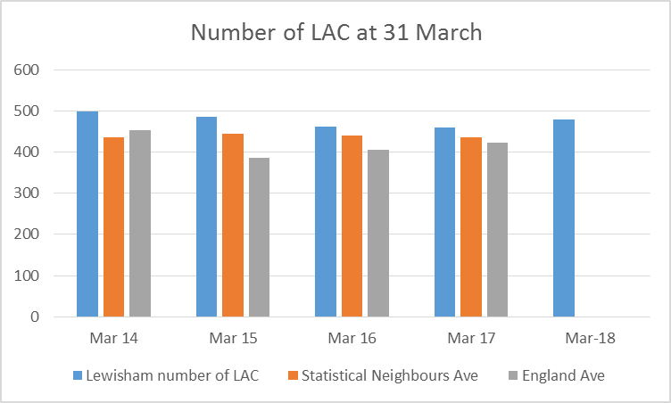

*Figure 3 Number of LAC at financial year end*

* 1. Numbers of Looked After Children in Lewisham have been traditionally higher than both statistical neighbours and the England average. The comparative data for 2018 is not available at present. The number of looked after children has risen in Lewisham and at 26th June 2018 the number had risen further to 492. This can create pressures on both the Social Work and the IRO services in ensuring that children’s placements are well sourced, promote wellbeing and stability in relation to their health, educational and emotional needs.
  2. The table below demonstrates the year on year reduction in the LAC population locally per 10,000 of children and young people in the general population 2014 to 2017. At March 31st 2018 the number had increased. The data is showing an incremental rise to children and young people received into care over the year. Discussion is taking place between looked after and front line services to review the rise of Looked After Children.

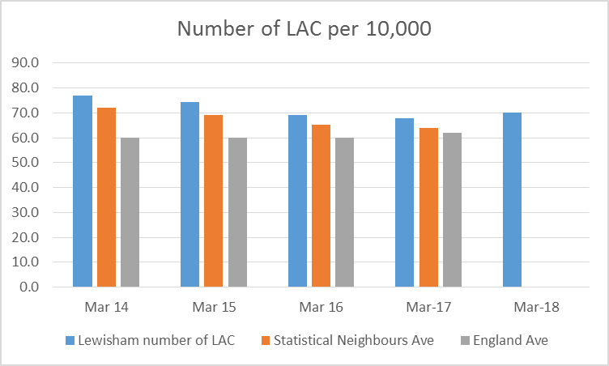

*Figure 4 LAC Population per 10.000*

* 1. The following information indicates the numbers of Looked After Children by age group. As can be seen, the highest proportions of our LAC population are in the older children and adolescent categories (10 to 14 years and 15 to 17 years). In the year 2016/2017 the 0 to 4 age group was the only one to decrease.
  2. The increase in the adolescent population, who often are accommodated as a result of family breakdown or challenging behaviours has led to specific challenges. Maintaining placements for an older LAC population requires both the Social Work and Placement teams and the IRO Service to ensure that placements are resilient, that care and pathway planning is effective in preparing young people for independence and transition to adulthood. Those children accommodated in early years are more often subject to Care Proceedings necessitating the IRO working with social work colleagues to ensure good permanency planning and working to the CAFCASS/IRO protocol.



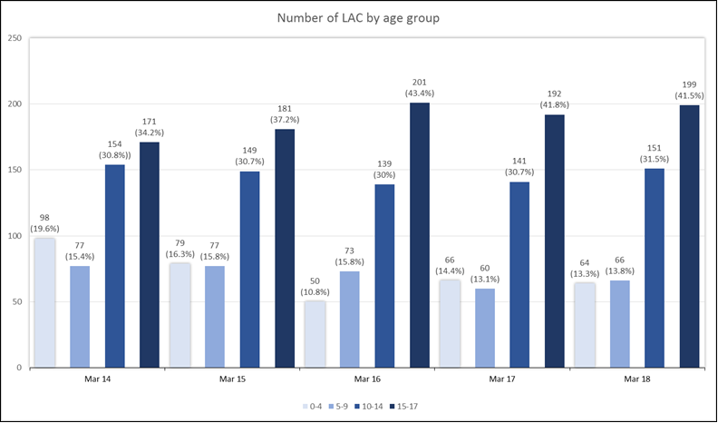

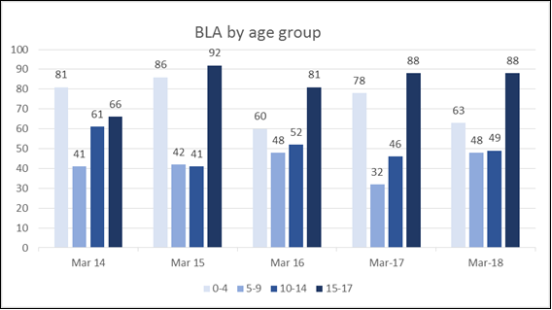

|  |  |  |  |  |
| --- | --- | --- | --- | --- |
| BLA by age group | 0-4 | 5-9 | 10-14 | 15-17 |
| Mar 14 | 81 | 41 | 61 | 66 |
| Mar 15 | 86 | 42 | 41 | 92 |
| Mar 16 | 60 | 48 | 52 | 81 |
| Mar-17 | 78 | 32 | 46 | 88 |
| Mar -18 | 63 | 48 | 49 | 88 |

* 1. The information above shows the age children became looked after. The highest numbers are age 0-4 and the 15-17 year group. In 2017 -18 there were fewer children becoming looked after in the early years, a drop of 15% but an almost equal increase of 16% in the 5- 9 age range. This begs the question whether we are successfully supporting younger children to remain at home only to become looked after when older. Those at the older adolescent stage come in to care for reasons related to acute family stress, community safety concerns such as going missing, sexual exploitation and criminal/gang involvement, or when family circumstances reach crisis point and breakdown. There are also a number of unaccompanied asylum seeking children who are most often in this age group
  2. The proportion of Looked After Children by ethnicity is shown below for the years 2014 to 2017 and then for the year ending 31st March 2018. The proportion of children and young people who are classified as from Black African/Black Caribbean/Black “Other” heritages continues to be the predominant population within the LAC cohort- but with a 3% decrease since last year. Those children and young people who are classified within the White British/White Other strand including those from Ireland and Europe has seen a very small .6% increase but has been constant within a 1-2% range since 2014. Similarly with that group of young people who are classified as of Multi heritage. Young people of Asian heritage also fluctuate within a 1-2% range but form a much smaller cohort within the wider LAC population. A further very small group has not self-identified or been categorised within an ethnicity banding.

|  |  |  |  |  |  |
| --- | --- | --- | --- | --- | --- |
| **% of LAC by Ethnicity** | **BLACK** | **WHITE** | **ASIAN** | **Mixed Heritage** | **OTHER** |
| Mar-14 | 37.8 | 31.2 | 5.4 | 21.6 | 4 |
| Mar-15 | 39.9 | 32.7 | 6 | 18.1 | 3.3 |
| Mar-16 | 41.3 | 30.9 | 7.1 | 19 | 1.7 |
| Mar-17 | 41.0 | 30.3 | 5.0 | 21.4 | 2.4 |
| Mar – 18 37.9 30.9% 4.3% 23.2% 5% | | | | | |
|  | | | | | |

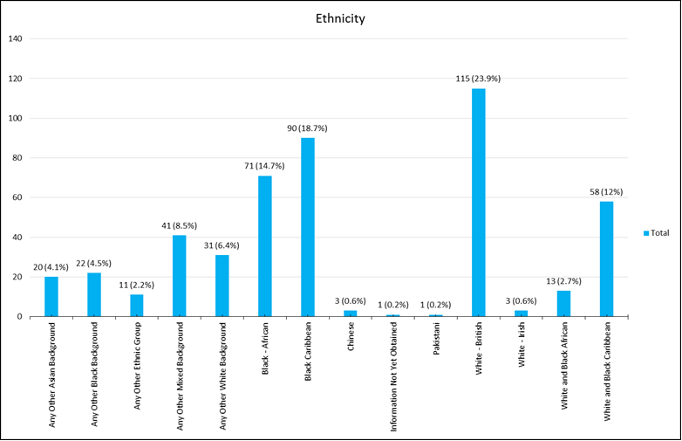

*Figure 8 Percentage of LAC by ethnicity*

* 1. This range of needs represented by a diverse LAC population again has implications for IROs in ensuring that placements for children and young people are attentive to and address the cultural needs of our LAC population. This is addressed through appropriate care planning and subsequent review of these needs and how they are met, by the IRO Service, working with the social work and placement teams, of these needs and how they are met.
  2. The age profile of the White British groups in Lewisham is older than the other ethnic groups with significantly larger proportions of young people amongst Mixed and Black or Black British groups. This is likely to contribute to there being a higher proportion of young people from combined BME communities within the Lewisham LAC population.
  3. The ethnicity of looked after children reflects the Borough’s school age population quite well. We do not have available data for the whole under 18 population. Each ethnic category –White, Asian, Black and Other are slightly lower compared to the school age population. The exception to this is those recorded as of mixed or multi ethnic heritage. They are over represented in care compared to the school age population by 7.8 %.

5.11 At 31st March 2017, 7 % of the looked after population were Unaccompanied Asylum seeking children and young people. Some of this group present direct to a Lewisham agency and some are referred to Lewisham on the Croydon Home Office rota system. The care and planning for this group needs to be tailored to their specific needs including support related to their past - trauma therapy, search for relatives, legal support, language and education as well as adjusting to a different culture.

1. **Placement Type, Permanency and Stability**
   1. Permanency and stability are twin priorities for IROs in ensuring children are well looked after and able to grow into happy and successful adults. When a child or young person becomes looked after they need to live in the environment that will best meet their needs. The IROs ensure there is a permanency plan for each child. Until this is determined through assessment, work with the family and the outcome in some cases of care proceedings, there will be a parallel plan in place to ensure there is no delay whatever the final plan is. If the child does not return to family care there will be a plan for permanency in care or through adoption. For most this will be permanency within a fostering setting where the child can grow up feeling that they are accepted as part of the family, will be supported and that they have a sense of belonging. This can become a matched placement signifying to all that this is the child’s home until they have a plan to move on for example into independent living. For some children foster care can be difficult due to their own experiences within birth families, impacting on their ability to settle and thrive within a family-based setting. For some children particularly in the adolescent age range, who have not had clear boundaries or have become involved in a lifestyle where their main attachments are outside the family perhaps in a negative peer group, similar problems that occur within birth families can emerge in fostering settings. For some of these young people a residential setting may suit their needs better.
   2. Some children are in specialist placements due to specific needs as a result of a disability or other complex need. For some young people Looked After status can come as a result of a period on Remand within a Youth Justice setting. There is a distinct group of young people who present as in need of support after their 16th birthday and for whom fostering and residential settings may not be appropriate. These young people may be placed straight into a setting such as a semi- independent placement or supported lodgings where they can be supported to develop their independence. More recently children who have been looked after may “stay put” with their foster carer. Another growing group are those who are placed with family members under Special Guardianship Orders (SGO’s). For all of these children and young people the goal is a successful transition to adult life rooted in a stable and nurturing care experience. It is those outcomes that the Care and Pathway Plans seek to be the vehicle for and which the IRO seeks to guide.

**Fig 9. LAC Placement Type and in or out of Lewisham March 31 2018**

|  |  |  |  |  |
| --- | --- | --- | --- | --- |
| Provision (2017-18) | Inside LA Boundary | Outside LA Boundary | Total | % of all Total |
| Children's Homes |  | 36 | 36 | 7.50% |
| Family Centre or Mother/Baby |  | 7 | 7 | 1.50% |
| Independent Living | 3 |  | 3 | 0.60% |
| Placed for Adoption |  | 4 | 4 | 0.80% |
| Foster Placement With Relative Or Friend | 11 | 16 | 27 | 5.60% |
| Placement With Other Foster Carer | 146 | 196 | 342 | 71.20% |
| Residential Accom. not subject to Children’s Regs | 18 | 23 | 41 | 8.40% |
| Residential Care Home | 1 | 4 | 5 | 1.00% |
| Residential School |  | 5 | 5 | 1.00% |
| Secure Unit |  | 2 | 2 | 0.40% |
| Young Offender Institution |  | 8 | 8 | 1.70% |
| Grand Total | 179 | 301 | 480 |  |

* 1. The majority of children are in foster placements provided either in house via Lewisham foster carers or by independent fostering agencies or with relatives. In common with many London authorities placement sufficiency in-Borough is an ongoing issue due to the availability of in-house carers who are able to care for young people with challenging needs and those who have the room to care for sibling groups. The impact of Independent Fostering agencies and the proximity of other authorities is also a challenge for London Boroughs. These areas of challenge are being addressed locally by the Fostering and Placements Service through targeted recruitment activity and sourcing of placements to meet children’s identified needs.
  2. Lewisham has invested in our placements service to increase Family Finding capacity, to enhance long term matching; search capacity, to ensure that we are rigorous in our search for a good match for individual children’s needs and placement choice and a contracts officer to add further rigour to placements providing good value for money, deliver on service specifications and meet specified outcomes. We expect continued improvement through 2017/18 as our Commissioning and Sufficiency Strategy actively addresses those areas where we have identified a need such as engaging with London Care Services to ensure the widest possible range of services are available through their framework. Engaging with regional partners in South London to explore alternative delivery models and options for joint working whilst continuing to develop a high quality in-house fostering service. Through targeted training we are enhancing the capacity of in house foster carers to meet the complex needs of some of our young people.
  3. Placement stability is always a focus for IRO activity as children need a permanent stable base and a sense of belonging if they are to flourish. IROs monitor the stability of placements, and when placements appear fragile ensure that support is planned and in place to attain this for each child. The IRO ensures that there is a clear placement agreement setting out expectations for the carer and the young person. At the Review of the Care Plan detailed discussions take place about how far the placement is continuing to meet the child’s needs, whether the child or young person is unhappy in any way with their placement, and whether there are any strains and needs of support for the carers so that these can be attended to. Despite this, placements do break down for a variety of reasons including that the placement is not a good match for the child. One challenge we have for a small number of young people is engaging them with the support or key-work on offer when they become looked after in order to develop more positive futures and prevent them absconding due to the pull of previous lifestyles which may lead them back into exploitation and /or offending. It can take years of support, building relationships and alternatives and intervention to successfully break these cycles. 10% of children and young people had experienced placement breakdown in the previous year (2016/17) and this remained stable in the year 2017 -18. This remains below the statistical and England averages as outlined in the chart below***.***
  4. Lewisham is meeting its target for Placement stability. The children and young people with three or more placement moves in a year are predominately teenagers who display a number of complex and challenging needs as a result of earlier childhood experiences and safeguarding concerns. In all cases individual care plans are reviewed and agreed by the independent reviewing officer to ensure everything is being done to promote and achieve stability.

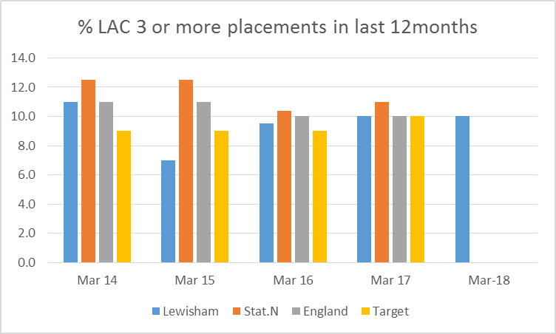

*Figure 10 Children with 3 or more placements*

1. **Performance, Scrutiny & Challenge**
   1. Timeliness of reviews

7.2 99.1% of Looked after children’s Reviews were held within timescales. The few which were late were due to a delay in notification to the IRO team or the need to reschedule to a later date. Two initial Reviews were late due to a query whether children provided placement for 38 weeks in a residential placement during term time should be considered looked after children.

7.3 Key areas of IRO activity include ensuring that reviews are held in timescales set out in guidance (the [Care Planning, Placement and Case Review Regulation, 2010](http://www.legislation.gov.uk/uksi/2010/959/pdfs/uksi_20100959_en.pdf)) and ensuring that concerns in respect of delay and drift to care planning are escalated appropriately. The graph above shows the former national indicator NI66 (% of LAC Reviews in timescale). Comparative national and regional data is no longer available for this indicator as it is no longer reported nationally, but the figures above demonstrate that local performance has been maintained.

* 1. Escalation of Issues Regarding Children Looked After
  2. Lewisham’s IRO Service utilises a quality assurance model that uses both monitoring and escalation to highlight issues which may require redress and attention either from the social worker or varying levels of management.
  3. IROs highlight and detail concerns and through the use of a RAG rating system which flags up children where swift action is needed. The details are noted on the post review monitoring form, placed on the child’s records and the team and service manager notified so that action to address the concern is progressed for those cases rated at Red or Amber. Examples of these concerns are:

1. Gang related activity - suspicion that young person is involved in drugs related activities and may be running “county lines”. Care Plan is appropriate but choosing not to engage with the support available. IRO will monitor progress.
2. Missing Episodes, Risk of Sexual Exploitation, and Health Concerns including substance misuse / physical/emotional/mental health. There has been significant improvement in Secure Unit, does excellent Education work, however needs to be found a move on from Secure.
3. Delay in completing records and reports in the ICS electronic recording system.
   1. Following the Reviews, IROs target cases for active monitoring. This signposts that informal escalation is needed on some aspects of the work being undertaken. Cases rated Amber or Red indicates that there is concern about a child or the plan to address these concerns is not yet adequate in the IRO’s view.

|  |  |  |  |
| --- | --- | --- | --- |
| **% of Informal and formal Escalation for Looked After Children to end of March 2018** | | | |
|  | **Informal escalation (active monitoring)** | **Formal Escalation** | **Total Number** |
| **%** | |
| Total of Reviews where IRO has escalated a concern. | 52% | 5% | 57% |

*Figure 11 Escalation by %*

7.8 Some of reasons behind the formal escalations in 2017/18 include the following:

* Delay in getting a passport for a child to enable them to go on holiday with their foster carers.
* Delay in achieving permanence through having a matched foster placement.
* Delay in doing Life Story work with the child to give an understanding of why they are looked after and to support their identity.
* Delay in initiating Care Proceedings.

Concerns are highlighted with the relevant service areas and work undertaken to resolve the immediate issue or to look at other wider service issues.

7.9 Escalation of themed Issues to senior management level

IROs have a responsibility to bring themed concerns to senior management attention. In Lewisham this is done by collating individual monitoring form information into a monthly report which is presented at the senior management team meeting. This provides a clear and regular account of practice standards as well as issues or concerns which have led to cases being formally escalated.

7.10 Issues raised by the IRO team this year have included:

* The need for IROs to receive documents related to children in care proceedings and attendance at legal planning meetings
* Better coordination of inter-agency communication, planning and action for young people at risk of Child Sexual Exploitation, Missing and criminal/gang involvement.
* The importance of establishing a child’s nationality and immigration status.
* Issues around the quality and sufficiency of placements.
* The need to ensure continuity of social work when transferring from one social work team to another.
* Need to improve timeliness of social work reports for the child’s Review.
  1. The wellbeing of, and services delivered to, looked-after children for the year ending 31st March 2018.

7.12 The table and graph below is taken from the IRO monitoring forms for LAC Reviews. There are a proportion of cases (8%) where the Care or Pathway Plan does not appear to be based on an updated/current assessment of need at the time of the LAC Review. In these situations the IRO will escalate the issue to the social worker and team manager for action as it has a critical impact on the Reviewing process.

7.13 Overall, care planning for Looked After Children ensures that children have an updated care plan based on assessed need, children and young people are aware of the content of their care plan and, importantly, the majority are satisfied with their Care Plans being 75.6%. In those situations where young people have expressed dissatisfaction with the Care Plan, the IRO will discuss their concerns and discuss any remedy with the social work team. A recommendation that the young person has access to an independent advocacy service, such as our commissioned service at Coram Voice, is also an option.

|  |  |  |
| --- | --- | --- |
| **Care Planning for Looked After Children** | | |
| **% of Children** | **Yes** | **No** |
| Updated Care Plan based on Assessed Need | 88% | 12% |
| Is the child satisfied with the Care Plan | 75.6% | 16% |

*Figure 12 Quality of Care Planning*

|  |  |
| --- | --- |
|  | |
| Poor and / or Requires Improvement 27% | **Good and/ or Outstanding 73%** |

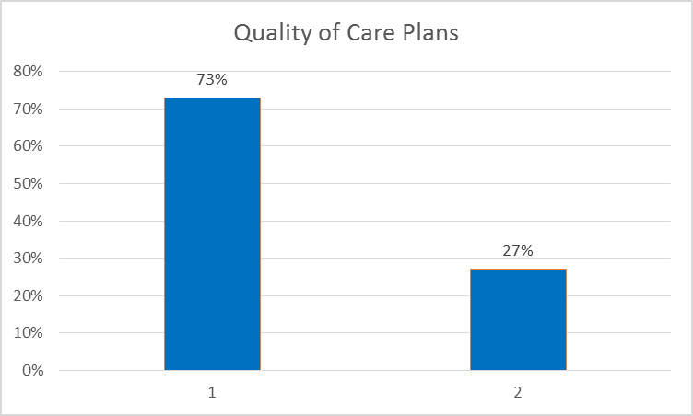

*Figure 13 Care Plan Quality*

7.14 The above graph shows that the majority of care plans (73%) are deemed to be of good quality. A proportion were graded by the IRO as requiring improvement or poor (27%). Where this has been the case, the IRO will highlight this both with the social worker and Team Manager asking them to address identified areas of deficit in a timely way. The findings in 2016/17 demonstrated an improvement in the quality of Care Plans, which was an identified area for priority action within Children’s Social Care, with 83% being noted as good quality. 2017/18 data indicate a decrease in performance with 73% of Care Plans noted as of Good Quality. This will need to be tackled. The improvement needed will be a result of work across social work services and the IRO team bringing clarity about standards expected and the provision of briefings and training sessions. This is in addition to the regular informal and formal escalation by the IRO team and the presentation of monthly performance data to the senior management team in the IRO monthly monitoring report which identifies area for review and where necessary improvement.

7.15 As outlined previously there is a dedicated work strand that is looking at Placement Sufficiency.

7.16 Work is also being done around timely transfer between teams. This includes the roll out in July 2017 of a new Transfer Protocol to provide the transfer framework.

7.17 Investment in digital upgrade and how this impacts on the availability and accuracy of performance data also enables services to actively monitor the quality of the delivery to looked after children and young people was noted in 2016 -17. In the financial year 2017-18, the corporate Digital Transformation Programme provided social workers with the tools for mobile working, implemented a Child Protection Information Sharing system which facilitates better data sharing with NHS unscheduled care settings, and saw all Children’s Social Care staff receive comprehensive refresher training on the case management system, LCS.

* The priorities for the Digital Transformation Programme going forward include: implementing a better system at the front door to Children’s and Young People’s Services
* improving end to end financial processes and systems for Children’s Social Care introducing new, more sophisticated performance management tools for use across the directorate in order to make better use of performance and management information.
* a planned review of LCS forms. Re-designing LCS forms and workflows to streamline processes, making it easier for social workers to use the system
* the development of an online portal to support foster care engagement. This would be a key digital enabler to proposed transformation around fostering and residential care.

1. **Participation of Children & Young People, and parents.**
   1. When children and young people come into the Council’s care they are provided with an information pack, which includes the Lewisham Pledge to Looked After Children which gives the following assurances:

* To have a named Social Worker
* To have a care plan all about them and their needs
* To review the care plan with them and regularly check that all is well
* To have a named IRO
* To involve children in decisions about them
* To give children in care the same chances as each other and other children and respect their different needs and treat them equally
* To listen and respond if they are unhappy about their care
  1. The IRO has a key role in representing the wishes and feelings of young people within the Review setting and holding the social work service and other parts of the children’s partnership to account. Advocacy can be an essential addition for some children and young people and these processes can make a vital contribution to safeguarding and promoting their welfare and rights.

* 1. IROs routinely check that children and young people know about how to access advocacy services and how this service can support them in having an alternative voice represent them in the decision-making affecting their lives. Likewise IROs ensure that children and young people know how they can make a complaint and who they can complain to. 66 children and young people used the advocacy service in the year up to 2018. 54% were female and 44% male with 2 % of unspecified gender. 32% of young people represented by an advocate are noted as having a disability. In most cases this would be a learning difficulty including autism.

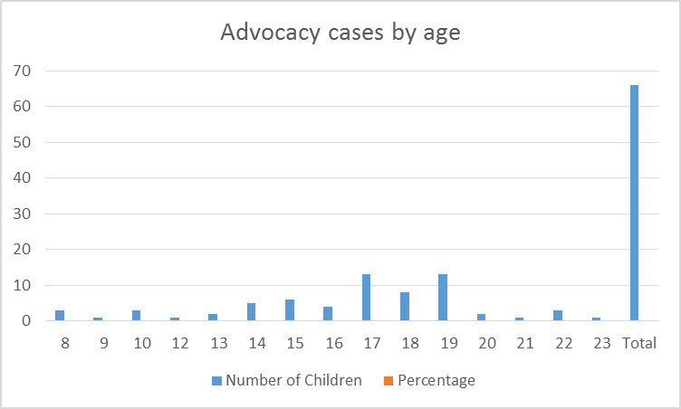

8.4 Advocacy cases by ethnicity show a very similar pattern to the ethnic spread of our looked after population showing that they have had fair access to this service.



* 1. In Lewisham the Child in Care Council (CICC) is active and one of its activities is surveying children’s views. The IRO team work together with the CICC to learn about how they can best support children in care and respond to their views. Children’s views about their statutory Reviews vary greatly; some would prefer not to have them at all as they feel this emphasises their difference to other children. Some children and young people are very keen to be fully involved and participate by setting the agenda. The IRO team manager visited the junior child in care council to gain their views about their Reviews and to gain ideas about any improvements we can develop. The four children present said they didn’t want Review meetings as they didn’t like to tell everyone their business. On the other hand they all knew who their IRO is and said they like them and told stories about what their IROs did with them e.g. playing on the trampoline, listening to their poems etc. This highlighted for me the difficult task of ensuring the children ranging from 0 to 18 are comfortable and engaged with their Review and able to express their views at the same time as ensuring that the adults, parents, family members, carers and professionals are also involved and participating and that the important decisions are discussed and Reviewed. Lewisham IROs really try to focus on each individual child and young person they are responsible for in order to work out how best to engage them. One IRO has discovered that she can engage with some young people who are feeling angry and generally not wanting to be in a meeting by taking her shoes off and quietly pulling on her unicorn slippers. One 15 year old recently in secure accommodation and caught up with gang and criminal exploitation rolled around in laughter when the socks appeared. The importance of the IROs ability to engage with children and young people is not only to hear their views about their Care Plan and find out how they are doing but as an added safeguarding and conduit to share. For example young people have been able to tell IROs over the past year that they are not happy in their placement, that for one young person his Muslim identity as not being respected and for one young person was able to share that he is gay for the first time.
  2. For young people in the transition period to leaving care the Review is of great importance in confirming the type and level of support they will need to promote a successful transition to independence post-18. For younger children whose future may be being considered within court proceedings and who do not know whether they will be remaining in care or returning home, the Review can be a helpful arena to ask questions, explore the care plan and find out what people are thinking and saying.
  3. The IROs in Lewisham are acutely aware of the need to positively engage children and young people in their Review. An individual participation plan for each young person is drawn up which ranges from seeing a child outside of the meeting, to the young person leading the meeting. Alongside this the IRO facilitates the participation of parents and the range of professionals involved, to provide the young person with an enhanced experience where perhaps for the first time they are truly listened to throughout the planning and review process by all involved. There are regular discussions within the team about how to talk with a child in a meaningful way without asking too many questions and garnering views without the child or young person feeling quizzed. An example in response to children’s feedback that reviews can be boring was to ask the child to describe what was most important to them within the review. The important next task is to ensure this is carried through in the discussion and in the decisions.
  4. One IRO has begun a special focus project aimed at enhancing the participation and gaining the wishes and feelings of children with communication difficulties. In this she is working with an advanced practitioner from the Complex Needs social work team.

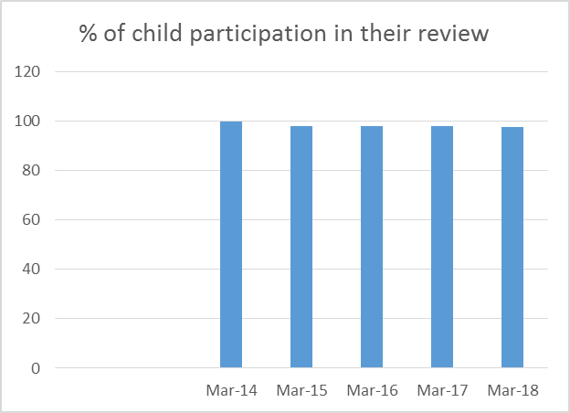

*Figure 14 Participation by LAC*

* 1. As can be seen from the above chart, performance has been stable from 2014 to 2018. Of the children at the end of the year 2017/18, only 2.5% did not participate in some manner. Sometimes this is because they were missing at the time of the Review. The children who are recorded as not participating will be analysed for the reasons so that a participation plan can be tailored for them. Everything possible is done to encourage children and young people to participate in their reviews and IROs will speak to children before, during and after reviews to garner their views and thoughts on how well they feel that their placement is meeting their needs. If a child or young person cannot attend their Review the IRO will try to visit them separately or contact them by phone or some other method. Children and young people are encouraged to complete an online consultation which is accessed by the IRO prior to the Review. This provides a valuable insight into what is happening for the child, what needs to be focussed on in the review and enables the IRO to represent the wishes and feelings of children who may have more difficulty in speaking out. The social work report and Care Plan will also include the child’s voice and a range of audit activities seeks evidence of continual dialogue with children and young people about the plans being made for them.
  2. One example of children fully participating in the Review of their plan was a 15 year old was able to give his views on how he is doing emotionally, at school, in leisure –wanting to join a basketball team and enjoying being a mentor, in developing skills –wanting to do more cooking, in contact with family –wanting a response from his father, to have more unsupervised time with his Mother and to see his half-brother. When a young person is able to participate in this way the resulting Care Plan can be really effective in addressing the needs of a teenager in care who is doing well but who in developing his independence and identity needs good support to continue his positive development and avoid the pitfalls.

8.11 The IRO of one 13 year old boy notes in his review report that:

*He spoke one on one with the IRO and thereafter participated throughout his review meeting where he led most of the conversations including what seemed to be a 'trip down memory lane' for him and his social worker allocated since 2011 (at which time he was approximately 7yrs).*

8.12 IROs encourage children and young people to voice what is most important for them and this becomes a starred decision. One 17 year old’s starred decision, which he was able to discuss at his Review, was to have unsupervised overnight contact with his Aunt. This was discussed and agreed. His Aunt is also to be involved in supporting his life story work.

8.13 A 15 year old girl: *Before the Lac Review I contacted xxx to let her know she can decide (as usual) how she wants to participate. Last time she had laminated flash cards that we used as the agenda for her meeting. This time Molly wanted a pre-meeting discussion with me, she attended the full meeting and she brought a list that was typed up and neatly cut out with patterned scissors. The only time during the meeting that she wanted to go for a smoke break was after we discussed her current relationship with her sister.*

8.14 Post Review survey of children and young people.

At the end of the year the IRO team sought feedback from children and young people following reviews in order to evaluate how we improve our service. Overall their experiences of their Reviews were positive. However, Young People also recommend that the meetings are less formal and that we talk about different subjects of interest to them so that it does not feel as if they are just asked a number of questions. The comments about what IROs did well included: Felt listened to, the IRO was nice, the IRO was friendly, the IRO wants to help me, the IRO gave me good advice, I felt supported, the IRO turns up on time.

8.15 The suggestions for improvement were to make the meeting less formal, for the meeting not to be a discussion between a bunch of adults which x felt had to agree with, should be more a general discussion about life issues rather than a specific questions. The outcome of the survey will be discussed and the IRO team will continue to consider how we can tailor Reviews to the needs and wishes of the children and young people. One important way is to ensure that the child’s participation is discussed before the review with the social worker and carers in the context of the child’s wishes. One dilemma is that although it is important for children and young people to participate in the Review they can entail some rather “boring” but important discussion between adults. The best way to manage this can be to have split meetings and IROs do this quite a lot but there is a time cost. There is also the question that parents often also need separate meetings with the IRO to be involved in a Review.

8.16 This survey and the questionnaires completed by IROs after Reviews are a rolling process with a view to continuously consult young people about how we can conduct their views.

8.17 Life Story Work

Ensuring that children and young people understand their life story and why they came to be in care has been a focus for IROs over the past year. The IROs address life story work within the child’s Review to ensure it is taking place. The above example of the 17 year old illustrates the good work on this with the Review also noting that he has been supported to prepare an album that was put in the post to his family in Ethiopia. It took a long time to get there, but SW received an email from Ethiopia indicating the photo album has been received. SW has provided her contact details for birth parents to be able to send a letter and photos to the young person. The Review report for a 15 year old notes that: *Life story work has been started and a timeline has been developed which xxx and his mother have contributed to – foster carer has also been asked to contribute to this*

8.12 Involving the Parent

This has also been a focus of the team over the past year and will continue. Parents have a right and responsibility to participate in their child’s Care Plan and review. The parents can be very involved if the plan is being discussed in court proceedings but can also be contentious. When some teenagers become looked after due to difficulties in parenting there can be a break down in child parent relationship and although the plan may be for the child to return home, the parent may not want to work to this plan. Later once the permanency plan is determined through a Care order and the child is in a permanent foster placement or in a residential placement it is essential that the parents and other family members are encouraged as long as appropriate and safe , to be involved in their children’s lives and the planning for them. The IRO team is working with the Fostering service to promote good working between carers and parents and feeling comfortable with the Review taking place at the child’s foster home with their parents also in attendance. Where this is not possible or appropriate the IRO needs to meet or communicate with the parent separately.

Example of IRO engaging parents: *I also spoke to the parents as part of the LAC review process, I asked for the special curried goat recipe that xxx (child) asked for but Dad said he cannot write this down he has to tell carer in person so she knows how to do it right. I also told the parents that it has been confirmed the boys are staying with x and x and that the carers will continue to receive support from their agency to meet the boys’ needs; Father thanked me.*

1. **Areas for Improvement for IROs 2017: Update**
   1. The IRO Service continues to evidence strength in the timeliness of reviews, their encouragement of children and young people’s participation in reviews and case monitoring and quality assurance between and at the point of review. The Service however is not complacent and have identified the following areas for further development.

* Completion of monitoring forms on LCS. The IRO Service reports to SMT monthly on the outcomes from monitoring activity on children and young people’s care planning needs. The service has worked with the Digital Transformation Team to develop a revised monitoring form which will go live from July. This will assist in providing enhanced data/reporting on themes to senior management.

*The revised monitoring form embedded in the child’s records went live. The IRO team manager continues to report to the senior management team on a monthly basis, collating information from the monitoring.*

* IRO Liaison across Children’s Social Careto highlight and address areas of mutual concern and development, for example, input to Placement Scrutiny Panel, Permanence Planning Meetings and Legal Planning Meetings. Our aim is to assist in preventing delays to care planning, improve the quality assurance of placements and promote placement stability and promote wider (health, education and personal) outcomes for children and young people. We have introduced link IROs to provide consistency and expertise to these activities. The service also provides training to develop understanding and support aspirational expectations for our planning for children and young people. This is targeted at newly qualified social workers and students social workers currently but we envisage a wider take-up from more established social workers also.

*The IRO team manager has continued to attend Placement Scrutiny panel where scrutiny of new and increased cost placements is given. The IROs views are included for the children being presented to this. The IRO team manager chairs the permanence planning meetings where between the child’s first and second review we ensure there is a permanency plan in place with parallel planning to prevent any drift in achieving permanence. The IROs attend legal planning meetings where possible and give their views if not available to attend. We have stopped having link IROs with social work services, instead we have introduced IRO team manager/service manager interface meetings.*

*IROs continue to offer briefings on Care Planning and Review expectations. This has included individual sessions as well as group. One IRO delivered a training session to a group of AYSE social workers. There was some really positive feedback from the attendees who said that the information the IRO shared was very helpful to them. The service manager for children with complex needs service requested an IRO floor walk to her service once a month and this is also now taking place. Instead of being links for different social work services IROs now take on short focussed projects to enhance specific practice areas.*

* Enhanced representations. We are working with colleagues in Legal and operational Social Work services to ensure the IRO is supported to give informed views in Care Proceedings; through participation in Legal Planning meetings and awareness of the outcomes of Assessments and Directions ordered by the court.

*This continues to be in development but has seen improvement. IROs are usually invited to legal planning meetings but the sharing of the legal documents needed to develop an informed view of the Local Authority Care Plan needs to be improved.*

* Increased consultation with children and young people in between reviews to ensure their understanding of the purpose of care planning and involvement in the process. *This is not possible on an individual basis given the resources available. However the IRO shares their contact details with the children and young people they Review to encourage communication when wanted and the social worker has a responsibility to ensure the child understands the Review process and is prepared for it. We aim that by working with CICC and Fostering groups we will be able to enhance understanding of the review process and the importance of being involved in it.*
* To ensure that a greater number of young people are supported to chair their own reviews and explore the use of new media platforms for enhanced participation and consultation activity. *Lewisham IROs have only found a small number of young people wanting to pursue this but in these cases the young person is fully encouraged. Increasingly IROs use other media options such as WhatsApp to message young people.*

* 1. CSC Areas for review based on IRO monitoring 2017 : Updates

9.3 Placement sufficiency and stability – this is being addressed in the Placement Strategy Review

*The London Borough of Lewisham aims to have a wide range of placement provision in order to most appropriately meet the health, educational and social needs of our looked after children. The Commissioning and Sufficiency Strategy 2017-19 sets out how the Council will meet its sufficiency duties under Section 22C of the Children Act 1989 and details the current and future needs of young people in the Borough. The CYP Joint Commissioning Team is responsible for commissioning arrangements for placements and support services for looked after children and care leavers; the role of the Joint Commissioner for Looked After Children is to ensure that the Council has access to sufficient placements, which offer good quality whilst provide value for money. The Council is a member of London Care Services Framework for residential and Independent Fostering Agency (IFA) placements. A local preferred provider framework is also in operation for IFAs and semi-independence accommodation; these are due to end in October 2019 and 2018 respectively. The benefit of using frameworks for placements is to ensure clarity, on cost and quality, for local authorities and providers. A new framework is currently in development in partnership with the Royal Borough of Greenwich for semi-independence placements, the new framework will incentivise good quality key work support and ensure that placements for those over the age of 16 are effective at supporting transition to independent living. The London Borough of Lewisham is a member of the South London Commissioning Programme (SLCP), formed of 8 local authorities primarily in the South East of London. From April 2019, the SLCP will implement an integrated commissioning solution across all 8 boroughs; it is expected that this commissioning solution will improve value by removing competition between local authorities and improve quality by affording greater market control to local authorities due to economies of scale.*

* 1. Continued focus on the clear and coordinated response to young people with increased vulnerabilities through missing episodes, exploitation via gang activity and criminal involvement. Activity through the MET(Missing, Exploited & Trafficked) multi-agency forum identifies particular vulnerabilities and the IRO Missing Strategy meeting when looked after children go missing reviews the particular issues associated with a young person, including additional vulnerabilities such as CSE or gang affiliation.

Over the past year a consultant has been reviewing these processes and new procedures and training implemented. A report on this The CSE and Missing Children Annual Report 2016-17 has been submitted to the Lewisham Safeguarding board in June and provides detailed information.

Child Sexual Exploitation: It reports that Lewisham’s data in relation to CSE reflects to a large extent the national trends. Whilst all children are vulnerable to CSE, certain factors tend to increase their vulnerability regardless of their background, age, gender race, sexuality or wherever they live.

The NSPCC research indicate that these risk factors include;

• A history of abuse, particularly sexual abuse

• Recent bereavement or loss

• Homelessness

• Low self-esteem or self confidence

• Being a young carer

• Being in or leaving care

• Links to a gang through relatives, peers or intimate relationships

• Living in a gang affected neighbourhood

• Lacking friends from the same age group

The CSE profile for the borough has developed significantly in the last reporting year. Peer on peer abuse if the most prevalent form of CSE, and the important role of schools in providing PSHE and input regarding healthy relationships is vital in partnership with parents, and multi-agencies to safeguard all children effectively. There is evidence of good partnership working and good outcomes for the children involved.

It is noted that the department has developed a new CSE protocol, a new LCS recording module, and provided briefings to staff in relation to this.

Missing from Care:

The report notes that Lewisham’s children are currently three times more likely to go missing from home than from care.

Reasons why children go missing:

Feedback from St Christopher’s, which is our Commissioned Voluntary agency for children who go missing, has revealed some useful information received directly from children about the reasons they go missing from Care. The most common reasons given are:

• to be closer to family and peers (LAC placed out of borough/London)

• struggling to cope with family dynamics (LAC returned to family)

• to flee DV or family tensions

• to spend time with boyfriend

• County Lines/Trafficking

• CYP not feeling to be listened to by SW and other professionals. Feeling let down by ‘the system’

• CYP wishing to be more involved in the decision making regarding his care plan.

9.5 YOS/LAC interface meetings which the IRO team manager participates in are held quarterly and are a helpful forum for examining and progressing joint areas of practice which may need attention.

* 1. Further scrutiny on the quality of social work reports for children’s statutory reviews, targeting the presence of the child and parent’s views, timeliness and relevance to the child or young person’s lived experience. The IRO team will continue to raise this as relevant on individual cases and on a collated basis to monthly senior management meetings. IROs will continue to offer briefings, individual and team training sessions and consultation on expected standards. Children’s Social Care Social Work services will undertake planning improvement action through performance management and social work supervision.

*This will continue as part of the IRO team Ensuring Standards plan. The quality of Care Plans will also be included in this.*

* 1. CSC areas for improvement based on IRO monitoring 2018

Improvement in communication and clarity of procedures.

IROs have raised the need for timely response to their communication which may include queries relating to quality assurance and relating to Review arrangements.

IROs have raised the need for clear procedures to be confirmed throughout the department relating to for example the matching of permanent placements, the chairing and process for missing from care, exploited (see S9.4 in relation to the new protocol that was developed for child sexual exploitation) and trafficked children, the care status of children in a placement for 38 weeks.

* 1. The transfer process

IROs have raised the need for a smooth transfer of responsibility between social workers and social work services to ensure that there is no delay in children and young people receiving the support they need or in progressing their plans and agreed actions.

9.9 The IROs are raising the need for social work and fostering services to work with them to ensure that the Care Plan review process for looked after children and young people is effective.

This includes:

* having a good Care Plan shared with all
* a good assessment and analysis of progress
* any changes needed reflected
* the child and parents view’s present in the Review report
* timely social work review reports
* pre review preparation between social worker and IR)O social worker and child and parent, supervising social worker and foster care.

1. **IRO plan for 2018 to 19**

Team statements of intent

1. **Ensuring standards** (Back to Basics):

Ensuring effective Reviews and Care Planning

1. **Empowering through Relationships**

10.1 To develop practice standards throughout the department.

e.g. monitoring, quality assurance including positive feedback, briefings etc.

10.2 The IRO team held a team day in January when we reviewed how we are doing, what we do well and how we think we can be more effective. Resulting from this we developed our two team statements of intent and targets for the year ahead.

* 1. Ensuring Standards

This came from the need to really ensure we are leading on and facilitating with our partners good standards in the Care Planning and Review process for children and young people. Sometimes when people are busy and resources are stressed these basic standards can be overlooked in the context of attending to high priority situations. However we know that if standards are adhered to children develop better more stable care and make better progress in all areas of their lives. This can also help to avoid crises developing for them and enable faster more effective responses when problems do occur. Therefor the IRO team is emphasising the need for good Review preparation, assessment of progress and changes needed to Care Plans, involvement of carers, children and family.

* 1. Empowering through Relationships

This statement reflects the knowledge that we can only achieve better outcomes together. Therefore we will continue our efforts to enable children and families to participate as fully as possible in their review. We will work with our social work and other partners by providing training and briefing, by participating in joint practice projects, by contributing to auditing, by providing both positive challenge and feedback on good practice and by raising themed issues of concern to senior management.

* 1. IRO Areas of Special Focus

These will be short term pieces of work identified within the team usually to explore an area of practice or understanding.

Looking at how other LA undertake LAC reviews specifically to consider the IRO review report and whether it could take the format of a letter to the child.

Clarifying Lewisham's CAMHS and Virtual School offer.

Creating a formal feedback loop for IROs to feedback their concerns about in-house and IFA placements to Lewisham's placements team

Understanding the new service areas in R&A and how we interrelate.

Young People running county lines –update on services and knowledge.

Obtaining the views, wishes and feelings of children with complex communication needs – developing practice and tools.

|  |  |  |
| --- | --- | --- |
| **Key activity/action** | **How will the Team work to deliver this key activity** | |
| 1. **Improve effectiveness of Reviews** | | **1. 1. No review without a PMR even if this puts the review out of timescale.**  **1. 2. IRO to focus on review preparation to promote engagement of SSW, ensure the SW has a clear plan discussed with their TM, ensure review arrangements are clear.**  **1.3.Promote participation of children and parents by ensuring SWs have prepared child**  **1.4 Promote involvement of parents in their child’s Care Plan and Review.**  **1.5. IRO special focus on gaining the wishes and feelings of children with additional communication needs.**  **1.6. Be robust yet helpful in feeding back quality of PMRs and Care Plans.** |
| 1. **Improvement in children’s emotional wellbeing and support available to child and carer** | | **2.1. Promote use of SDQ**  **2.2. Ensure SDQ outcomes are addressed in PMR and discussed at review if appropriate.**  **2.3. Ensure there is assessment and support in place if needed.**  **2.4 Discuss progression of Life Story work in the Review meeting.** |
| **3. Escalation of concerns** | | **3.1 Follow through and resolve formal escalations without delays.**  **3.2 Use Informal stage of QA escalation form to record areas of concern raised.**   * 1. **Use IRO monitoring title “Management alert” for areas of action needed.**   2. **Themed concerns raised with senior management team to be tracked and fed back.** |
| **4.Promote practice improvement through collegiate working.** | | **4.1. through interface meetings with service managers.**  **4.2. through IRO surgeries and briefings for students, AYSEs and new staff.**  **4.3 through IRO special focus projects.** |