Lewisham Nitrogen Dioxide Diffusion Tube Survey 2018
London Borough of Lewisham

Project Number: 60194269

May 2019

Quality information
Prepared by |  | Checked by |  | Reviewed by |  | Approved by
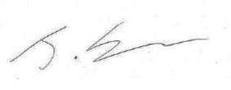 |  | 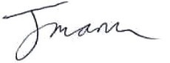 |  | 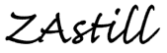 |  | 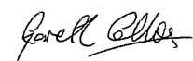
James Berman  Graduate Air Quality Consultant |  | Julian Mann  Air Quality Consultant |  | Zadie Astill  Senior Air Quality Scientist |  | Gareth Collins  Regional Director

Revision History
Revision | Revision date | Details | Authorized | Name | Position
01 | 29/03/2019 | Draft | 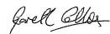 | Gareth Collins | Regional Director
02 | 30/05/2019 | Final |  | Gareth Collins | Regional Director

Distribution List
# Hard Copies | PDF Required | Association / Company Name

Prepared for:
London Borough of Lewisham

Prepared by:
James Berman
Graduate Air Quality Consultant
T: +44 (0)20 8639 3587
E: james.berman@aecom.com

‌AECOM
10th Floor, Sunley House,
4 Bedford Park,
Croydon
CR0 2AP

T: +44 (0)20 8639 3500
aecom.com

© 2019 AECOM Limited. All Rights Reserved.
This document has been prepared by AECOM Limited (“AECOM”) for sole use of our client, in accordance with generally accepted consultancy principles, the budget for fees and the terms of reference agreed between AECOM and our client. Any information provided by third parties and referred to herein has not been checked or verified by AECOM, unless otherwise expressly stated in the document. No third party may rely upon this document without the prior and express written agreement of AECOM.

Contents
1. Introduction 1
2. Legislative Background 2
3. Monitoring Methodology 3
3.1 Description of Network 3
3.2 Procedures and Site Changes 3
3.3 Tube Preparation, Analysis and Laboratory QA/QC 3
3.4 Factors Affecting Diffusion Tube Performance 3
3.5 Data Validation and Data QA / QC 4
3.5.1 Blanks 4
3.5.2 Rejection of Diffusion Tube Results 4
3.5.3 Bias Adjustment Factor 4
3.6 Site Designations 5
4. Results and Discussion 6
4.1 Data Capture 6
4.2 Bias Adjustment 6
4.2.1 Local Bias Adjustment Factor 6
4.2.2 National Bias Adjustment Factor 6
4.3 Annual Mean NO₂ Concentrations 7
4.3.1 Comparison with Limit Values and Objectives 7
4.3.2 Seasonal Variation 8
4.4 Historical Trends 9
5. Conclusions 10
Appendix A: Diffusion Tube Locations 11
Appendix B: Diffusion Tube Results 12
Appendix C: Diffusion Tube Bias Adjustment 15

Introduction
AECOM was commissioned by the London Borough of Lewisham to install and maintain a network of NO₂ diffusion tubes to assess the spatial variation of nitrogen dioxide (NO₂) concentration within the Borough. The diffusion tube network in 2017 comprised of 37 NO₂ diffusion tubes at 35 locations, one of which is a triplicate tube location with all others comprising a single tube. Since the start of 2018, 16 new locations have been added, and Stanstead Road (L25) has been decommissioned, giving a total of 50 monitoring locations. The diffusion tubes were exposed for periods of between 4 and 5 weeks in accordance with the UK NO₂ Survey Timetable. The results of the survey provide Lewisham Borough Council with valuable monitoring data for use in their Local Air Quality Review and Assessment (LAQM) process.
This report outlines the results of the survey for January 2018 to December 2018, inclusive. The spatial variation in NO₂ concentration throughout the Borough is discussed and the annual mean values for each location are compared against the annual mean objective for NO₂ to indicate locations that may be likely to exceed the objective. Monthly concentrations are examined for evidence of seasonal trends.

Legislative Background
Limit values and air quality objectives for nitrogen dioxide and oxides of nitrogen (NO_{X}) were set out in the First Daughter Directive (1999/30/EC) and subsequent revisions. An annual mean NO₂ objective was set at 40 µg/m³ to be achieved by 1st January 2010. A 200 µg/m³ hourly mean standard not to be exceeded more than 18 hours per year was also outlined, to be achieved by the same compliance date. These objectives were reiterated in the 2008 Directive on ambient air quality and cleaner air for Europe (2008/50/EC).
The UK has published its own Air Quality Strategy, which detailed the UK’s position on nitrogen dioxide. The UK air quality objectives differ from the European objectives only in their compliance dates; the UK objectives were to be achieved by the end of 2005. European and UK air quality objectives have also been set for oxides of nitrogen for the protection of vegetation and ecosystems. A summary of the principal air quality objectives for NO₂ and NO_{X} is given in Tables 1 and 2.
Table 1. UK Air Quality Objectives for NO₂ and NO_{x}
Pollutant | UK Air Quality Objectives
 | Standard/Concentration | Measured as | Date to be achieved by and maintained thereafter
Nitrogen Dioxide | 200 µg/m³ not to be exceeded more than 18 times a year | 1 Hour Mean | 31st December 2005
 | 40 µg/m³ | Annual Mean
Nitrogen Oxides (for the protection of vegetation) | 30 µg/m³ | Annual Mean | 31st December 2000
Table 2. EU Air Quality Objectives for NO₂ and NO_{x}
Pollutant | EU Air Quality Objectives
 | Standard/Concentration | Measured as | Date to be achieved by and maintained thereafter
Nitrogen Dioxide | 200 µg/m³ not to be exceeded more than 18 times a year | 1 Hour Mean | 1st January 2010
 | 40 µg/m³ | Annual Mean
Nitrogen Oxides (assuming as nitrogen dioxide) | 30 µg/m³ | Annual Mean | 19th July 2001

Monitoring Methodology

Description of Network
The Lewisham Diffusion Tube Network has been maintained by AECOM since January 2011. In 2011, the network consisted of 47 sites, in which one of these was a triplicate co-located site at the automatic monitoring station in New Cross Road and the remaining were single sites, using a total 49 diffusion tubes. In 2012, the network was reduced to 34 diffusion tubes at 32 sites, comprising single tubes at 31 sites and triplicates co-located at the New Cross Road continuous monitoring station. During December 2016, 2 new sites were commissioned at Kender Primary School and Deptford Park Primary School. In October 2017 a new site was also added at St James Hatcham Primary School. Finally in 2018, 16 new sites were added, and one existing site removed, bringing the total number of sites up to 50. Diffusion tubes throughout the Borough have been deployed and collected at 4 to 5 weeks intervals in accordance with the UK NO₂ Diffusion Tube calendar.
The locations of the diffusion tubes are shown in Appendix A.

Procedures and Site Changes
All diffusion tubes used in the network were stored in a refrigerator prior to deployment and after collection to reduce the possibility of degradation of the chemicals involved. Tubes subject to contamination (e.g. spider webs, foreign bodies, etc.) or vandalised have also been excluded from the final dataset.

Tube Preparation, Analysis and Laboratory QA/QC
The diffusion tubes were supplied and analysed by Gradko International Ltd, using a 50% triethanolamine (TEA) in acetone method. Gradko participates in the AIR Proficiency Testing (PT) scheme for diffusion tubes, operated by LGC Standards and supported by the Health and Safety Laboratory (HSL), which provides a Quality Assurance / Quality Control (QA/QC) framework for local authorities carrying out diffusion tube monitoring as a part of their local air quality management process. The percentage of results submitted by Gradko International Ltd that were subsequently determined to be satisfactory was 100% for all tests in AIR-PT Rounds AR024-AR028 (January 2018 -October 2018).

Factors Affecting Diffusion Tube Performance
NO₂ diffusion tubes are an indicative monitoring technique, as they do not offer the same accuracy as the reference method for NO₂, the automatic chemiluminescent analyser. NO₂ diffusion tubes are affected by several factors, which may cause them to exhibit bias relative to the reference technique.
Over-estimation may be attributed to one of the following three interfering factors:
- The shortening of the diffusive path length caused by the wind;
- The blocking of UV light resulting in reduced NO₂ photolysis in the tube; and
- The interference effects of peroxyacetyl nitrate (PAN).
Under-estimation can be caused by the following factors:
- Increasing exposure period, and is thought to be due to degradation of the absorbed nitrate with time;
- Insufficient extraction of nitrite from the meshes;
- The photochemical degradation of the triethanolamine-nitrite complex by light, although this is minimised by the use of opaque end-caps; and
- The solution used. For example, 50% solution of TEA in water has been reported to lead to comparatively reduced NO₂ uptake.
There are a number of additional factors that may also affect diffusion tube performance including time of the year, the exposure setting (i.e. sheltered or open sites), the proximity to roads, the preparation method and analytical laboratory used, the exposure concentration and the ratio of NO₂ to NO_{X}.

Data Validation and Data QA / QC
Validation of diffusion tube readings is vital to ensure public confidence in the measurements produced. Validation is achieved through the following steps described in sub-sections below.

Blanks
The laboratory reserved a set of diffusion tubes for use as laboratory blanks for each dispatches of tubes to the user. These are kept in sealed containers in a refrigerator and analysed with the exposed tubes to provide a measure of nitrite concentration on unexposed tubes.
One travelling blank was taken to site during each of the monthly changeovers. These tubes accompany the user during tubes changeover but are not themselves exposed. The purpose of using field blanks is to identify possible contamination of the tubes during transportation or in storage by the user.
Laboratory and field blanks were routinely screened by AECOM to ensure quality of data. Neither the laboratory blanks nor the travel blank results were subtracted from the results of exposed tubes, in accordance to Defra’s Local Air Quality Management Technical Guidance (LAQM.TG(16)) and the Diffusion Tube Practical Guidance.

Rejection of Diffusion Tube Results
Diffusion tube results obtained for each month were checked to meet the following criteria for inclusion in the final dataset:
- Correct calculation of exposure hours;
- Concentrations less than 3 µg/m³ were rejected as these concentrations are unlikely to occur in an urban area.
- Concentrations at the high end were not routinely rejected unless good evidence can be shown to prove they were spurious results.
- Exposure records were checked for possible explanation of any unusual results (e.g. foreign objects, bonfires, pollution episodes, construction works, tampering, etc.).
- For triplicate site, diffusion tube that exhibits poor precision (>20%) was excluded from the final dataset. For single sites, professional judgement was used to accept or reject the results based on observations made during site visits.

Bias Adjustment Factor
Diffusion tube monitoring is indicative and does not offer the same accuracy as the reference method for monitoring NO₂ i.e. using an automatic chemiluminescent analyser. Several factors could affect NO₂ concentrations measured with diffusion tubes, which may cause them to exhibit bias (over-read or under-read readings) relative to the reference method (see Section 3.4). To correct this bias, comparison of the NO₂ concentration as measured by diffusion tubes is made with continuous monitoring data to derive a bias-adjustment factor.
Bias adjustment factor can be obtained using the Nitrogen Dioxide Diffusion Tube Bias Adjustment spreadsheet, which is updated periodically and collates the bias-adjustment factors obtained in co-location studies conducted nationally. It can also be derived locally through co-location of diffusion tubes with automatic analysers and comparison of results obtained from both methods of monitoring.
Further details of the monitoring sites used and the derivation of the factor can be found in Appendix B and Appendix C. The local bias factor was applied to all diffusion tube results in the period unless indicated otherwise.

Site Designations
The designation of site types is used to compare different locations statistically. Sites were categorised as kerbside, roadside, near road (intermediate) and urban background sites according to the definitions given in LAQM.TG(16). These definitions are reproduced in Table 3 below.
Table 3. Site Designation Criteria
Type | Definition
Urban Centre | An urban location representative of typical population exposure in towns or city centres, for example, pedestrian precincts and shopping areas.
Urban Background | An urban location distanced from sources and therefore broadly representative of city-wide background conditions, e.g. urban residential areas. For example:  > 50m from any major source of NO₂, such as multi-storey car parks;  >30m from any very busy road (> 30000 vehicles per day);  > 20m from any busy road (10000 – 30000 vehicles per day);  > 10m from any main road (quiet roads e.g. within residential estates are acceptable); and  > 5m from any area where vehicles are likely to be idling.
Suburban | A location type situated in a residential area on the outskirts of a town or city
Roadside | A site sampling typically 1-5m of the kerb of a busy road (can be up to 15 m from kerb in some cases)
Kerbside | A site sampling within 1m of the kerb of a busy road
Industrial | An area where industrial sources make an important contribution to the total pollution burden
Rural | An open countryside location, in an area of low population density distanced as far as possible from roads, populated and industrial areas
Other | Any special source-orientated or location category covering monitoring undertaken in relation to specific emission sources such as power stations, car-parks, airports or tunnels

Results and Discussion

Data Capture
Data capture rates for the Lewisham Diffusion Tube Survey Network during 2018 were high, achieving an overall average of 97.1% for all site types. The lowest annual data capture for any site was 67% (4 months missing out of 12), at site LWS008 / L20 (Hatcham Park Rd). This tube was annualised using continuous monitoring data from the Wandsworth Town Hall, Elephant and Castle and Putney AQMS. These sites were chosen as urban background sites to match site L20. The annualisation factor obtained for this site was 1.01, and was applied accordingly to the bias-adjusted results.
Sites recording lower than 100% data capture were as a result of tubes being stolen, clips being vandalised or data not being included in the final dataset (see Section 3.5.2).

Bias Adjustment

Local Bias Adjustment Factor
The co-location site annual mean NO₂ concentrations measured by the diffusion tubes and the continuous monitors are displayed in Table 4.
The AEA Diffusion Tube Precision Accuracy Bias Spreadsheet tool was used to calculate the local bias adjustment factor for the co-location site. Continuous monitoring data was sourced from the London Air Quality Network (LAQN) website. Further details can be found in Appendix C.
The complete diffusion tube results without the application of a bias adjustment factor can be found in Appendix B.
Table 4. Comparison of Diffusion Tube Measurement and Continuous Monitors at Co-located Site
Site Name | 2018 Annual Mean NO₂ Concentration (µg/m³)
 | Unadjusted Diffusion Tube | Continuous Monitor
Lewisham – New Cross | 46.2 | 42.1
Monthly readings from the triplicate diffusion tubes were compared with the concentration at Lewisham New Cross (Figure 1). An average bias adjustment factor of 0.91 was obtained. It can be seen that for 9 months of the year, the monthly average diffusion tube concentration was greater than the monthly average concentration recorded by the New Cross AQMS, although during January, February and March this trend was reversed. In general, at locations close to sources of NO_{X} such as roadside and kerbside sites, within-tube chemical reactions of NO and O₃ have been found to result in over-reading in relation to reference method.

National Bias Adjustment Factor
The national bias adjustment factor for 2018 is 0.92 for the laboratory and preparation method, based on 8 studies (spreadsheet version 03/19). Based on the fact that the national factor was greater than the local factor, it was recommended that the national bias adjustment factor was used in 2018, to ensure a more conservative estimate was obtained of annual mean concentrations from diffusion tubes.
Figure 1. Comparison of Diffusion Tube Measurement and Continuous Monitors at Co-located Site
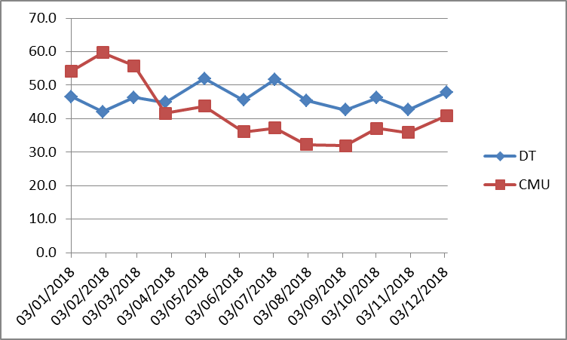

Annual Mean NO₂ Concentrations
The mean NO₂ concentration over the whole network during 2018 was 31.9 µg/m³ applying the national bias adjustment factor of 0.92. The mean concentration calculated using the local bias adjustment factor was 31.5 µg/m³. Using either bias adjustment factor, the mean concentration across the whole network is below the annual mean NO₂ objective of 40 µg/m³. The maximum annual mean NO₂ concentration was measured at the L51 site at 290 Brownhill Road, South Circular (53.5 µg/m³). The second highest annual mean NO₂ concentration was measured at LWS017 site at Baring Road (46.3 µg/m³). L51 and LWS017 are both roadside sites.
Table 5. Annual Mean NO₂ Concentration (Bias Adjusted), 2018
Site Type | Annual Mean NO₂ Concentration (µg/m³)
 | Raw | Bias Adjusted, using New Cross Co-located Tubes  (Factor = 0.91)* | Bias Adjusted, using National Bias Adjustment Factor  (Factor = 0.92)*
All Sites | 34.6 | 31.5 | 31.9
Roadside | 39.2 | 35.7 | 36.1
Urban Background | 28.8 | 26.2 | 26.5
*Annualised

Comparison with Limit Values and Objectives
The air quality objectives and limit values of relevance to NO₂ in the UK are detailed in Table 1. The results in Table 5, obtained after applying the national bias adjustment factor, indicate that the annual mean NO₂ objective of 40 µg/m³ was not exceeded by the mean diffusion tube network concentration during 2018. From Appendix B, it can be seen that bias-adjusted annual mean NO₂ concentrations, applying the national adjustment factor of 0.92, were greater than 40 µg/m³ at 7 of the individual diffusion tube locations. Similarly, results based on the local bias adjustment factor show that 6 sites exceeded the NO₂ annual mean objective.
Where diffusion tube locations are not representative of relevant exposure (for example, where a tube is kerbside, but residential facades are several metres back from the kerb), annual mean NO₂ concentrations can be distance-corrected to take into account the fall-off in concentration away from the kerb. Appendix B presents the full set of diffusion tube results including distance-corrected concentrations. When considering the national bias-adjusted diffusion tube results, there are four locations that, when distance-corrected to the nearest relevant exposure, exceed the annual mean objective, reduced from seven when not taking into consideration relevant exposure.
A report issued by Air Quality Consultants analysed the relationship between annual mean and hourly mean NO₂ concentrations, concluding that locations where the annual mean concentration is greater than 60 µg/m³ may be susceptible to breaches of the hourly mean objective (hourly mean NO₂ concentration of 200 µg/m³ or more not to be exceeded more than 18 occasions per year). After bias adjustment, there are no sites with measured NO₂ concentrations greater than 60 µg/m³ in 2018.

Seasonal Variation
The seasonal variation in NO₂ concentrations during 2018 are shown in Table 6 and Figure 2. Due to seasonal variations in the bias adjustment that can occur at diffusion tube sites, the results that have been presented are the raw concentrations with no bias adjustment applied.
The highest mean concentrations occurred in March at roadside sites. For urban background sites, the highest mean concentrations were measured during November. Mean NO₂ concentrations were lowest in June and August for all site types.
Table 6. Monthly Mean NO₂ Concentrations in Lewisham, 2018 (µg/m³; Unadjusted)
Site Type | Jan |  | Feb | Mar | Apr |  | May |  | Jun |  | Jul |  | Aug |  | Sep |  | Oct |  | Nov |  | Dec
All Sites | 36.7 |  | 36.2 | 38.8 | 35.9 |  | 32.3 |  | 28.1 |  | 32.3 |  | 28.6 |  | 31.5 |  | 38.0 |  | 38.4 |  | 37.6
Roadside | 40.0 |  | 39.6 | 43.7 | 40.5 |  | 38.4 |  | 33.6 |  | 37.6 |  | 33.1 |  | 34.1 |  | 42.0 |  | 42.2 |  | 41.5
Urban Background | 32.5 |  | 31.8 | 32.7 | 30.2 |  | 24.4 |  | 21.0 |  | 24.8 |  | 22.6 |  | 28.1 |  | 32.9 |  | 33.4 |  | 32.0
Table 7. Unadjusted Winter and Summer Period Mean Concentrations in Lewisham, 2018
Site Type | Winter Mean Concentration  (October – March) (µg/m³) | Summer Mean Concentration  (April – September) (µg/m³) | Ratio Winter : Summer
All Sites | 37.6 | 31.5 | 1.2
Roadside | 41.5 | 36.2 | 1.1
Urban Background | 32.5 | 25.2 | 1.3
Table 7 shows that the ratio of winter to summer mean NO₂ concentration was 1.1 for roadside sites, indicating mean concentrations were higher in the winter than the summer period. The urban background sites display a greater winter: summer ratio compared to roadside sites with a value of 1.3 in 2018. For all sites, collectively, the ratio of winter to summer mean NO₂ concentration was 1.2.
Figure 2. Seasonal Trend of NO₂ Concentrations in Lewisham, 2018
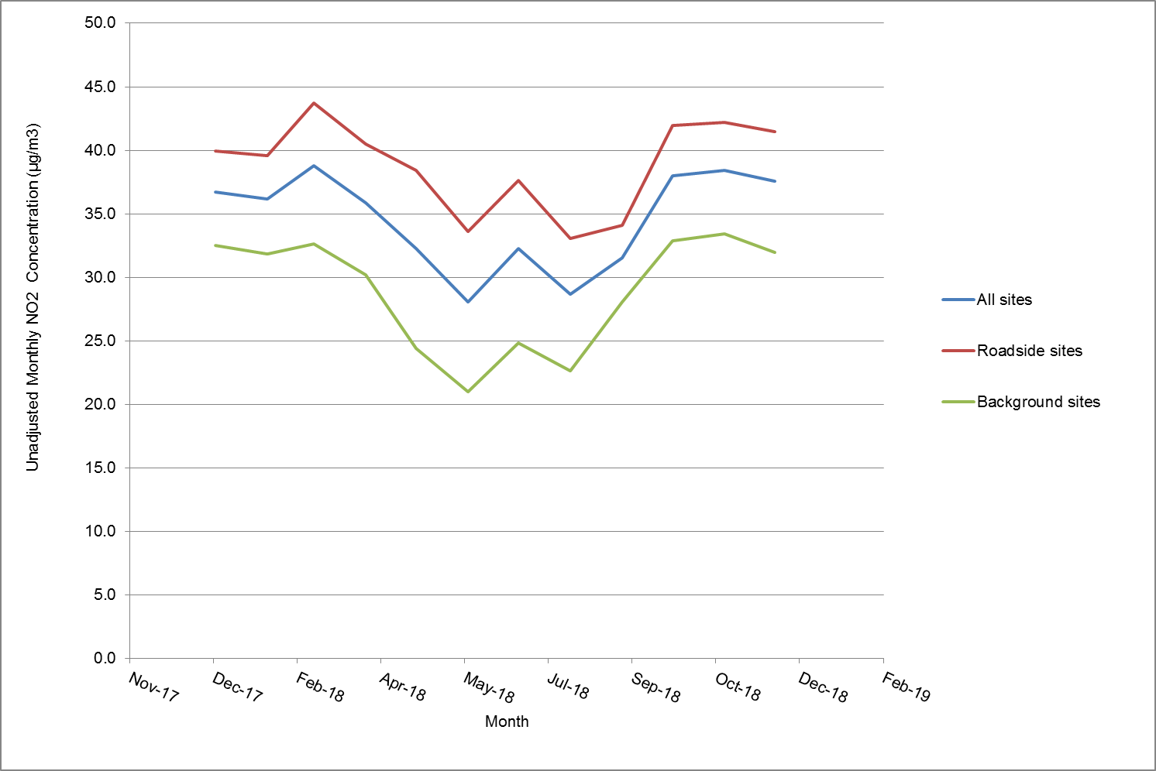

Historical Trends
Table 8 summarises the results of the Lewisham Tube Network by site type from 2014 to 2018; results for each site in 2018 are detailed in Appendix B. These results have been bias adjusted and the factors can be found in Appendix C Table 9.
Measurements from the past year showed a decrease in annual mean NO₂ concentration across the network between 2017 and 2018. The national bias adjustment factor for 2017 was greater than the national bias adjustment factor for 2018.
Table 8. Annual Mean NO₂ Concentration (bias-adjusted) by Site Type, 2014 – 2018
Site Type | Bias Adjusted Annual Mean NO₂ Concentration (µg/m³)
 | 2014 |  | 2015 |  | 2016 |  | 2017 |  | 2018
 | Bias Adjusted using New Cross Co-located tubes  (Factor = 0.82) | Bias Adjusted using National Bias Adjustment factor  (Factor =0.97) | Bias Adjusted using New Cross Co-located tubes  (Factor = 1.02) | Bias Adjusted using National Bias Adjustment factor  (Factor = 0.95 | Bias Adjusted using New Cross Co-located tubes  (Factor = 0.92) | Bias Adjusted using National Bias Adjustment factor  (Factor = 1.03) | Bias Adjusted using New Cross Co-located tubes  (Factor = 1.00) | Bias Adjusted using National Bias Adjustment factor  (Factor = 0.97) | Bias Adjusted using New Cross Co-located tubes  (Factor = 0.91) | Bias Adjusted using National Bias Adjustment factor  (Factor = 0.92)
All sites | 33.1 | 38.8 | 37.7 | 35.1 | 34.5 | 38.7 | 35.5 | 34.4 | 31.5 | 31.9
Roadside | 37.6 | 44.2 | 43.5 | 40.5 | 39.4 | 44.1 | 40.1 | 38.9 | 35.7 | 36.1
Urban Background | 26.5 | 31.3 | 29.3 | 27.3 | 27.4 | 30.7 | 29.9 | 29.0 | 26.2 | 26.5

Conclusions
The main conclusions of the 2018 Lewisham Diffusion Tube Network study are:
- The mean NO₂ concentration for the whole network, based on national adjustment factor was 31.9 µg/m³.
- NO₂ concentrations were greatest at roadside monitoring locations, and lowest at urban background sites, as would be expected.
- The maximum annual mean NO₂ concentration was measured at the L51 site at 290 Brownhill Road, South Circular (53.5 µg/m³). The second highest annual mean NO₂ concentration was measured at LWS017 site at Baring Road (46.3 µg/m³). L51 and LWS017 are both roadside sites.
- The mean roadside NO₂ concentration across the network was 36.1 µg/m³ based on the national bias adjustment factor and the mean urban background concentration was 26.5 µg/m³.
- Results obtained after applying the national bias adjustment factor show that 7 sites exceeded the annual mean NO₂ objective of 40 µg/m³. Results based on the local adjustment factor show that 6 diffusion tube locations recorded annual mean NO₂ concentrations exceeding the annual mean NO₂ objective.
- When correcting for distance between the monitoring location and the nearest receptor, 4 locations of relevant exposure exceed the objective, based on using the national bias adjustment factor.
- None of the locations recorded an annual mean above 60 µg/m³, indicating that it is unlikely that the short term objective was exceeded in 2018.

Appendix A: Diffusion Tube Locations
Figure 3. LB Lewisham Diffusion Tube Network (South) in 2018
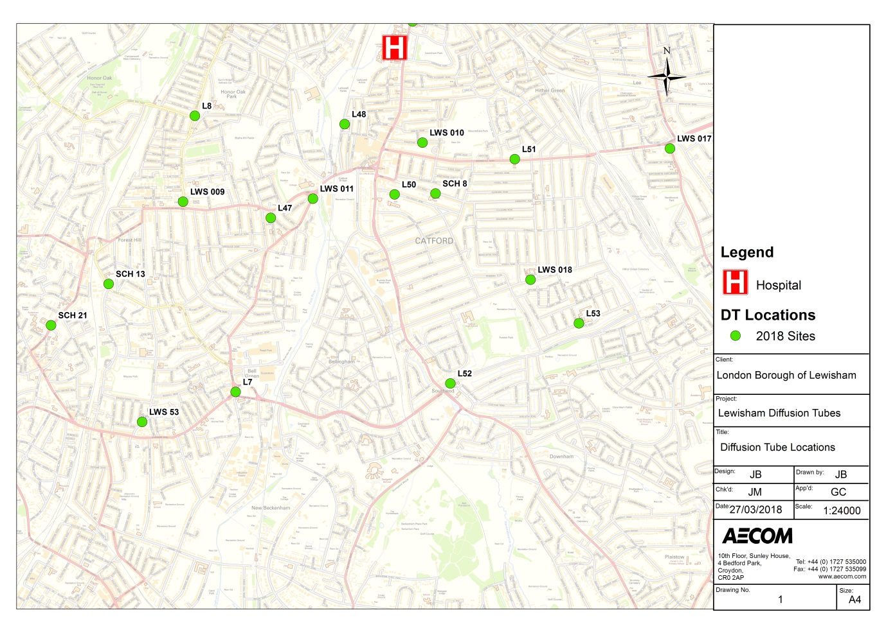
Figure 4. LB Lewisham Diffusion Tube Network (North) in 2018
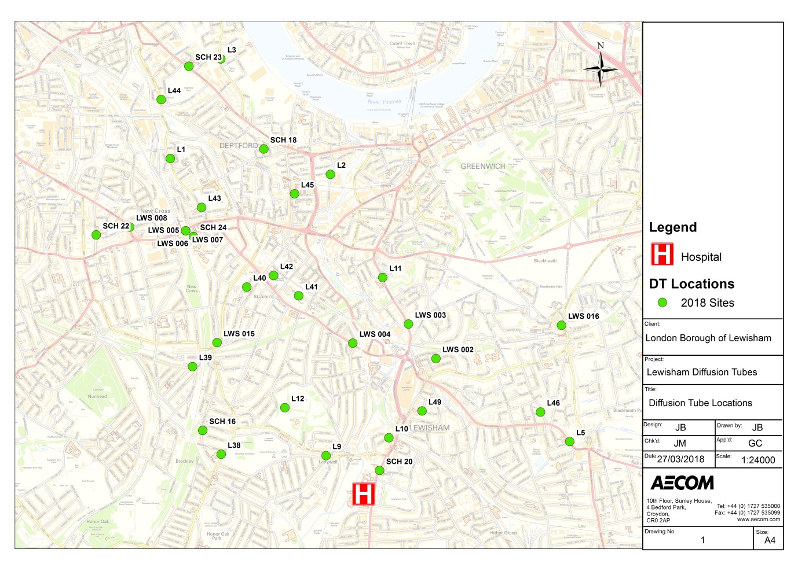

Appendix B: Diffusion Tube Results
Table 9. Lewisham Diffusion Tube Network 2018 – Raw and Bias Adjusted Results
Original Site Name | New Site Name | Address | X | Y |  | Site Type | Raw |  | Locally Adjusted |  | Nationally Adjusted | Distance Corrected
L1 | L1 | Chubworthy Street | 536109 | 177580 |  | Roadside | 31.8 |  | 28.9 |  | 29.2 | 27.9
L2 | L2 | Bronze Street | 537540 | 177439 |  | Urban Background | 27.4 |  | 24.9 |  | 25.2 | 25.2
L3 | L3 | Grove Street | 536561 | 178471 |  | Urban Background | 33.3 |  | 30.3 |  | 30.6 | 30.6
L4 | L4 | Plough Way | 536534 | 178926 |  | Urban Background | 31.3 |  | 28.5 |  | 28.8 | 28.8
L5 | L5 | Lee High Road | 539678 | 175050 |  | Roadside | 32.5 |  | 29.6 |  | 29.9 | 29.9
L6 | L6 | Le May Avenue | 540615 | 172337 |  | Urban Background | 33.2 |  | 30.2 |  | 30.5 | 30.5
L7 | L7 | Bell Green | 536556 | 171810 |  | Roadside | 41.5 |  | 37.7 |  | 38.2 | 38.2
L8 | L8 | Stondon Park | 536229 | 174032 |  | Roadside | 36.4 |  | 33.1 |  | 33.5 | 33.5
L9 | L9 | Ladywell Road | 537500 | 174925 |  | Roadside | 39.4 |  | 35.8 |  | 36.2 | 36.2
L10 | L10 | Whitburn Road | 538062 | 175085 |  | Roadside | 41.3 |  | 37.6 |  | 38.0 | 36.2
L11 | L11 | Sparta St, opp Morden Mount School | 538007 | 176517 |  | Roadside | 36.6 |  | 33.3 |  | 33.6 | 31.7
L12 | L12 | Hilly Fields | 537132 | 175353 |  | Urban Background | 27.5 |  | 25.0 |  | 25.3 | 25.3
SCH 8 | L29 | Holy Cross School | 538165 | 173406 |  | Roadside | 30.6 |  | 27.8 |  | 28.1 | 28.1
SCH 13 | L30 | St George's CofE School | 535535 | 172679 |  | Roadside | 31.2 |  | 28.4 |  | 28.7 | 28.3
SCH 16 | L31 | St Mary Magdalen's School | 536399 | 175150 |  | Urban Background | 28.2 |  | 25.6 |  | 25.9 | 25.5
SCH 18 | L32 | Grinling Gibbons School | 536944 | 177665 |  | Urban Background | 29.8 |  | 27.1 |  | 27.4 | 27.4
SCH 20 | L33 | St Mary's Lewisham School | 537979 | 174792 |  | Roadside | 41.5 |  | 37.8 |  | 38.2 | 38.2
SCH 21 | L34 | Sydenham School | 535071 | 172346 |  | Urban Background | 25.9 |  | 23.6 |  | 23.8 | 23.8
SCH 22 | L35 | Kender Primary School | 535447 | 176897 |  | Roadside | 29.5 |  | 26.8 |  | 27.1 | 27.1
SCH 23 | L36 | Deptford Park School | 536275 | 178405 |  | Roadside | 42.6 |  | 38.7 |  | 39.2 | 39.2
SCH 24 | L37 | St James Hatcham School | 536317 | 176883 |  | Urban Background | 29.8 |  | 27.1 |  | 27.4 | 27.4
LWS 53 | L13 | Mayow Road | 535804 | 171567 |  | Urban Background | 25.9 |  | 23.6 |  | 23.8 | 23.8
LWS 002 | L14 | Boyne Road | 538482 | 175792 |  | Urban Background | 28.6 |  | 26.0 |  | 26.3 | 26.0
LWS 003 | L15 | Lewisham Road | 538237 | 176101 |  | Roadside | 36.8 |  | 33.5 |  | 33.9 | 33.9
LWS 004 | L16 | Loampit Vale | 537740 | 175930 |  | Roadside | 44.0 |  | 40.0 |  | 40.4 | 40.4
LWS 005 | L17 | New Cross AQMS | 536246 | 176934 |  | Roadside | 45.9 |  | 41.8 |  | 42.3 | 42.3
LWS 006 | L18 | New Cross AQMS | 536246 | 176934 |  | Roadside | 46.1 |  | 42.0 |  | 42.4 | 42.4
LWS 007 | L19 | New Cross AQMS | 536246 | 176934 |  | Roadside | 46.7 |  | 42.5 |  | 43.0 | 43.0
LWS 008 | L20 | Hatcham Park Road | 535746 | 176969 |  | Roadside | 40.4 |  | 37.3 |  | 37.7 | 36.9
LWS 009 | L21 | Brockley Rise | 536133 | 173341 |  | Roadside | 44.8 |  | 40.7 |  | 41.2 | 41.2
LWS 010 | L22 | Ringstead Road | 538060 | 173816 |  | Urban Background | 30.5 |  | 27.8 |  | 28.1 | 25.5
LWS 011 | L23 | Catford Hill | 537178 | 173365 |  | Roadside | 46.8 |  | 42.6 |  | 43.1 | 34.3
LWS 015 | L26 | Shardeloes Road | 536527 | 175935 |  | Roadside | 42.4 |  | 38.6 |  | 39.0 | 37.3
LWS 016 | L27 | Montpelier Vale | 539605 | 176090 |  | Roadside | 47.3 |  | 43.1 |  | 43.5 | 37.6
LWS 017 | L28 | Baring Road | 540051 | 173769 |  | Roadside | 50.4 |  | 45.8 |  | 46.3 | 34.9
LWS 018 | L24 | Torridon School Hazelbank Road | 538930 | 172713 |  | Urban Background | 35.7 |  | 32.5 |  | 32.8 | 29.1
L38 | L38 | Beecroft Primary School | 536564 | 174937 |  | Roadside | 32.3 |  | 29.4 |  | 29.7 | 26.8
L39 | L39 | John Stainer Primary School | 536308 | 175721 |  | Roadside | 32.6 |  | 29.7 |  | 30.0 | 27.0
L40 | L40 | Myatt Garden Primary School | 536792 | 176432 |  | Urban Background | 25.7 |  | 23.4 |  | 23.7 | 23.7
L41 | L41 | Ashmead Primary School | 537256 | 176353 |  | Urban Background | 26.1 |  | 23.7 |  | 24.0 | 24.0
L42 | L42 | Lucas Vale Primary School | 537032 | 176534 |  | Urban Background | 29.1 |  | 26.5 |  | 26.8 | 26.7
L43 | L43 | Childeric Primary School | 536389 | 177144 |  | Urban Background | 28.9 |  | 26.3 |  | 26.6 | 26.0
L44 | L44 | Sir Francis Drake Primary School | 536028 | 178107 |  | Roadside | 38.3 |  | 34.8 |  | 35.2 | 34.2
L45 | L45 | Tidemill Academy | 537219 | 177264 |  | Roadside | 36.3 |  | 33.1 |  | 33.4 | 32.9
L46 | L46 | St Margaret Lee Primary School | 539416 | 175315 |  | Urban Background | 27.1 |  | 24.7 |  | 24.9 | 24.6
L47 | L47 | Rathfern Primary School | 536839 | 173211 |  | Roadside | 29.9 |  | 27.2 |  | 27.5 | 26.6
L48 | L48 | Holbeach Primary School | 537433 | 173965 |  | Urban Background | 29.6 |  | 27.0 |  | 27.3 | 24.9
L49 | L49 | St Saviours RC Primary School | 538358 | 175324 |  | Urban Background | 29.8 |  | 27.1 |  | 27.4 | 26.9
L50 | L50 | Rushey Green Primary School | 537836 | 173400 |  | Urban Background | 26.5 |  | 24.1 |  | 24.3 | 24.3
L51 | L51 | 290 Brownhill Road S Circular | 538803 | 173683 |  | Roadside | 58.2 |  | 53.0 |  | 53.5 | 40.1
L52 | L52 | St John CofE School | 538285 | 171877 |  | Roadside | 36.1 |  | 32.8 |  | 33.2 | 30.9
L53 | L53 | Greenvale School | 539319 | 172362 |  | Urban Background | 24.7 |  | 22.4 |  | 22.7 | 22.3

Appendix C: Diffusion Tube Bias Adjustment
Table 10. Summary of Local and National Bias Adjustment Factors for Lewisham NO₂ Diffusion Tube Surveys, 2009 to 2018
Site Type | Mean Local  Factor |  | National  Factorª
2009 | 0.84 |  | 0.97
2010 | 0.69 |  | 1.03
2011 | 0.59 |  | 0.95
2012 | 0.79 |  | 1.01
2013 | 0.93 |  | 1.00
2014 | 0.82 |  | 0.97
2015 | 1.02 |  | 0.95
2016 | 0.92 |  | 1.03
2017 | 1.00 |  | 0.97
2018 | 0.91 |  | 0.92

Notes: ª National factor obtained from Bias Adjustment Factor spreadsheet³ version 03/19 based on Gradko as the analysing laboratory using the 50% TEA in acetone method;
Figure 4. Local Bias Adjustment Factor Calculation, Lewisham – New Cross (LW2)
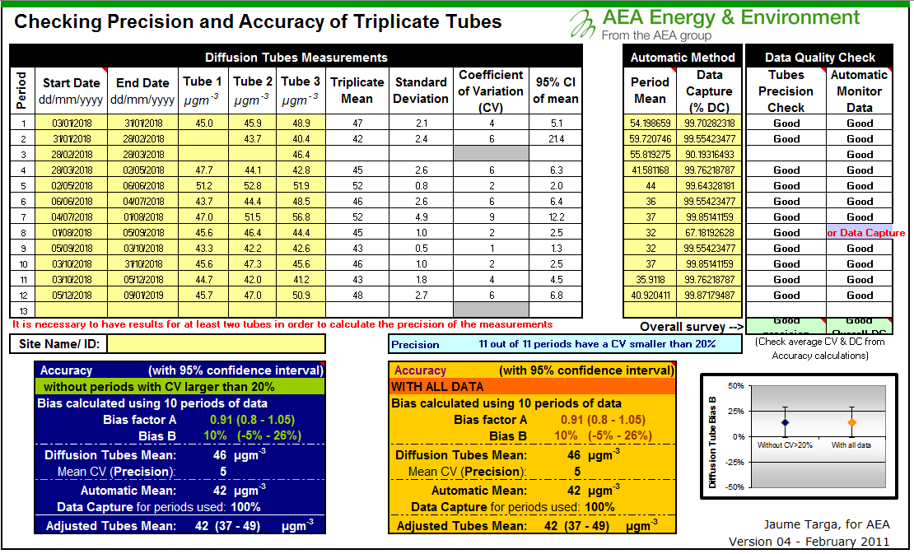
Figure 5. National Bias Adjustment Factor Calculator
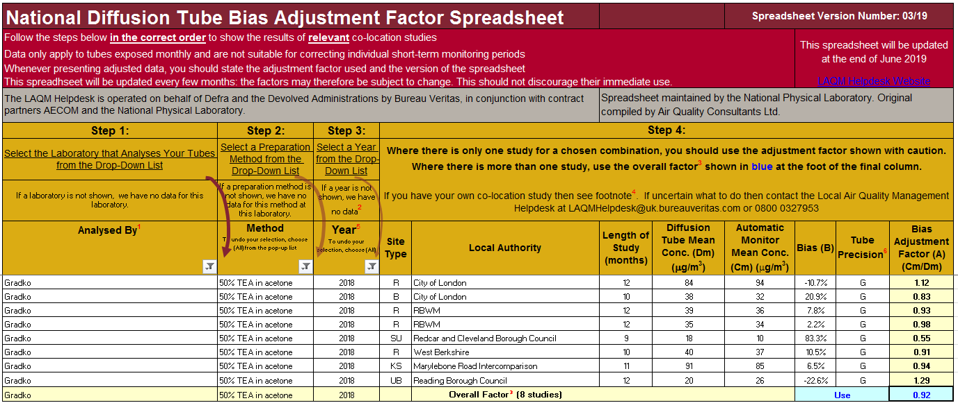

aecom.com

Defra, The Air Quality Strategy for England, Scotland, Wales and Northern Ireland, 2007.
Defra, Local Air Quality Management, Diffusion Tubes, Nitrogen Dioxide Diffusion Tube Monitoring, Calendar of Suggested Exposure Periods. Available at http://laqm.defra.gov.uk/diffusion-tubes/data-entry.html
Summary of Laboratory Performance in AIR NO₂ Proficiency Testing Scheme. Available at: https://laqm.defra.gov.uk/assets/laqmno2performancedatauptooctober2018v1.pdf
Defra, Local Air Quality Management Technical Guidance LAQM.TG(16).
Defra, National Diffusion Tube Bias Adjustment Factor Spreadsheet (Version 09/18). Available at http://laqm.defra.gov.uk/bias-adjustment-factors/national-bias.html
AEA Diffusion Tube Precision Accuracy Bias Spreadsheet. Downloaded from http://laqm.defra.gov.uk/bias-adjustment-factors/local-bias.html September 2018.
London Air Quality Network Website. Available at http://www.londonair.org.uk.
Cape, J.N., Review of the Use of Passive Diffusion Tubes for Measuring Concentrations of Nitrogen Dioxide in Air, 2005. Available at http://uk-air.defra.gov.uk/reports/cat05/0810141025_NO2_review.pdf
Air Quality Consultants (2007). Deriving NO₂ from NO_{X} for Air Quality Assessments of Roads.

