Animal Fleas
Pre-treatment preparation sheet

Please read & keep for future reference
Your appointment with the Pest Control Service to treat your premises for an infestation of Animal Fleas is on:-

Treatment Date………………………….

Job Reference…………………………..

Before the Pest Control Officer arrives to commence treatment you must carry out the following preparations:

- To carry out a really effective treatment will need to get access to as much floor area as possible.
- Remove all items from the floor areas of the rooms to be treated.
- All furniture should be moved from the edges of the room to allow access to the floor wall junctions.
- Thoroughly Hoover all carpets and rugs and clean all carpet free floor areas. Pay particular attention to areas where pets may sleep or where the sun may heat an area of floor. Empty the vacuum cleaner directly into the dustbin or change the bag after cleaning.
- Make sure any pet bedding is washed and the beds are thoroughly cleaned.
- If you have a pet make sure it is being treated with an approved formulation, preferably via a vet.

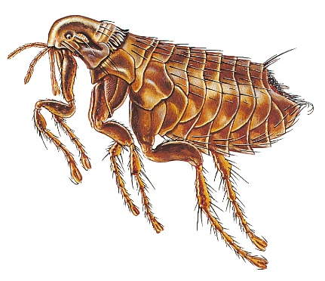

- People and domestic pets must leave the rooms being treated and not be allowed to return until the insecticide is dry.

If you do not carry out these preparations the Pest Control Officer
will not carry out the treatment and you will lose your fee.

After the Pest Control Officer has carried out the treatment

- Do not enter these rooms for at least two hours or until the Officer advises.
- Do not vacuum or clean any treated floors for at least 15 days to allow the insecticide time to work.

One treatment is usually sufficient to control the infestation as the products used carry on working for some weeks. The fleas should die off gradually after coming into contact with the insecticide

If there is still a problem 14 days after the original treatment you can contact our call centre to book a re-treat. The same technician will contact you to arrange a date for this visit. If you contact us after 6 weeks from the original appointment it would be classed as a new job.
For further advice contact Call point on 0208 3147171 or visit www.lewisham.gov.uk

