Please read & keep for future reference

Cockroaches
Post treatment advice sheet

As you are aware we have treated your property for cockroaches today. Please take the time to read the customer information below as following this advice will greatly assist a speedy and successful treatment. Should you require any further information please contact us on the telephone number provided.

Please ensure that children and domestic animals are kept away from the bait during the treatment period.

If you suspect accidental poisoning, immediately contact the Accident and Emergency Department of your local hospital, or your local GP. The products that have been used will be indicated on the separate (yellow) job sheet also given to you by the operative.

DO NOT:

- Leave foodstuffs and/or dirty dishes out, particularly overnight.

- Leave household rubbish in containers that could be accessed, preferably remove it from the property regularly.

- Leave any food spillages, clean them up immediately.

- Leave foodstuffs on the cooker top.

- Leave pet food down; remove it after your pet has eaten.

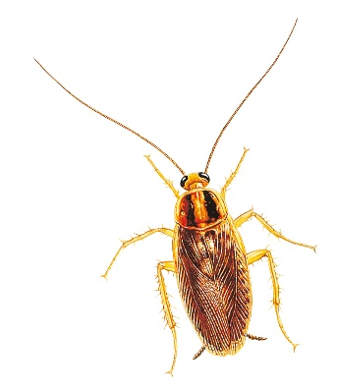

- Do not touch or remove any bait, try not to spill food, liquids or fats on them.

- After treatment is done do not kill any insects you see, and do not be tempted to use alternative treatments such as sprays etc, as this will interfere with our treatment.

DO:

- Keep all foodstuffs in airtight containers.

- keep your kitchen clean, especially behind cookers, fridges etc.

- Contact pest control every 4-6 weeks for more treatment if you are continuing to see these insects (even if you are only seeing one or two).

- Make sure you wash all pots, pans crockery etc. prior to use, especially if there is evidence of cockroaches having been in the cupboards where they are kept.

- Wipe food preparation surfaces down with an anti-bacterial cleaner.

- Clean up any droppings or urine with disinfectant. Wear disposable gloves.

Most cockroach treatments will require a programme of visits over a period of time. The minimum being three, but it could go on for several months.

If you live in a block it may prove to be more difficult to control the infestation as other tenants around you may also have the problem and are not reporting it or having treatment. This could lead to your property being re-infested. If you suspect this is the case then the block may need to be surveyed/treated as a whole. This would have to be a decision made by your Housing Office, so please discuss the matter with them.

The fee paid (£156 full rate, £78 for discretions or the commercial rate) is for 3 visits.

Our technician will agree with you the follow up visit dates. Please make a note of these, if any appointment is missed this will count towards your 3 visits. So please let us know well in advance if you cannot keep any given appointment.

Each visit will be 4-6 weeks apart.

We require 1 working days notice to cancel or change any appointment or you may lose that appointment and/or forfeit the fee.

After the third visit we will revue the situation and our technician will make his recommendations with regards to the necessity of further visits.

It will be up to you, the client, to make your own arrangements to repeat the programme if necessary. To do this you can contact Call point on 020 8314 7171.

LEWISHAM COUNCIL PEST CONTROL RESERVES THE RIGHT TO WITHDRAW FROM TREATMENTS IF ANY ADVICE GIVEN IS NOT FOLLOWED UP.

For further advice contact Call point on 020 83147171 or visit our website www.lewisham.gov.uk

