The Digital Telephone Switchover
The impact for you as a Lewisham Linkline Service User

By 2025 the telephone companies in the UK are switching off analogue telephone services and replacing it with digital technology.
We need to let you know how this affects you.
Your existing Lewisham Linkline equipment will need to be upgraded or changed completely.
Soon you will be contacted directly by your telephone provider to upgrade to a digital line. Lewisham Linkline are not responsible for any changes to your telephone line and you should speak to your provider to assist you with connecting your router.
Your telephone provider will provide a Home Hub that will have an adapter for you to plug in your existing equipment, whether that’s a phone or a Linkline alarm unit. You should speak to your provider to assist you with connecting your existing equipment.
This will be a temporary measure and Service Users will have to upgrade their equipment to IP enabled alarms in the future and Lewisham Linkline will be in touch with you about this.
At the present time our Control Room will only receive analogue calls but we are hoping to become a digitally enabled Control Room in 2022 – Please ensure you make your telephone provider aware of this.
When your telephone provider installs the Home Hub you need to know this is connected to the mains power. If there is no power, it will not work. This means your Linkline alarm will not work.
You need to speak to your telephone provider and ask how they intend to keep your equipment working.
Once our Control Room has been upgraded to the new digital solution we will be in contact with you to replace your Linkline alarm unit.
On the next page we show you how to determine what type of telephone connection you currently have in your property.

What if I’m not sure if I do have a digital line?
You can check if you have an analogue line as your alarm unit will be connected to a traditional home telephone socket:
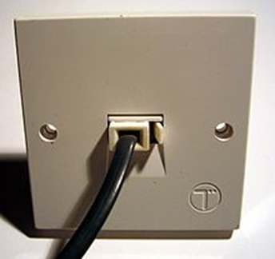

If you have a digital telephone line the Linkline alarm unit may be connected to an internet router like this:
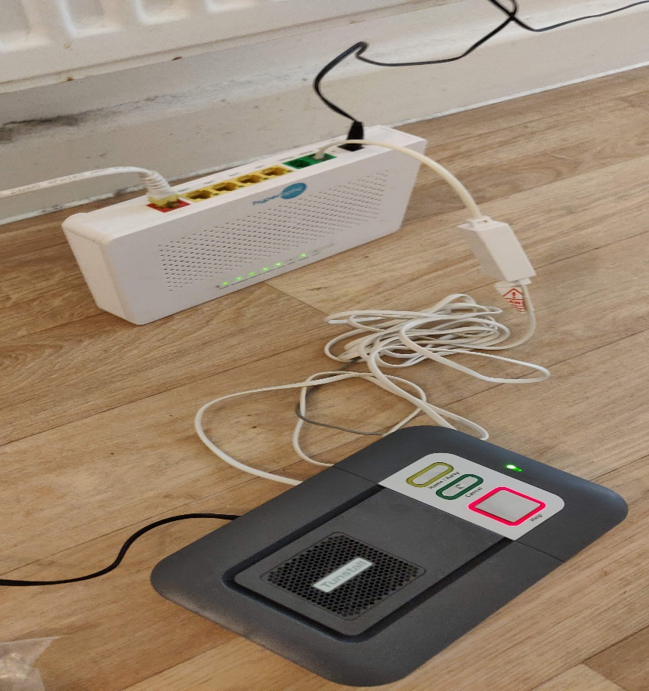
More Information on the digital switchover can be found at
Click this link to access further information from the telephone providers about UK telephone lines

