Small Cell 4G/5G
Lewisham
www.lewisham.gov.uk

Lewisham Digital Infrastructure Toolkit

February 2022

September 2020

Version: 2.0

Contents
- Introduction
- Digital Infrastructure Guidance
- Process
Annex 1 – Expression of Interest

Introduction
Lewisham’s vision is to become a truly digital council and borough. With ambitious plans to deliver digital transformation, we will maximise opportunities for digital design, data and technology to enhance growth, quality of life, sustainability and individual opportunity in Lewisham.
Lewisham published its first creative and digital industries in 2017 outlining how the council and its partners plan associated industries within the borough. The 2022 digital strategy, currently being formed, addresses how the council will deliver key digital services and infrastructure to residents to thrive and live happy, healthy lives. The overarching ambitions of the strategy are the development of a modern, sustainable borough that harnesses the latest in digital technologies and infrastructure.
Improving Lewisham’s digital infrastructure through enhanced mobile and broadband connectivity to residents, communities and businesses is one of our highest priorities. Lewisham’s challenge is to develop a digital infrastructure that matches our ambition and helps tackle the digital inequalities the borough faces. As the 10th most deprived borough in London (and 48th in England), Lewisham residents face multiple challenges associated with digital inequalities including inadequate bandwidth, limited digital skills and both data and device poverty. Improving our digital infrastructure is a key component in tackling the digital divide in Lewisham. We aim to improve connectivity speeds and capacity across the borough by creating the conditions for, and enabling the provision of technically capable and future proof digital connectivity infrastructure. Delivering an improved digital infrastructure will empower our residents, businesses, community and voluntary sector and public services, and contribute to Lewisham’s economic growth.

Digital Infrastructure Guidance
Guidance published by the Department for Digital, Culture, Media & Sport (DCMS) paves the way for “a clear and transparent process for industry and government”. Lewisham Council has developed this Digital Infrastructure Toolkit on the basis of the DCMS guidance and has adopted a non-exclusive, open access approach to Telecommunication Operators.
This toolkit provides:

  - Guidance to Code Operators seeking to host 4G/5G Small Cells on Lewisham Council assets including street lamps;

  - Guidance on setting up an agreement between the Local Authority and the Code Operator;

  - Standard Financial Terms

  - Advice on the processes for Code operators to follow when considering siting digital communications infrastructure on Lewisham Council assets.

This Toolkit sets out the Council’s guidance as of the 4th of February 2022. Code operators must satisfy themselves as to the accuracy of any information contained in it and otherwise provided by the Council. The Council may amend its guidance and the process to be followed at any time.

Electronic Communications Code

This toolkit follows the electronic communications code as set out in Schedule 3A of the Communications Act 2003. The regulations support the Government’s commitment to establish reliable mobile connectivity across the country, as well as supporting faster and cheaper deployment of the infrastructure. Details of the Electronic Communications Code can be found here.

Process

Expression of Interest

Lewisham Council will consider proposals for the installation of 4G/5G Small Cells from Code Operators seeking to deploy their technology in Lewisham on an “Open Access” basis. The Council are not looking to operate a “concession” model.
Operators should submit the completed Expression of Interest (Annex 1) to:

Joseph Chambers
Digital Public Lead
London Borough of Lewisham
Email: digital.infrastrucutre@Lewisham.gov.uk

Installation Information

The code operator must provide the Council with the following information:

- Confirmation as a code operator
- Scope of the project
- Deployment approach
- Technical information (technical information of the small cells to deploy, architecture, contracted network provider details)
- Identified/pre-selected assets (geographic information)
- Additional social value
- Process for managing conflict with sharing of assets with multiple operators
- Project Timelines

Lewisham Council is under an exclusive PFI contract with Milestone, thus any work on our street lighting columns must be carried out or approved by them. The council will facilitate the introduction to the PFI contractor. The Code Operator will be required to agree a scope of works and payment schedule with Milestone prior to commencement of any works in relation to installation and maintenance of small cells on street lamp columns.

The information listed above will be shared with the highways department and the PFI contractor, who will review it and raise any potential concerns. If required, a workshop will be arranged with all the stakeholders to address potential issues or gain a better understanding of the proposed solution.
The open access approach advocates for multiple Code Operators and technology uses sharing the same assets, hence the Code Operator must consider the following three scenarios:

- Un-deployed Asset: When an asset has not been previously deployed, the first Code Operator to deploy small cells needs to demonstrate to the Council that other Code Operators can share the same asset, specifying capacity limitations and highlighting potential interoperability issues.

- Deployed Asset: When an asset has been previously deployed, the existing Code Operator will be consulted to avoid any interoperability issues with its legacy infrastructure. If required, the Council could arrange a workshop to address any concerns.

- More than one operator requesting access to the same asset: The Council will assess both requirements in parallel, giving the priority for the deployment on the asset to the operator that successfully demonstrates that:
  - Its deployment approach has been approved by the relevant groups at Lewisham Council and the PFI contractor
  - Its deployment approach can actually benefit the second operator (i.e. by deploying shareable infrastructure, by having reduced times of deployment, by taking less space or capacity from the asset)
  - Allow the council to implement smarter services or can benefit a wider part of the community

The Council does have specific technical requirements in relation to, for example, compatibility with festive lighting on street lamp assets, and these requirements will be shared with operators at an early stage to ensure they are included in any design documentation and budgeting.

Planning Regulations

Proposals for 4G/5G small cell sites can be classed as ‘permitted development’ under the ‘The Town and Country Planning (General Permitted Development) (England) (Amendment) (No. 2) Order 2016’. On this basis, an application for 28 day ‘prior notification’ to the Council’s Planning Department is required under the GPDO.
Code Operators should make use of the Lewisham Planning pre-application meeting service to confirm this. Lewisham Planning Department can be contacted through the Lewisham Planning Portal or via the Planning Department inbox (planning@lewisham.gov.uk)

Legal Agreement

Lewisham Council streetlamp assets are managed, operated and maintained under a PFI arrangement with Milestone. Our standardised legal agreement is based on the DCMS standard agreement, adapted to integrate the relationship with our contractor.
- An agreement to host infrastructure in Lewisham must be in writing to: Record the agreed terms between the Local Authority, the Contractor and the Operator.
- Ensure the interests of all parties are protected for the duration of the Agreement
- Takes into consideration other operators that will seek to host infrastructure in the borough
- Help avoid disputes

Lewisham reserves the right to reject any application if the Code Operator fails to prove that its solution is not preventing another Operator from hosting infrastructure in the same asset.

A subsequent Code Operator deploying a solution on a deployed asset must prove that the solution will not interfere with the previously deployed solution.

Financial Terms

The Electronic Communications Code provides for two forms of remuneration: Consideration and Compensation.
- Consideration:

Consideration is dealt with in paragraph 24 of the Code. Where a Tribunal is required to determine the consideration payable by an operator, their calculation must be based on: “an amount or amounts representing the market value of the agreement ... to confer or be bound by the code right”, with “market value” for these purposes being assessed by reference to specific assumptions.
- Compensation:

Compensation is dealt with in paragraph 25 of the Code and is intended to allow landowners to recover loss or damage that has been sustained or will be sustained as a result of an agreement to host infrastructure on land or buildings. Typical matters [Heads of Claim] which could be taken into account as compensation might include:
  - Surveyors Fees;
  - Legal Expenses;
  - Access - e.g. Creation of management information system to handle enquiries for access;
  - Disturbance - during the build and subsequently (maintenance visits); and
  - Injurious Affection - reduction in land value as a consequence of granting the rights.
  - Joint site surveys involving the Highways department

- Business Rates

Departments, advisers, and operators should note that installation of infrastructure will create a separate assessment for business rates payable on the property/asset. . Additional business rates consequently payable will be the responsibility of the operator.

Lewisham Rates

In order to maintain openness and transparency Lewisham has adopted a non-exclusive, open access approach for Telecommunication Operators seeking to deploy in Lewisham.
Lewisham has set the following standard financial terms for the deployment of 4G/5G Small Cells technology on its assets within the borough:
- The Code Operator will cover all liabilities, expenses, costs (including but not limited to any solicitors' or other professionals' costs and expenses), claims, damages and losses related to installation, maintenance, upgrade and removal of small cells equipment.

- In addition to the above, a project co-ordination fee of £5000 will be payable (prior to contract) to the council per application to cover the following activities:
  - Initial discussions and legal agreement to proceed.
  - Installation support

Performance monitoring

Note: This fee will be payable on the first phase deployment and when a Code Operator introduces an additional MNO on to any existing or new sites. Where further deployments by the same Operator working in conjunction with the same MNO, using the same approach and hardware as the initial deployment, the co-ordination fee will be waived.

Payment per year per asset/site/lamppost deployment per Operator – 1st small cell: £300, 2nd small cell £150, 3rd small cell £100, 4th small cell £100 payable to the Council by the operator.
The Code Operator will incur additional fees for adding further devices onto the street lighting columns.

The length of the agreement can cover a minimum term of 5 years and a maximum term of up to 12 years.

When an asset is not suitable to host telecom infrastructure the Code Operator will be given the option to upgrade the asset at its own cost, however this option must be approved by the planning team and the PFI contractor.

If no installation work is carried out within 12 months of the license being allocated to a Code Operator, then the node license will lapse.

Annex 1:

Expression of Interest for Code Operators seeking to install 4G/5G small cell technology on London Borough of Lewisham assets.

Please ensure you answer ALL the questions. Missing information may delay or prevent you from progressing with the opportunity. The council is happy for you to engage with them to ensure you complete the expression of interest as fully as possible. Please email the completed questionnaire to: digital.infrastructure@Lewisham.gov.uk

Part 1: Operator Applicant Details

Lead Contact Name:
Lead Contact Position:
Operating Company:
Address (including postcode):
Email address:
Telephone number:
Are you a licensed Telecoms Code Operator?
Do you have an existing agreement with a network provider? (If yes, please state which one)

Part 2: Site or Geographical areas of interest

The council are looking to provide 4g / 5g small cell coverage across the borough via the existing lamppost infrastructure, please list the areas you are interested in developing. You can attach a separate file if preferred
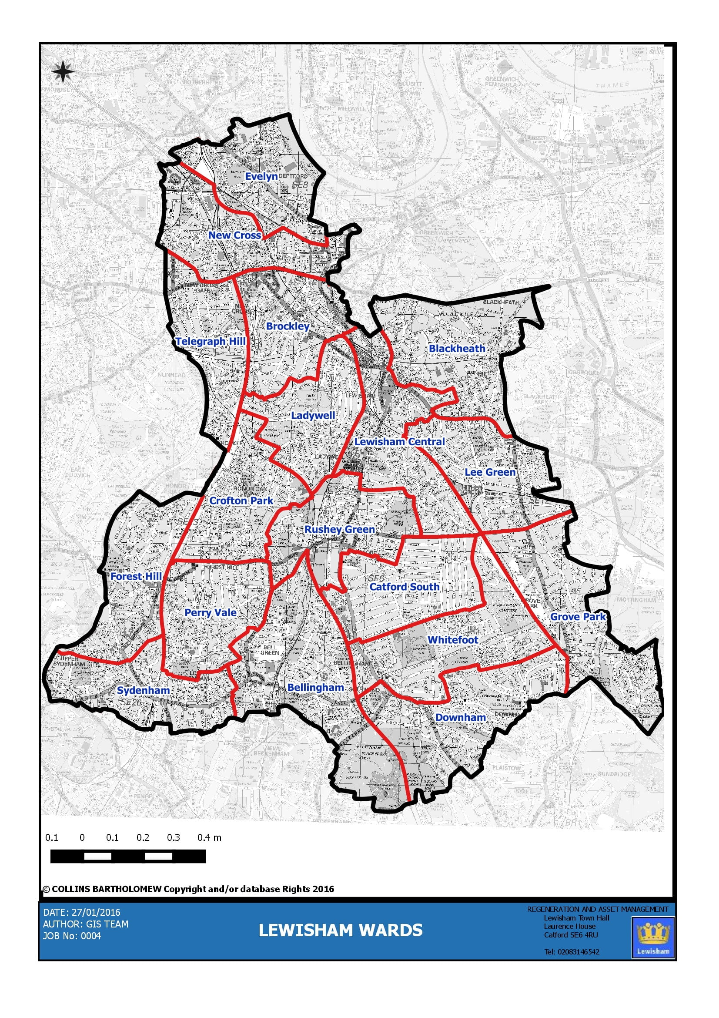
Lewisham wards: Bellingham, Blackheath, Brockley, Catford South, Crofton Park, Downham, Evelyn, Forest Hill, Grove Park, Ladywell, Lee Green, Lewisham Central, New Cross, Perry Vale, Rushey Green, Sydenham, Telegraph Hill, Whitefoot

Post codes within the borough (some shared with Bromley, Greenwich and Southwark):
SE9, SE3, SE4, SE6, SE10, SE14, SE26, SE13, SE12, SE8, SE23, SE15, SE16, BR1

Small cell 4G/5G priority areas for Lewisham Council:
Evelyn, Newcross, Rushey Green, Bellingham, Lewisham Central, Catford & Whitefoot

A full list of assets is available upon request.

Site name or area (if applicable)
Site address (including postcode) or location

Part 3 – Evaluation criteria

Please provide the Council with the following information:

- Scope of the project
Response

- Deployment approach
Response

- Technical information (technical information of the small cells to deploy, architecture)
Response

- Project timelines
Response

- Project’s social impact (information about the project’s infrastructural and social engagement components that help address digital inequalities in Lewisham)
Response

Our open access approach advocates for multiple Code Operators sharing the same assets, hence you will need to consider the following three scenarios:

- Un-deployed Asset: When an asset has not been previously deployed, the first Code Operator to deploy small cells needs to demonstrate to the Council that other Code Operators can share the same asset, specifying capacity limitations and highlighting potential interoperability issues.

HOW WILL YOU MEET THIS REQUIREMENT?
Response

- Deployed Asset: When an asset has been previously deployed, the existing Code Operator will be consulted to avoid any interoperability issues with its legacy infrastructure. If required, the Council could arrange a workshop to address any concerns.

HOW WILL YOU MEET THIS REQUIREMENT?
Response

- More than one operator requesting access to the same asset: The Council will assess both requirements in parallel, giving the priority for the deployment on the asset to the operator that successfully demonstrates that:
  - Its deployment approach has been approved by the relevant groups at Lewisham Council and the PFI contractor
  - Its deployment approach can actually benefit the second operator (i.e. by deploying shareable infrastructure, by having reduced times of deployment, by taking less space or capacity from the asset)
  - Allow the council to implement smarter services or can benefit a wider part of the community

HOW WILL YOU MEET THIS REQUIREMENT?
Response

Part 4: Signature

Please sign to confirm that the information contained here is complete and accurate. The Electronic Communications Code 2017 specifies that site providers may reclaim all “reasonable” costs of external advisors (i.e. surveyor and legal) in negotiating and concluding any agreement. Signature also confirms that the operator will meet these costs.

Signature of Operator

Date

Please send the completed form to: digital.infrastructure@Lewisham.gov.uk

