Application for a vehicular crossover
Highways Act (1980) Section 184

It is an offence under Section 184 of the Highways Act 1980, to allow a vehicle to cross the footway other than via an approved crossover.

This is an area of lowered pavement and kerb to give access across the pavement onto a private parking area. The crossover has to be constructed to a specified standard to protect the footway and the utility services underneath (underground pipes) from damage. For safety reasons it is not permissible for an individual to carry out these works themselves or to arrange for others to carry out these works on their behalf. If vehicular access is required, the Highways Act enables Highway Authorities to provide a crossover at the applicant’s expense.

The minimum cost of a crossover is £1060. Crossovers on wide footways will cost more. In addition, other factors may increase these costs (see paragraph 9 of the Terms & Conditions). We regret that due to administrative costs there is also an application fee of £116. Applicants are under no obligation to proceed with the application if he/she considers the quotation to be unacceptable. However, the application fee is non-refundable.

Although in general, the Council prefers cars to be kept off the Highway, there are certain circumstances when a crossover is not permissible.

Please read the Terms and Conditions attached thoroughly before submitting the application form.

Terms and Conditions

- A crossover will only be permitted if:-
- it serves an adjacent lock-up garage;
or;
- there is presently no reasonable means of access to off-street parking within the property;
and
- if your vehicle will not be parking in front of the main entrance, there is an available parking space, perpendicular to the footway, at least 4.8m long (depth of front garden from front of house to back of footway). ;
or
- if your vehicle will be parking in front of the main entrance, there is a distance of 5.8m in front of the main entrance;
and
- the proposed parking area is at least 3m wide.

If your vehicle is longer than 4.8m, you will be committing an offence if any part of it overhangs the footway.

This rule is not negotiable.

- The maximum width for a crossover is 4.5 metres for a normal domestic property or 5 metres for a multiple-dwelling property. These widths include the sloping kerbs at each side of the crossover. A wider crossover may be permitted for a commercial premises.

- Planning permission is required and should be obtained for:-

- Properties on a classified Road or where any boundary line adjoins a classified Road (see Appendix 1), or;
- Properties in a conservation area or other area that is subject to a relevant Article 4(1) Direction (see Appendix 2 or visit
https://lewisham.gov.uk/myservices/planning/conservation/conservation-areas
- A listed building, or;
- Properties in multiple-dwelling (i.e flats or maisonettes); or
- An industrial or commercial premises; or
- Driveways that do not have provision for natural drainage (see Condition 12).

If you are in any doubt whether you need planning permission you should email the Planning Service for advice planning@lewisham.gov.uk

You need to obtain planning permission before submitting your request to Highways, as a copy of the planning approval must be included with your application for a vehicular crossover.

To obtain planning permission please visit our website
https://lewisham.gov.uk/myservices/planning/apply-for-planning-permission
- A crossover request for any road on the Red Route network must be submitted to Transport for London to action. Applications must be made through their Call Centre (0845 305 1234). See Appendix 3, attached for list of affected roads.

- A request for a crossover serving a property on a Housing Estate Road should be made to the relevant Housing Association. Please contact them directly and do not submit this form.

- If you live in rented accommodation then you must obtain permission from the Landlord or Housing Association before applying for a crossover.

- If the property is within a Controlled Parking Zone, an additional fee of £265 is payable. This fee is a contribution towards the cost the Council will incur amending the existing signage, road markings and Traffic Order. A crossover may be refused should it negatively impact on, or, cause the loss of designated parking spaces, such as disabled bays, car club bays, loading bays, electrical vehicle charging bays and the like.

- An officer of the council will inspect the proposed crossover site and advise the applicant of any circumstances that may constitute a danger to road users, such as walls or fences, which impair visibility or if the site is too close to a junction. The officer may suggest ways in which visibility could be improved.

- Subject to the agreement of the conditions above, the officer will prepare a quotation. The cost of re-siting any lamp columns, telegraph poles, signs, parking bays, removal of a tree, or of any special measures to protect underground mains, covers, cables or cabinets will be added to the quotation and may affect the completion time. If the apparatus/obstruction is not owned by Lewisham you will need to contact the organisation directly to arrange for the work and you will need to meet the cost of this work separately. The quote is open to acceptance for the period stated on the quotation.

- If your application is accepted, the position of the crossing will be indicated by the Council using white marks. If you disagree with the location of the marks you must contact the named officer before paying for the crossover, as the position cannot be altered once the work has started.

- The crossover will be constructed to the specification of the London Borough of Lewisham. We regret that we are unable to vary this specification. The crossover will remain the maintenance responsibility of Lewisham Council in perpetuity. It will comply with the council’s Highways Works specification.

- Prior to the installation of the crossover, the applicant must construct a suitable hard-standing area level with the back of the footway (not higher or lower). The area where the vehicle’s wheels will rest must be constructed using either concrete, paving or bituminous material (two lines of paving stones at least 600mm wide, where the vehicle’s tyres would pass, would be acceptable). However due to current Planning rules, it is not permissible to entirely pave your garden, nor to allow rainwater to flow directly onto the public footway. Provision must be made to allow rainwater to drain into the ground. This can be achieved in various ways, such as:-
- allowing the parking area to slope towards flower or shrub beds or lawn alongside;
- provision of gravel-filled drainage holes in the paved area;
- the use of permeable concrete block paving.

For further guidance see

https://www.planningportal.co.uk/info/200130/common_projects/45/paving_your_front_garden

- In some cases, prior to the construction of your hard-standing, it may be necessary for a trial trench to be excavated by the council to identify any tree roots, services, or underground obstructions which may affect the viability of the works. The cost would be payable by the applicant and the council would not be held responsible for any abortive costs or for the non-viability of the scheme due to hitherto unknown underground obstructions.

- The construction of a domestic vehicular crossover is solely to permit safe access to and egress from premises as defined in the Highways Act 1980. A crossover does not give the right to any person to park wholly or partly on the public footway or in any way obstruct or overhang the footway with a parked vehicle. Should any obstruction as described above take place, London Borough of Lewisham, Highways Group, reserve the right to take such action as is necessary to prevent any destruction or damage to the public highway.

- The above Terms and Conditions have been updated to reflect modern standards and apply to all applications submitted after 1st May 2020. Previous Terms & Conditions cannot be used as precedents.

Appendix 1 - List of classified roads

Adelaide Avenue  Baring Road  Beckenham Hill Road  Bell Green  Belmont Hill  Bestwood Street  Blackheath Village  Brockley Cross  Brockley Grove  Brockley Rise ⁵  Brockley Road  Brookmill Road  Burnt Ash Hill  Burnt Ash Road  Bush Road  Canadian Avenue  Catford Hill ¹  Chinbrook Road  Courthill Road ⁶  Creek Road  Crofton Park Road ⁷  Crystal Palace Park Road ²  Dartmouth Road  Deptford Church Street  Downham Way ⁸  Drakefell Road  Edward Street ⁹  Endwell Road  Evelina Road  Evelyn Street  Florence Road |  | Forest Hill Road ³  Friendly Street  Gellatly Road  Geoffrey Road  Grove Park Road  Grove Street  Hazelbank Road ¹⁰  Hither Green Lane  Honor Oak Park  Honor Oak Road  Jerrard Street  Kent House Road  Kirkdale  Ladywell Road  Lausanne Road  Lawrie Park Road  Lee Road  Lee Terrace  Lewisham Road  Malpas Road  Mantle Road  Manwood Road  Marnock Road  Marvels Lane ¹¹  Montpelier Row  Montpelier Vale  Newlands Park  Northover  Pagnell Street  Perry Hill |  | Perry Rise  Perry Vale  Plough Way  Pomeroy Street  Prince Charles Road  Prince of Wales Road  Ravensbourne Park  Royal Parade  St Asaph Road  Sandhurst Road ¹²  Sanford Street  Sangley Road ¹  Somertrees Avenue ¹³  Southend Lane  Springbank Road ¹⁴  Stanton Way  Stondon Park  Sydenham Hill ⁴  Sydenham Rise  Sydenham Road  Thurston Road  Torridon Road  Tranquil Vale ¹⁵  Trundleys Road ¹⁶  Verdant Lane  Waldram Place  Westwood Hill  Whitefoot Lane  Wickham Road  Wood Vale ³

Key
1 | Part South Circular Road - See also Appendix 3. | 9 | Sanford Street to Pagnell Street only.
2 | Boundary road (Apply to L.B. Bromley). | 10 | Torridon Road to Verdant Lane only.
3 | Boundary road (Apply to L.B. Southwark). | 11 | Chinbrook Road to Somertrees Avenue only.
4 | Boundary road (Part L.B. Southwark). | 12 | Torridon Road to Sangley Road only.
5 | Stanstead Road to Gabriel Street only. | 13 | Coopers Lane to Marvels Lane only.
6 | Lewisham High Street to Hither Green Lane only. | 14 | Torridon Road to Nightingale Grove only.
7 | Brockley Grove to Manwood Road only. | 15 | Blackheath Village to Royal Parade only.
8 | Except section from Old Bromley Road to Bromley Road. | 16 | Bush Road to Sanford Street only.

Appendix 2 - List of roads in conservation areas

Aberdeen Terrace | Dartmouth Grove | Kirkdale (part) | Rokeby Road
Adelaide Avenue (part) | Dartmouth Hill | Kitto Road | Royal Parade
Admiral Street | Dartmouth Row | Ladywell Road (part) | Rutt's Terrace (part)
Albion Villas Road | David's Road | Lamerton Street | Ryculff Square
Albury Street | Dennett's Grove | Lawn Terrace | Sandbourne Road
Albyn Road (part) | Dennett's Road (part) | Lee Park (part) | Sherwin Road
All Saints Drive | Deptford High Street | Lee Road (part) | Smiles Place
Allenby Road | Devonshire Road (part) | Lee Terrace | Somerset Gardens
Allison Close | Drake Road | Lewisham High Street (part) | South Row
Arbuthnot Road | Drakefell Road (part) |  | Southbrook Road
Arran Road | Duke Humphrey Road | Lewisham Hill (part) | Southvale Road
Ashby Road | Dukesthorpe Road | Leylang Road | Speedwell Street
Ashmead Road | Earlsthorpe Road | Lind Street | St Austell Road
Avon Road | Eastern Road (part) | Lloyd's Place | St John's Vale (part)
Avonley Road (part) | Edric Road | Lock Chase (part) | St Joseph's Vale
Baizdon Road | Effingham Road (part) | Lockmead Road | St Margaret's Road
Bargery Road | Egmont Street | Longton Grove (part) | St Margaret's Square
Barlborough Street | Eliot Cottages | Macauley Mews | St Stephen's Grove
Belmont Grove (part) | Eliot Hill | Manor Avenue | Strickland Street
Belmont Hill (part) | Eliot Park | Manor Lane (part) | Sydenham Hill (part)
Belmont Park (part) | Eliot Place | Manor Lane Terrace (part) | Sydenham Park (part)
Billington Road | Eliot Vale | Manor Mount | Sydenham Park Road (part)
Bishopsthorpe Road | Erlanger Road | Mary Ann Gardens
Blackheath Grove | Eton Grove | Mayow Road (part) | Talbot Place
Blackheath Rise | Ffinch Street | Mercia Grove | Taunton Road (part)
Blackheath Vale | Fludyer Street (part) | Michaels Close | Taymount Rise
Blackheath Village | Friendly Street (part) | Micheldever Road | The Fieldings (part)
Bolden Street | Garlies Road | Mona Road (part) | The Glebe
Bousfield Road | Gellatly Road | Monson Road (part) | The Orchard
Boyne Road | Geoffrey Road | Montague Avenue | Thornsbeach Road (part)
Brandram Road | Glensdale Road | Montpelier Row | Tranquil Vale
Breakspears Road | Glenton Road (part) | Montpelier Vale | Tressillian Crescent
Brigade Street | Goffers Road | Morden Hill | Tressillian Road
Brocklehurst Street | Granville Grove (part) | Morden Road | Tristan Square
Brockley Cross (part) | Granville Park (part) | Mount Ash Road | Troutbeck Road
Brockley Road (part) | Grote's Buildings | Mounts Pond Road | Tyrwhitt Road
Camden Row | Grote's Place | Musgrove Road | Upper Brockley Road
Camplin Street | Hales Street | Nettleton Road | Upwood Road (part)
Canadian Avenue | Halifax Street | Newquay Road | Ventnor Road
Casella Road | Handen Road | Oakcroft Road | Vesta Road (part)
Caterham Road | Hare And Billet Road | Ommaney Road | Vicars Hill
Chalsey Road | Harefield Road | Oppenheim Road | Vulcan Road
Church Grove | Hart's Lane | Orchard Road | Vulcan Terrace
Church Terrace | Hatcham Park Road | Pagoda Gardens | Waldenshaw Road
Clandon Street | Hatcliffe Close | Paragon Place | Walerand Road
Cleeve Hill | Havelock Walk | Pearcefield Avenue | Waller Road
Cliff Terrace | Heath Lane | Pendrell Road (part) | Walsham Road
Coffey Street | Hilly Fields Crescent | Penerley Road | Wantage Road (part)
Collins Street | Honor Oak Road (part) | Pepys Road | Wells Park Road (part)
Coulgate Street | Horniman Drive (part) | Perry Rise (part) | Wemyss Road
Cranbrook Road | Houston Road (part) | Priestfield Road (part) | Westwood Park (part)
Cranfield Road | Hunsdon Road | Prince Charles Road | Wickham Gardens
Crescent Way | Hyde Street | Prince Of Wales Road | Wickham Road
Cressingham Road | Inchmery Road | Princethorpe Road | Willshaw Street
Crossfield Street | Ivy Road (part) | Queensthorpe Road | Windfield Close
Culverley Road | Jerningham Road | Quentin Place | Windmill Close
Dacre Park (part) | Jews Walk (part) | Quentin Road | Woodyates Road (part)
Dacre Place | Kingsthorpe Road | Recreation Road (part) | Woolstone Road (part)
Darling Road | Kingswood Place | Reservoir Road | Wrigglesworth Street
Note that an Article 4(1) Direction applies to the grass verge at Jevington Way

Appendix 3 - List of roads forming The Red Route Network

Amersham Road | All
Baring Road | St Mildreds Road to Westhorne Avenue only
Blackheath Hill | All
Bromley Hill | All
Bromley Road | All
Brownhill Road | All
Catford Hill | Catford Road to Stanstead Road only
Catford Road | All
Deptford Bridge | All
Deptford Broadway | All
Devonshire Road | London Road to Waldram Crescent only
Eltham Road | All
Lee High Road | All
Lewisham High Street | Excluding section from Clock Tower to southern junction with Molesworth Street.
Lewisham Way | All
Loampit Hill | All
Loampit Vale | All
London Road | All
Lordship Lane | All
Molesworth Street | All
New Cross Road | All
Old Kent Road | All
Parkfield Road | All
Plassy Road | All
Queens Road | All
Rushey Green | All
Sangley Road | Bromley Road to Plassy Road only
Shooters Hill Road | All
St Mildred's Road | All
Stanstead Road | Sunderland Road to Catford Hill only
Sunderland Road | Stanstead Road to Waldram Park Road only
Waldram Crescent | All
Waldram Park Road | All
Westhorne Avenue | All

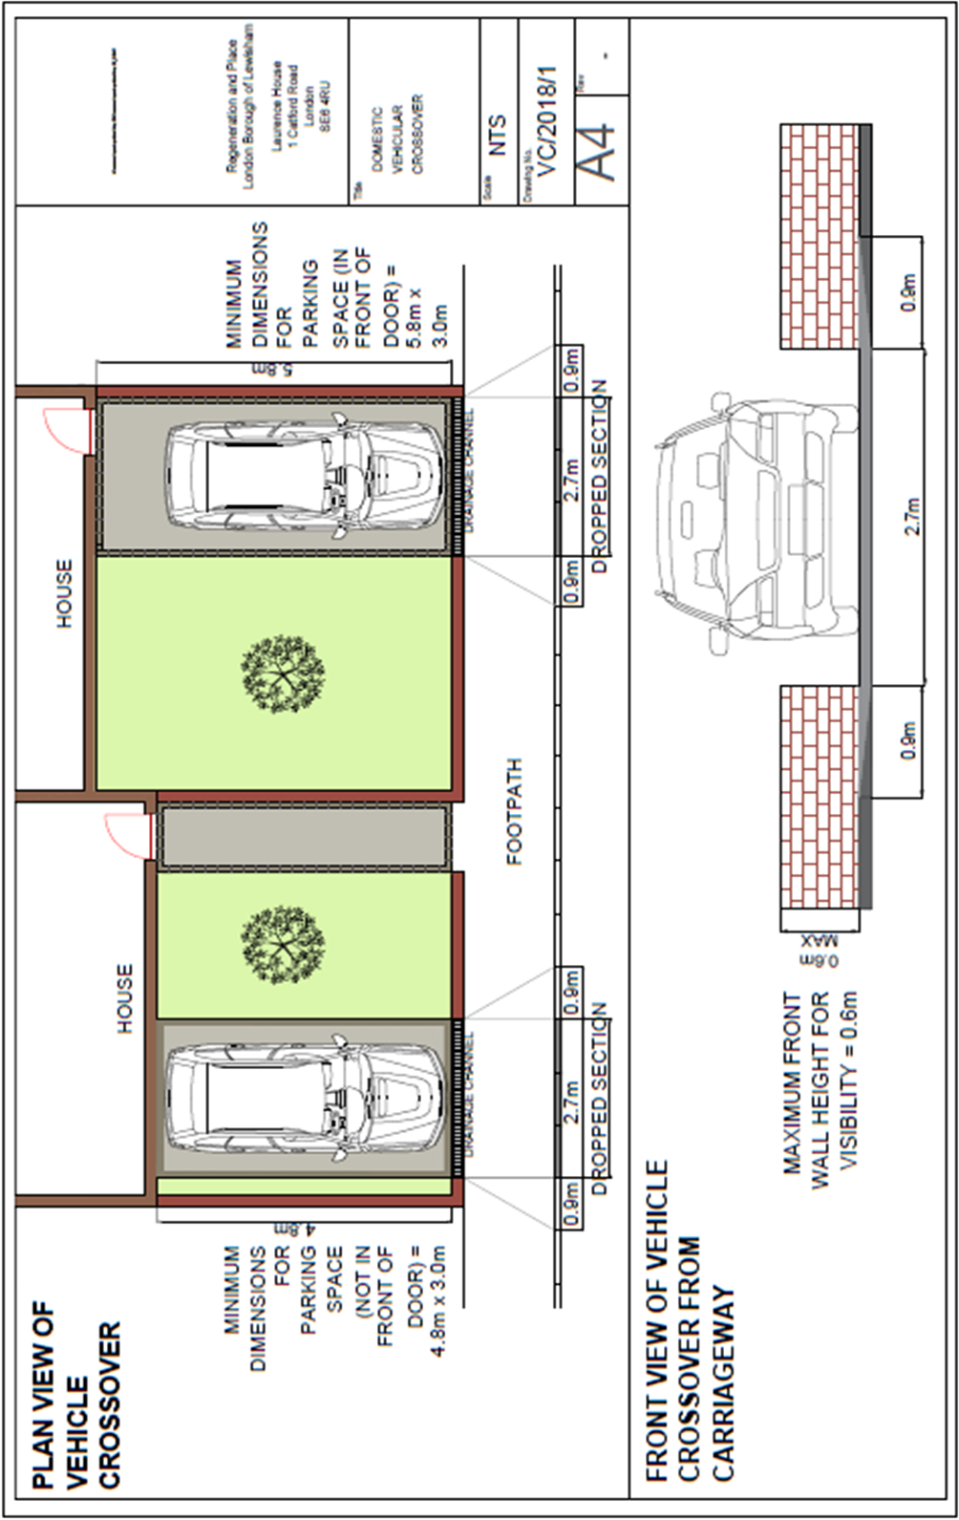
Reference ___________________
(Office use only. Please leave blank)
Application for the construction of a vehicular crossover.

Name | Mr/Mrs/Miss/Ms/Other
Address of premises for crossover
Daytime telephone no
Email address
Contact address
(if different from above)

1 | I have measured the proposed parking area and it is sufficient width and depth.  (at least 4.8m deep or 5.8m deep if installed in front of the door and 3m wide)  (see Terms & Conditions item 1) | Yes/No | If the answer is no a crossover will NOT be permitted.  Please note this measurement has changed in recent years and you should not assume that your garden is sufficient size just because a neighbouring property has a crossover.
2 | Is the property on a classified road?  (see Appendix 1) | Yes/No | If you have answered yes to any of these questions  (2, 3, 4, 5, 6, or 7)  you must obtain Planning Permission before submitting this form.  Please attach a copy of your Planning Permission
3 | Is the property in a Conservation area or subject to a relevant Article 4(1) Direction? (see Appendix 2) | Yes/No
4 | Is the address on the Red Route Network?  (see Appendix 3) | Yes/No
5 | Is the address within a multi-dwelling building?  (see Terms & Conditions item 3) | Yes/No
6 | Is the address used for commercial purposes? | Yes/No
7 | Is the property a listed building? | Yes/No
8 | Does the proposed parking space currently have a hardstanding in place?  (see Terms & Conditions item 12. ) | Yes/No | If the answer is no, you will be required to install a suitable hardstanding within 3 months of receiving our estimate.
I confirm that I have read the Terms & Conditions before  Submitting this form. |  | Signed ___________________  Date___________________

Please return the completed form to:
Business Support Highways, 4th Floor Laurence House, 1 Catford Road, London, SE6 4RU
Or email to businesssupporthighways@lewisham.gov.uk

Once we receive this form a member of our admin team will contact you to take the application fee by telephone.

