

**Midday Meal Supervisor**

Recruitment Information and Application Pack

To Start As Soon As Possible

Gordonbrock Primary School

Amyruth Road

London, SE4 1HQ

Website: www.gordonbrock.lewisham.sch.uk

Email: [admin@gordonbrock.lewisham.sch.uk](mailto:admin@gordonbrock.lewisham.sch.uk)

Executive Headteacher: Maria Gilmore

Head of School: Jane Wright

Chair of Governors: Peter Fidel

**Contents**

|  |  |
| --- | --- |
|  | Page |
| Letter from the Headteacher | 3 |
| School Description | 4 |
| Federation Description | 6 |
| Application Information | 7 |
| Job Profile | 9 |
| Person Specification | 10 |

[](http://gordonbrock.lewisham.sch.uk/wp-content/uploads/2013/10/CIMG0228.jpg)

[](http://www.google.co.uk/url?sa=i&rct=j&q=&esrc=s&source=images&cd=&cad=rja&uact=8&ved=0CAcQjRxqFQoTCIzivda86ccCFcI8FAodLrYJMg&url=http://www.urbansynergy.com/2013/12/role-model-seminar-gordonbrock-primary-school/&psig=AFQjCNGD2dI4ZHr369D9RNRgug6E4IL-Yg&ust=1441871651672060)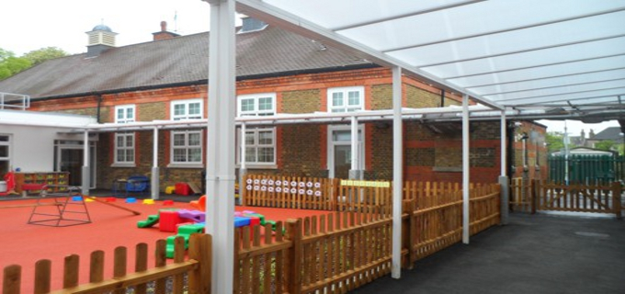



**The Eliot Bank and Gordonbrock Schools Federation**



Executive Headteacher: Ms Maria Gilmore

Eliot Bank School Gordonbrock School

Thorpewood Avenue Amyruth Road

London SE26 4BU London SE4 1HQ

Tel: 020 8699 0586 Tel: 020 8690 0704

Fax: 020 8699 4489 Fax: 020 8690 7201

info@eliotbank.lewisham.sch.uk admin@gordonbrock.lewisham.sch.uk

Head of School: Mr Mark Ridler Head of School: Mrs Jane Wright

1 April l2019

Dear Candidate,

Thank you for your interest in this position.

If you intend to apply for the position, please ensure you complete and return the application form and include the Safer Recruitment form as part your application. Please ensure that your application form arrives before the closing date of **Thursday 25th April** at **12 noon**.

If you are shortlisted you will be invited to school on **Tuesday 30th April 2019** for a short observation followed by an interview. Please note that we will not be able to contact candidates who are not shortlisted.

I look forward to receiving your application, which can be returned by email to admin@gordonbrock.lewisham.sch.uk by post or by hand to Gordonbrock School address above.

Yours faithfully,

Jane Wright

Jane Wright

Head of School

*The Eliot Bank and Gordonbrock Federation of Schools is committed to safeguarding and promoting the welfare of children and young people and expects all staff and volunteers to share this commitment. We implement all elements of the safer recruitment process and all posts are subject to pre-employment checks. References will be sought and successful candidates will need to undertake an enhanced Disclosure & Barring Service (DBS) check.*

**Gordonbrock School**

Gordonbrock is a community primary school in Brockley in South East London. It is large school with approximately 650 on roll.

From September 2013 Gordonbrock became part of a hard federation with Eliot Bank School. Staff across the schools work closely together. Our curriculums and assessment cycles are aligned, enabling joint planning and moderation. The Executive Head has the strategic lead across the federation, whilst the day to day running of the school is the responsibility of the Head of School.

From September 2011 Gordonbrock was designated a three forms of entry school. There is also a nursery providing part time and full time placements.

The intake to the school is a wonderful mix of ethnicity, race culture and socio-economic backgrounds. The children have a wide range of needs including those with special educational needs and many who are very able. We are focussed on children’s learning and have developed meaningful cross curricular planning building up layers of knowledge and understanding. We believe in making learning exciting and our curriculum is skills based and includes a wide variety of visits and visitors. We encourage children to demonstrate their learning through a range of strategies. We value music and PE highly, buying in additional expertise in these areas.

This is an exciting time for Gordonbrock. We have been part of a £10,000,000 redevelopment of the school which has resulted in a purpose built school with excellent ICT facilities, large classrooms and group rooms.

A small number of our children can make demands in terms of their behaviour and social skills, however the school has a calm working atmosphere and the behaviour of the children is good. This is brought about through the clear and consistent behaviour policy applied throughout the school.

Teachers are supported in their role in a variety of ways:

* The leadership team is experienced and highly motivated with a clear focus on raising standards through purposeful learning.
* Year groups are organised into phases each with a phase leader who is a member of the leadership team.
* Good organisation throughout the school with a wide range of policies and systems in place.
* Teaching Assistants are knowledgeable, experienced and motivated, taking responsibility for a number of intervention strategies as well as for some assessment and feedback.
* Our admin and premises staff ensure that the school is well maintained and organised. They play a vital part in school life.

Staff are very supportive of each other and plan in teams. There are positive relationships within the school with staff working hard within a relaxed atmosphere.

There is a full programme of CPD with induction, quality professional development meetings, coaching and access to high quality external INSET. Newly qualified teachers receive guaranteed NQT time and a mentor to support them. We have a well-established cycle of monitoring, evaluation and support, focussing on various aspects of the school. Performance management, observations and peer coaching are part of this process.

The staff, children and parents of Gordonbrock are caring, friendly and supportive. We believe in a learning environment for all in which everyone has a part to play and a contribution to make. Parents are made welcome and there is an ongoing dialogue between staff and parents, which is established in the early years foundation stage and continues throughout the school. There is a strong Parent Teacher Association that is very representative of the community it serves.

In our Ofsted Inspection of February 2018 the school was judged as ‘Good with outstanding features’. Please see a copy of the report included in your application pack.

We welcome staff who enjoy working with children, who work hard, are determined to learn and improve, and thrive on challenge. Above all, we welcome staff who are confident that they can deliver, to the children of Gordonbrock, a quality education.

**The Federation**

Gordonbrock is in federation with Eliot Bank, with both schools working closely together led by Maria Gilmore, Executive Headteacher.

The leadership teams meet regularly to ensure that systems that are aligned are working well.  The Heads of School work together where required to support and challenge one another. The schools work from the same curriculum map and year group teams meet regularly to plan. Phase leaders and curriculum leaders are also developing their partnerships with joint learning walks and shared strategic planning.

We became a hard federation in September 2013. This gives a formal framework to the partnership and enables the schools to move forward with long term security. We are determined that the schools will keep their individuality underpinned by common expectations and purpose.

**Application Information**

**Salary: Salary Scale 2, Spine Point Range 11 – 13, £20,617.00 - £20,951.00**

**Term Time only pro-rata (38 weeks per year)**

**Actual Annual Salary - £3063.47**

1. **Application Form**

Application forms can be obtained by;

* Downloading the Application Form document that is attached to the advert online.
* E-mailing Allesha McDonald at admin@gordonbrock.lewisham.sch.uk.

Applications will not be considered without a completed application form.

CVs will not be accepted unless accompanied by a fully completed application form

1. **Safer Recruitment Form**

Applicants are asked to download and complete the safer recruitment form that is attached to the vacancy advert.

Applications will not be considered without a completed safer recruitment form.

1. **Closing date for Applications**

Completed application forms should be emailed to **amcdonald36.209@lgflmail.org** by **12 noon** on **24th September 2018.** We will email you to acknowledge safe receipt of your application.

1. **Shortlisting**

If you have been successful we will contact on **26th September 2018** to invite you to an interview.

1. **Interviews**

Interviews will be held on **Tuesday 30th April 2019.**

1. **Appointment**

The successful candidate will be appointed as soon as possible.

Any appointment will be subject to: satisfactory references, medical clearance, right to work in the UK, satisfactory enhanced Disclosure and Barring Service (DBS) clearance.

Our stringent pre-employment checks reflect The Eliot Bank and Gordonbrock Schools Federation commitment to safeguarding and promoting the welfare of children and young people. We expect all staff and volunteers to share this commitment.

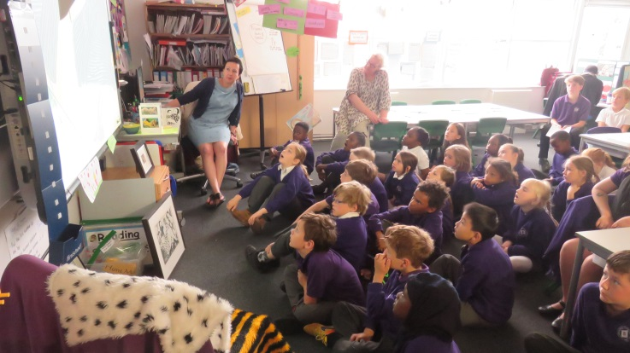







**The Eliot Bank and Gordonbrock**

**Schools Federation**

|  |
| --- |
| **Meals Supervisor**  **Job Description** |
| **Reporting to**: Senior Midday Meals Supervisor  **Grade:** SC2  **Disclosure Level**: Enhanced |
| **Purpose of Job:** |
| To work as part of a team of adults including teachers and other support staff, to promote the learning and well-being of all pupils. To take responsibility for the supervision, health and safety and control of pupils during the midday break both during dining and play. |
| **Summary of Responsibilities and Duties** |
| **Support for Pupils** |
| * Supervise pupils receiving school meals and packed lunches ensuring orderly conduct and good behaviour. * Promote and encourage healthy eating and balanced choices of food. Be aware of the varying dietary requirements of pupils for medical or cultural reasons. * Supervise pupils in the play area or within the building in the event of bad weather ensuring that a safe environment is maintained and that the school’s behaviour policy is adhered to. |
| **Support for Teachers** |
| * Respond to the welfare needs of pupils by comforting them or applying first aid, reporting any concerns on the general well-being of the pupils to the senior midday supervisor or the class teacher. * In accordance with the school’s child protection policy report any concerns about individual pupils to the senior midday supervisor or the class teacher. |
| **Support for Curriculum** |
| * Encourage appropriate exercise and activities to promote the health and well-being of pupils. * Encourage and develop pupils’ understanding of team activities as well as individual pursuits. * Support and encourage the development of pupils’ social interaction with each other. |
| **Support for the School** |
| * Assist with any administrative processes involved in taking school meals and packed lunches. * Ensure that any people entering the play area from outside the school are identified and escorted to the school reception. * Maintain awareness and observe the school guidelines on security. |
| **Equalities** |
| Ensure implementation and promotion in employment and service delivery of the Council’s/School’s equal opportunities policies and statutory responsibilities. |



**The Eliot Bank and Gordonbrock**

**Schools Federation**

|  |  |  |
| --- | --- | --- |
| **Meals Supervisor**  **Person Specification** | | |
| **Reporting to**: Senior Midday Meals Supervisor  **Grade:** SC2  **Disclosure Level**: Enhanced | | |
| **Notes to Candidates:** | | |
| The Person Specification is a picture of the skills, knowledge and experience needed to carry out the job. It has been used to draw up the advert and will also be used in the shortlisting and interview process for this post.  Those categories marked 'S' will be used especially for the purpose of shortlisting.  If you are a disabled person, but are unable to meet some of the job requirements specifically because of your disability, please address this in your application. If you meet all the other criteria you will be shortlisted and we will explore jointly with you if there are ways in which the job can be changed to enable you to meet the requirements. | | |
| **Equal Opportunities** | | |
| * Commitment to implement the Council’s Equal Opportunities policies. * Awareness of Equal Opportunities issues. | | **S** |
| **Knowledge** | | |
| * Good health and hygiene procedures. * Needs of children and families in a multi-racial, inner city area. | | **S**  **S** |
| **Skills** | | |
| * Ability to work as part of a team * Communication Skills |  | |
| **Experience** | | |
| * Experience of working with groups of children. | **S** | |
| **General Education** | | |
| * Current Food Handling & Hygiene certificate |  | |
| **Personal Qualities** | | |
| * Sensitivity and awareness of the needs of young children |  | |
| **Physical** | | |
| * Generally candidates must meet the standard Lewisham requirements for the post * Good general health * Able to attend meetings / site visits in locations both inside and outside of the borough. * Able to use computer, telephone, and read correspondence |  | |